Guidance for Those Working with Livestock in the Era of COVID-19

Until a vaccine becomes widely available and the risk of contracting COVID-19 is greatly reduced, people tending to livestock need to make some changes to their practices to reduce their risk of illness. This is particularly true where different individuals may care for a group of animals such as on larger farms, stables, cooperative farms, school farms, FFA chapter farms, or 4-H club farms. The risk comes not from livestock but close contact with other humans. Here are some recommendations about how to reduce that risk.

Communication
Rapid and accurate communication between people has never been easier. Group texts/messaging/chats are simple to use on smart phones. Email chains or even phone trees can be employed as well.

If a group of people is sharing duties and caring for the same group of livestock, a schedule should be created to ensure all feeding, watering, and cleaning chores will be completed but without contact between individuals from different households. Ensure there is at least five hours between shifts because the COVID-19 virus can persist in air for over three hours.¹ The schedule could be divided by AM and PM, a 24-hour period, weekly, or whatever the group decides. A backup person should be available for each shift as well. Each caregiver should send a group text/message confirming chores have been completed for that part of the schedule. If the message is not received by a certain time, someone in the group can investigate why and ensure animals receive care from the back-up person.

This cooperative system means instructions for each animal’s care must be written down and shared with all caretakers. Animals must have visible identification so special needs can be addressed and any concerns communicated accurately. Instructions must be simple yet detailed enough so those who might not have much experience with or knowledge of that species can do basic feeding, watering, and cleaning chores safely and effectively. Be specific about hay and feed amounts; use weight or volume measures, not such terms as “an armful.”

Pay particular attention to details related to feeding medicated feed. Be sure such feed is only fed to the designated animals; feeding details (dates and amounts) must be recorded so the owner can report what was done for quality assurance documentation. Feeding errors could result in unacceptable medication residues in food animals, risk to consumers, loss of income, and fines and penalties.

Those performing chores should take a cell phone along so they can call someone knowledgeable if any problems are encountered. A text message, photo, or video could be shared between the person on site and a knowledgeable person off site, who can give advice about what action(s) to take. Each caregiver should have each animal’s owner, the property owner, and local veterinarians’ contact information at hand.

Establish signage at the site to minimize confusion and needless foot traffic. “Parking,” “Tools,” “Hay,” “Steer Feed,” “Sheep Minerals,” etc. are examples of signs that can decrease confusion or the chance of animals receiving the wrong type of feed. Weatherize signage to keep it legible.

Discuss how veterinary services will be provided if necessary, in advance of need. Ask the veterinarian which practices or treatments could be postponed or eliminated and which are essential. Also arrange for emergency services if needed for any of the animals kept at the common location.

Four linked documents are available as planning templates. These include:
- Caretaker Contact List
- Group Livestock Care Schedule
- Group Livestock Care Instructions
- Cleaning and Disinfection Protocol

Logistics
Advanced planning will be needed to coordinate all the details involved with multiple people caring for multiple animals at a single site. Supplies and feed will need to be inventoried, re-ordered, and re-stocked as needed, leaving plenty of time in case of delivery delays.

Transportation issues will need to be addressed. People from different households should not carpool together due to increased disease transmission risk for people sharing a small space. Access to the premises should be limited to a single entry/exit to limit and monitor vehicle and foot traffic and encourage people to use the handwashing station and trash receptacles kept nearby.

In some situations, animals may need to be separated and moved to multiple premises to ensure animal care and protect human health. Humans should abide by all social distancing recommendations during this process and thoroughly clean and disinfect all equipment used to transport the animals.

Personal Protective Equipment (PPE)
Standard PPE while caring for livestock includes gloves, coveralls, and disinfected footwear. With the added concern of COVID-19, additional consideration should also be given to the use of face masks. However, these may not be necessary if those doing chores in a given shift are all from the same household. If that is not the case, masks covering one’s mouth and nose are encouraged along with a minimum of 6 feet of interpersonal distance.

Additional PPE to consider includes hair protection (i.e., a hat), a beard net, and/or safety goggles. Although there is no evidence this extent of protection is warranted to prevent contracting COVID-19 from livestock,^{2,3} these biosecurity aids reduce transmission of zoonotic diseases from livestock to humans and transport of pathogens off the farm.

Disinfection
Handwashing with soap and water for 20 seconds is more effective than sanitizing gels, particularly when hands are visibly dirty, such as after performing chores. The simple and inexpensive portable handwashing station shown in Figure 1 can be set up at any site and used to wash hands effectively. Sanitizing gel can then be applied to clean and dry hands if desired. Hands should be washed before handling animals, between groups of animals, and after all chores are done.
Don’t Forget These
Key Risk Reduction Strategies

- Keep your hands away from your mouth, nose, eyes, and face.
- Frequently wash your hands with soap and water for 20 seconds.
- Stay at least 6 feet away from people not in your household.
- Cough or sneeze into a tissue and discard it.
- Stay home if you are ill.

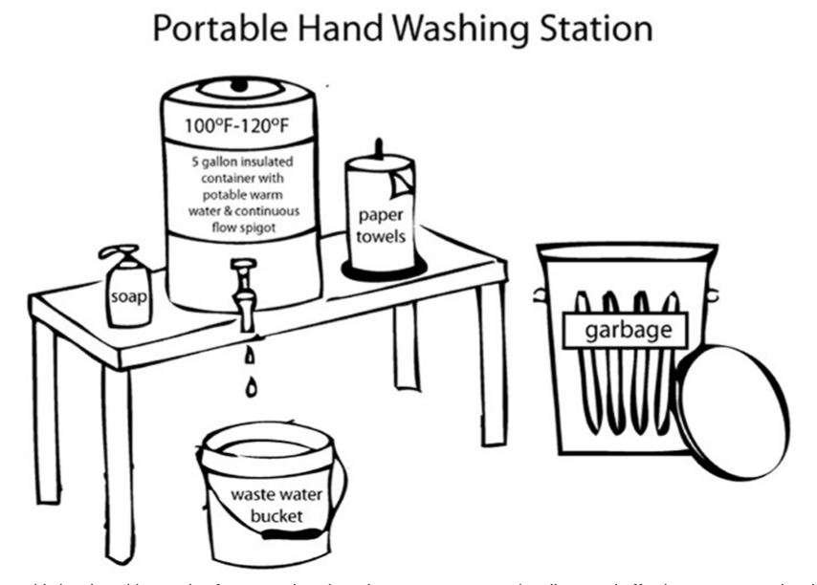
Figure 1. Low cost portable handwashing station for remote locations. Use a paper towel to turn water spigot on and off and dispense soap. Wash hands with soap and running water for 20 seconds. Replenish warm water as needed. Adapted from Kalamazoo (MI) County Environmental Health by Sarita Role Schaffer as published in Washington State University Extension FS257E, Practical Biosecurity Recommendations for Farm Tour Hosts, 2017.

Convenient boot washing stations should be established to encourage use. A hose, long-handled boot brush, and soap should be used to remove all visible manure, mud, and other organic debris (Photo 1). Clean boots are then ready for disinfecting; this can be done at the livestock housing site, or the boots could be transported home in garbage bags or buckets to be disinfected there. Do NOT rely on foot baths—they are hard to maintain and do not promote adequate contact time with disinfectant.

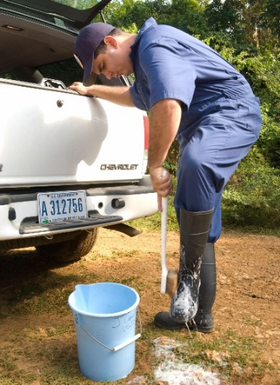
There is no reason to believe contact with any livestock species increases the risk of humans contracting COVID-19.^{2,3}
Photo 1. Cleaning boots with soap, water, and a boot brush before disinfecting. Source: USDA APHIS. https://www.flickr.com/photos/usda-aphis/34483833884/
Disinfectants registered with the EPA and proven effective against the SARS-2 corona virus are listed on the EPA resource below.^{.4} Note that very few are effective on soft or porous surfaces. Some are familiar over-the-counter brands such as specific Lysol® and Clorox™ products. A solution of four (4) teaspoons of fresh household bleach to one (1) quart of water is effective if there is at least one minute of contact time.⁵
Vinegar, baking soda, and other substances touted by some sources as effective against pathogens are neither effective nor registered by the EPA as disinfectants, so it is a violation of federal law to use them for this purpose.⁶

People factors
Working in shifts should reduce the risk of person-to-person disease transmission. Other people-based disease control factors include only allowing essential personnel (i.e., animal caretakers) on the premises; maintaining recommended 6’ social distancing between people from different households; installing “No Visitors” signage; and ensuring each shift’s workers are from just one household. Additionally, everyone in the group should take his/her/their temperature twice daily—if his/her/their temperature is elevated and/or he/she/they feel sick, no one in that household should do livestock chores for at least 14 days. Anyone who is immunosuppressed or has underlying health conditions should not put themselves at added risk and leave animal caretaking to others.

Because some caregivers may not be as familiar with some livestock species as others and some livestock are wary of strangers, caution should be taken when working with unfamiliar animals. In some cases, just providing feed and water may be safest, letting someone else more confident or familiar with those animals clean their facilities. Human safety must come first.

Biosecurity
While taking care to reduce the risk of contracting COVID-19, do not neglect the biosecurity practices that should be second nature in preventing the spread of animal-to-animal and animal-to-human diseases:
- Wash hands before and after handling groups of animals
- Wear disposable gloves if zoonotic diseases are a concern (sore mouth, ringworm, etc.)
- Have clothing (coveralls) and footwear dedicated to on-farm use
- Clean and disinfect footwear between groups of animals and before leaving premises
- Place dirty coveralls in plastic garbage bags for transport home; launder after pre-soaking with EPA-approved Lysol® or Maquat® laundry pre-soak products⁴
- Do healthy animal chores first, then tend to sick animals
- Tend to young animals before older animals
- Quarantine new or returning animals for at least 30 days before adding to herd
- Keep animals up to date on vaccinations
- Decide how veterinary care will be provided if needed
- Use metal, concrete, or plastic in place of wood or dirt whenever possible to aid disinfection
- Have dedicated tools for handling feed vs. manure
- Monitor animals daily for signs of illness; separate sick animals from others and keep them in an isolation pen
- Remove dead animals and bury, compost, or landfill carcasses promptly
- Control fly, vermin, wildlife, pest, dog, and cat activity on farms to reduce the spread of disease agents
- Protect feed and water from contamination
- Prevent contact between sick people and livestock
- Prevent contact between poultry and wild waterfowl
- Prevent contact between sheep and goats and cattle or bison
- Prevent contact between swine and poultry
- Minimize number of surfaces touched
- Do not share grooming equipment or tools with others
- Clean and disinfect any surfaces touched, such as cell phones, gates, doorknobs, water faucets, panels, tools, brush handles, etc.
- Do not touch animals other than your own to reduce the risk of transmitting disease agents
- Blow your nose and discard the tissue before you leave the shared premises

Summary
The COVID-19 outbreak has caused worldwide examination of risks associated with daily activities. For groups of people working with livestock, new procedures must be developed and followed to reduce human-to-human transmission of the novel coronavirus, SARS-CoV-2, while caring for animals. Heightened attention to biosecurity should minimize risks associated with groups of people caring for multiple animals. Happily, this increased emphasis on biosecurity should also result in fewer cases of animal-to-animal and animal-to-human diseases.

References
^{1.}van Doremalen, N. et al. March 17, 2020. Aerosol and Surface Stability of SARS-CoV-2 as Compared with SARS-CoV-1. New England Journal of Medicine. DOI: 10.1056/NEJMc2004973.
https://www.nejm.org/doi/10.1056/NEJMc2004973

Kerr, S.R. 2017. Practical Biosecurity Recommendations for Farm Tour Hosts. Washington State University Extension Fact Sheet FS257E. https://pubs.extension.wsu.edu/download/sample/4022

^{2.}Centers for Disease Control and Prevention. Coronavirus Disease 2019 (COVID-19): If You Have Animals. March 27, 2020. https://tinyurl.com/cdc-covid19-animals

^{3.}World Organization for Animal Health (OIE), Jan. 4, 2020. Questions and Answers on the 2019 Coronavirus Disease (COVID-19). https://www.oie.int/en/scientific-expertise/specific-information-and-recommendations/questions-and-answers-on-2019novel-coronavirus/

^{4.}U.S. Environmental Protection Agency. April 2, 2020. Pesticide Registration, List N: Disinfectants for Use Against SARS-CoV-2. https://www.epa.gov/pesticide-registration/list-n-disinfectants-use-against-sars-cov-2
^{5.}Centers for Disease Control and Prevention. March 26, 2020. Cleaning and Disinfection for Households: Interim Recommendations for U.S. Households with Suspected or Confirmed Coronavirus Disease 2019 (COVID-19).https://www.cdc.gov/coronavirus/2019-ncov/prevent-getting-sick/cleaning-disinfection.html

^{6.}Dvorak, G. 2008. Disinfection 101. Center for Food Safety and Public Health, Iowa State University. CFSPH www.cfsph.iastate.edu/Disinfection/Assets/Disinfection101.pdf

