Addressing the Food-Energy-Water System Trilemma:
Balancing Reliance on Technological and Institutional Solutions
October 7 – 9, 2015 | W Seattle Hotel, 1112 4th Ave., Seattle, Washington

Travel and Restaurant Information

Getting From the Airport to the Hotel:
Light Rail
Seattle has a great public transportation system and we strongly encourage you to use it. It’s generally faster and cheaper than driving during peak traffic hours.
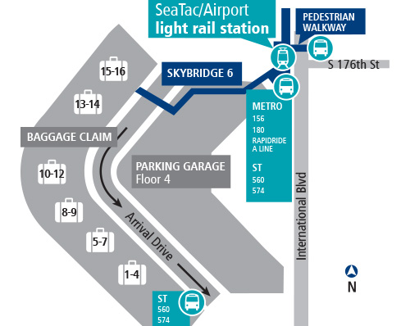
Boarding: From the airport, follow the signs to Link Light Rail by way of the 4th floor of the parking garage (and not Public Transit). The fare is $3.00. Trains leave every 6-10 mins, but a detailed the schedule of times can be found here. Buy tickets in the Link station ticket vending machine (TVM) using cash or credit card before going up to the platform level.
Exiting: You’ll be getting off at the University Street Station (Bay C). Walk one block NE towards 4th St. The W Seattle Hotel is on the corner of 4th St. and Seneca St.
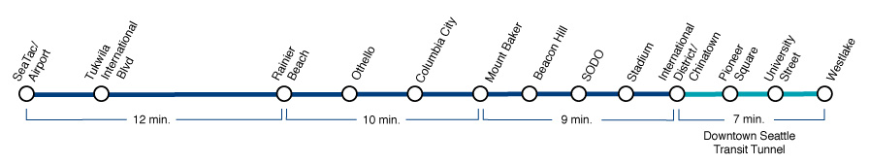

Airport Shuttle Service
There is also a shuttle service offered by Shuttle Express that runs from the airport to the W Seattle Hotel. This shuttle is $18 per person, and vans leave SeaTac Airport at the top of the hour, every hour. Pre-booked trips are not required, but are appreciated- (425) 981-7000.
Boarding: From baggage claim, cross Skybridge 4 to the airport parking garage and go to the 3rd floor to the center of the Ground Transportation Plaza. Check in with an attendant to activate your walk-up or pre-paid ticket. Our coordinators will check you in between 7:00 a.m. and 2:00 a.m. After 2:00 a.m., check in by using the courtesy phone, which connects you to our Guest Service Center.

Driving and Parking
For those of you joining us from the Seattle area who are staying at the W Seattle Hotel, we have arranged for your parking to be included in with your room.
For those driving in for each day event, there are three parking options available. We will have vouchers on hand at the workshop for the Hotel and Olympic parking facilities.
- W Seattle Hotel- 1112 4th Ave, Seattle WA
Hotel parking is 24-hour, secure valet parking. This includes unlimited in-and-out privileges and whatever/whenever service. Parking is based on availability.
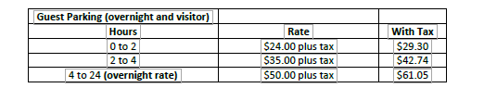

- Olympic parking address is 1100 5th Ave, Seattle WA
This public self-parking garage has no in-and-out privileges (must pay each time), and is located a block away from the W Seattle hotel. Parking is based on availability.

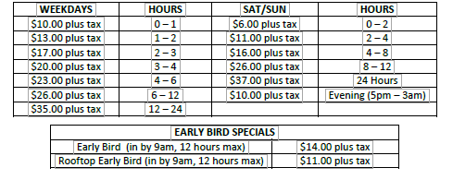

- Rainer Square address is 407 Union Street, Seattle WA
This lot is valet parking, and does not have in-and-out privileges (must pay each time). This garage is located two blocks from the hotel. There is no overnight parking available, the garage closes at midnight. Parking is based on availability.

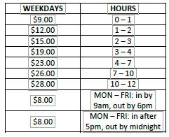

Map of Parking Garages and Light Rail Station:
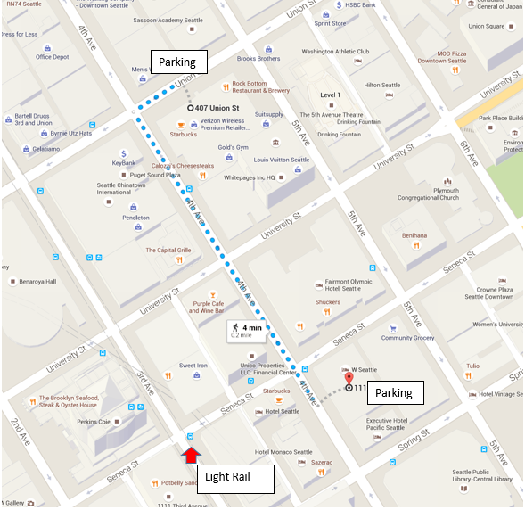
Olympic
Hotel
Rainer

Dining and Nearby Restaurants:
These are a few breakfast and lunch suggestions from Yelp that are within a 5 blocks of the hotel. Additional restaurant suggests are also included in the section entitled “Other Restaurants”.
Breakfast:
Phoenix Café ($)- 1017 3rd Ave- Coffee & Tea
Caffee Migliore ($$)- 1215 4th Ave- Coffee & Tea
Top Pot Doughnuts ($$)- 720 3rd Ave- Coffee, Artisanal Donuts
Cherry Street Coffee House ($)- 1212 1st Ave- Coffee & Tea, Sandwiches, Cafes
Sweet Iron ($): 1200 3rd Ave – Belgian, Breakfast & Brunch, Desserts
BOKA Restaurant + Bar ($$)- 1010 1st Ave- American (new), Breakfast & Brunch
Belle Epicurean ($$)- 1206 4th Ave- Bakeries, Desserts, Cafes
Homegrown ($$)- 999 3rd Ave Plz- Sandwiches, Salad, Breakfast & Brunch

Lunch/Dinner:
Umma’s Lunch Box ($): 1301 5th Ave- Korean, Buffets
Italina Family Pizza ($): 1206 1st Ave- Pizza, Italian
Market Fresh ($)- 925 4th Ave- Sandwiches
Harbor Café ($)- 1411 4th Ave- Thai, Asian Fusion, Café
MOD Pizza ($)- 1302 6th Ave- Pizza, Fast Food
Japonessa ($$)- 1400 1st Ave- Japanese, Sushi Bar
Von’s Gustobistro ($$)- 1225 1st Ave- American (new), Burgers, Cocktails
Sazerac ($$)- 1101 4th Ave- American (new)
Veggie Grill ($$)- 1427 4th Ave- American (new), Vegan, Vegetarian
Homegrown ($$)- 999 3rd Ave Plz- Sandwiches, Salad, Breakfast & Brunch
BOKA Restaurant + Bar ($$)- 1010 1st Ave- American (new), Breakfast & Brunch

Other Internet-Suggested Restaurants
Walking Distance
ANDALUCA - 407 Olive Way at 4th Ave; (206) 382-6999; www.andaluca.com - Mediterranean cuisine
BAROLO -1940 Westlake Avenue & 7th Street; (206) 770-9000 - “Old World” Northern Italian atmosphere
BROOKLYN SEAFOOD, STEAK & OYSTER HOUSE – 1212 2nd Ave & University St; (206) 224-7000 - a local favorite!
CAPITAL GRILLE - 1301 4th Ave at University; (206) 382-0900 - Steak, seafood, fine dining
DAHLIA LOUNGE - 2001 4th Avenue & Virginia Street; (206) 682-4142 - Northwest menu with Pacific Rim influence
EL GAUCHO- 2505 1st Avenue and Wall Street-(206) 728-1337- Steak
ELLIOTT’S - Pier 56; (206) 623-4340; www.elliottsoysterhouse.com - Top rated oyster bar and great seafood
ETTA’S SEAFOOD - 2020 Western Ave (Virginia & Lenora); (206) 443-6000 - Seafood with Pacific Rim influence
GORDON BIERSCH - Pacific Place, 6th & Pine Street; (206) 405-4205 - Brew Pub & Restaurant
HARD ROCK CAFE-Pike St between 1st and 2nd Ave (206) 204-2233-American cuisine
IL BISTRO – 93 A Pike St; (206) 682-3049; www.ilbistro.net - Warm, charming Northern Italian cuisine
IL FORNAIO - 601 Pine Street at 6th Avenue & Olive Way; (206) 264-0994 - Delicious Italian cuisine624-346
LOLA - 2000 4th Ave at Virginia; (206)441-1430 - Mediterranean/Greek cuisine with Northwest flavor
METROPOLITAN GRILL - 802 2nd Avenue & Marion Street; (206) 624-3287 - Top ten steakhouses in the country
MORTON'S OF CHICAGO - 6th Avenue/Pike Street; (206) 223-0550 - Upscale steakhouse with large portions
BLUEARCE - 1700 7th Avenue & Olive Way; (206) 267-2277 - Premiere Fresh seafood, large portions
PALOMINO - City Centre Building; (206) 623-1300 - Mix of Italian & Northwest fare with lively atmosphere
PF CHANG’s - 400 Pine Street on 5th Avenue; (206) 393-0070 - Trendy Southeast Asian & Chinese fusion
PURPLE CAFÉ & WINE BAR - 1224 4th Ave at University; (206) 829-2280 – Fun place with a large menu
RN74 – 1433 4th Ave (206) 456-7474 – Contemporary French cuisine with a fun atmosphere and expansive wine list
RUTH’S CHRIS - 7th Avenue/Pine Street (Grand Hyatt Hotel); (206) 774-6400 - Upscale steakhouse
SERIOUS PIE- 316 Virginia Street & 4th Ave (206) 838-7388-Gourment Pizzas
STEELHEAD DINER: 95 Pine Street Seattle, WA 98101-1530 (206) 625-0129-Gourmet Comfort and Seafood
TULIO'S - 1100 5th Avenue & Spring Street; (206) 624-5500 – Authentic Italian cuisine using local ingredients
UMI SAKE HOUSE: 2230 1st Avenue Between Bell and Blanchard (206) 374-8717- Sushi

Short Cab Ride
ANTHONY’S AT PIER 66 - Pier 66; (206) 448-6688; www.anthonys.com - Casual seafood on the waterfront
CANLIS - 2576 Aurora Avenue North; (206) 283-3313 - One of Seattle’s classiest restaurants with a beautiful view
CHANDLER’S CRABHOUSE - 901 Fairview Avenue North on Lake Union; (206) 223-2722 - Finest Seafood world
CUTTER'S - (206) 448-4884; www.cuttersbayhouse.com (offers shuttle service, reserve through hotel concierge)
DANIEL’S BROILER - 809 Fairview Place North on Lake Union; (206) 621-8262 - Prime Steakhouse great view
IL TERRAZZO CARMINE – 411 1st Avenue S & King Street, Merrill Place Bldg; (206) 467-7797 - Classical Italian
PALISADE - (206) 285-1000; www.palisaderestaurant.com (offers shuttle service, reserve through hotel concierge)
PONTI SEAFOOD GRILL - 3014 3rd Avenue North; (206) 284-3000 - A local Seafood favorite w/ gorgeous view
RAY’S BOATHOUSE - 6049 Seaview Ave NW; (206) 789-3770 - Northwest seafood, award-winning wine list
RESTAURANT ZOE – 1318 East Union Street; (206) 256-2060 - New American Cuisine
SALTY’S - (206) 937-1600; www.Saltys.com/alki (offers shuttle service, reserve through hotel concierge)
AQUA BY EL GAUCHO - Pier 70; (206) 956-9171; www.elgaucho.com/Aqua-by-El-Gaucho - Fine dining with water view

