MAJOR FRIEDRICH H. “RICO” MARTIN
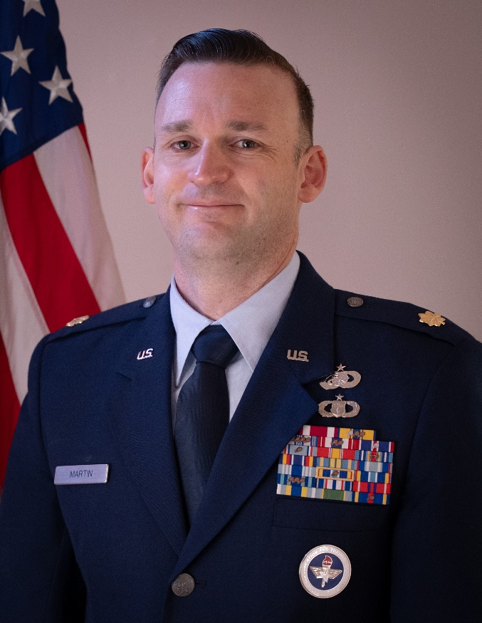
Major Friedrich Martin is the Education Officer of the Air Force Reserve Officer Training Corps Detachment 905 at Washington State University and University of Idaho. He is responsible for recruiting, leading, training, counseling, and evaluating over 100 highly qualified young men and women as prospective Department of the Air Force Officers. Promotes DAF career and scholarship opportunities to university staff, college & high school students, faculty, and parents. Instructs college curriculum covering Foundations of the DAF, DAF History, Leadership, and National Security Affairs.

Major Martin is from Colville, WA and enlisted in the Air Force in 2009, holding a variety of duties as a weather forecaster. He was commissioned in 2016 and held several positions to include Flight Commander of Military Personnel at Mountain Home AFB. From there, he deployed in support of Operation Inherent Resolve in 2018 as Director of Operations for the 407 Expeditionary Force Support Squadron. He served as Flight Commander of Sustainment Services at Buckley AFB where he deployed as Chief of Manpower and Personnel to the 9th Air Expeditionary Task Force-Levant at Camp Arifjan, Kuwait. At Fairchild AFB, he served in a variety of duties including Wing Executive Officer.

EDUCATION
2005 Bachelor of Arts, International Affairs and German, Eastern Washington University, Cheney, WA
2008 Bachelor of Arts, Geography, Eastern Washington University, Cheney, WA
2011 Associate of Applied Science, Weather Technology, Community College of the Air Force, Montgomery, AL
2012 Airman Leadership School, Kapaun AS, Germany
2014 Associate of Applied Science, Instructional Technology, Community College of the Air Force, Montgomery, AL
2016 Basic Officer Training, Officer Training School, Maxwell AFB, AL
2017 Personnel Officer Course, Keesler AFB, MS
2022 Squadron Officer School, Maxwell AFB, AL
2024 Masters of Science, Human Resources Management, Southern New Hampshire University, Hooksett, NH

ASSIGNMENTS
- February 2009 – April 2009, Basic Trainee, 323rd Training Squadron, Lackland AFB, TX
- April 2009 – November 2009, Weather Trainee, 335th Training Squadron, Keesler AFB, MS
- December 2009 – May 2013, Weather Forecaster, 21st Operational Weather Squadron, Kapaun AS, Germany
(May 2011 – September 2011, Security Escort, 386th Air Expeditionary Wing, Ali al Salem AB, Kuwait)
- June 2013 – March 2016, Instructor, 335th Training Squadron, Keesler AFB, MS
- March 2016 – May 2016, Officer Training School Cadet, 24th Training Squadron, Maxwell AFB, AL
- May 2016 – May 2017, Officer in Charge, Fitness, 366th Force Support Squadron, Mountain Home AFB, ID
- May 2017 – Nov 2017, Officer in Charge, Readiness, 366th Force Support Squadron, Mountain Home AFB, ID
- Nov 2017 – August 2019, Flight Commander, MPF, 366th Force Support Squadron, Mountain Home AFB, ID
(July 2018 – January 2019, Director of Operations, 407th Expeditionary Force Support Sq, Al Jaber AB, Kuwait)
- August 2019 – May 2021, Flight Commander, Sustainment, 460th Force Support Squadron, Buckley AFB, CO
(November 2020 – May 2021, Chief, Manpower and Personnel, 9th Air Expeditionary Task Force-Levant, Camp Arifjan, Kuwait)
- June 2021 – July 2022, Section Commander, 92nd Aircraft Maintenance Squadron, Fairchild AFB, WA
- August 2022 – July 2023, Section Commander, 92nd Maintenance Squadron, Fairchild AFB, WA
- July 2023 – June 2024, Chief Innovation Officer, 92nd Air Refueling Wing, Fairchild AFB, WA
- July 2024 – June 2025, Wing Executive Officer, 92nd Air Refueling Wing, Fairchild AFB, WA
- July 2025 – Current, Education Officer, Detachment 905, Washington State University, WA

MAJOR AWARDS AND DECORATIONS
Meritorious Service Medal
Air and Space Commendation Medal with seven oak leaf clusters
Air and Space Achievement Medal with four oak leaf clusters

OTHER ACHIEVEMENTS
2009 Honor Graduate, Basic Military Training
2009 Distinguished Graduate, Weather Initial Skills Course
2010 Senior Airman Below-The-Zone
2010 Airman of the Year, 21st Operational Weather Squadron
2011 Airman of the Year, 3rd Air Force
2011 Lance P. Sijan Award Nominee, 435th Air Ground Operations Wing
2012 NCO of the Year, 21st Operational Weather Squadron
2017 Distinguished Graduate, Personnel Officer Course
2017 CGO of the Quarter, 366th Fighter Wing
2018 CGO of the Quarter, 366th Mission Support Group
2019 A1 CGO of the Year, Buckley Air Force Base
2020 CGO of the Quarter, 466th Force Support Squadron
2020 CGO of the Year, 466th Force Support Squadron
2021 CGO of the Quarter, 9th Air Expeditionary Task Force-Levant
2022 CGO of the Quarter, 92nd Maintenance Squadron
2022 CGO Maintenance Support Professional of the Year, 92nd Maintenance Group
2022 Airlift Tanker Association Young Leader Award Nominee, 92nd Maintenance Group
2023 Excellence in Innovation Quarterly Award, 92nd Maintenance Group
2023 CGO of the Quarter, 92nd Air Refueling Wing
2023 CGO of the Year, Wing Staff Agencies, 92nd Air Refueling Wing
2024 Technology, Transfer, and Transition Annual Award, Department of the Air Force

EFFECTIVE DATES OF PROMOTION
Senior Airman 17 December 2010
Staff Sergeant 1 August 2012
Technical Sergeant 1 July 2015
Second Lieutenant 20 May 2016
First Lieutenant 20 May 2018
Captain 20 May 2020
Major 1 March 2026

(Current as of 1 march 2026)

