ADDITIONAL ITEMS TO BRING WITH YOU TO CAMPUS

Large black backpack to carry gear – recommend separate than one for school.
Pocket Notebook (Always have it on you, starting at Orientation)

Physical Training Gear (Small brand logos are OK, please no graphics)
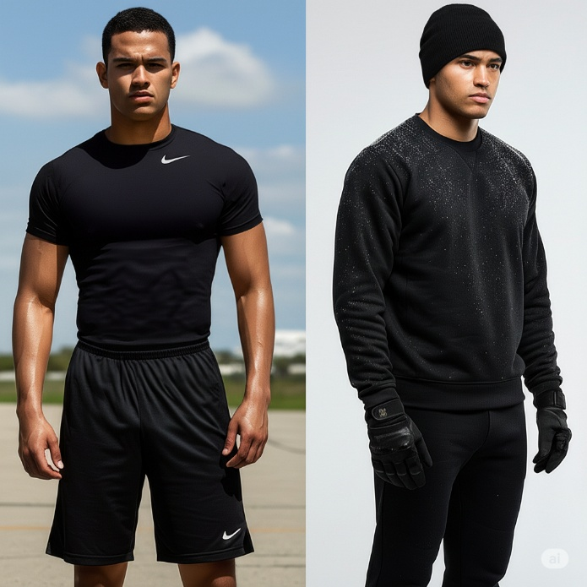
-Plain Black Tee Shirts
-Plain Black Shorts
-Plain Black Sweatpants
-Plain Black Sweatshirt (Hoody OK)
-Running shoes
-Black Beanie
-Black Gloves
-Reusable water bottle (bring a couple)
-Wristwatch with stopwatch (Smart Watch with exercise tracking recommended to track progress, but optional)
Outdoor Winter Gear (We will be outside in cold weather)
-Warm Jacket
-Insulated hiking shoes/boots/or anything warmer than sneakers that you can walk long distances in.
-Warm socks
-Thermal underlayers (optional)
-Pocket handwarmers (optional)

Freshman Uniform
-Kakhi Pants and belt with a tucked in polo shirt (Black/Blue/Gray).
-AFROTC Polo will be provided about a month into semester
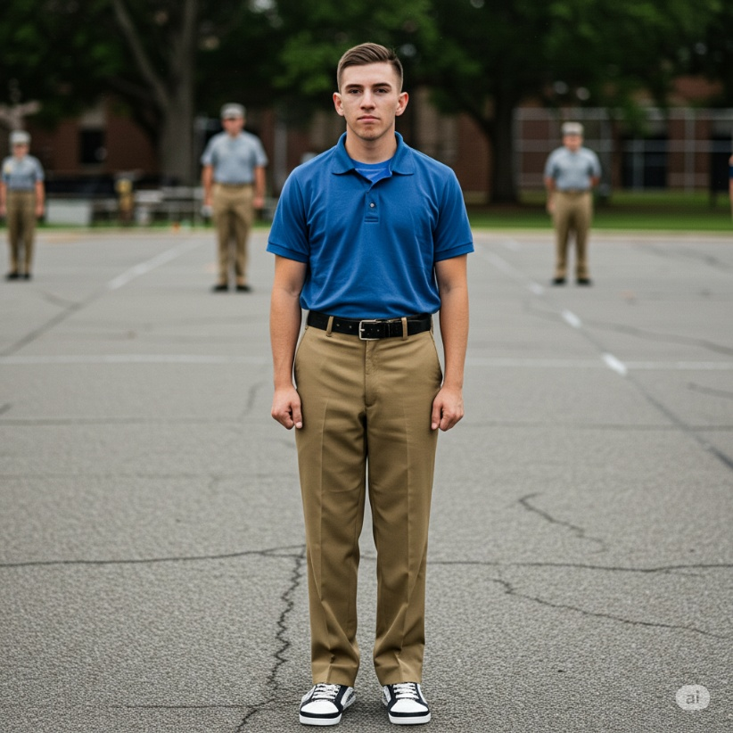

Room Essential Recommendations
-Dedicated plug in alarm clock (Your phone WILL fail you)
-Protein powder and a shaker bottle
-Planning Desk Calender for event tracking and critical times
-High Quality Shaving Razors (You will need to be clean shaven at every ROTC event)
-Hair clippers for last minute touch ups (Haircut regulations are in effect)
-Electrolyte powder

