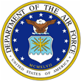 |  | 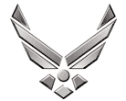

U N I T E D S T A T E S A I R F O R C E
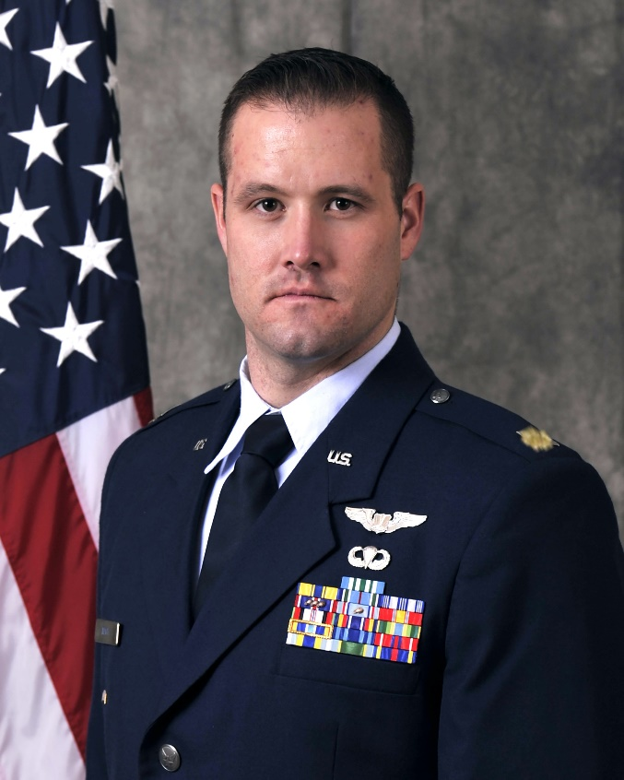
MAJOR DANIEL E. MACK
Major Daniel Mack is the Recruiting Officer of the Air Force Reserve Officer Training Corps, Detachment 905 at Washington State University and University of Idaho. He is responsible for leading, recruiting, training, counseling, and evaluating 100 highly qualified young men & women as prospective Department of the Air Force officers. Responsible for development, management, execution, and funding of all unit recruiting efforts. Promotes DAF career and scholarship opportunities to university staff, college & high school students, faculty, & parents. Instructs college curriculum covering Foundations of the DAF, DAF History, Leadership, & National Security Affairs.

Major Mack was born in Biddeford, Maine and joined the United States Air Force in 2007. Captain Mack commissioned through Officer Training School in 2015 after serving 8 years as an enlisted SERE Specialist. He has 1600 combined flight combat hours in the MQ-1B, MQ-9, and MQ-9X, and has deployed in various roles to Afghanistan, Iraq, and Guatemala. He is also United States Army Airborne and Ranger qualified.

EDUCATION:
2007 Bachelor of Science, Exercise Science, Southern Connecticut State University, Conn.
2011 Master of Science in Leadership: Emphasis on Crisis Management and Disaster Preparedness, Grand Canyon University, AZ.

ASSIGNMENTS:
1. 2007-2015, SERE Specialist, 22nd Training Squadron, Fairchild AFB, Wash.
2. 2015, Student, Undergraduate RPA Training, 558th Flying Training Squadron, JBSA-Randolph, Tex.
3. 2016-2021, Evaluator Pilot/ADO, 867th Attack Squadron, Creech AFB, Nev.
4. 2021-2024, URT Course Director, 558th Flying Training Squadron, JBSA Randolph, Texas
5. 2024-Present, Instructor/Recruiting Officer, DET 905, Washington State University

FLIGHT INFORMATION
Rating: Senior Pilot
Flight Hours: 1600+ hours
Aircraft Flown: MQ-9, MQ-1B

MAJOR AWARDS AND DECORATIONS:
Meritorious Service Medal with two oak leaf clusters and 2 “R” devices
Aerial Achievement Medal with twenty oak leaf clusters
Joint Forces Commendation Medal
Air Force Commendation Medal with one oak leaf cluster
Joint Forces Achievement Medal
Army Achievement Medal

OTHER ACHIEVEMENTS:
2007 Top Honor Graduate, Basic Military Training
2008 Distinguished Graduate, SERE Specialist Training
2011 Distinguished Graduate, Airman Leadership School
2014 Spokane Armed Forces Person of the Year, Spokane, WA
2015 Distinguished Graduate, Officer Training School
2016 Distinguished Graduate, RPA Initial Qualification Training
2017 JCGO of the Year, 867th Attack Squadron
2018 JCGO of the Year, 432d Air Expeditionary Wing
2019 CGO of the Year, 732d Operations Group
2020 CGO of the Year, 732d Operations Group

EFFECTIVE DATES OF PROMOTION:
2d Lt 13 Mar 2015
1st Lt 13 Mar 2017
Captain 13 Mar 2019
Major 1 Oct 2024

