UTC Project Information – National UTC TriDurLE
Project Title | Inversion of poro-elastic sound propagation model and measurement to monitor both rebar corrosion and crack formation using high frequency ultrasonics and contact transducers
University | Florida Atlantic University
Principal Investigator | Pierre-Philippe Beaujean
PI Contact Information | Department of Ocean and Mechanical Engineering  Florida Atlantic University, SeaTech  101 North Beach Road, Dania Beach FL 33004  Phone: 954-924-7051  Email: pbeaujea@fau.edu
Funding Source(s) and Amount Provided (by each agency or  organization) | TriDurLE: $48,848  FAU matching fund: $48,848
Total Project Cost | $97,696
Agency ID or Contract  Number | 2022-FAU-02
Start and End Dates | Start date: 07/30/2022  End date: 06/30/2024
Brief Description of Research Project | The goal of this project is to demonstrate the ability to detect early appearance of cracks in reinforced concrete due to rebar corrosion, using ultrasonic nondestructive acoustic testing with no direct contact between the sensor and the concrete block, in conjunction with a poro-elastic ultrasound propagation model. The objectives are threefold: (1) Identify the proper measurement configuration and predict the performance, using the modeling of the ultrasound propagation in the reinforced concrete; (2) Perform a series of targeted measurements using the proper ultrasonic transducers on a set of existing reinforced concrete samples placed in partial or complete immersion; (3) Evaluate the degree of corrosion within the reinforced concrete with confidence levels according to the poro-elastic model, and correlate the results with those obtained (separately from this proposal) using traditional non-invasive techniques (e.g. corrosion current and corrosion potential measurements).
Describe Implementation of Research Outcomes (or why not implemented)  Place Any Photos Here | A new set of concrete samples (shown in Figure 1), showing various degrees of cracking, was identified for new acoustic tests. The intent was to compare the corrosion potential measurements with the acoustic measurements to establish corrosion and cracking trends in the data.  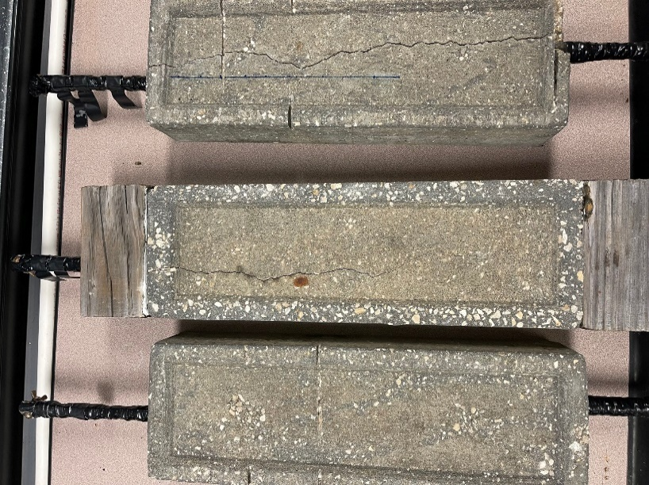  Figure 1. Set of reinforced concrete samples showing various levels of cracking due to corrosion. Note that each sample contains two rebars.  Rebar Potential Measurements: A series of rebar potential measurements was first performed to verify that corrosion is indeed taking place. A galvanostatic pulse (GP) approach was used to obtain R_{s} and i_{corr} , one week after the samples were placed indoors. These measurements were done using a saturated calomel electrode along with a galvanostatic pulse to gather R_{s} and i_{corr}. Both measurements were repeated every time new acoustic measurements were taken to quantify the corrosion of the rebar over time.  Acoustic Measurements: The acoustic measurement procedure was applied to these samples. The data acquisition process went as follows; each reinforced concrete block has two steel rebar beams embedded inside of it. Each rebar beam extended 25.4 [cm] inside the concrete and each beam had a diameter of 1.6 [cm]. The concrete sample was then submerged in a saltwater solution (15% NaCl concentration by mass) to mimic a marine environment. All acoustic data was collected using a high-frequency, narrow beam transducer operating at 500 [kHz] connected to a high-frequency impulse generator and an oscilloscope. The transducer was placed in the water and positioned 12 [cm] above the surface of the concrete directly in line with the corroded rebar sample. The origin is 2.5 [cm] off the edge of the concrete, this is to ensure that the acoustic measurements were not hitting the edge and disrupting the signal. Measurements were taken at 5mm increments along the rebar running for 10 [cm]; at each point along the rebar 10 acoustic samples were taken. These samples were then averaged to reduce noise in the signal. After the data were averaged, the average will be given to the TRR to fit to the Biot-Model. This process was repeated for all rebar beams.  Acoustic measurements were completed at distinct time intervals to start trend analysis measurements for changes in Biot-Stoll model parameters.  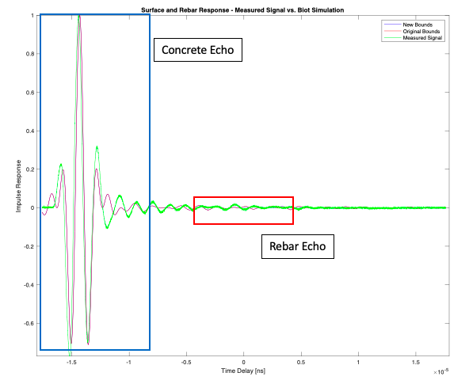  Figure 1. Example of measured (green) vs. simulated (red and blue) acoustic signature of concrete sample 1 at rebar 1, at 130 [mm] off the edge of the rebar. The initial guess is in blue, while the fitted guess is shown in red.
Impacts/Benefits of Implementation (actual,  not anticipated) | Acoustic measurements have been completed at distinct time intervals to start trend analysis measurements for changes in Biot-Stoll model parameters. The results clearly indicate that ultrasonic propagation model and measurements match closely.  TRR and first order optimality measures have been completed for all measurements to date. The model has been stabilized for an initial set of free parameters with tight numerical bounds.  The TRR requires a set of free parameters that are adjusted to reduce the mean-squared-error between the data and the Biot-Stoll model. These parameters are then given numerical bounds to ensure that the converged solution produces physically realistic values for each of the free parameters.  Increasing these bounds and adding more parameters is currently underway to produce a better fitting between the data and the model.  These are important steps towards estimating the degree of corrosion and crack propagation in the rebar according to the match between ultrasonic measurements and the poro-elastic model prediction.
Web links  - Reports  - Project website | www.ome.fau.edu

