UTC Project Information – National UTC TriDurLE
Project Title | Impacts of Magnesium Chloride Deicer on the Durability of Nanosilica-Modified HVFA Concrete
University | Washington State University
Principal Investigator | Xianming Shi, PI  Jialuo He, Co-PI
PI Contact Information | Phone: 509-335-7088  Email: xianming.shi@wsu.edu; jialuo.he@wsu.edu
Funding Source(s) and Amount Provided (by each agency or  organization) | UTC funding and Matching Funds from Washington State University
Total Project Cost | $108,000
Agency ID or Contract
Number
Start and End Dates | 05/01/2020 – 06/30/2023
Brief Description of Research Project | In the U.S., approximately 20 million tons of sodium chloride used for every typical winter season, along with unconventional deicers for snow and ice control present new challenges for the durability of concrete infrastructure, beyond freeze/thaw (F/T) damage. For instance, deicer magnesium chloride (MgCl₂) is commonly used when pavement temperature drops below 15F, and our recent study has revealed that this chemical can compromise the strength of ordinary Portland cement (OPC) concrete without any visible surface distress, thus evading the traditional inspection methods. In this context, there is an urgent need to identify concrete mixes that are more resistant to MgCl₂ by design. High volume fly ash (HVFA) concrete can be cast with denser microstructure and reduced pore sizes, but its resistance to the impact of MgCl₂ remains poorly known. Compared with OPC concrete, HVFA concrete (with or without modification by nanosilica) features different microstructure as well as different chemistry of hydrates, and thus may exhibit different behaviors when subjected to physical loading (e.g., F/T cycles) and chemical loading (e.g., MgCl₂). The overarching goal of this project is to investigate the impacts of MgCl₂ on the durability of HVFA concrete in cold climates and the role of nanosilica in the HVFA concrete, in terms of both engineering properties and fundamentals at the micron and nanometer scales. To achieve the goal, this study aims to:  1) investigate the influences of concentrated and diluted MgCl₂ solutions on the durability of HVFA concrete (with or without modification by nanosilica) under both constant ambient temperature and F/T cycling conditions,  2) characterize physical and chemical deteriorations of the microstructures and different phases of HVFA concrete and elucidate the role of nanosilica on the improved resistance against MgCl₂ attack.  The engineering properties of HVFA concrete will be characterized through weight change, compressive and split tensile strengths, water sorptivity and surface resistivity tests. Afterwards, the physical and chemical deteriorations of the microstructures and different phases as well as the beneficial role of nanosilica for the durability will be examined and analyzed through microhardness test, SEM/EDX, XRD, DSC/TGA, EMPA/WDS, and ²⁹Si/²⁷Al MAS-NMR.
Describe Implementation of Research Outcomes (or why not implemented)  Place Any Photos Here | Building on the success of this research, field operational tests will be conducted as part of a follow-up study. The team will work closely with local communities/agencies to apply HVFA concrete to replace the old concrete infrastructure at a selected location on Washington State University (WSU) campus or around the local area. Concrete cores will be taken at each season to evaluate the degradation of compressive and split tensile strengths. Prospective users of the research product include highway agencies, local mix concrete suppliers (e.g., Pre-Mix Inc.), and other stakeholders related to reducing the life cycle maintenance of concrete infrastructure.  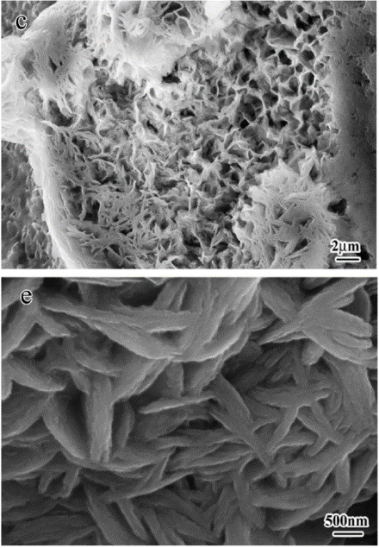
Impacts/Benefits of Implementation (actual,  not anticipated) | Increasing use of coal fly ashes in HVFA concrete will divert them from waste stream and landfill as well as reduce greenhouse gas emissions and environmental contamination. This can also promote the wide application of HVFA concrete in pavement to mitigate the deicer salt attack. Through understanding the mechanism of physcial and chemical attack due to deicer salts, more effective measures can be taken to preserve and maintain the pavement infrastructure and prolong the service life.
Web links  - Reports  - Project website | https://tridurle.wsu.edu/impacts-of-magnesium-chloride-deicer-on-the-durability-of-nanosilica-modified-hva-concrete/

