WASHINGTON STATE UNIVERSITY

Insert Program Name
BLOODBORNE PATHOGENS
EXPOSURE CONTROL PLAN

State of Washington WAC 296-823

Revised _________

A. Introduction 3

B. Exposure Determinations 4

C. Universal Precautions/Body Substance Isolation (BSI) 5

D. Controls 6
1. Engineering Controls 6
2. Work practices 6
3. Waste 7
4. Transporting Biohazardous Material 7
5. Equipment Servicing and Maintenance 8

E. Personal Protective Equipment 9
1. General 9
2. Hazard Assessment 9
3. Training 9
4. Use 9
5. Removal 9
6. Cleaning Laundering or Disposal 10

F. Worksite Conditions 11
1. Responsibility 11
2. Spill Clean-up 11

G. Biohazard Labels and Signs 12

H. HBV Immunization Evaluation and Follow-Up Immunization 13

I. Exposure Incident 14
1. Exposure Incident 14
2. Immediate Response 14
3. Supervisor Responsibility 14
4. Evaluation 14

J. Training Program 16
1. Responsibility 16
2. Training Requirements 16

K. Recordkeeping 18
1. Medical Records 18
2. Training Records 18
3. Availability 18

L. Accessibility 19

M. Annual Update 19

Appendix A Site Specific Bloodborne Pathogens Exposure Control Plan 20
Appendix B WSU’s Health Care Professionals Opinion for Hepatitis B Vaccination 31
Appendix C WSU’s Hepatitis B Vaccination Declination 33
Appendix D WSU’s Post-Exposure Evaluation 35
Appendix E Example of Safe Donning and Removal of Personal Protective Equipment (PPE) 38
Appendix F Donning and Doffing of PPE for Ebola or Other Highly Infectious Diseases 42
Appendix G Medical Waste Disposal Quick Reference 45
Appendix H Permission of Source for Post Exposure Blood Testing 49
Appendix I Health Screening Consent Form 51
Appendix J Syllabus Statement 53

A. Introduction

Washington State University’s (WSU) Bloodborne Pathogens Exposure Control Plan (BBP ECP) Template has been designed to assist areas with potential exposure to bloodborne pathogens to meet Washington Administrative Code 296-823 Bloodborne Pathogen Standard. These regulations apply to all occupational exposure to human blood or other potentially infectious materials. The standard requires employers to identify occupational exposures and implement methods to mitigate these exposures through a variety of methods. The BBP ECP applies to both employees and students (who are not employees).

Washington State University’s Environmental Health and Safety (EH&S) department assists departments in complying with regulatory requirements for bloodborne pathogens and all provisions of the bloodborne pathogens standard. Principal investigators/supervisors are responsible for ensuring hazards under their control are corrected and that contractor’s employees and students are protected from any hazards generated by work, learning, or research conducted in their areas.

To assist with the development of area specific Bloodborne Pathogen Exposure Control Plans, EH&S has developed a unit-specific template and training resources. Appendix A contains the template that once tailored to the exposure hazards of a specific area, in conjunction with this manual, will serve as the Bloodborne Pathogens Exposure Control Plan for that area.

For further assistance in developing your areas specific Bloodborne Pathogens Exposure Control Plan contact EH&S at 335-3041.

B. Exposure Determinations

1. Possible Occupational Exposure Job Categories Exposure Determination

Principal Investigators/Supervisors must perform an exposure determination to identify their employees and students who have occupational exposure to blood or other potentially infectious materials (OPIM). Occupational exposure means “reasonably anticipated skin, eye, mucous membrane or parenteral contact with blood or other potentially infectious material that may result from the performance of an employee’s or student’s duties.”

2. Tasks and Procedures in which Occupational Exposure Occurs

Individual exposure determinations must be made for existing employees and students prior to assigning or reassigning employees and students to job classifications or activities with potential exposure by the Supervisor or their designee. The exposure determination must be made without regard to the use of personal protective equipment (PPE).

The following are examples of tasks covered by the Bloodborne Pathogens Standard.

- Tasks that involve handling human blood or body fluids including semen, vaginal secretions, cerebrospinal fluid, peritoneal fluid, pericardial fluid, amniotic fluid, saliva and any other body fluid that is visibly contaminated with blood.

Note: Blood includes human blood, human blood components, products made from human blood, tissues and cells. None of the body fluids listed would be exempted because the donor has been pre-screened for known bloodborne pathogens.

- Cleaning up a blood/body fluid spill or handling contaminated waste or laundry.

- Providing emergency services or function in public safety where delivery of trauma care is likely (e.g., lifeguards, police officers, etc.).

- The removal, preparation and/or storage of any unfixed tissue or organ from a human.

- Providing patient care, care for developmentally and/or psychiatrically impaired persons.

- The culture and propagation of bloodborne pathogens including all human and primate retroviruses in laboratory culture and experimental animals.

C. Universal Precautions/Body Substance Isolation

Universal Precautions and Body Substance Isolation (BSI) are methods of limiting potential exposure to pathogens. Universal Precautions require that all human blood and body fluids be treated as if they contain potentially infectious materials. BSI identifies specific methods to protect yourself from exposure to BBP or OPIM in Healthcare settings. In addition to Universal Precautions/BSI, all other provisions of the BBP Exposure Control Plan must still be followed. Universal Precautions is the practice recommended to reduce exposure to BBP and OPIM at WSU.

Universal Precautions requires the use of controls (engineering and work practice) to eliminate or minimize employee and student exposure. All human body fluids shall be considered potentially infectious materials and require the use of Universal Precautions.

Universal Precautions shall be followed when employees and students are exposed to:

1. Human body fluids including semen, vaginal secretions, cerebrospinal fluid, peritoneal fluid, pericardial fluid, amniotic fluid, saliva in dental procedures and any other body fluid that is visibly contaminated with blood and all body fluids in situations where it is difficult or impossible to differentiate between body fluids,
2. Any unfixed human tissue or organ (intact skin in patient care situations is an exception),

3. HIV-containing cell or tissue cultures, organ cultures or culture media containing HIV or HBV or other solutions and,

4. Tissues from experimental animals infected with any human/non-human primate retrovirus including HIV.
D. Controls

1. Engineering Controls

Engineering controls are the primary method utilized to reduce employee and student exposure by either removing the hazard or isolating the employee and student from exposure. Examples of engineering controls are:

- protective splatter shields
- self-sheathing needles
- capture ventilation
- biosafety cabinets
- HEPA filtration
- ventilated equipment
- sharps disposal containers
- enclosures

It is important to periodically verify that engineering controls are in place and working. Contact EH&S at 335-3041 if you have any questions regarding who to contact to verify that engineering controls are appropriate.
Main, East, West Campus 206-685-
2. Work Practices

Handwashing

Facilities with soap and water for cleaning hands, other skin, and mucous membranes must be readily accessible to employees or students immediately or as soon as feasible after removal of gloves or other personal protective equipment (PPE).

Washing the affected area with soap and water or flushing of mucous membranes with water for a minimum of 15 minutes immediately following contact with blood or other potentially infectious materials. (e.g., when splashed) is required to minimize exposure to Bloodborne Pathogens or OPIM.

When handwashing facilities are not feasible, antiseptic hand cleanser in conjunction with clean cloth/paper towels or antiseptic towelettes must be provided. When antiseptic hand cleansers or towelettes are used, hands shall be washed with soap and running water as soon as possible

Eating, drinking, tobacco use

Eating, drinking, tobacco use, and other activities including applying cosmetics or lip balm, handling contact lenses, placing any article in the mouth, eyes, or nose or other contact with mucous membranes is prohibited in work areas where there is a likelihood of occupational exposure to blood or potentially infectious materials.

Food and drink shall not be kept in refrigerators, freezers, shelves, cabinets or on countertops or benchtops where blood or potentially infectious materials are stored.

Aerosols

All procedures involving blood or other potentially infectious materials shall be performed in such a manner as to minimize splashing, spraying, splattering, and generation of droplets.

3. Waste

Regulated Waste
Regulated waste is defined as:
- Liquid or semi-liquid blood or OPIM
- Contaminated items that may release blood or OPIM in a liquid or semi-liquid state if compressed (such as paper towels, absorbent material)
- Items that are caked with dried blood or OPIM and capable of releasing these materials during handling
- Contaminated sharps
- Pathological and microbiological waste which contain blood or OPIM
Contaminated waste shall be double bagged in a color-coded biohazard bag and discarded as soon as possible in closeable, puncture resistant and leak resistant containers. For guidance review the WSU Biological Waste Disposal Program or contact the Office of Research Assurances at 509-335-4462.

Contaminated Sharps

Immediately or as soon as possible after use, disposable sharps shall be placed in color coded, puncture resistant, leakproof and closable containers. Supervisors are responsible for providing and properly maintaining these containers. (Order from University Stores).

Contaminated sharps such as needles, scalpels or capillary tubes must never be picked up by hand. Always use a mechanical device such as tongs, dustpan, or forceps to pick up sharps.
Glass waste
Broken glass must not be handled directly by hand but must be removed by mechanical means such as tongs, dustpan or forceps and immediately placed in a labeled, designated waste container for broken glass. The waste must be decontaminated using the methods defined in the Site Specific ECP and disposed of appropriately.

4. Transporting Biohazardous Materials

On campus transportation to disposal containers or other labs

Specimens of blood or OPIM shall be double contained during collection, handling, processing, storage, transport or shipping. The container shall be labeled and/or color coded in accordance with WAC-296-823-14025 (e.g., double bag material before moving to designated containers for pickup).
Contaminated items which could puncture the primary container must be placed in a secondary container which is puncture resistant.

Off Campus by mail or courier

In addition, all specimens of blood or other potentially infectious materials shall be properly packaged for shipment by mail or courier service. For further information on shipping bloodborne pathogens contact the Office of Research Assurances at 335 – 4462.

5. Equipment Servicing and Maintenance

Equipment which may be contaminated with blood or OPIM shall be decontaminated prior to servicing or maintenance. WSU requires a Maintenance/Construction Permit to be completed and posted verifying that the equipment has been appropriately decontaminated prior to any handling or servicing.

For further information contact EH&S at 509-335-3041.

E. Personal Protective Equipment

1. General

Personal protective equipment (PPE) shall be provided, cleaned, laundered or disposed of, repaired or replaced by the department at no cost to the employee or student.

It is the Principal Investigator/Supervisor’s responsibility to ensure that the employee or student uses appropriate PPE when performing the designated tasks and procedures.

Personal protective equipment (PPE) includes but is not limited to gloves, gowns, laboratory coats, aprons, face shields or masks and eye protection, and mouthpieces, resuscitation bags, pocket masks or other ventilation devices as determined in the exposure evaluation portion of the Site Specific BBP Exposure Control Plan.

2. Hazard Assessment

A completed hazard assessment documented for the tasks/procedures with potential exposures to blood or OPIM will be completed on the Site Specific BBP Exposure Control Plan. This assessment will identify tasks which may result in potential exposures to blood or OPIM. For each identified task the appropriate PPE will be assigned and listed.

Separate regulatory requirements apply to the required use of respiratory protection. If respiratory protection is required contact EHS at 335-3041.

3. Training

Once PPE is assigned to the task, the employee or student must be trained in its proper use and a written record of this training retained by the department. Training in the use of PPE is completed within one’s professional medical training for positions such as physician, mid-level provider, registered nurse, and medical assistant. Within the WSU Health Sciences, this information will be maintained in the learning management system, experiential learning management system or equivalent.

4. Use

PPE must be appropriate to the task and procedure as identified in the hazard assessment. PPE will be considered appropriate if it prevents blood or OPIM from soaking through to the user's work clothes, street clothes, undergarments, skin, eyes, mouth or other mucous membranes under normal conditions of use and for the duration of time which the protective equipment will be used.

PPE shall be repaired or replaced as needed to maintain its effectiveness.

The Principal Investigator/Supervisor shall ensure that appropriate PPE in appropriate sizes is readily accessible at the worksite or is issued to the employee or student.

5. Removal

Clothing, gloves and masks, etc., worn to provide employee and student protection must be removed before leaving the work area.

If a garment is contaminated with blood or potentially infectious materials, the garment shall be removed immediately or as soon as feasible.

When PPE is removed it shall be placed in a designated area or appropriately labeled container for storage, washing, decontamination or disposal.

6. Cleaning, Laundering or Disposal

The disposal of single use PPE shall be in accordance with WSU Biological Waste Disposal Program.

The cleaning and laundering of reusable PPE will be done at the worksite or laundered by a contracted cleaner. At no time will employees or students be expected to take PPE home for laundering or cleaning.

Contaminated laundry must be handled with minimal agitation and contained in a labeled and leak proof container.

Contaminated scrubs shall be double bagged in color-coded biohazard bags, sealed with tape, the outer bag labeled as to contents and potential hazard(s) and laundered by a commercial laundry service. The commercial laundry service under contract with WSU is qualified to properly manage scrubs contaminated with human blood/body fluids.

F. Worksite Conditions

1. Responsibilities

It is the responsibility of the Principal Investigator/Supervisor to ensure that the worksite is maintained in a clean and sanitary condition and that all aspects of the areas BBP ECP are adhered to.

2. Spill Clean-up

All employees shall be familiar with procedures for decontamination and cleanup of spills of blood and/or OPIM. Decontamination of blood and/or OPIM will be conducted using the appropriate spill response procedures found in Appendix A.

Each area shall have a specific procedure for dealing with spill clean-up based on the type and quantity of blood or other potentially infectious material handled as well as the surfaces to be decontaminated. In addition to the procedure, clean-up supplies shall be readily available. As a minimum, these supplies should include suitable disinfectants, gloves, paper towels or other absorbent material, forceps or tongs for broken glass or other sharps, and appropriate disposal containers.

G. Biohazard Labels and Signs

Prior to the storage, shipment, or transport of individual containers of human blood or OPIM, all materials shall be labeled using approved Biohazard labels. Biohazard Labels and bags are available for purchase through University Stores.

Warning labels shall be affixed to containers of biohazardous waste, refrigerators and freezers containing blood or potentially infectious material, and other containers used to store, transport, mail or ship blood or other potentially infectious materials, except as provided below. These labels shall either be an integral part of the container or shall be affixed as close as feasible to the container by string, wire, adhesive, or other method that prevents their loss or unintentional removal.

These labels shall include the universal biohazard symbol and shall be fluorescent orange or orange-red or predominantly so, with lettering or symbols in a contrasting color:


Warning labels required for contaminated equipment shall be as described above and shall also state which portions of the equipment remain contaminated.

H. HBV Immunization Evaluation and Post-Exposure Immunization

1. HBV Immunization Evaluation

All employees with occupational exposure are to be offered Hepatitis B vaccination during initial training and/or within 10 days from the start of the work assignment. The department will ensure that the vaccinations are provided at no cost to the employee. As an expectation of enrollment, human health science students in clinical programs provide evidence of immunity by vaccination to Hepatitis B. Students are responsible for costs associated with vaccination and titer immunity testing.
Hepatitis B immunization is given as recommended by the U.S. Public Health Service. Booster immunizations are not recommended at this time. If a need for booster immunization is demonstrated in the future, these immunizations shall be offered.

Employees who decline vaccination must sign the WSU Hepatitis B Declination Form (Appendix D) indicating an understanding of the risks of not receiving immunization. A decision to refuse vaccination can be reversed by the employee at any time.
Students requesting a vaccination exception should refer to the WSU Health Sciences Immunization Policy.

I. Exposure Incident

1. Exposure Incident

An exposure incident is defined as specific eye, mouth, other mucous membrane, non-intact skin or parenteral contact with blood or other potentially infectious materials. Examples of exposure incidents include needlesticks, splash/spatter to the mucous membranes of the face, and any other incident that involves contact between blood or other potentially infectious materials and non-intact skin (cuts, scratches, chapped skin, etc.).

2. Immediate Response

Following an exposure incident, the exposed employees or student:

- Shall wash the wound with soap and water or flush mucous membranes with water for a minimum of 15 minutes.

- Shall report the incident to their supervisor, who will assist the employee or student in the follow-up exposure incident evaluation.

- Shall seek the opinion of a Health Care Professional of their choice as outlined in Section 4.

3. Supervisor Responsibility

The Principal Investigator/Supervisor is responsible for assisting the exposed employee or student in seeking the necessary and immediate medical evaluation and consultation following an exposure incident.

During the evaluation, if the employee or student is unable, the Supervisor/Preceptor is responsible for completing and providing the required information on the Post-Exposure Evaluation Form (located in Appendix D) to the local Hospital Emergency Department (ED) or Emergency Room (ER) Note: ER doctors have demonstrated a better understanding of when post exposure prophylaxis should be recommended compared to most General Practitioners.

The exposure incident shall be reported to EH&S through the use of WSU Incident Reporting system. Incident review will be conducted in order to identify and correct problems to prevent recurrence of similar incidents.

Post exposure support will be provided by EH&S, if needed. EH&S will not assist in most initial responses and referrals – but is available to consult as needed – particularly for complex situations.

4. Evaluation

The exposed student will receive a referral to a local ER for post-exposure evaluation, education, counseling and appropriate testing. WSU Students are responsible for costs associated with all clinic visits, medication, laboratory, and any other related costs that occur after the incident. WSU strongly recommends that students purchase health care insurance to assist with these costs.. Students should notify their clinical site supervisors and college program directors of financial issues related to bloodborne pathogen exposure. Programs may be able to assist in identifying sources of potential financial support.

WSU students are not employees while they are engaging in education-related activities at clinical sites and are, therefore, not covered by workers’ compensation at either the clinical site or WSU. Treatment for exposures is NOT considered an on-the-job injury since students are NOT employees at clinical training sites.

Exposed employee will receive:

- A confidential medical evaluation will be performed by a local ED documenting:

1) The circumstances leading to the exposure incident,
2) Route of exposure,
3) The source of the potentially infectious material.

b. The employee will be offered appropriate post-exposure prophylaxis, as recommended by the U.S. Public Health Service.

c. HIV, HBV, and HCV testing will be completed on the source material. If the source individual can be identified, consent for testing must be obtained. See Appendix H for consent form.

d. The exposed employee will be offered HIV, HBV, and HCV testing to assess serological status at the time of the incident, and at recommended intervals such as at 1 month, 3 months and 6 months after the incident.

e. The employee will be provided with post-exposure counseling and education. Results of the source individual's testing shall be made available to the exposed employee and the employee shall be informed of state laws and regulations concerning disclosure of this information.

f. Illnesses reported by the exposed employee subsequent to the exposure incident will be assessed in relationship to the incident.

g. Within 15 days the ED’s Health Care Professional will provide the employee and WSU HRS with a copy of the WSU Health Care Professional’s Written Opinion for Post Exposure Follow-up (Appendix D) form regarding the medical findings of the incident exposure evaluation.

This written opinion includes whether Hepatitis B vaccination is indicated for an employee and if the employee has received such vaccination. It documents that a medical evaluation took place following the incident exposure, that the employee has been informed of the results of the evaluation and that the employee has been counseled about potential medical conditions resulting from exposure to bloodborne pathogens. All other findings shall remain confidential.

J. Training Program

1. Responsibility

The department shall ensure that all employees and students with occupational exposure participate in a training program that must be provided at no cost to the employee and students during working hours.

This training shall be provided at the time of initial assignment to tasks where occupational exposure may take place and annually thereafter.

Environmental Health and Safety routinely offers initial training in bloodborne pathogens. Contact EH&S for further information at 509-335-3041.

Principal Investigators/Supervisors shall provide additional training when changes such as modification of tasks or procedures or institution of new tasks or procedures affect the employee's and students occupational exposure. The additional training may be limited to addressing the new exposures created.

Material appropriate in content and vocabulary to educational level, literacy, and language of laboratory staff, students, and employees shall be used.

The person conducting the training must be knowledgeable of the workplace that the training will address and the requirements of the standard.

2. Training Requirements

The training program for all potentially exposed employee and students shall cover the following.

a. An accessible copy of the regulatory text of the Bloodborne Pathogens Standard and an explanation of its contents;
b. A general explanation of the epidemiology and symptoms of bloodborne diseases;
c. An explanation of the modes of transmission of bloodborne pathogens;
d. An explanation of the WSU’s and the Site Specific Bloodborne Pathogens Exposure Control Plan for their area and the means by which the employee can obtain a copy of the written plan;
e. An explanation of the appropriate methods for recognizing tasks and other activities that may involve exposure to blood and potentially infectious materials;
f. An explanation of the use and limitations of methods that will prevent or reduce exposure including appropriate engineering controls, work practices, and personal protective equipment;
g. An explanation of the basis for selection of personal protective equipment; as well as information on the types, proper use, location, removal, handling, decontamination and disposal of personal protective equipment;
h. Information on the Hepatitis B vaccine, including information on its efficacy, safety, method of administration, the benefits of being vaccinated, and that the vaccine and immunization will be offered free of charge for employees;
i. Information on the appropriate actions to take and persons to contact in an emergency involving blood or other potentially infectious materials;
j. An explanation of the procedure to follow if an exposure incident occurs, including the method of reporting the incident and the medical follow-up that will be made available;
k. Information on the post-exposure evaluation and follow-up that the principal investigator is required to provide for the employee following an exposure incident;
l. An explanation of the signs and labels and/or color coding as required and used;
m. An opportunity for interactive questions and answers with the person conducting the training session.

K. Recordkeeping

1. Medical Records

The Health Care Professional (HCP) will establish and maintain accurate records for each employee with occupational exposure in accordance with WAC 296-802.

In addition, for employees, copies of the following records will be sent to WSU Human Resource Services to be retained for at least the duration of employment plus thirty years in accordance with WAC 296-802. These records are to be kept strictly confidential.

a. Employee name and WSU ID number.
b. A copy of the WSU HCP’s Written Opinion for Hepatitis B Vaccination, or the WSU Hepatitis B Declination form signed by the employee declining the Hepatitis B immunizations.
c. A copy of the WSU HCP’s Written Opinion for Post-Exposure Follow Up following an exposure incident.
d. A copy of the WSU HCP’s Written Opinion for Post Exposure Evaluation which includes the information provided by the employee or supervisor following an exposure incident.

2. Training Records

Initial Bloodborne Pathogen training records will be maintained by the training provider for at least three years after the date on which the training occurred. Principal Investigators/Supervisors must also maintain records of Bloodborne Pathogen training conducted by the laboratory and/or department.

Annual refresher training must be completed every 12 months and records must be maintained for at least 3 years.

Training records shall contain:

a. The date(s) of the training session
b. A summary of the training course content
c. The names and qualifications of the instructors
d. The names of all persons attending the training

3. Availability

All records described shall be made available for examination and copying to Director of the Washington State Department of Safety and Health.

All records will be available for examination and copying to the employee or any person with the employee's written consent.

L. Accessibility

It is the Supervisor’s responsibility to ensure the completed Bloodborne Pathogens Exposure Control Plan for their area will be located where it is accessible to staff, employees, and students at any time.

A copy of the exposure plan must be made available to WSU authorities and the Director of the Washington State Division of Occupational Safety and Health upon request.

M. Annual Update

The Supervisor is responsible for reviewing their Site Specific BBP Exposure Control Plan annually, whenever necessary to reflect new or modified tasks and procedures that affect occupational exposure, and to reflect new or revised employee positions or student activities with occupational exposure.

WSU’s Bloodborne Pathogens Exposure Control Plan Template will be reviewed annually by EH&S. In addition, it will be reviewed any time changes in tasks involving bloodborne pathogens are made and when new technologies warrant review.

Appendix A

Health Sciences
Site Specific Bloodborne Pathogens
Exposure Control Plan

Site Specific BBP Exposure Control Plan

- Person in Charge |  |  | - Department
- Building |  |  |  | - Room(s)
5. Phone |  |  | 6. Campus Zip
7. Location of ECP
8. Job titles with potential occupational exposure

High risk: Physician, Advanced Practitioner Professional (APP), Registered Nurse, Medical Assistant, Custodian Lead, Custodian 2, Student Custodian, Public Health Immunization Specialist.

Low risk: Executive Director, Director of Counseling Services, Psychologist, Testing Director, Counselors, Office Support Supervisor, Testing Program Coordinator, Internship Program Coordinator, Psychiatrist, Psychiatric NP, Health Psychologist, Graduate Assistants, Postdoctoral Coordinator, Practicum Coordinator, Postdoctoral Resident, Predoctoral Intern. Patient Support Services Manager, Patient Services Representative, Director of Pharmacy, Pharmacist, Pharmacy Technician. Optometrist, Vision Clinic Manager, Optician, Ophthalmic Technician. Nutritionist. Personnel & Finance Coordinator, Administrative Assistant, Program Specialist. Budget & Finance Manager, Fiscal Specialist. Director of Health Promotion, Community Engagement Specialist, Health Education Lead, Health Educator, Health Promotion Specialist/Research, Health Promotion Specialist, Computer Systems Administrator, IT Specialist, EMR Manager, and Social Worker.
9a. Procedures/tasks with potential exposure |  | 9b. Personal protective equipment (PPE)  required for each task
Venipuncture and other vascular access procedures (such as IV starts and blood draws) |  | Gloves  Goggles/Face shield (based on exposure risk)  Lab coat/Gown (based on exposure risk)
Wound care |  | Gloves  Lab coat/Gown (based on exposure risk)  Goggles/Face shield (based on exposure risk)  Lab coat/Gown (based on exposure risk)  Shoe covers (based on exposure risk)
Laceration repair |  | Gloves  Goggles/Face shield (based on exposure risk)  Lab coat/Gown (based on exposure risk)  Shoe Covers (based on exposure risk)
Minor surgeries/procedures (such as mole removal, skin tag removal, I&D, matrixectomy, Nexplanon, IUD, colposcopy) | Gloves  Goggles/Face shield (based on exposure risk)  Lab coat/Gown (based on exposure risk)  Shoe Covers (based on exposure risk)
Cardiopulmonary Resuscitation | Gloves (optional)  Pocket Face Mask (when available)  Bag Valve Mask (when available)
Clean-up of bodily fluids | Gloves  Goggles/Face shield (based on exposure risk)  Lab coat/Gown (based on exposure risk)  Shoe Covers (based on exposure risk)
All health care workers routinely use appropriate barrier precautions to prevent skin and mucous membrane exposure when contact with blood or other body fluids of any patient is anticipated.

- Gloves are worn for touching blood and body fluids, mucous membranes, or non-intact skin of all patients, for handling items or surfaces soiled with blood or body fluids, and for performing venipuncture and other vascular access procedures. Gloves are removed, and hands washed immediately after contact with each patient.

- Masks and protective eyewear or face shields are worn during procedures that are likely to generate droplets of blood or other body fluids to prevent exposure of mucous membranes of the mouth, nose and eyes.

- Gowns or aprons are worn during procedures that are likely to generate splashes of blood or other body fluids.

- Shoe Covers are worn during procedures that are likely to generate splashes of blood or other body fluids.

Standard Precautions combine the major features of Universal Precautions (1985) and Body Substance Isolation (1987) and are practiced by all personnel for all patients. Transmission Based Precautions (contact precautions, droplet precautions, and airborne precautions) are used when the route(s) of transmission is (are) not completely interrupted using standard precautions alone.

Universal Precautions
- An approach to infection control to treat all human blood and certain human body fluids as if they were known to be infectious for HIV, HBV and other bloodborne pathogens.
Contact Precautions
- Although saliva has not been implicated in HIV transmission, to minimize the risk in emergency mouth-to-mouth resuscitation, mouthpieces, resuscitation bags, and other ventilation devices are available for use in areas in which the need for resuscitation is predictable.
- Health care workers who have exudative lesions or weeping dermatitis refrain from direct patient care and from handling patient care equipment until the condition resolves, unless the health care worker can adequately cover the lesion.
- Single patient room, PPE put on prior to entering and removed before exit.
Droplet Precautions
- Intended to prevent transmission of pathogens through close respiratory or mucus membrane contact. The patient should wear a mask even when outside the exam room, as well as, following respiratory hygiene and cough etiquette.
Airborne Precautions
- For prevention of transmission of infectious agents that remain airborne over long distances such as measles, chicken pox, and tuberculosis. Health care personnel wear an N95 or higher-level respirator, such as a PAPR hood. Whenever possible, non-immune health care personnel should not care for patients with vaccine preventable airborne diseases. Personnel are required to be fit tested to wear an N95 respirator. Fit testing is performed annually or sooner if needed.

10. Engineering Controls (specify when each is used)

- Sharps Container with safety mechanism – for placement of any sharps such as needles (such as injection, IV, suture), scalpels, broken glass, lancets, etc. by the user.
- Needleless systems – used with IV tubing.
- Needles with safety systems – lockable needle covers for syringes, end of needle covering on IV needle, retractable IV needle, and retractable lancets.
- Plastic venipuncture tubes – for blood draws.
- Tongs or forceps - to handle broken glass.
- Scalpels with shields that slide over blade – used for procedures.
- HEPA filters – to use in rooms with airborne diseases such as influenza, measles, chickenpox, covid-19, and tuberculosis.
- Bag Valve Masks and Pocket Face Masks – for use during CPR
- Personal Protective Equipment (PPE) such as gloves, masks, goggles, face shields, hoods, gowns, aprons, booties – used for exposure to blood or other potentially infectious material.

11a. Sharps containers are inspected, maintained, replaced: | Whenever necessary to prevent overfilling (replaced when reach fill line)  By: Clinical Staff Every: As Needed
11b. Sharps container disposal procedure

When sharps box reaches full line, lid is locked, and it’s taken to the large biohazard burn boxes (located in the Crimson bathroom (room 110) and the Minor Surgery room (room 138)). When the burn box is full, custodial staff will remove, close and seal the box. Then placed in the biohazard room (G34). Once 4-5 boxes are full, custodial staff will call Environmental Health & Safety for pick up and incineration. New biohazard sharps containers are in the storage room (room 118AA).

Site Specific BBP Exposure Control Plan

12. Work practice controls (in addition to Universal Precautions)

Safe Injection Practices
- All health care workers take precautions to prevent injuries caused by needles, scalpels, and other sharp instruments or devices during and after procedures. To prevent needle stick injuries, needles are not recapped, purposely bent or broken, removed from disposable syringes, or otherwise manipulated by hand. If it is necessary to recap a needle, use the one-handed scoop technique or use a mechanical device.
- Needles and syringes (including prefilled syringes) are used for only one patient. The rubber septum/stopper on a medication or vaccine vial, whether unopened or previously accessed, is disinfected with alcohol prior to piercing. Medication and vaccine vials are always entered with a new sterile needle and syringe, except when used to reconstitute medication. If a medication is pre-drawn it is labeled with the date and time of draw, initials of the person drawing, medication name, strength and discard date and time. Single dose (single-use) medication vials are used for only one patient. If multi-dose vials must be used, both the needle and syringe used to access the multi-dose vial must be sterile. If sterility of the multi-dose vial is compromised or questionable it must be discarded. Bags of IV solutions are used for only one patient and not as a source of flush solution for multiple patients. Medication administration tubing and connectors are used for only one patient.
- After they are used, disposable syringes and needles, scalpel blades, and other sharp items are placed immediately by the user into puncture-resistant sharps containers for disposal; the puncture-resistant containers are located as close as practical to the use area and secured from tampering. When putting sharps into the container, visually look at the sharp’s container opening to ensure no needles or other sharps are present and unsecure. If visually clear, put the sharp in the opening with one hand. Assure the sharp goes into the container. Needleless syringes do not go into the sharp’s container. If sharps container opening is closed, do not attempt to use; replace the container. Sharps containers are replaced when the fill line is reached.
- See Medical Waste Disposal Quick Reference (Appendix H).

Multi-dose/Single-dose Items
- Sterile irrigating solution (e.g. sterile water and sterile saline) are discarded after use.
- Multi-dose vials (e.g. 1% or 2% Lidocaine, Lidocaine with epinephrine) are dated with expiration date when opened and discarded if not used within 28 days unless the manufacturer specifies a different (shorter or longer) date for that opened vial.
- Multi-dose vials of vaccines are used until expiration, except for tuberculin PPD, which is dated with expiration date and discarded if not used within 28 days.
- Single-dose or single-use vials are discarded immediately after use on a single patient.
- Multi-dose medication vials used for more than one patient are stored in the medication preparation area and do not enter the immediate patient care area (i.e., procedure rooms and patient exam spaces). If a multi-dose vial does enter the immediate patient care area, it must be dedicated for single patient use and discarded immediately after use.

Safe Handling of Equipment
- Used patient care equipment soiled with blood or body fluids is handled in a manner that prevents skin and mucous membrane exposures, contamination of clothing, and transfer of microorganisms to other patients and environments.
- Reusable equipment is appropriately cleaned, or autoclaved, and single use items are properly discarded.
- Equipment which may become contaminated with blood or other potentially infectious materials is examined prior to servicing or shipping and is decontaminated as necessary.

Procedure Rooms
- After any procedure, clean or dirty, soiled materials are discarded in labeled biohazard containers. Bed/exam-table, counter top, and table/tray surfaces are cleaned with an approved germicidal disinfectant solution. Gloves are worn during clean up procedures. Soiled instruments are scrubbed under water with a brush in the exam room. Immediately after the procedure using the biohazard transfer container in the exam room, the instruments are taken to the autoclave room (136). Instruments are placed in the soak pan on the counter in the Autoclave room (room 136), in preparation for additional cleaning and sterilization.
- Specimens of blood or other potentially infectious materials are placed in a container which prevents leakage during collection, handling, processing, storage, transport or shipping. A tissue biopsy (which is placed in the container with formalin) is placed in a biohazard bag.
- All bins, pails, cans and similar receptacles intended for reuse which have a reasonable likelihood of becoming contaminated with blood or other potentially infectious materials are inspected and decontaminated on a regularly scheduled basis by custodial staff. Receptacles are cleaned and decontaminated immediately or as soon as feasible upon visible contamination by custodial staff or clinical/medical personnel.

Laboratory Specimens/Hazard Communication
Refer to policy “Handling Laboratory Specimens”

Refrigerators
- Clinic supply refrigerators containing medication, vaccines, food/drinks for patients, or lab specimens are labeled and used for that purpose only.
- Staff food refrigerators contain only foods that have been properly wrapped or placed in properly closed containers.

Hand Hygiene (per CDC guidelines)
- Sinks for water, soap and/or hand sanitizers are in exam and procedure rooms, bathrooms, and medication preparation areas.
- An alcohol-based hand rub is the preferred method for hand hygiene in all situations, except for when your hands are visibly dirty or contaminated or outbreak of C. difficile or Norovirus.
- Wash hands with soap and warm water or 60% or greater alcohol-based hand sanitizer according to the product manufacturer’s instructions for use. Always wash hands immediately before and after contact with each patient, after touching contaminated equipment or work surfaces, immediately after removing gloves, immediately and thoroughly if contaminated with blood and/or other body fluids, after using the restroom, and before eating. It may be necessary to wash hands between tasks and procedures on the same patient to prevent cross-contamination of different body sites. Hand hygiene is performed before any invasive procedure (e.g. placing an IV).
- Gloves are worn for procedures that might involve contact with blood or body fluids, handling potentially contaminated patient equipment, and removed before moving to the next task and/or patient. Change gloves whenever soiled/torn/punctured and remove prior to exiting work area.
- Personnel providing direct patient care do not wear artificial fingernails and/or extenders when having direct contact with patients.
- Hand hygiene protocols are posted at sinks.

Hepatitis B Vaccine
- All students are required to submit proof of immunity by vaccination for Hepatitis B as a part of programmatic enrollment.

Safe Work Practices
- No eating, drinking, smoking, applying cosmetics or lip balm, or handling contact lenses in work areas where there is a reasonable likelihood of occupational exposure to blood or other potentially infectious material.
- Food and drinks are not kept in refrigerators, freezers, shelves, countertops, bench tops, or cabinets where blood or other potentially infectious materials are present.

13a. How employees and supervision is involved in identifying changes to engineering controls, work practices, and evaluating potential new products/processes.

- Employee feedback (demonstration of new products at unit meetings as needed, open communication amongst employees and administrators of any concerns or suggestions for improvements).

  - Review of new safety devices annually with feedback and selection by clinical/medical personnel.

- Safety Committee and Infection Control Committee activities (review of policies/procedures annually or as needed).

- Exposure Incident Investigation
13b. Person responsible for implementing changes identified through the processes outlined in 13a.

14a. Location of PPE
14b. Order PPE as removed | Gloves, goggles/face shield, gown, mask or respirator. See Example of Safe Donning and Removal of PPE (Appendix E). See separate guidelines if Ebola is suspected (Appendix F).
14c. Procedure for handling used PPE | All PPE is disposable, except PAPR device. It is decontaminated per manufacturer specifications. We follow PPE conservation strategies per CDC and Washington State Dept. of Health guidelines during periods of communicable disease outbreak.

Site Specific BBP Exposure Control Plan

15a. Laundered articles
(if applicable)
15b. Person responsible for laundry
(if applicable)
16a. Procedure and schedule for routine cleaning and decontamination of area
(specify surfaces, equipment, disinfectant, contact time)
16b. Spill and decontamination procedure (specify disinfectant and contact time)

The following procedures should be adhered to when responding to and cleaning up blood and human body fluid spills:

1. Secure the spill area by posting floor signs, using a person, or using a barricade around the area. People must not enter the spill site and become contaminated or spread the contamination.

2. Determine the approximate area of the spill.
a. If the spill is less than an approximately 5X5 inch covered surface, it may be cleaned up by any trained personnel.
b. If the spill is larger than an approximately 5X5 inch covered surface a custodian should be called to clean and disinfect area.

3. Prepare an adequate quantity of Alpha HP solution in a bottle or bucket, or 1:10 bleach solution can also be used (1-part bleach to 9 parts water). However, bleach and Alpha HP CANNOT be used at the same time! Oxivir Tb cleaners can also be used. In case of TB infection, a tuberculocidal disinfectant is used for clean-up (Oxivir Tb cleaner or the bleach solution. Alpha HP does not kill tuberculosis).

4. When performing general cleaning of blood or body fluids, all employees must wear disposable gloves and proper personal protective equipment (such as gown, shoe covers, eye shield/goggles, face mask) prior to making any contact with blood or body fluids. When the procedure is completed, discard disposable articles from each contact or cleanup into plastic biohazard trash bags.

5. Broken glassware is not picked up directly with the hands. It is cleaned up using mechanical means, such as a brush or broom and dustpan, tongs, or forceps. Dispose of glass in a biohazard sharps container. Disinfect the cleaning supplies if they become contaminated.

6. First remove any visible organic matter with absorbent paper towels and place into a biohazard bag.

7. If small spill, absorb fluid with a dry paper towel or absorbent powder from spill kits and place it into a biohazard bag. Apply appropriate disinfectant (Oxivir Tb cleaner, bleach, or Alpha HP spray) to the contaminated surface and allow proper dwell time per the product label (1 minute for Oxivir Tb, 1 minute for bleach, and 10 minutes for Alpha HP). Wipe the contaminated area with a paper towel and place in biohazard bag. Wet the contaminated surface again with disinfectant and allow to air dry. Carefully remove gloves and wash hands.

8. If large spill, may use emergency spill kit or fluid solidifier such as sawdust mixture over spill, wait until semi-solid, and then remove solid material with kit scoop and scraper, or brush/broom and dustpan. Dispose of material and scoop/scraper in biohazard bag. Place absorbent paper towels over the spill and saturate the towels with Alpha HP, Oxivir TB cleaner, or a 1:10 bleach solution so that it soaks into the spill. Allow the disinfectant to penetrate the material and sit for the appropriate dwell time. Wipe up the contaminated area with paper towels and place any contaminated waste materials and disinfected cleanup materials in a biohazard bag. Wet the contaminated surface again with disinfectant and allow to air dry. Carefully remove contaminated gloves and dispose of them in the plastic biohazard bag. Be careful not to contaminate the exterior surfaces of the bag with paper towels, gloves, etc. Seal the bag. Dispose of it in the biohazard burn box located in Room 110 (Crimson bathroom near injection room) or 138 (Minor Surgery room). Wash hands with warm water and soap immediately.

9. For spill on carpet or upholstery, use absorbent powder if needed and disinfectant as above. Custodial staff can use a carpet extractor, filled with an appropriate disinfectant cleaner, to extract the spot and the surrounding area. Allow to stand for 10 minutes. Next, spray the affected area with clean water and extract only. Clean the equipment following the BBP Standard and store for the next use.

10. Double bagged contaminated disposable items must be disposed of according to procedures in the Safety Policies and Procedures Manual Disposal of Biohazardous Waste S80.12.

17. Bloodborne Pathogen waste procedures (specify how waste is packaged and disposed of)

18. Person responsible for providing Site Specific BBP training | BBP training is arranged by HRS and the experiential departments and required for all high-risk employees and students. Training can be in person or online.
19. Person responsible for reviewing exposure incidents
20. Emergency Procedures for Management of Occupational Exposures

This policy will be followed to minimize infection and provide adequate surveillance to employees and students. Percutaneous or mucous membrane exposure to body secretions/excretions will be documented and Centers for Disease Control (CDC) Guidelines followed.

Percutaneous exposure includes needle stick, cut or exposure to blood or body fluids when exposed skin is chapped, abraded, or afflicted with dermatitis. Mucous membrane exposure includes splash to the eyes, nose, and/or mouth.

EMPLOYEE

- Immediately wash exposed area with soap and water. Change clothes if necessary.
- Thoroughly flush/irrigate splashes to the nose, mouth, eyes, or skin with water.
- Report exposure to your supervisor immediately.
- The employee is to seek care immediately with a local Emergency Department (ED) unless there was only an exposure to intact skin. Urgent prophylaxis may be indicated, and baseline serology should be performed.
- Complete the following forms:
- WSU’s Health Care Professionals Opinion for Post-Exposure Evaluation & Follow-up (Appendix D). Complete and take to ED for the healthcare provider to finish evaluation and treatment.
• Labor and Industry form. Form will be provided at the ED. Keep a copy for yourself and present claim number when seeking any other medical care. Completion of L&I forms provide the basis for possible future financial compensation. If the worker decides to seek compensation, these records will be shared with L&I and the Washington State University retirement insurance office.
• Accidental Injury, Occupational Illness, Workplace Incident report form within one business day. These will be kept for thirty years beyond employment. Recommendation: Employee retains personal record of exposure. Form completed online at http://ihr.hrs.wsu.edu/forms/incident_report.aspx
• Cougar Health Services Quality Management Report (in PowerDMS)
• OSHA 300 log. See Safety Committee chair.
- During the follow-up period, the exposed worker shall follow the CDC recommendations for preventing bloodborne pathogen transmission.
- The employee shall be advised to seek medical evaluation for any febrile illness that occurs within twelve weeks after the exposure. Such an illness, particularly one characterized by fever, rash, or lymphadenopathy, may be indicative of recent HIV infection.

STUDENT

- Immediately wash exposed area with soap and water. Change clothes if necessary.
- Thoroughly flush/irrigate splashes to the nose, mouth, eyes, or skin with water.
- Report exposure to your instructor or preceptor immediately.
- Seek care immediately with a local Emergency Department (ED) unless there was only an exposure to intact skin. Urgent prophylaxis may be indicated, and baseline serology should be performed.
  - WSU Students are responsible for all clinic visits, medication, laboratory, and any other related costs that occur after the incident. Students should consider purchasing health care insurance that may assist with these additional costs. Students should notify their clinical site faculty and college program directors of financial issues related to bloodborne pathogen exposure.
- Complete the following forms:
- WSU’s Health Care Professionals Opinion for Post-Exposure Evaluation & Follow-up (Appendix D). Complete and take to ED for the healthcare provider to finish evaluation and treatment.
- WSU Incident Report Form (http://hrs.wsu.edu/managers/incident-report/)
- The Supervisor or Preceptor will initiate the process of contacting and consenting for blood tests from the source. Environmental Health and Safety supports contacting and consenting by request.

While the affected person is in clinic or in the ER being evaluated, they must contact one of the course/clerkship/rotation preceptors or supervisors (course director, experiential director, clerkship coordinator, or an attending physicians or small group leader).

SOURCE PATIENT
The Supervisor, Preceptor or designee will identify the source patient (if known). The attending ER physician will assign risk categories as follows:
- Known Hepatitis B positive source or known HIV positive source.
- High risk group:
▪ Had clinical hepatitis B, AIDS or exposure to HIV
▪ On renal dialysis
▪ Had renal or bone marrow transplant
▪ Had heterologous blood transfusions before 1985
▪ Drug abusers
▪ Homosexual/bisexual males
▪ Persons of foreign origin with high endemic rate for hepatitis

- Obtain permission from source patient for post-exposure blood testing (Appendix H)

PATIENT EXPOSURE

If a patient has a parenteral or mucous membrane exposure to blood or body fluids of a health care worker, the patient shall be informed of the incident and the same procedure outlined above for management of exposures shall be followed for both the source health care worker and the exposed patient.

Infectious Disease Resources

For consultation on infectious disease issues call the Center for Disease Control and Prevention at 1-800-CDC-INFO (1-800-232-4636) or the University of Washington through Medcon at 1-800-326-5300 and ask for the infectious disease attending physician or fellow.

__________________________________________________________________________________
Signature of Medical Director Date Completed

__________________________________________________________________________________
Signature of Medical Director or Nurse Manager Date reviewed/updated

__________________________________________________________________________________
Signature of Medical Director or Nurse Manager Date reviewed/updated

Appendix B

WSU’s Health Care Professional’s Opinion for Hepatitis B Vaccination

WSU’s Health Care Professional’s Opinion for Hepatitis B Vaccination

Instructions: For WSU employees only. As required by the Occupational Exposure to Bloodborne Pathogens Standard, Chapter 296-823 WAC the Health Care Professional is to provide a written opinion for the vaccination. Provide a copy of this completed form to the employee within 15 days of initiation of the series. The employee will supply the employing department with a copy of form as verification of immunization status.

Employee’s Name: __________________________________________

Date of Evaluation: __________________________________________

Hepatitis B vaccination is ____ is not ____ recommended for the employee named above.

The employee named above is scheduled to receive 3 total hepatitis B vaccinations on the following dates:

1st ________________________________

2nd ________________________________

3rd ________________________________

Health Care Professional’s Name: _________________________________________________

Health Care Professional’s Address: ______________________________________________

______________________________________________

Health Care Professional’s Telephone: ______________________________________________

________________________________ _____________________
Health Care Professional’s Signature Date

The employing department will return a copy of this form to HRS at the address below. Please label the outside of the envelope “Confidential.”

Washington State University
HRS
PO Box 641014
Pullman, WA 99164-1014
Phone: 509-335-4521

Appendix C

WSU’s Hepatitis B Vaccination Declination

WSU’s Hepatitis B Vaccination Declination

Instructions: Employees declining the Hepatitis B Vaccination series are to complete this form and provide a copy to the employing department.

I understand that due to my occupational exposure to blood or other potentially infectious materials (OPIM), I may be at risk of acquiring hepatitis B virus (HBV) infection.

WSU __________________________ (department name) has given me the opportunity to be vaccinated with the hepatitis B vaccine, at no charge to myself.

However, I decline hepatitis B vaccination at this time. I understand that by declining this vaccine, I continue to be at risk of acquiring hepatitis B, a serious disease. If, in the future, I continue to have occupational exposure to blood or other potentially infectious materials, and I want to be vaccinated with hepatitis B vaccine, I can receive the vaccination series at no charge to me.

- I have already received the hepatitis B vaccination series.
- I decline hepatitis B vaccination at this time

_________________________________________________________________
Employee’s Name (Print)

_________________________________________________________________
Employee’s Signature

_________________________________________________________________
Date

The employing department will return a copy of this form to HRS at the address below. Please label the outside of the envelope “Confidential.”

Washington State University
HRS
PO Box 641014
Pullman, WA 99164-1014
Phone: 509-335-4521

Appendix D

WSU’s Post-Exposure Evaluation & Follow-up for Employees and Students

WSU
Employee Post-Exposure Evaluation

Instructions: The Supervisor or Preceptor will complete this section of the form to provide the ED Health Care Professional with exposure information.

- Date, time and location of exposure: ______________________________________________

________________________________________________________________________________________

- Description of duties during exposure: _____________________________________________

_____________________________________________________________________________________

- What part of the body (eye, mouth, finger, leg) was exposed: __________________
_____________________________________________________________________________________

- Routes of exposure (splash, sprayed, needle stick etc.): ________________________
_____________________________________________________________________________________

- Name, contact information and results of source individuals blood tests if available (blood tests are not available in classroom based settings)
_____________________________________________________________________________________

- Copy of the employees’ Health Care Professional’s Written Opinion for Hepatitis Vaccination (does not apply to students).

- Medical records relevant to the source may be obtained from the sources Medical Provider:
_________________________ ________________________________ ________________
Medical Professional’s Name Address Phone

- Employee Health Care Professional’s Written Opinion for Post Exposure Evaluation form (On reverse side of this page)

WSU Employees Health Care Professional’s Opinion for Post-Exposure Follow-up

Instructions: Health Care Professional completes this section of the form. Return this form to the address below and provide a copy to the employee, within 15 days of completion of the evaluation. Please label the outside of the envelope “Confidential.”

Individual’s Name: ______________________________________

Date of Incident: ______________________________________

Date of Evaluation: ______________________________________

____ The indivdiual named above has been informed of the results of the evaluation for exposure to blood or other potentially infectious materials.

____ The individual named above has been told about any health conditions resulting from exposure to blood or other potentially infectious materials which require further evaluation or treatment.

____ Hepatitis B vaccination is____ is not____ indicated.

Health Care Professional’s Name: ___________________________________________________

Health Professional’s Address: ___________________________________________________

__________________________________________________

Health Professional’s Telephone: ___________________________________________________

___________________________________ __________________________
Health Care Professional’s Signature Date

Note to Health Care Professional:
WAC 296-823 Occupational Exposure to Bloodborne Pathogens may be found at the following link: http://www.lni.wa.gov/WISHA/Rules/bbpathogens/HTML/HT4.htm
If a hard copy is preferred contact WSU EH&S at 335-3041.

Washington State University
HRS
PO Box 641014
Pullman, WA 99164-1014
Phone: 509-335-4521

WSU
Student Post-Exposure Evaluation

Instructions: The Supervisor or Preceptor will complete this section of the form to provide the ER Health Care Professional with exposure information.

Date, time and location of exposure: _____________________________________________________________________________________________

_____________________________________________________________________________________________

Description of duties during exposure: _____________________________________________________________________________________________

_____________________________________________________________________________________________

What part of the body (eye, mouth, finger, leg) was exposed: _____________________________________________________________________________________________

_____________________________________________________________________________________________

Routes of exposure (splash, sprayed, needle stick etc.): _____________________________________________________________________________________________

_____________________________________________________________________________________________
Name, contact information and results of source individuals blood tests if available (blood tests are not available in classroom-based settings): _____________________________________________________________________________________________

_____________________________________________________________________________________________

Medical records relevant to the source may be obtained from the sources Medical Provider:

_________________________ ________________________________ ________________
Medical Professional’s Name Address Phone

Appendix E

Example of Safe Donning and Removal of Personal Protective Equipment (PPE)

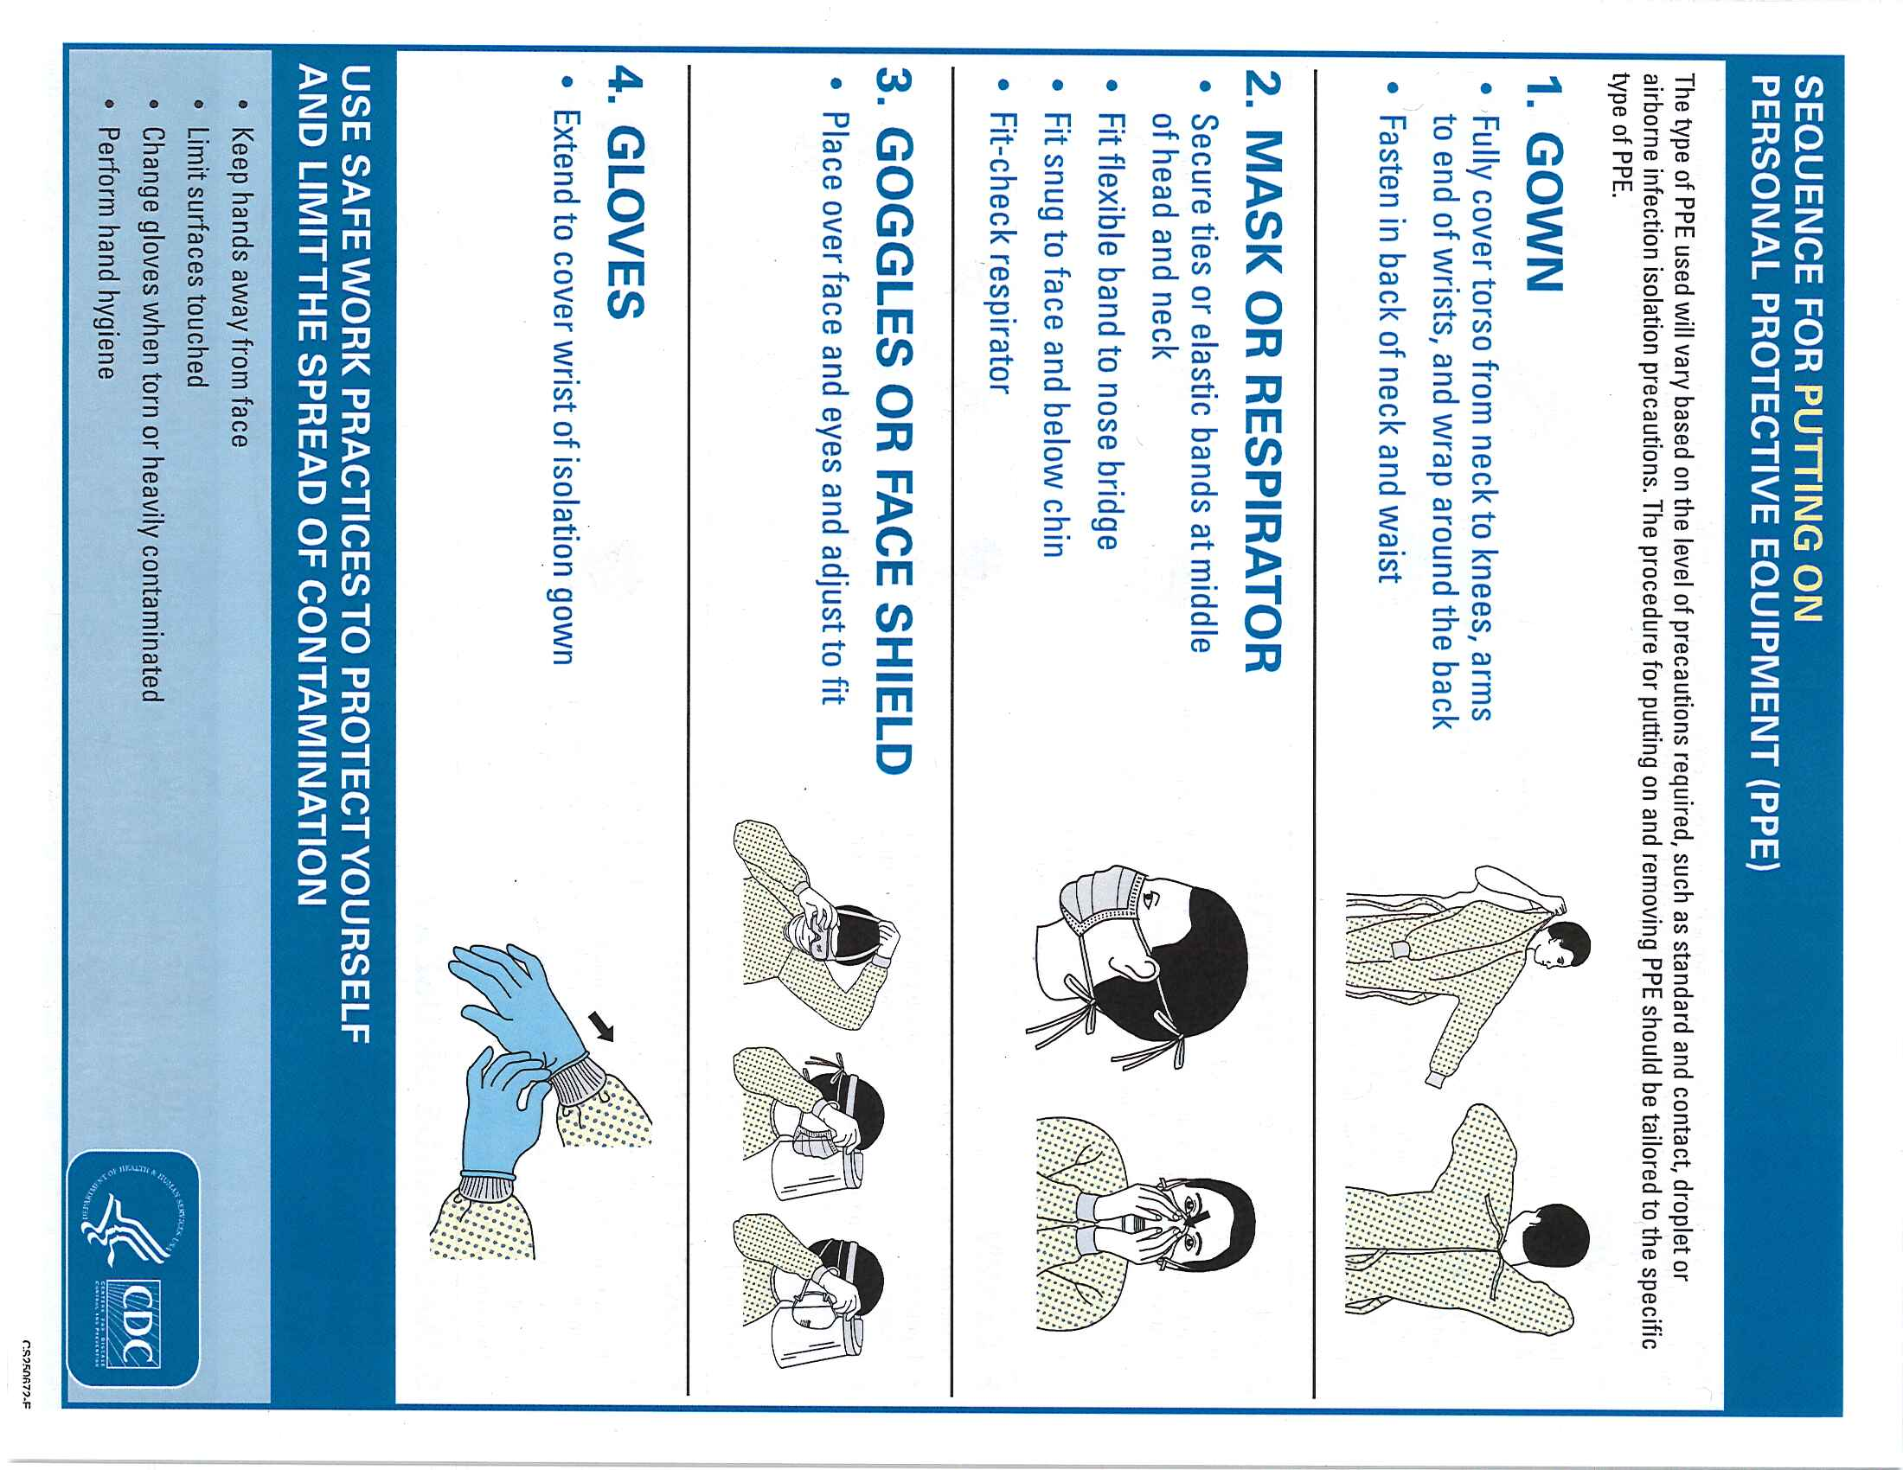
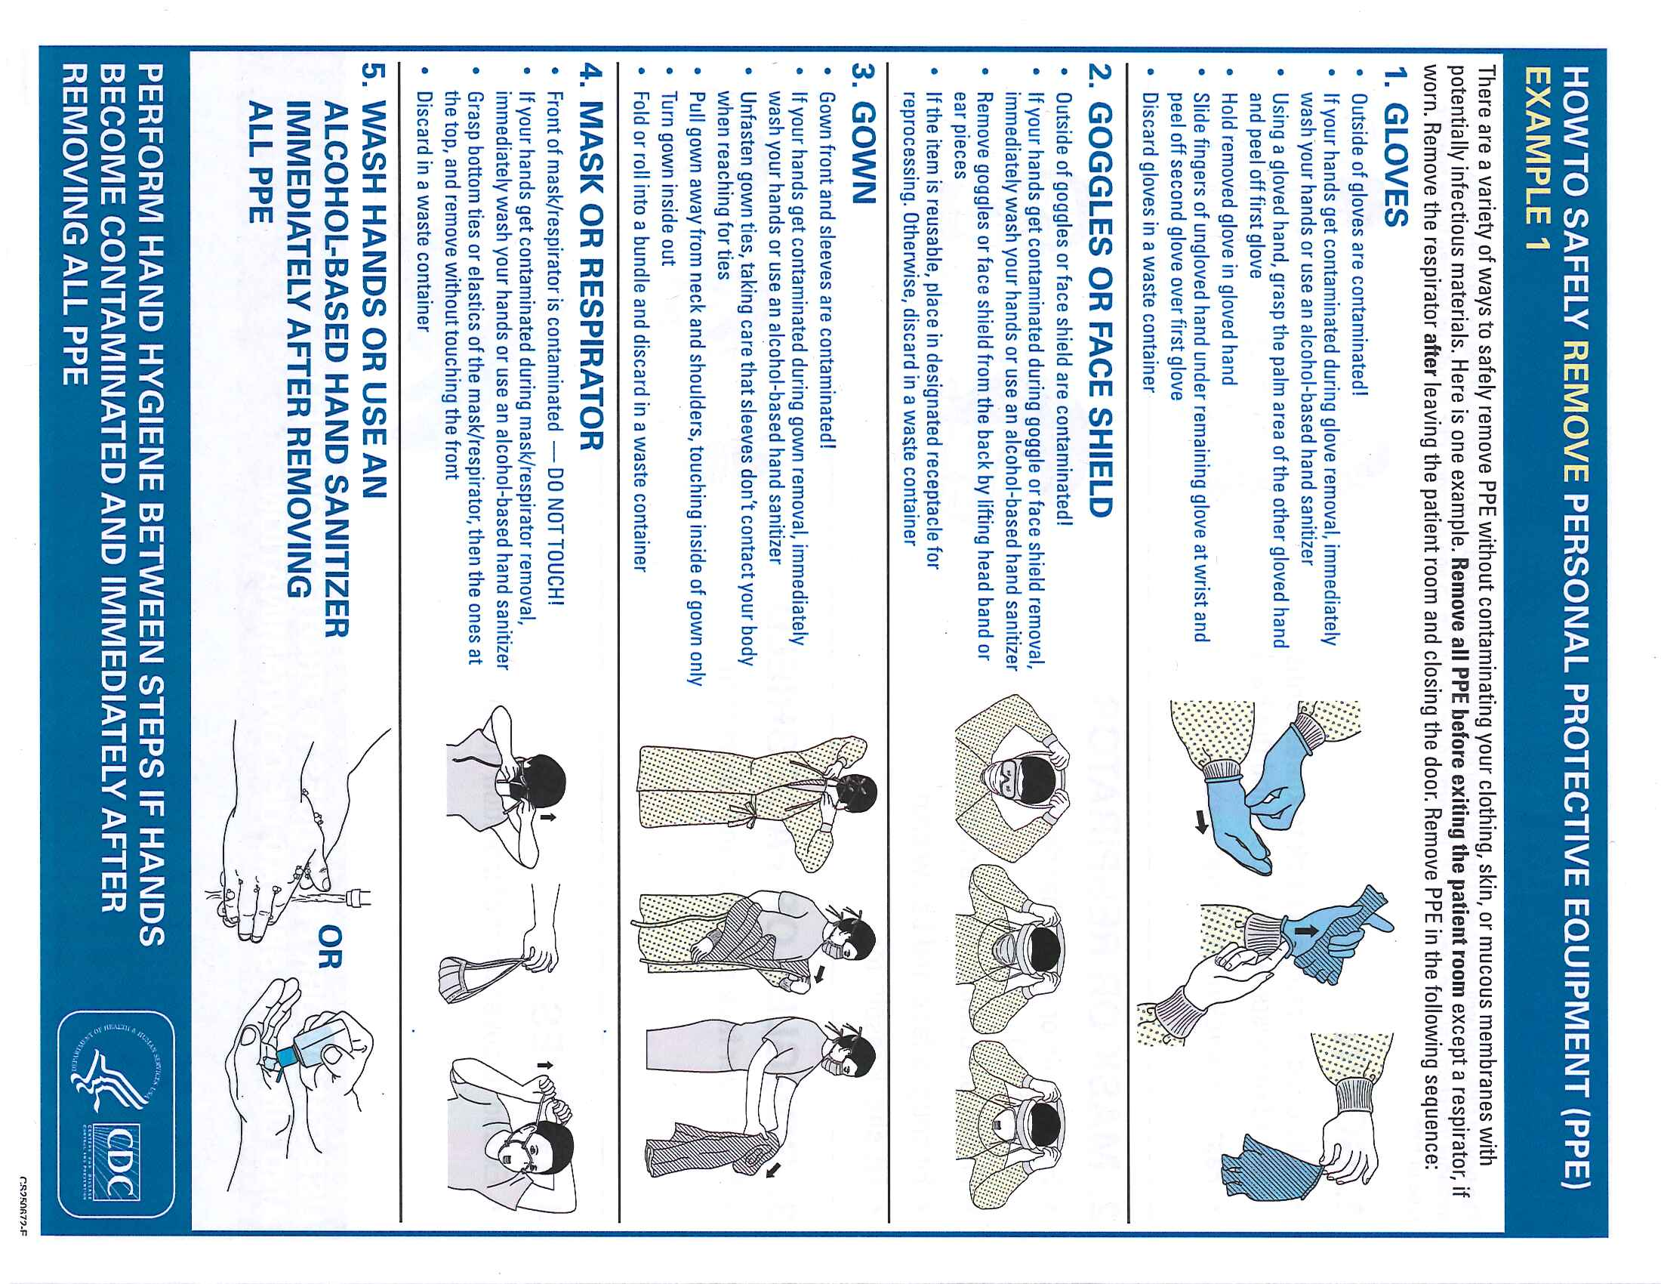

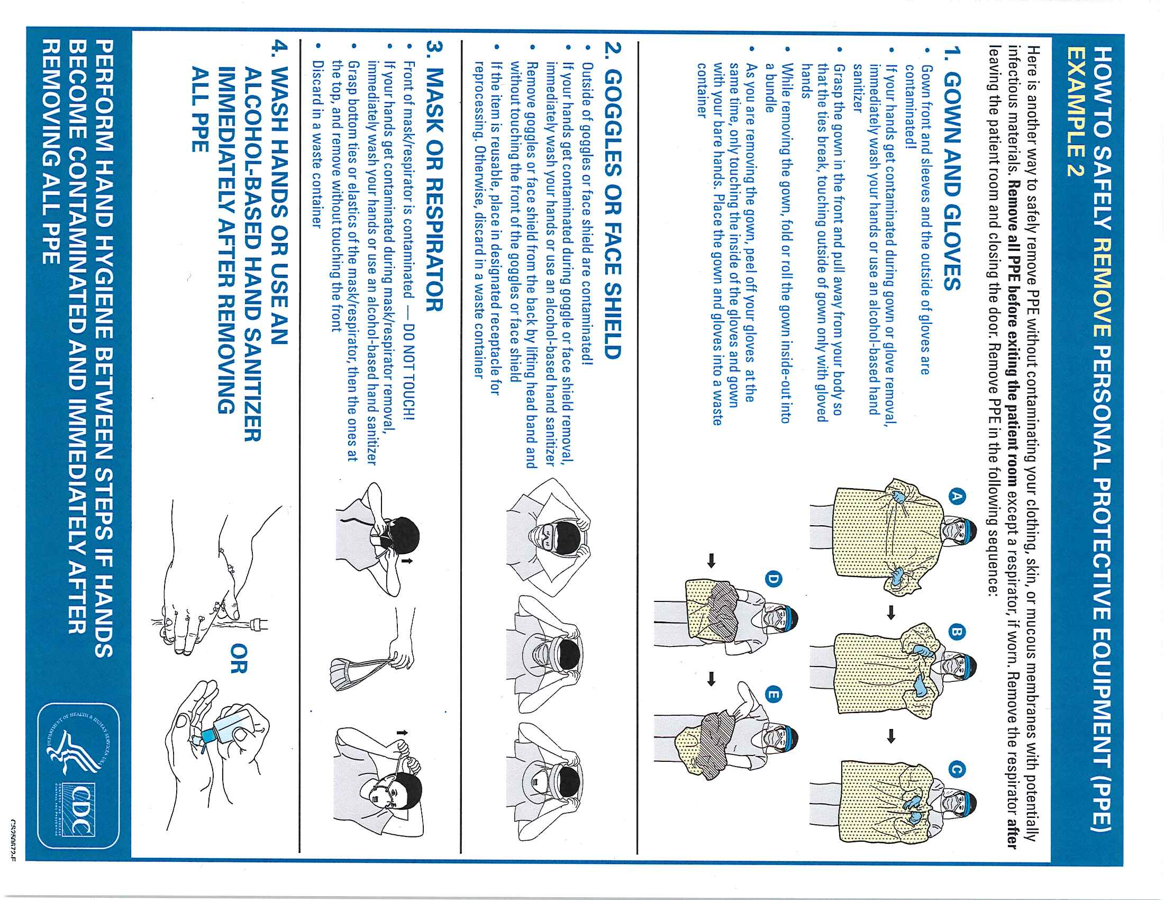

Appendix F

Donning and Doffing of
Personal Protective Equipment (PPE) for
Communicable Diseases

Donning and Doffing of Personal Protective Equipment (PPE) per CDC video

Donning (putting on)

Remove all jewelry, watches, etc.
Pull hair back and up, no bangs or hair below neckline

- Use alcohol-based hand sanitizer, let it fully dry
- Don regular exam gloves - nitrile
- Don mid-calf booties while sitting on a clean chair
- Don gown and tuck gloves under sleeve
- Put on N95 respirator mask—top strap first, bottom strap last
- Don surgical hood – head, ears, and neck covered
- Don long gloves with extended cuffs—pull over gown sleeve
- Put on face shield
- Check movement and body coverage—should be able to bend and move freely
- Use alcohol-based hand sanitizer before entering the room
Doffing (taking off)

OBSERVE patient care provider’s PPE to inspect for visible contamination, cuts or tears

- Use alcohol-based hand sanitizer
- Remove booties while sitting in a designated chair
- Use hand sanitizer
- Remove long gloves CAREFULLY
- Use hand sanitizer
- Remove face shield-- tilt head forward and grab rear strap pulling it forward to remove
- Use hand sanitizer
- Remove hood—tilt head forward and grab from back of head to remove
- Use hand sanitizer
- Remove gown SLOWLY and CAREFULLY rolling it inside out, only touching inside of gown
- Use hand sanitizer
- Remove regular gloves
- Use hand sanitizer
14. Put on new regular gloves
- Remove N-95 mask—tilt head forward, pull bottom strap over head, then top strap
- Use hand sanitizer
- Clean shoes with disinfectant wipes while sitting on clean chair
- Remove gloves and wash hands with soap and water

Donning and Doffing of Personal Protective Equipment (SUIT)
Donning (putting on)
Remove all jewelry, watches, etc.
Pull hair back and up, no bangs or hair below neckline
- Use alcohol-based hand sanitizer, let it fully dry
- Don regular exam gloves - nitrile
- Don mid-calf booties while sitting on a clean chair
- Don gown or suit and tuck gloves under sleeve
- Put on N95 respirator mask—top strap first, bottom strap last
- Don surgical hood – head, ears, and neck covered
- Don long gloves with extended cuffs—pull over gown sleeve
- Put on face shield
- Check movement and body coverage-- should be able to bend and move freely
- Use alcohol-based hand sanitizer before entering the room

Doffing (taking off)
OBSERVE patient care provider’s PPE to inspect for visible contamination, cuts or tears
- Use alcohol-based hand sanitizer
- Remove long gloves CAREFULLY
- Use hand sanitizer
- Remove face shield-- tilt head forward and grab rear strap pulling it forward to remove
- Use hand sanitizer
- Remove hood—tilt head forward and grab hood from back of head to remove
- Use hand sanitizer
- Remove gown or suit SLOWLY and CAREFULLY rolling it inside out, only touching inside of gown/suit. May also be able to remove booties while sitting in a designated chair
- Use hand sanitizer
- Remove regular gloves
- Use hand sanitizer
12. Put on new regular gloves
- Remove N-95 mask—tilt head forward, pull bottom strap over head, then top strap
- Use hand sanitizer
- Clean shoes with disinfectant wipes while sitting on clean chair
- Remove gloves and wash hands with soap and water

Appendix G

Medical Waste Disposal

MEDICAL WASTE DISPOSAL

QUICK REFERENCE

Items | Most Expensive | Expensive | Least Expensive
 | Sharps Containers  (Needles, scalpels, easily breakable, sharp objects) | Medical Waste (Red Bag)  (Garbage that is saturated, dripping or flaking with body fluid) | Garbage  (Solid Waste Stream)
Needles, Scalpels, Lancets | X
Needleless Syringe w/ Medicine |  |  | X
Needleless Syringe w/ Blood |  | X
Gloves |  |  | X
Dressing - small to medium of body fluid |  |  | X
Dressing – medium to large of body fluid |  | X
Glass Test Tubes w/ Blood | X
Medication Vials (intact) | X
Angiocaths | X
Disposable Gown |  |  | X
Peripads |  |  | X
Blue Pad / Chux |  |  | X
Glass Ampules / Broken Vials | X
Glass Slides | X
Suction Canisters - Full |  | X
Suction Canisters – Empty |  |  | X
IV Bags and Tubing |  |  | X

Appendix H

Permission of Source for Post Exposure Blood Testing

PERMISSION OF SOURCE FOR POST EXPOSURE BLOOD TESTING
I understand that a WSU employee/student/healthcare provider has been accidentally exposed to my blood or body fluid and I have been asked to have a sample of my blood collected and tested for:
☐ Hepatitis B (Surface Antigen)
☐ Hepatitis C (HCV)
☐ Human Immunodeficiency Virus (HIV)
I have been informed of the nature of the tests, its expected benefits and risks, and have been given the opportunity to ask questions about the test. I have been informed that there will be no charge to me for the HIV, HBV, or HCV testing.
I have been informed that I will be notified of my test results and that my test results and related documentation for HIV, HBV, HCV will be kept in a confidential file, accessible only to those involved in my counseling and medical care. My test results will not be released to others except to the extent required by law or except to the extent such disclosure is required in order to safeguard the well-being of healthcare providers, patients at the clinic or other persons at risk.
By my signature below, I acknowledge that I have been given all the information I have requested concerning HIV, HBV, and/or HCV testing and the requirements of disclosing test results.
Check one
_____ Give consent for a sample of my blood to be collected and tested for:
☐ Hepatitis B (Surface Antigen)
☐ Hepatitis C (HCV)
☐ Human Immunodeficiency Virus (HIV)
_____ I decline to have my blood collected and, as a result, take full responsibility for the consequences of this action.

_________ ________________________________________________________________________
DATE SIGNATURE OF SOURCE OR PRINTED NAME
GUARDIAN/FAMILY MEMBER

_________ ________________________________________________________________________
DATE SIGNATURE OF HEALTHCARE PROVIDER OBTAINING PERMISSION

Appendix I

Health Screening Consent Form

Washington State University Health Sciences
Spokane Health Screening Consent

Name:
[Please Print Full Name of Participant]
I give the affiliates of the Washington State University (WSU) College of Medicine, College of Nursing, and College of Pharmacy and Pharmaceutical Sciences permission to provide health screenings and preventative care administered by WSU students and/or faculty to myself. I acknowledge that these health screenings and preventative care are part of a student training exercise. Screenings and preventative may include, but are not limited to, blood glucose, blood pressure, lipids, cholesterol, body composition, bone density, oxygen level, hearing, and immunizations.
I hereby voluntarily agree to assume all risks involved with the health screenings and preventative care including foreseeable and unforeseeable risks that may occur and WSU cannot specifically anticipate. I understand that risks of health screens include of personal injury and/or death, including, but not limited to, numbness, finger soreness, bruising, prolonged bleeding, and tingling of lower arm and fingers.
In the unlikely event of a needle stick injury, or other exposure event for which I am identified as the source individual, I agree to undergo appropriate, reasonable medical evaluation and testing as recommended by healthcare professionals at my own expense. I understand my personal health information will be kept confidential and handled in accordance with applicable privacy laws.
Release of Liability
I release the state of Washington, the Regents of WSU, WSU, any subdivision or unit of WSU, its officers, employees, and agents, and any student, from any and all liability, claims, costs, expenses, injuries and/or losses, that I may sustain as a result of participation in the above event.
I am 18 years of age or older. I have carefully read this document, understand its contents assume the risk of participation and release WSU from liability as set forth herein.

Participant’s Signature:

Date:

Preceptor Printed Name:

Preceptor Signature:

Date:

Appendix J

Syllabus Statement

For skills-based courses with required activities that include the risk of bloodborne pathogen exposure, include the following statement in the course syllabus:

As part of this course, students will be required to provide health screenings and immunizations to volunteer participants as well as other students. Students must read and adhere
to the program’s Bloodborne Pathogens Exposure Control Plan, which is available here [link]. By participating in this course, in the unlikely event of a needle stick injury or other exposure event for which a student is identified as the source individual, students agree and consent to undergo appropriate, reasonable medical evaluation and testing, as recommended by healthcare professionals, at the student’s own expense. Personal health information will be kept confidential and handled in accordance with applicable privacy laws.

WSU students are responsible for all costs associated with clinic visits, medication, laboratory,
and any other related costs that occur after the incident, whether they are the exposed
individual, or the source individual. WSU strongly recommends that students purchase health care insurance to assist with these costs. Students should notify their clinical site supervisors and college program directors of financial issues related to bloodborne pathogen exposure. Programs may be able to assist in identifying some sources of potential financial support.

WSU students are not employees while they are engaging in education-related activities at clinical sites and are, therefore, not covered by workers’ compensation at either the clinical site or WSU. Treatment for exposures is NOT considered an on-the-job injury since students are NOT employees at clinical training sites.

