CoFirGE-2: A national project to identify regionally adapted Trojan, Turkish and Nordmann fir to produce high quality Christmas trees.
Chal Landgren and Gary Chastagner
A national cooperative project called the Collaborative Fir Germplasm Evaluation (CoFirGE) experiment was initiated in 2010. Conceived by retired Christmas tree geneticist Dr. John Frampton at North Carolina State University, cones were collected from 60 GPS-located trees in three Turkish fir provenances and 40 GPS-located trees in two Trojan fir provenances within the natural range of these species in Turkey.
Origins of Turkish and Trojan firs in CoFirGE-1 trials.
Species | Symbol | Family | Province | District | Locality
Turkish | BOL | 1-20 | Bolu | Aladağ | Kokez
Turkish | KAR | 21-40 | Karabük | Keltepe | Keltepe
Turkish | AKY | 41-60 | Adapazarı | Akyazı | Dokurcun
Trojan | KAZ | 61-80 | Balıkesir | Edremit | Kazdaği
Trojan | CAN | 81-100 | Ҫanakkale | Ҫan | Ҫan
The goal was to identify regionally adapted alternative firs for use as Christmas tree species to help combat climate change and threats from diseases, such as Phytophthora root rot. The first project (CoFirGE-1) focused on performance of families of seedlings from the Turkish and Trojan fir trees, but also included seedlings from several sources of Nordmann fir and commonly grown North American species of true firs, such as noble and Fraser fir.
To evaluate regional adaptability, seedlings were planted across six regions in the US and Denmark in 2013. The WSU CoFirGE-1 plot was located on Snowshoe Evergreen’s Nisqually Christmas tree farm. Data were collected on bud break, growth, quality, disease resistance, and postharvest needle retention at various times throughout the rotation. After 8 years, the height and grade (quality) of 2,445 trees from 92 families was determined. These variables and the prevailing wholesale prices of trees were then used to estimate the value of each tree. Based on these estimates, Trojan fir represented 8 of the top 10 and 17 of the top 25 families in the trial. As indicated by the yellow bars in the following figure, the Kazdaği Trojan fir families were consistently among the highest value families in the trial. In addition, among all the trees in the plot, the top 1% of trees with the highest value were all from Kazdaği families.
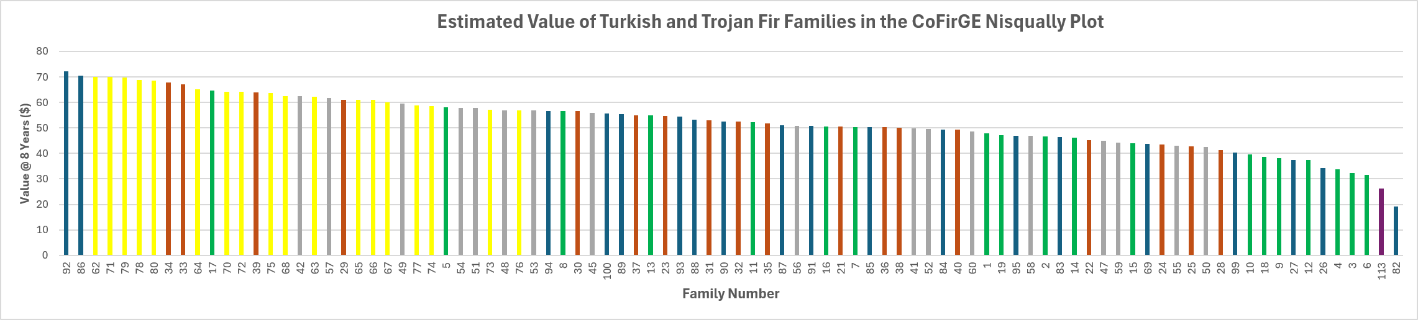
About five years ago, Chal Landgren, Judy Kowalski, Rick Bates (Penn State Univ.), and Gary Chastagner started laying the groundwork for the initiation of a second range-wide progeny test (CoFirGE-2). The goal of this RCTB funded project is to compare the adaptability and performance of seedlings from 12 of the top performing KazdağI Trojan fir families from the CoFirGE-1 trial and 11 families of potentially late bud breaking Nordmann fir from within the Ambrolauri, Okriba, Bakhmaro, and Borjomi provinces in the Republic of Georgia. Seedlings of Nordmann, Turkish, balsam, Canaan, Fraser and noble firs from established seed orchards located in the U.S., Canada, and Denmark are included for comparison.
Collaborators on this project include Drs. Bert Cregg (Michigan State Univ.), Rick Bates, Rich Cowles (CT Ag. Exp. Station), and Justin Whitehill (North Carolina State Univ.). In consultation with Dr. Justin Whitehill, who is the new Christmas tree geneticist at NCSU, 2-year-old container grown seedlings were used to establish a series of regional, replicated CoFirGE-2 plantings in environmentally diverse research and Christmas tree production sites in CA, CT, ID, MI, NC, OR, PA, and WA in 2023. Dr. Whitehill helped design the layout of the plantings to maximize the amount of genetic information that will be obtained from selected plots. The regional plantings in WA, OR, ID, and CA, are located at WSU REC, Puyallup; BTN of Oregon, Salem; Rusty Gate Tree Farm, Harrison; and Rapetti Farms, Placerville, respectively.
Since planting, the condition of the trees in the WA, ID, and CA plots have been evaluated yearly. This includes the collection of data on bud break, frost/winter damage, disease and insect damage, and growth. Eurasian fir, especially Trojan and Turkish fir, are very prone to last spring frost damage due to their early bud break. As indicated in the 2025 bud break data from the plot at WSU Puyallup, there is considerable variation in bud break among the trees within families (vertical lines) and the average bud break between species. Of particular note is the relatively late bud break of the Rye family (#33) of Turkish fir. Similar variation is evident in the height of the trees in 2025 after three growing seasons.
Measurements of bud break, growth, form, phenology, winter burn, current season necrosis, disease, pest damage, and postharvest quality will be collected from the trees in these and the other CoFirGE-2 plots over the next 6 to 8 years to identify sources of trees that are adapted to environmentally diverse planting sites.
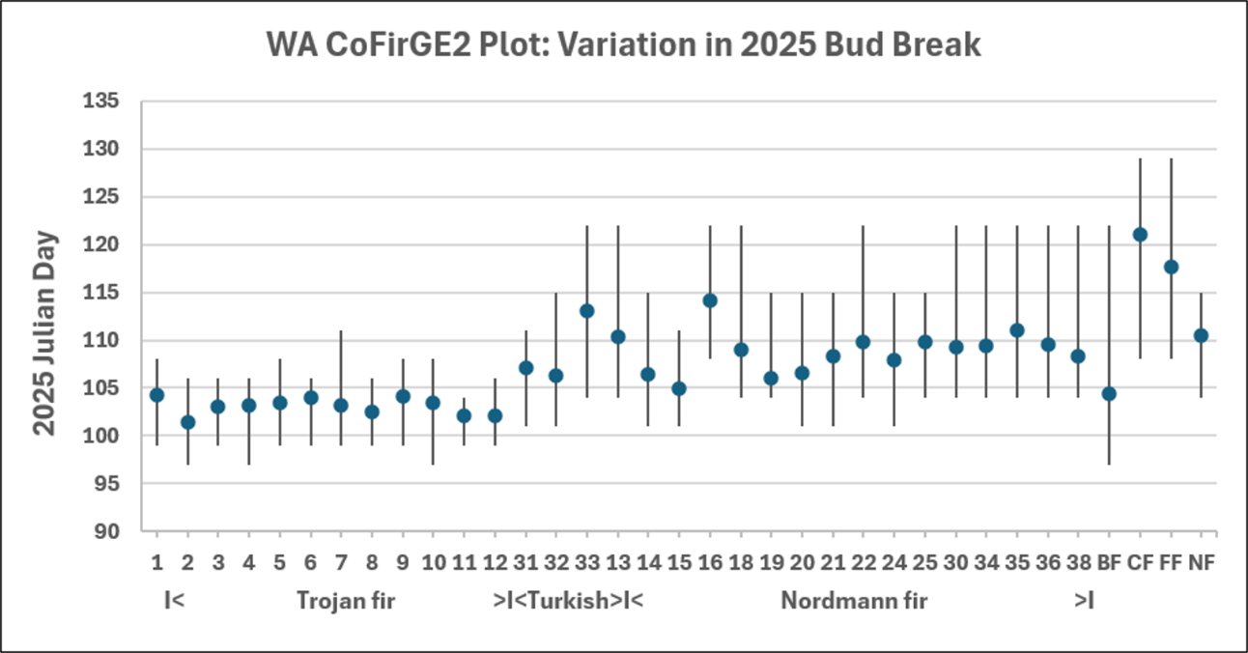
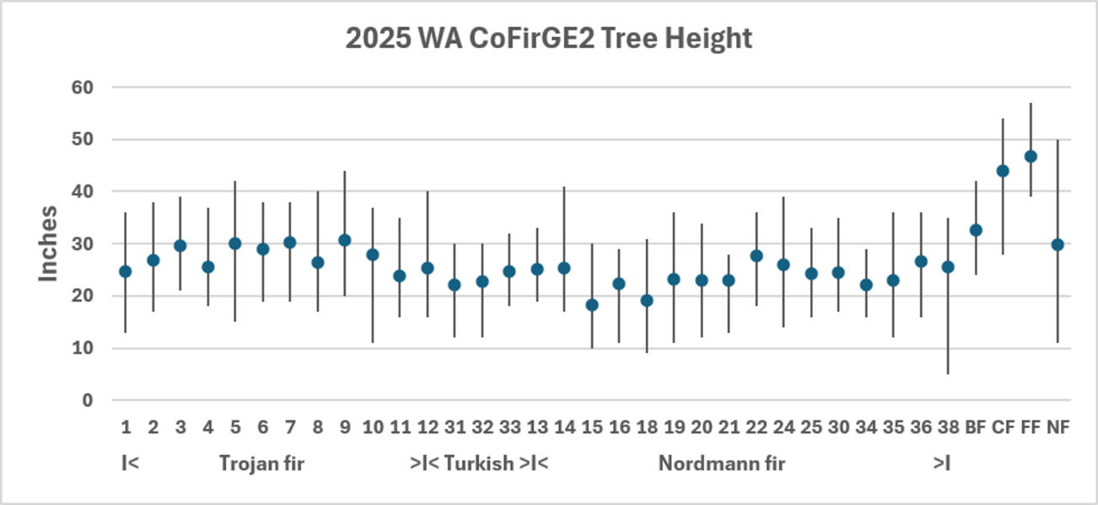
For a more detailed summary of the data that has been collected to date, view the slides from a presentation about the CoFirGE2 plots that was given at the 17th IUFRO International Christmas Tree Research and Extension conference in June ’26, which is available on this website.

