Team 1:
- Everyone go to ETRL and retrieve the blue pipe deburrer in the black toolbox.
- Go find Team 5 and give them the deburrer, and instruct them to deburr a copper pipe that is sitting on a red cart in 108B.

Team 2:
Everyone go find a 4 pin male bulkhead connector in the attic of TFRB and bring it downstairs.
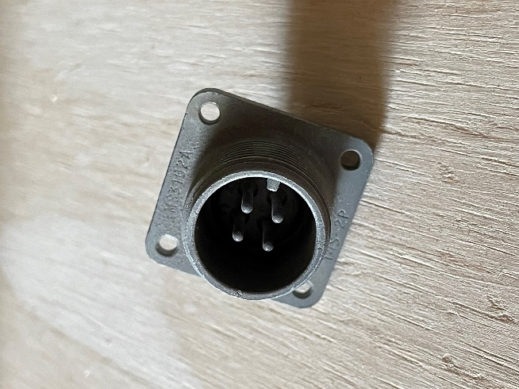

Team 3:
Find all the missing pieces of this drill bit box and put them where they belong, and organize the current bits if they’re in the wrong spots.

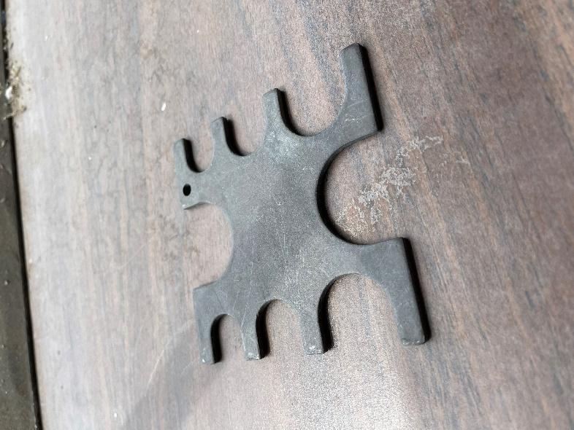
Team 4:
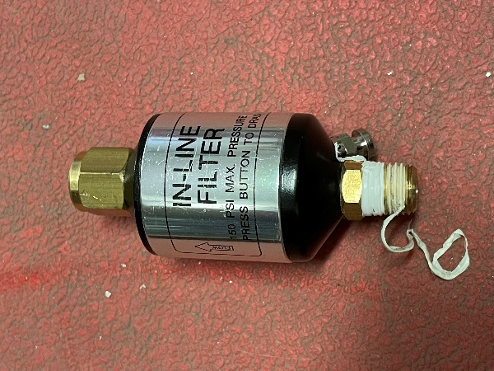
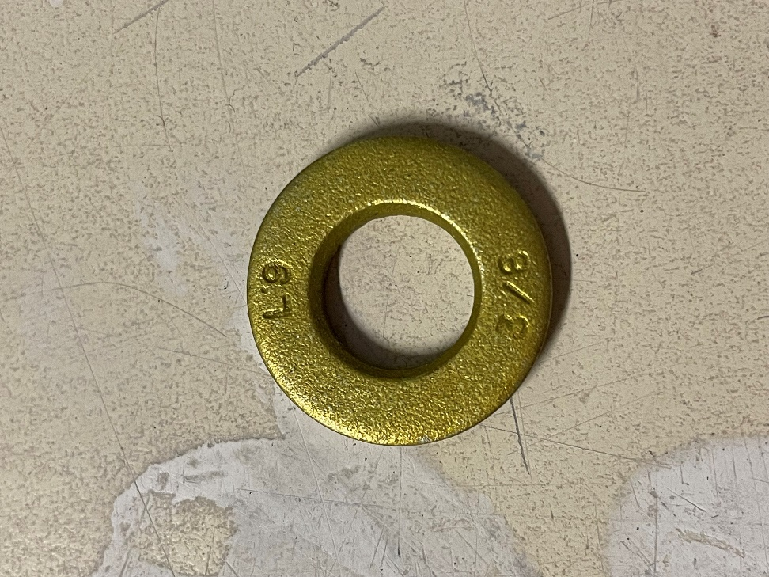
Find these things:

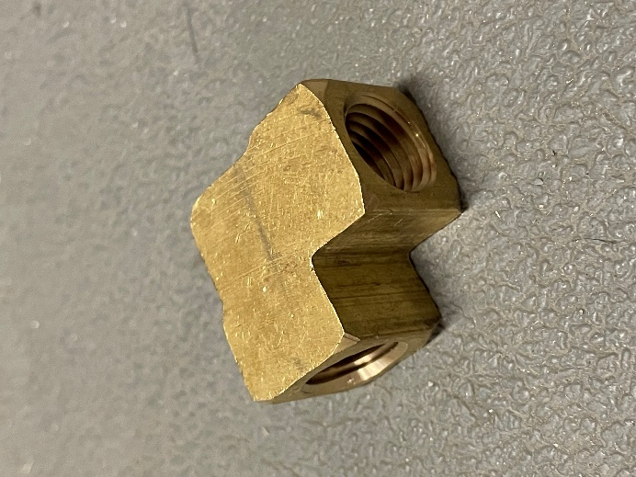
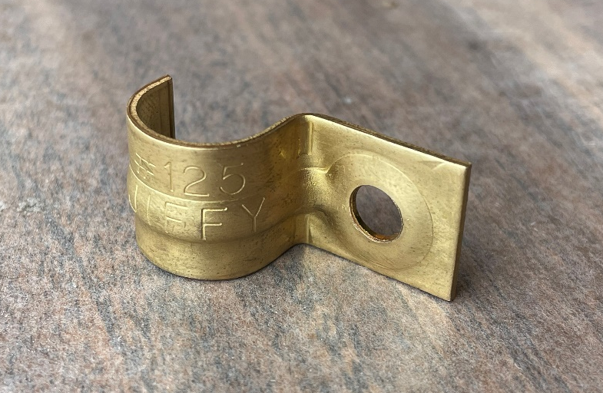

Team 5:
Wait by the couch for instructions from Team 1.

Team 6:
The floor is lava! Start on the black rug at the main entrance to TFRB and use all those scraps in the scrap bin as steppingstones to the safe land, Mark’s desk. Everything in-between the entrance rug and Mark’s desk is lava, so no touching the floor!

