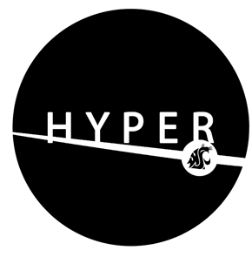

Weekly Community Meeting || Minutes

Meeting Time and Date: 6/25/2020 3:30 P.M || Meeting Location: Zoom

Meeting Facilitator:
Minutes Recorder:
Attending:
Warm Up Activity
Purpose: Warm up
Activity:
Action Items (Optional):
Responsibly Parties (Optional):
Due Date (Optional):

Project Leader Updates
Purpose: Each team lead is to talk about the key items from their backlog, including where they were, where they are, and where they are going

CRAFT
Where we were:
Where we are:
Where we’re going:
CHEF
Where we were:
Where we are:
Where we’re going:
CCC AKA “Bellow Fellows”
Where we were:
Where we are:
Where we’re going:
TANK
Where we were:
Where we are:
Where we’re going:
H2-Flo
Where we were:
Where we are:
Where we’re going:
CORE
Where we were:
Where we are:
Where we’re going (including backlog; should open to community suggestions):
Looking Ahead

Purpose: discuss things that we need to prepare for and improve upon as a community. (5 min).

Action Items (Optional):
Responsible Parties (Optional):
Due Date (Optional):
Takeaways
Purpose: Provide an update or share something neat learned

Recognition

Purpose: Promote community

High Five You’re the Bomb:
Nominees (and justification):

Winner:

For the next meeting…
Purpose: Any last comments before meeting close.

Action Items (Optional):
Responsibly Parties (Optional):
Due Date (Optional):

Next Meeting
Date:
Facilitator:
Minutes Recorder:
Meeting Adjourned At:

