Washington State University Stable Isotope Core Laboratory
Procedure for weighing and encapsulating solid samples
Suitable for 13C, 15N, 2H, 18O, 34S analysis

You will need:

Two pairs of forceps
Small spatula
4 or 5 place microbalance*
Appropriate capsules (tin for CNS, silver for HO)
96, 48 or 32 position polystyrene trays (dependent on sample size)
Laboratory wipes and ethanol
Sheet or computer to record weights
Check with our lab to determine appropriate weights for your material

*Accurate measures of mass are primarily needed for accurate elemental measurements. We do not need the mass to provide isotopic ratios or even the total weight of elements in your sample. We do require a specific target range of material for good isotopic data. This means that if you have a calibrated scoop, leaf punch or specific measurement strategy, samples could be prepared without a microbalance. If a sample is out of range due to customer prep miscalculations, we still charge for it.

Step 1:

Start with a clean area, clean balance, clean trays, and clean tools. To aid in seeing spills, we work on mirror surfaces at SICL. Use kimwipes and ethanol to clean tools and work area between every sample. To aid in balance stability, it can be installed on a marble table or pad.

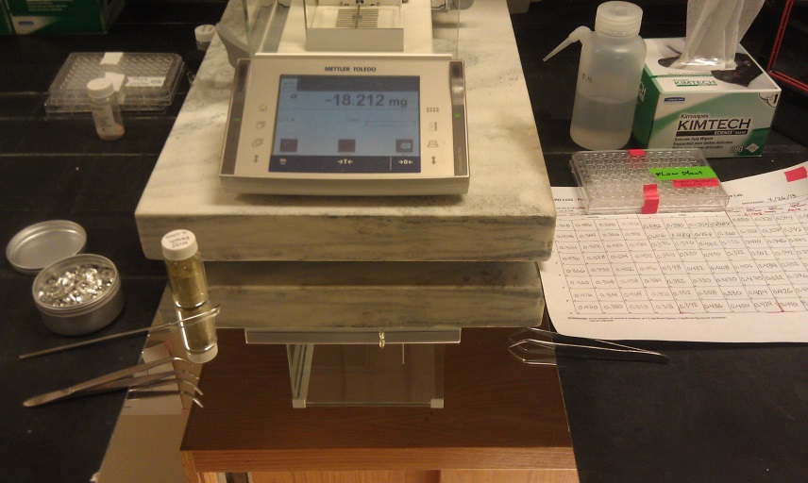

The sample you start with is ideally a homogenous powder. This will allow for the best reproducibility of measurements and aid in packing. Sometimes rough, irregular samples must be weighed. Use extra caution with rough or coarse samples. Contact us for the appropriate weight to use. Our minimum detection limits are 20 ug, and we target 2x that for N.

Step 2: Zero or tare the empty capsule. Keep your container of tins closed when not in use to minimize contamination.

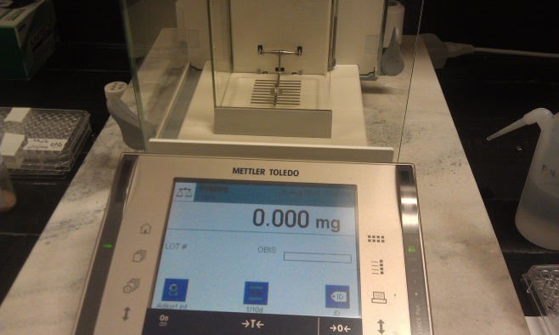

Step 3:

Add a small scoop of your material into the capsule. To get all the material off your scoop, gently tap the scoop with a free pair of forceps. Start with a small amount and add more if you need it. It is harder to remove material if you loaded too much. Some people prefer to hold tins in a small block for this step. Use caution however, that the block does not get dirty and contaminate subsequent samples.

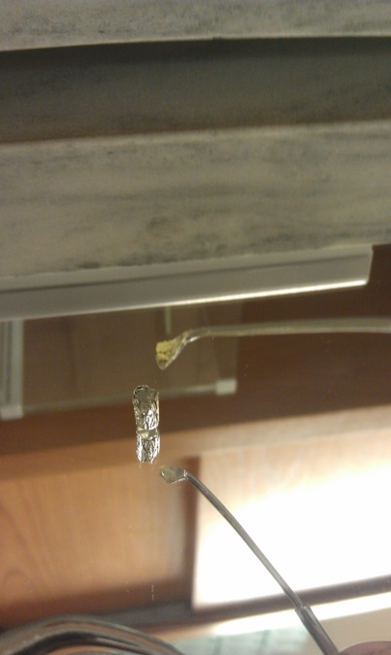

Step 4:

Using forceps, gently set the filled capsule down on your flat surface a few times. This forms the bottom flat so it stands better, and causes all loose material to fall into the tin or off the outside of the tin. It is much better to have any loose material fall off here than in your microbalance!

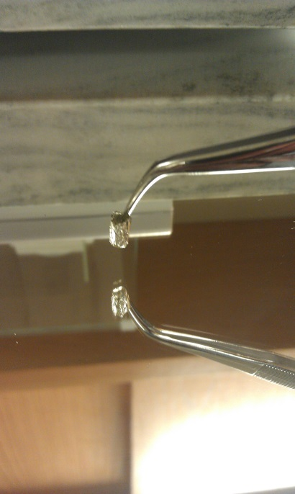

Step 5:

Return the filled capsule to the balance and check the weight. If it is low, go back to step 3. If it is too heavy, gently dump some material out. If ample material is left in the sample vial we usually dump it on the mirror to avoid contaminating the original batch. Once you have a good weight, close all draft shields and record the final value on your log sheet.

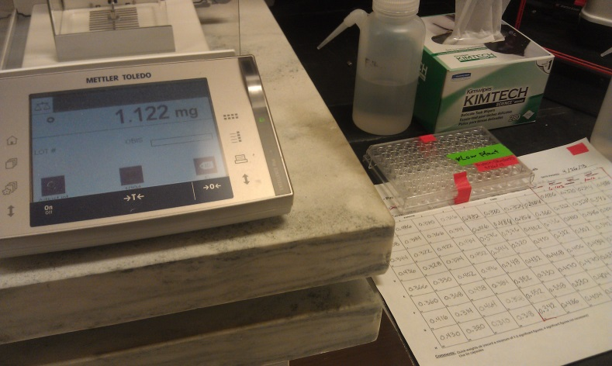

Step 6:

Using both pairs of forceps, pinch the capsule closed flat from just above the material to the open top.

.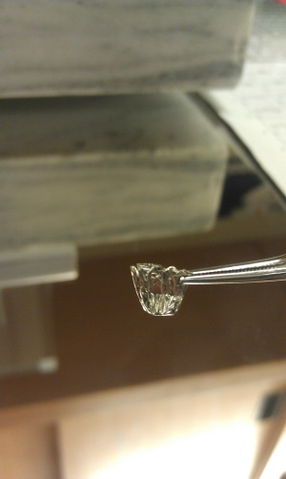

Step 7:

With forceps in each upper corner, make an “S” or “Z” motion to narrow the capsule, then repeat step 6.

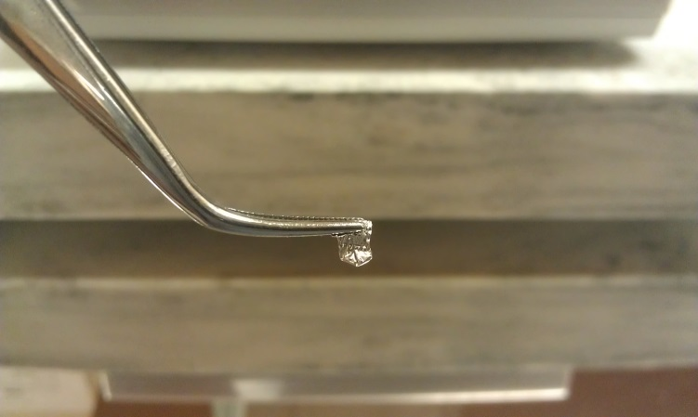

Step 8:

Roll the top of the capsule over, and then back into itself. Use both pairs of forceps in perpendicular orienation to sort of “corral” the sample into a square. You can hold the capsule in place and lightly press down from above with the other pair of forceps. Rotate the capsule 90 degrees and do this again.

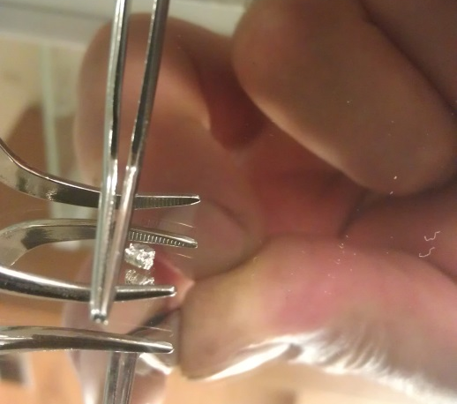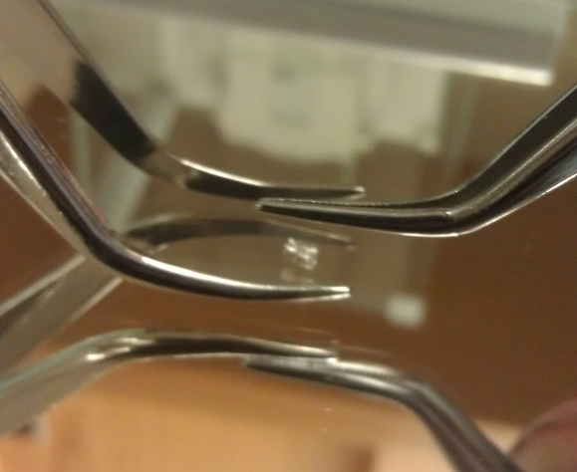

Take extra care to not over manipulate the sample because it can easily be punctured. Try to use the flat ends of the tools, not any of the sharp edges. Samples in squares or spheres are good. Cigars, pancakes and flag shapes are bad.

Step 9:

Drop the capsule a few times on a clean part of the work area (mirror) and check for leaks. If material leaks, you can reweigh and “double bag” into a new clean capsule. Some very coarse samples may require double tins.

Step 10:

Put final samples in a clean tray. Tape the lid on your tray whenver not in use. Many heartbreaks have happened from trays dropped with a loose lid! For added security, a small index card can be cut to fit under the lid, or silicone mats can be used before taping the lid on. Before shipping your trays to us, make sure your trays are well labeled with your name, the tray number, and type of analysis you are needing.

If samples arrive leaky or poorly shaped, we will let you know and advise you of anticipated surcharges for double bagging or reshaping.

Below are examples of how NOT to submit samples.

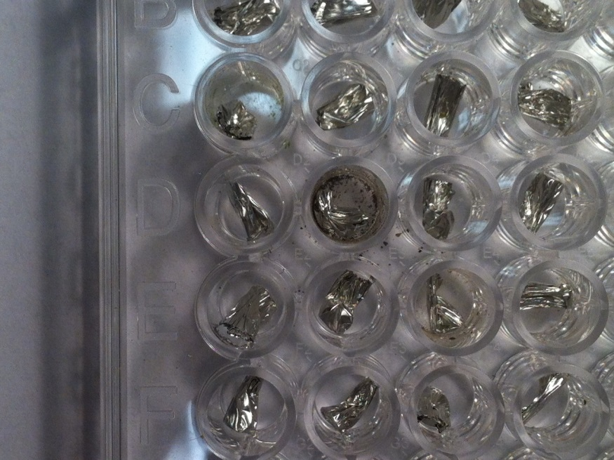

Samples not properly sealed or folded to a small shape. Obvious leaks into adjacent cells.

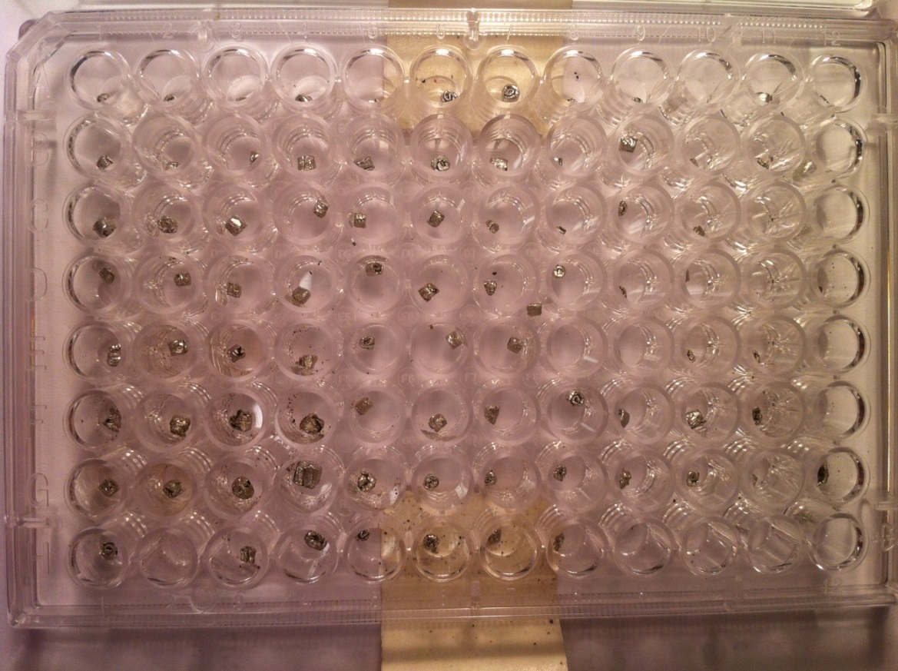

Leaking samples and samples jumped around severely during shipment, into adjacent cells or the innerspaces. Especially for tiny samples, make sure lid seals tightly. Cut a small gasket out of index paper to fit under the lid for a tighter seal.

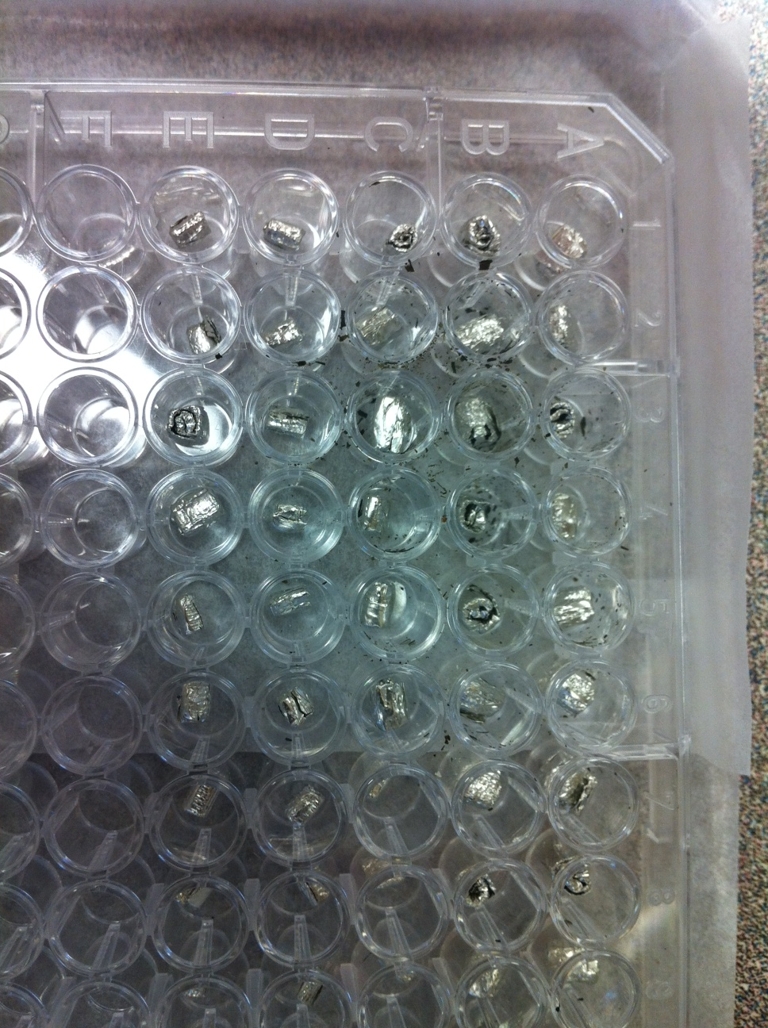

Badly contaminated samples. Leaks traveled to adjacent cells.

