Email: Should have looked like this – FOR EACH DAY:
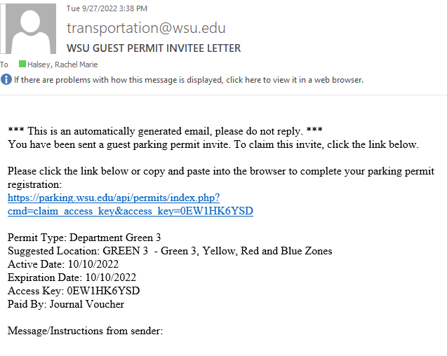

Click on the link:
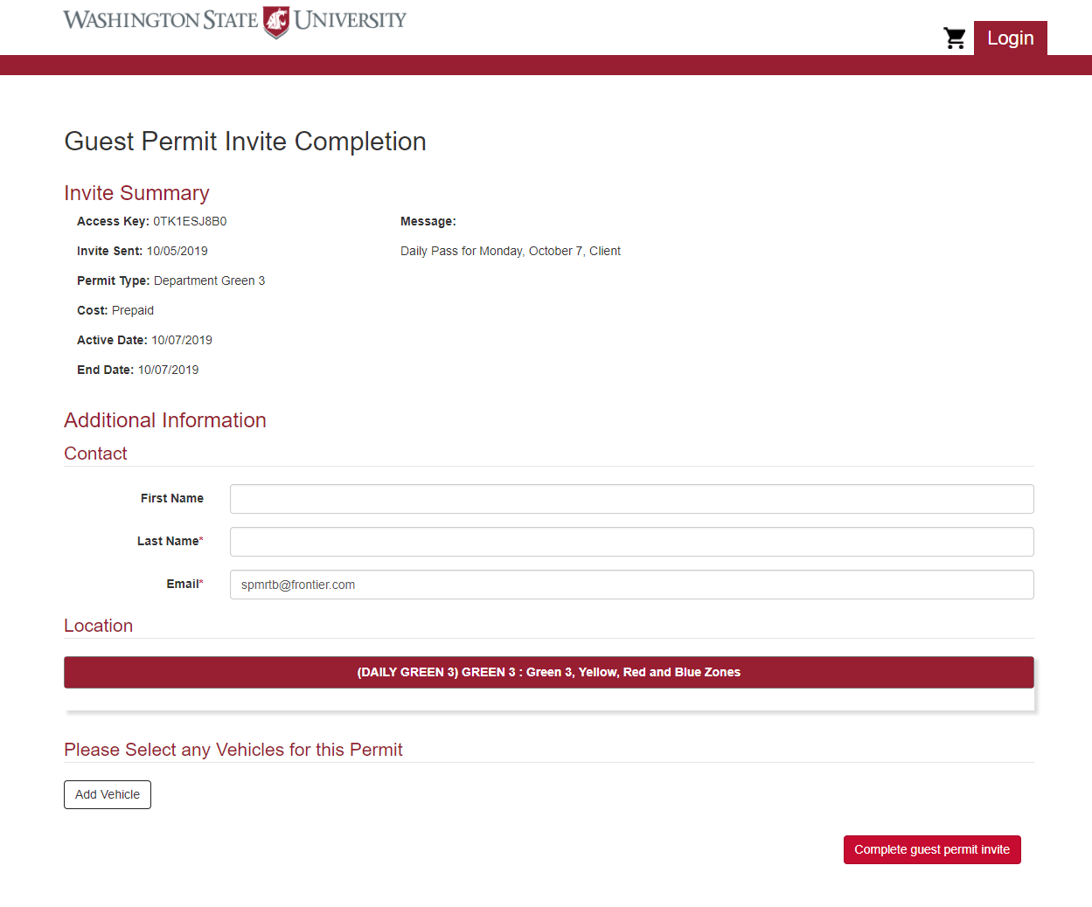
Starting filling out your information. Then click “Add Vehicle” This is where you would add Plate # (This needs to be accurate – so double check). You will need one for EACH day.

