
Welcome, INSERT CANDIDATE NAME HERE

Congratulations on making it to the on-site component of this recruitment. We are thrilled to have you visiting us here on the Everett Campus.
Within this packet you will find information regarding your on-site interview with DEPARTMENT NAME, an agenda for the next few days, and background information on Washington State University and its benefits, campus and surrounding area activities.

We truly hope you enjoy your stay, and encourage you to reach out
INSERT PRIMARY CONTACT NAME AND INFORMATION HERE
If you have any questions or concerns

Thank you again, good luck, and we hope you enjoy your time on campus. GO COUGS!

[This page is dedicated to department background information and may contain any information the search committee deems necessary for the candidate]

This page is dedicated to the agenda for the weekend.
On this page be sure to include all of the following:
- Events/Meetings the candidate will be partaking in
- Times and locations with a map/directions
- Transportation options
  - Flying into Tri Cities Airport
    - Rental Cars: Tri-Cities Airport | Ground Transportation (flytricities.com)
    - Ride share apps: Uber, Lyft, etc

About Washington State University- Spokane Campus
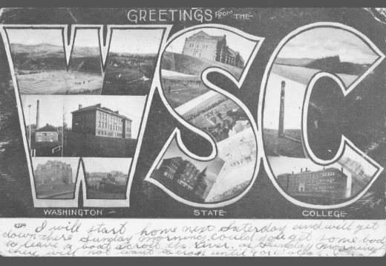
The Morrill Acts of 1862 and 1890 answered demand for practical education that was accessible to agricultural and industrial workers. The legislation granted federally controlled land to the states, which states could then sell to fund establishment of “land-grant” colleges
Washington State College was established in 1890 as a land-grant institution. It has become a distinguished public research university, but its mission remains rooted in accessibility and public service.
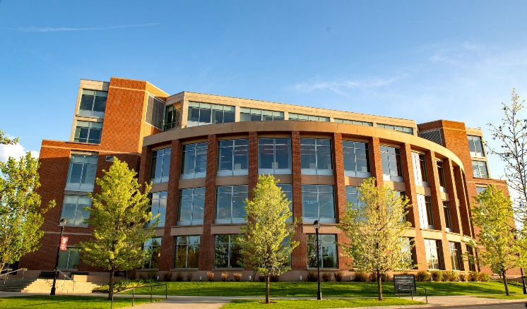
Today Washington State University proudly supports 5 campus locations across the state of Washington and one online Global campus. Across these different campuses WSU offers:
- 101 majors for undergraduates
- 79 masters programs
- 65 doctoral degree
3 professional degree programs
Everett Campus Background
The Tri-Cities campus of Washington State University was established in 1989. It serves as a leading public research university located along the beautiful Columbia River in the diverse and growing Tri-Cities. With a focus on energy, environment and agriculture, the campus delivers career-connected learning and innovative research that addresses economic and social challenges.
Today the Tri-Cities campus hosts nearly 1,430 students and provides 20 bachelor’s degrees and 30 graduate degrees.
For additional information on Washington State University please visit to following sites:
- WSU Difference | Washington State University
- Strategic Plan | Office of Strategy, Planning, and Analysis | Washington State University (wsu.edu)
- WSU Tri-Cities
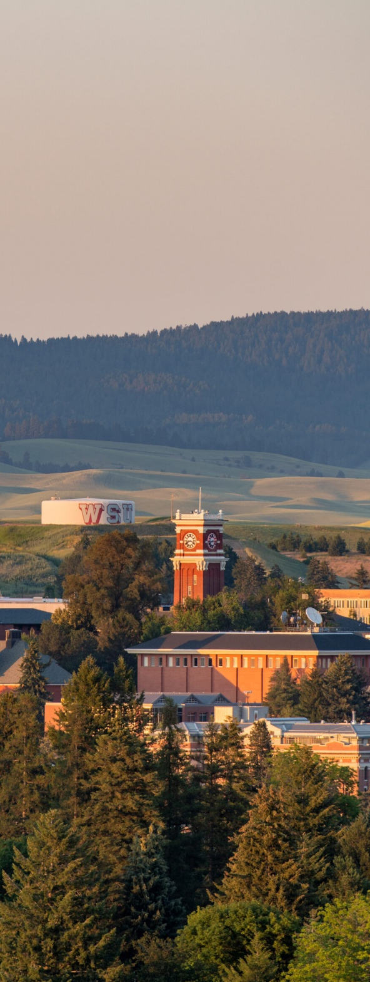
Washington State University Values:
QUALITY AND EXCELLENCE
We are committed to providing quality and excellence in all our endeavors.

INTEGRITY, TRUST, AND RESPECT
We are committed to ensuring trust and respect for all persons in an environment that cultivates individual and institutional integrity in all that we do.

RESEARCH, INNOVATION, AND CREATIVITY
We are committed to the pursuit of inquiry and discovery and to the creation and dissemination of knowledge.

LAND-GRANT IDEALS
We are committed to the land-grant ideals of access, engagement, leadership, and service to bring the practical benefits of education to the state, nation, and global community.

DIVERSITY AND GLOBAL CITIZENSHIP
We embrace a worldview that recognizes and values the importance of domestic and global diversity, global interdependence, and sustainability.

FREEDOM OF EXPRESSION
We are committed to the free exchange of ideas in a constructive and civil environment, including the canons of academic freedom in research, teaching, and outreach.

STEWARDSHIP AND ACCOUNTABILITY
We are committed to serving as ethical and responsible stewards of University resources.

The Washington State University Mission:
To advance knowledge through creative research and scholarship across a wide range of academic disciplines.
To extend knowledge through innovative educational programs in which emerging scholars are mentored to realize their highest potential and assume roles of leadership, responsibility, and service to society.
To apply knowledge through local and global engagement that will improve quality of life and enhance the economy of the state, nation, and world.
Tri-Cities Campus/Parking Information
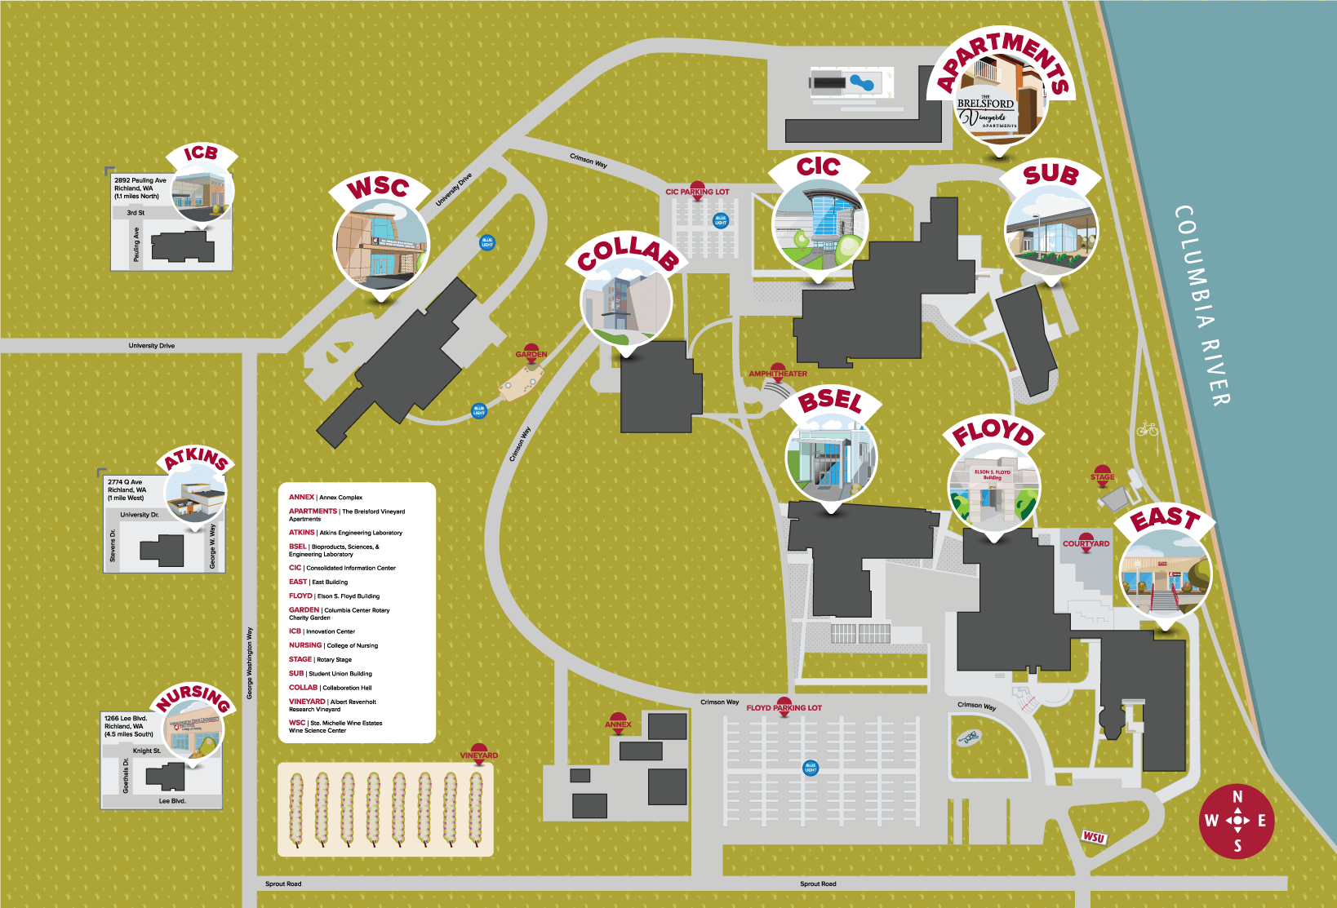
- There are two parking lots on campus and all guest parking is free!
  - Floyd parking lot
  - CIC Parking lot
  - For further information regarding the campus: Campus Maps - WSU Tri-Cities

Washington State University Benefits Overview

Washington State University offers a comprehensive benefits package, encompassing a sizable amount of our employees’ overall compensation package. Options to best fit our employees’ and their families’ needs are offered, and we are happy to extend these benefits to you!

- Medical Insurance: http://hrs.wsu.edu/medical-insurance/
- Premium Surcharges: http://hrs.wsu.edu/premium-surcharges/
- Dental Insurance: http://hrs.wsu.edu/dental-insurance/
- Life Insurance: http://hrs.wsu.edu/life-insurance/
- Long Term Disability: http://hrs.wsu.edu/long-term-disability/
- Dependent Care Assistance Program: http://hrs.wsu.edu/dependent-care-assistance-program/
- Flexible Spending arrangement: http://hrs.wsu.edu/flexible-spending-account/
- Health Savings Account: http://hrs.wsu.edu/health-savings-account/
- Commuter Benefit: https://hrs.wsu.edu/employees/benefits/benefit-details/commuter-benefit/
- Auto& Home Insurance: http://hrs.wsu.edu/auto-and-homeowners-insurance/
- Long-term Care: https://hrs.wsu.edu/employees/benefits/benefit-details/long-term-care-and-the-long-term-services-and-support-trust/
- WA 529 College Savings Plans: https://wastate529.wa.gov/
- Public Service Loan Forgiveness: https://hrs.wsu.edu/employees/benefits/benefit-details/public-service-loan-forgiveness/
- Mental Health Services: https://hrs.wsu.edu/employees/benefits/benefit-details/mental-health-services/

For a more comprehensive overview please refer to these handouts: only include the information for the candidates position!

- Faculty and Administrative Professional Positions: 2022-Benefit-Overview-for-Faculty-and-AP.pdf (wsu.edu)
- Classified Staff: Microsoft Word - 2022 Benefit Overview for Civil Service (wsu.edu)

Welcome to Tri-Cities Washington!
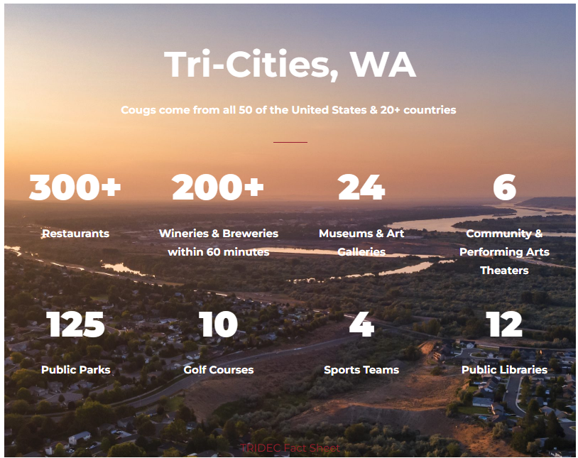
Tri-Cities Washington is made up of three different cities, Kennewick, Richland and Pasco. The WSU campus is located in Richland, however the two other surrounding towns are less than 5-10 miles from one another.
The Tri-Cities is home to 300 days of year round sunshine and offers a diverse amount of activities for any individual to take part in.
Take a Virtual Tour of the beautiful Tri-Cities: Tri-Cities Washington | SKYNAV
Visit Tri-Cities – A terrific website that breaks down the many activities happening throughout the Tri-Cities
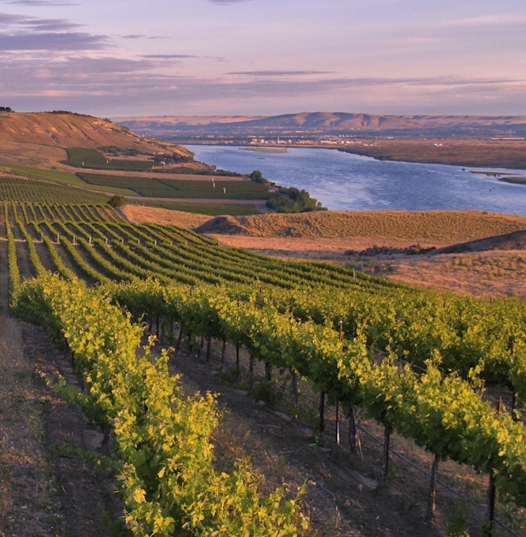
Below you will find links to more information regarding each city:
- Kennewick, Washington: The largest community, where the pursuit of happiness stretches 25 square miles
  - The City of Kennewick, Washington - Visit Tri-Cities

- Pasco, Washington: A thriving community with a population of more than 77,000 and host to the Fiery Foods Festival, the Cinco de Mayo Celebration, the Sacajawea Blue Grass Festival, and Heritage Days.
  - Pasco - City of Pasco Washington - Visit Tri Cities | Visit Tri-Cities

- Richland, Washington: A place where you can stroll along the Columbia River, enjoy an outdoor concert
  - Richland - City of Richland WA - Visit Tri Cities | Visit Tri-Cities
- Richland is divided into two sections, one of which known as Richland and the other is West Richland: along the beautiful Yakima River which meanders through the valley and borders the city just above its confluence with Columbia River.
  - West Richland - Tri-Cities, Washington | Visit Tri-Cities

Living in Tri-Cities, Washington
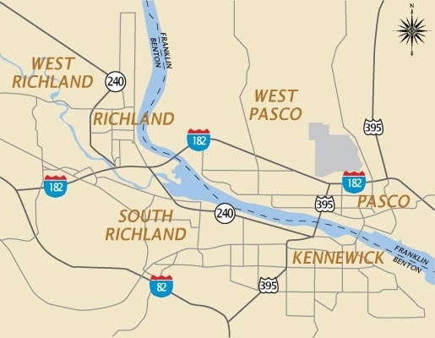

- Kennewick School District: Kennewick School District
- Pasco School District: Pasco School District
- Richland School District: Richland School District

