Spokane Candidate Packet Example


Welcome, INSERT CANDIDATE NAME HERE

Congratulations on making it to the on-site component of this recruitment. We are thrilled to have you visiting us here on the Spokane Campus.
Within this packet you will find information regarding your on-site interview with DEPARTMENT NAME, an agenda for the next few days, and background information on Washington State University and its benefits, campus and surrounding area activities.

We truly hope you enjoy your stay, and encourage you to reach out
INSERT PRIMARY CONTACT NAME AND INFORMATION HERE
If you have any questions or concerns

Thank you again, good luck, and we hope you enjoy your time on campus. GO COUGS!

[This page is dedicated to department background information and may contain any information the search committee deems necessary for the candidate]

This page is dedicated to the agenda for the weekend.
On this page be sure to include all of the following:
- Events/Meetings the candidate will be partaking in
- Times and locations with a map/directions
- Transportation options

- Spokane Intl Airport > Home (spokaneairports.net)
- Rental Car: Rental Cars (spokaneairports.net)
- Rideshare: Spokane features Uber and Lyft

About Washington State University- Spokane Campus
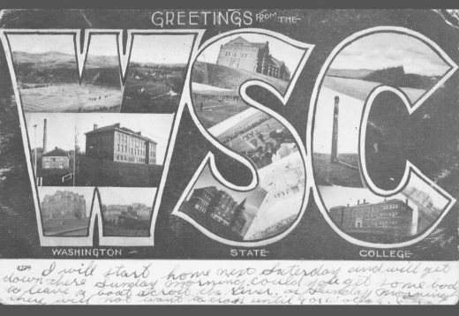
The Morrill Acts of 1862 and 1890 answered demand for practical education that was accessible to agricultural and industrial workers. The legislation granted federally controlled land to the states, which states could then sell to fund establishment of “land-grant” colleges
Washington State College was established in 1890 as a land-grant institution. It has become a distinguished public research university, but its mission remains rooted in accessibility and public service.
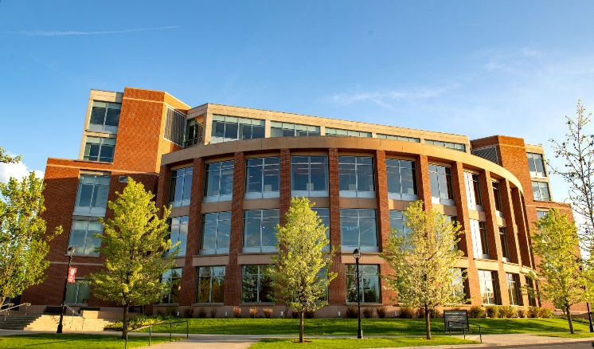
Today Washington State University proudly supports 5 campus locations across the state of Washington and one online Global campus. Across these different campuses WSU offers:
- 101 majors for undergraduates
- 79 masters programs
- 65 doctoral degree
- 3 professional degree programs
Spokane Campus Background
In 1987 the Higher Education Coordinating Board requested that Washington’s two Universities expand their campuses through the establishment of branch campuses. As a response to this Washington State University created the WSU Spokane Campus in 1989.
That same year WSU began offering classes and by 1991, the campus was accepting graduate students in areas such as Education, Engineering and Criminal Justice. The campus continued to flourish through the years and now has become a hub for health sciences hosting several modern facilities including the Pharmaceutical and Biomedical Sciences buildings.
For additional information on Washington State University please visit to following sites:
- WSU Difference | Washington State University
- Strategic Plan | Office of Strategy, Planning, and Analysis | Washington State University (wsu.edu)
- Quick Facts | Washington State University (wsu.edu)
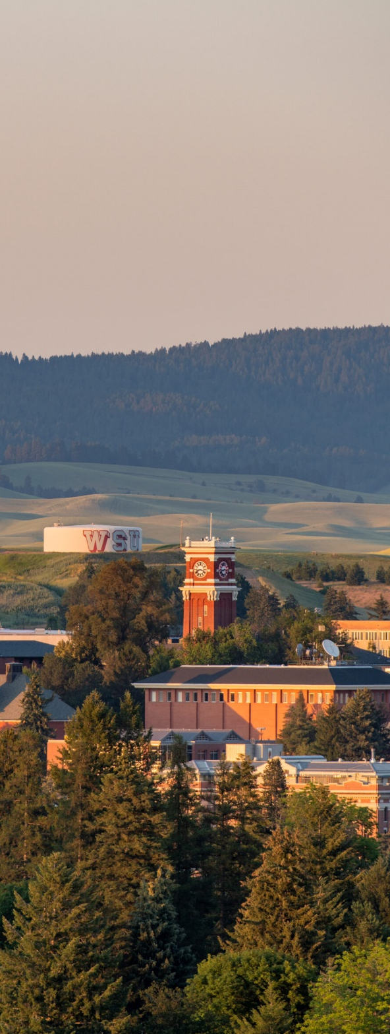
Washington State University Values:
QUALITY AND EXCELLENCE
We are committed to providing quality and excellence in all our endeavors.

INTEGRITY, TRUST, AND RESPECT
We are committed to ensuring trust and respect for all persons in an environment that cultivates individual and institutional integrity in all that we do.

RESEARCH, INNOVATION, AND CREATIVITY
We are committed to the pursuit of inquiry and discovery and to the creation and dissemination of knowledge.

LAND-GRANT IDEALS
We are committed to the land-grant ideals of access, engagement, leadership, and service to bring the practical benefits of education to the state, nation, and global community.

DIVERSITY AND GLOBAL CITIZENSHIP
We embrace a worldview that recognizes and values the importance of domestic and global diversity, global interdependence, and sustainability.

FREEDOM OF EXPRESSION
We are committed to the free exchange of ideas in a constructive and civil environment, including the canons of academic freedom in research, teaching, and outreach.

STEWARDSHIP AND ACCOUNTABILITY
We are committed to serving as ethical and responsible stewards of University resources.

The Washington State University Mission:
To advance knowledge through creative research and scholarship across a wide range of academic disciplines.
To extend knowledge through innovative educational programs in which emerging scholars are mentored to realize their highest potential and assume roles of leadership, responsibility, and service to society.
To apply knowledge through local and global engagement that will improve quality of life and enhance the economy of the state, nation, and world.
Spokane Campus/Parking Information

Online Spokane campus map: Campus Map
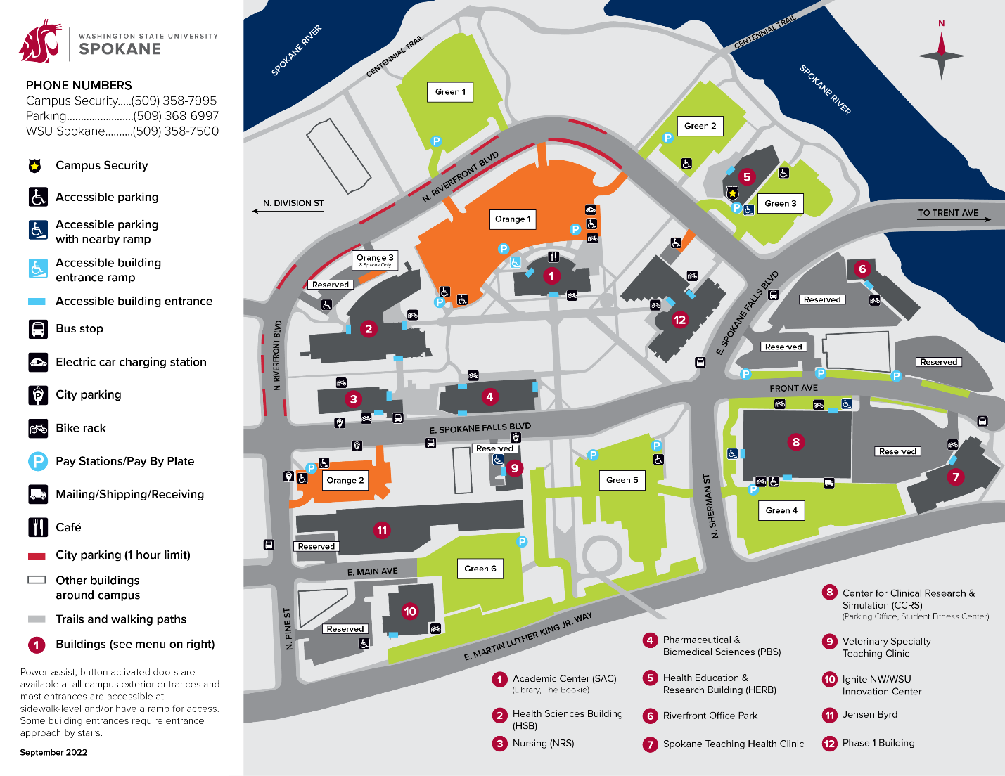
For parking information/permits please visit: Parking Permits
Quick Parking facts:
- For daily/hourly parking Spokane uses the HONK app which you can download previous to visiting!
- Payment for parking required in all lots every day, 24 hours a day.
- Your license plate number will be your permit – no need for paper or hanging permits.

Washington State University Benefits Overview

Washington State University offers a comprehensive benefits package, encompassing a sizable amount of our employees’ overall compensation package. Options to best fit our employees’ and their families’ needs are offered, and we are happy to extend these benefits to you!

- Medical Insurance: http://hrs.wsu.edu/medical-insurance/
- Premium Surcharges: http://hrs.wsu.edu/premium-surcharges/
- Dental Insurance: http://hrs.wsu.edu/dental-insurance/
- Life Insurance: http://hrs.wsu.edu/life-insurance/
- Long Term Disability: http://hrs.wsu.edu/long-term-disability/
- Dependent Care Assistance Program: http://hrs.wsu.edu/dependent-care-assistance-program/
- Flexible Spending arrangement: http://hrs.wsu.edu/flexible-spending-account/
- Health Savings Account: http://hrs.wsu.edu/health-savings-account/
- Commuter Benefit: https://hrs.wsu.edu/employees/benefits/benefit-details/commuter-benefit/
- Auto& Home Insurance: http://hrs.wsu.edu/auto-and-homeowners-insurance/
- Long-term Care: https://hrs.wsu.edu/employees/benefits/benefit-details/long-term-care-and-the-long-term-services-and-support-trust/
- WA 529 College Savings Plans: https://wastate529.wa.gov/
- Public Service Loan Forgiveness: https://hrs.wsu.edu/employees/benefits/benefit-details/public-service-loan-forgiveness/
- Mental Health Services: https://hrs.wsu.edu/employees/benefits/benefit-details/mental-health-services/

For a more comprehensive overview please refer to these handouts: only include the information for the candidates position!

- Faculty and Administrative Professional Positions: 2022-Benefit-Overview-for-Faculty-and-AP.pdf (wsu.edu)
- Classified Staff: Microsoft Word - 2022 Benefit Overview for Civil Service (wsu.edu)

Welcome to Spokane Washington!
During your visit we encourage you to explore Spokane and the many activities this city has to offer! Spokane is a beautiful city that offers fun filled activities in every season! Enjoy delicious restaurants, explore diverse galleries and museums or get outdoors and visit one of the many scenic parks or riverfront walkways!
Below you will find links to the many options Spokane has to offer!
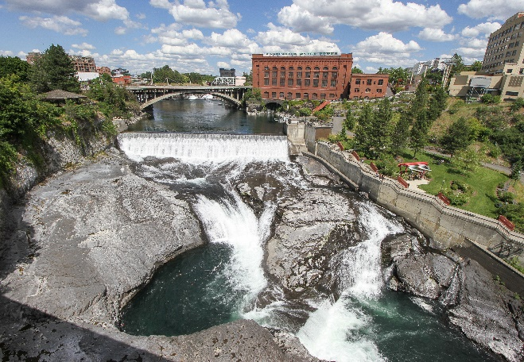
Visit Spokane, Explore the Best of Spokane in 2022: A terrific website that breaks down the many activities happening throughout Spokane by season!
Some more popular activities include:
- Explore Spokane Falls | Huntington Park & SkyRide Gondola
- Museums in Spokane | Spokane History, Art Museums
- Spokane Art Galleries and Museums
- River Park Square | Shopping, Dining and Entertainment
You can also catch a concert, play or show at the following venues:
- First Interstate Center for the Arts: Attend concerts, comedians, symphonies, and many others
- Fox Theater : Attend symphonies, concerts, and ballets
- Bing Crosby Theater: Attend concerts, motivational speakers, workshops and many others.
For a complete overview of all performing art venues and their events please follow this link: Spokane Theater & Performing Arts
If you are interested in venturing out, a short drive from Spokane is both Spokane Valley and Green Bluff!
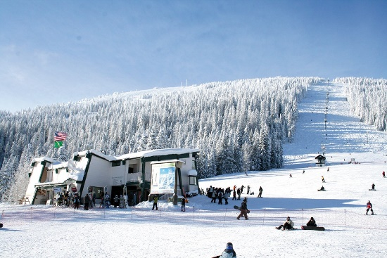
Spokane Valley:
Just east of Spokane is the Spokane Valley which offers adventures of all shapes and sizes. Explore nearby Mt. Spokane, enjoy a peaceful game of golf, or dive into one of the 14 lakes Spokane County has to offer!
Learn more about the many activities available here: The City of Spokane Valley

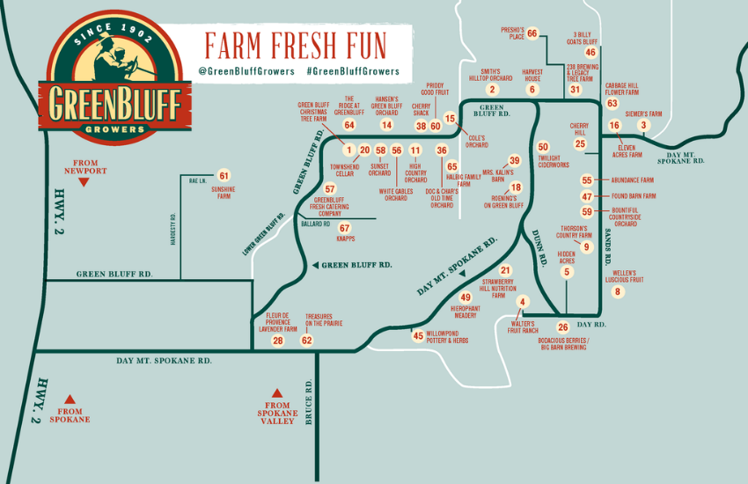
Green Bluff:
North of Spokane is a beautiful area that serves as a home base for numerous different farmers, wineries and breweries. With different events happening each season, pumpkin patches in the fall and Christmas trees in the winter, there is always something to do in Green Bluff! During your visit you can also pick up some delicious produce, wine and views!
See the link here for events taking place each month: Green Bluff Growers – Spokane, Washington

Living in Spokane, Washington
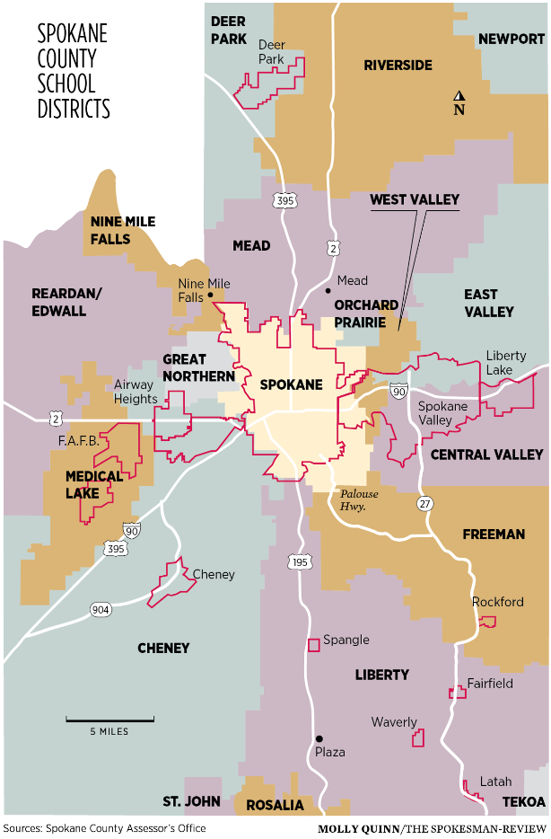
School Districts:
- Spokane Public Schools: Spokane Public Schools
- Spokane Private Schools: Spokane Private Schools
- East Valley School District: East Valley School District
- Central Valley School District: Central Valley School District

