WASHINGTON STATE UNIVERSITY
OFFICE OF THE CONTROLLER
SPONSORED PROGRAMS SERVICES

MANUAL ENTERED COST SHARE MEMORANDUM

To: Sponsored Programs Services-Award Management Team
From: _______________________________________________
Approving PI: _______________________________________________ Initial/signature: ____________________
(PI approval is required for cost share to be posted to the award. If the PI is unavailable to sign, an approval email from the PI is allowable.)
Approving Grant Manager: ________________________________________ Initial/signature: ____________________
Date: _______________________________________________
Subject: _______________________________________________

From:
Expense posted on: _____________________________________________
(Departmental account, Waiver, or third-party agency)
To:
Workday award number: ____________________________________
Post to cost share grant line: ________________________________

☐WSU cost share expense ☐3rd Party ☐Subrecipient reported Cost Share ☐ Match Account AWD00

Dear SPS,

I have attached to this memo the documentation required per the chart listed on page two. I have reviewed the documentation and approved the cost share to be added to the award cost share grant line.

The breakdown of the cost share is:
Reporting period from date: To Date:

Object Class Code | Spend Category | Amount to Post
000 Salaries and Wages
020 Contractual Services
030 Supplies & Services
040 Travel
060 Equipment - Capitalized
070 Fringe Benefits
071 Tuition & Student Fees
080 Stipends/Subsidies
081 Scholarship/Tuition Remission
130 F&A
300 Subcontract Expense
SC00216 Subcontract Salaries
SC00217 Subcontract Wages
SC00218 Subcontract Contractual Services
SC00354 Subcontract Expense Related to COVID-19
SC00219 Subcontract Supplies
SC00220 Subcontract Services
SC00221 Subcontract Cash Advances
SC00222 Subcontract Travel - Domestic
SC00223 Subcontract Travel - International
SC00224 Subcontract Computing Services
SC00225 Subcontract Equipment - Capitalized
SC00226 Subcontract Equipment - Non-Capitalized
SC00227 Subcontract Employee Benefits
SC00228 Subcontract Tuition
SC00229 Subcontract Stipends
SC00230 Subcontract Other Training Costs
SC00231 Subcontract Facilities and Administrative Costs
SC00232 Subcontract General and Administrative Fees
Total Cost Share to be posted |  | $

Required Backup Documentation:

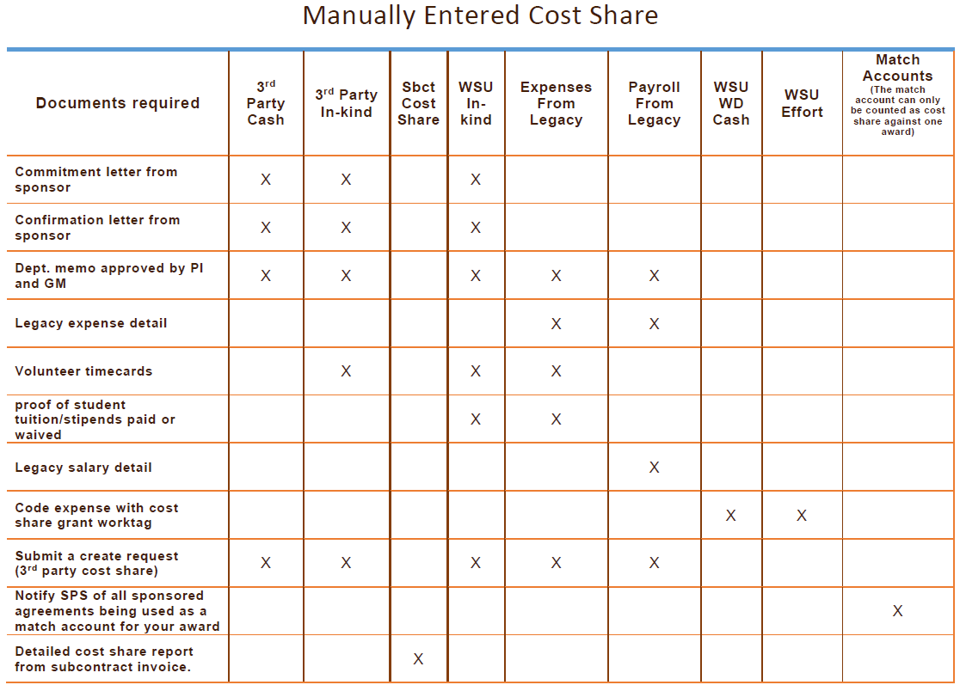

- Submit all manual entered cost share request via Workday Create Request: 3rd Party Cost Share.

- In your Workday Create request include all required documentation.

