Having trouble Matching Receipts to Invoiced Charges?

- Login to the WEX Website
- (Select)
- “ Transactions”
- “View Transactions”
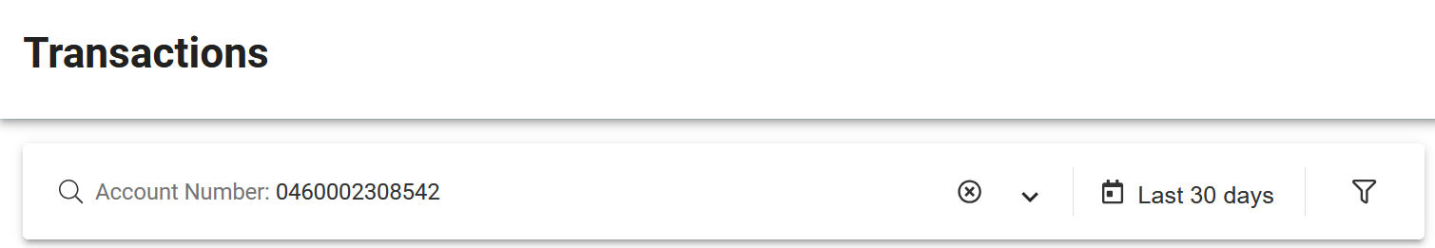
- Drop-down to the right of Account Number
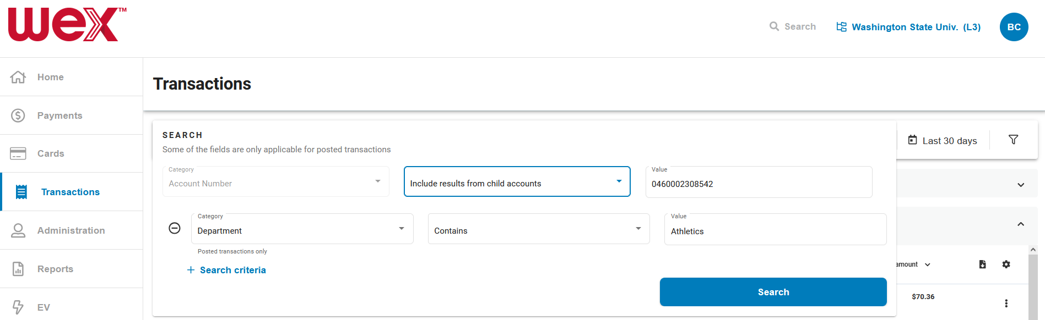
- + Search criteria:
“Department” “Contains” “Value” = Your Department Name in WEX
- Search

- Filter by DATE by selecting the “Date picker”
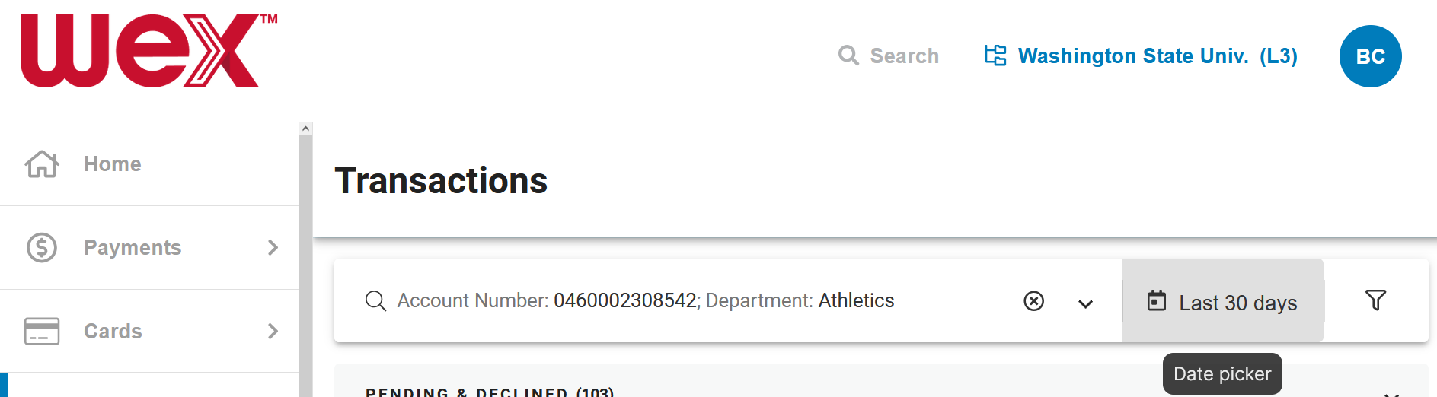
- Click on the “ Last 30 days” button
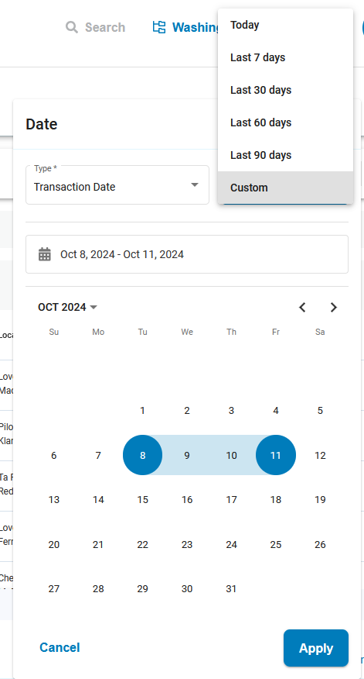
Filter by DATE

- Select a date “Range” (2 days minimum) to include the Date on the Receipt
  - Either by Selecting one of the
“Last ## days”, or
  - Create your own range by selecting two dates on the calendar while holding the “Ctrl” button
- Apply

You’ll now see the transactions from your chosen date range, including:
- Last 5 digits of the WEX Card Number,
- Location, and
- Total amount
To enable matching the charge to the receipt.
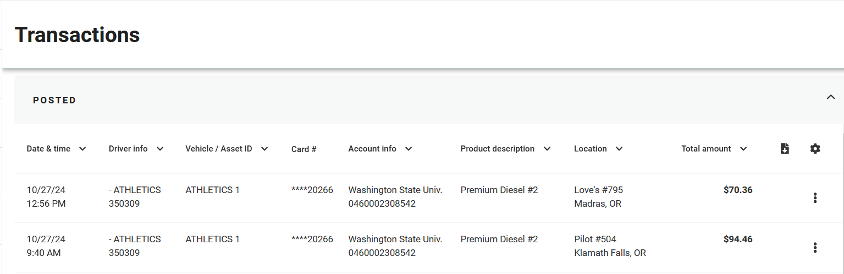

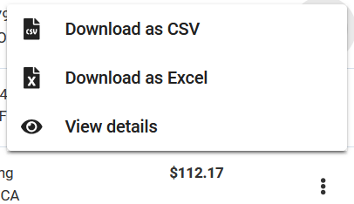
- If you select the Actions button,
- then View Details
You’ll be taken to a Receipt-style view of the Transaction Details to compare to your original receipt.
(You can also download or print from this view.)

