FUEL CARD CUSTODIAN:
Please login to the online portal at: go.wexonline.com/login
* User registration link sent to you by: OnlineServices@wexinc.com
* No User ID and password? Email: purchasing.card@wsu.edu to request one.

When you login, you will be taken to the portal homepage:

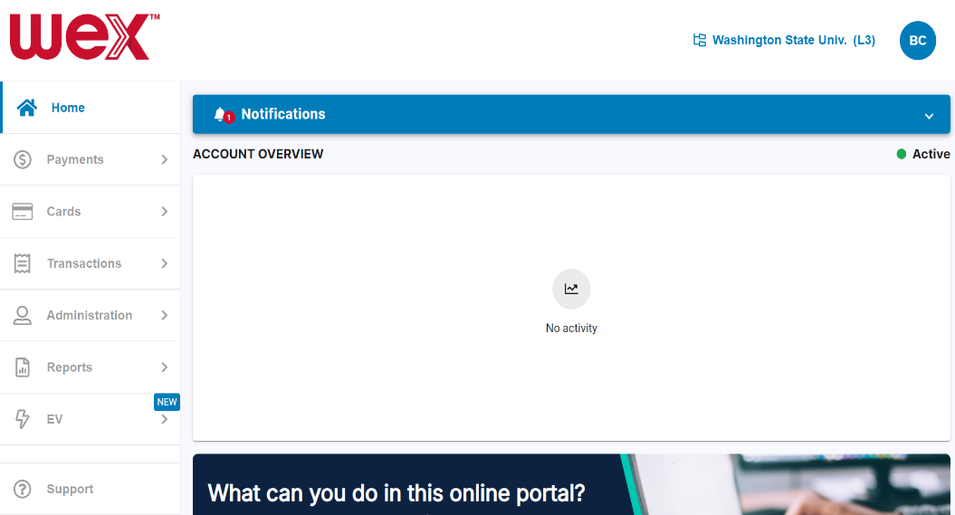
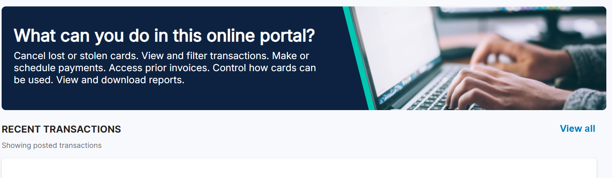

Butch T Cougar logged in here ->

Below are Instructions to:
- Locate Fuel stations Accepting the
Fuel Card by:
- List
- Map
- $ Price !

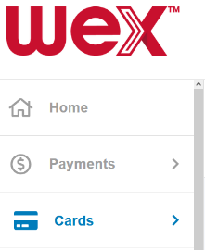
Accepting Locations:
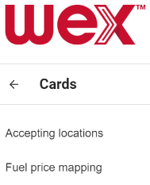
In the tool bar on the left:

- “Cards”
- “Accepting locations”

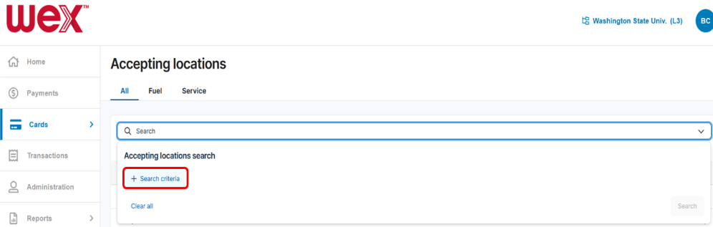
Note tabs along the top:
- All (fuel & services)
- Fuel only
- Service only

- “Search” select “ v ” (drop down arrow)
- “+ Search criteria”

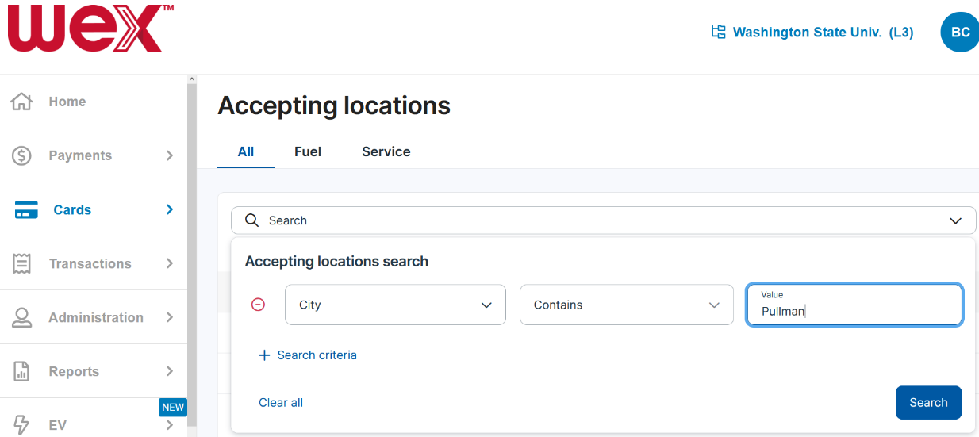

- Here, the filter is:
“City contains Pullman”

- Options also include
“Merchant Name”

- Select [ Search ]
button

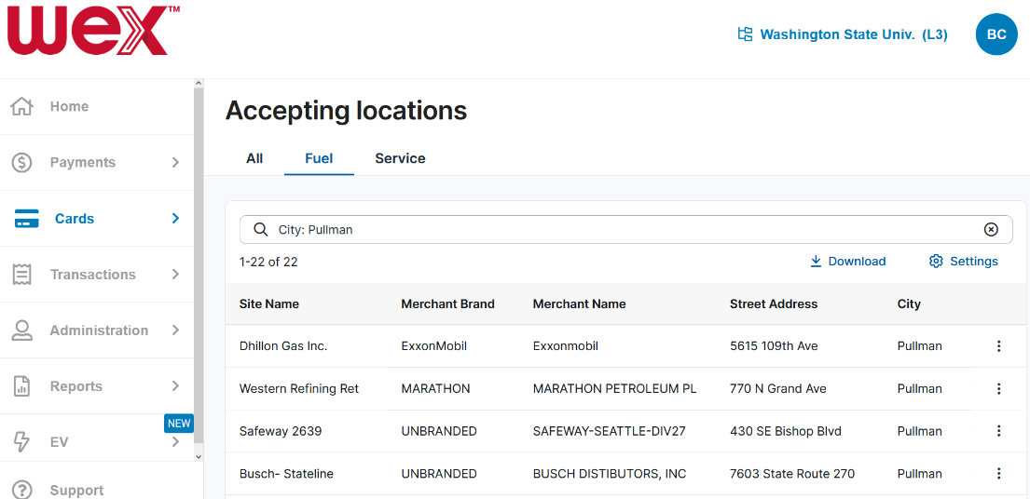

* Results: a list of
22 Locations in Pullman accepting WEX !!!

* This list may be downloaded *

Map and Pricing:
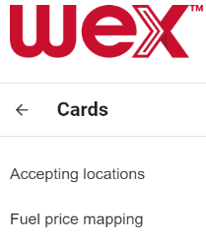
In the tool bar on the left:

- “Cards >”
- “Fuel price mapping”

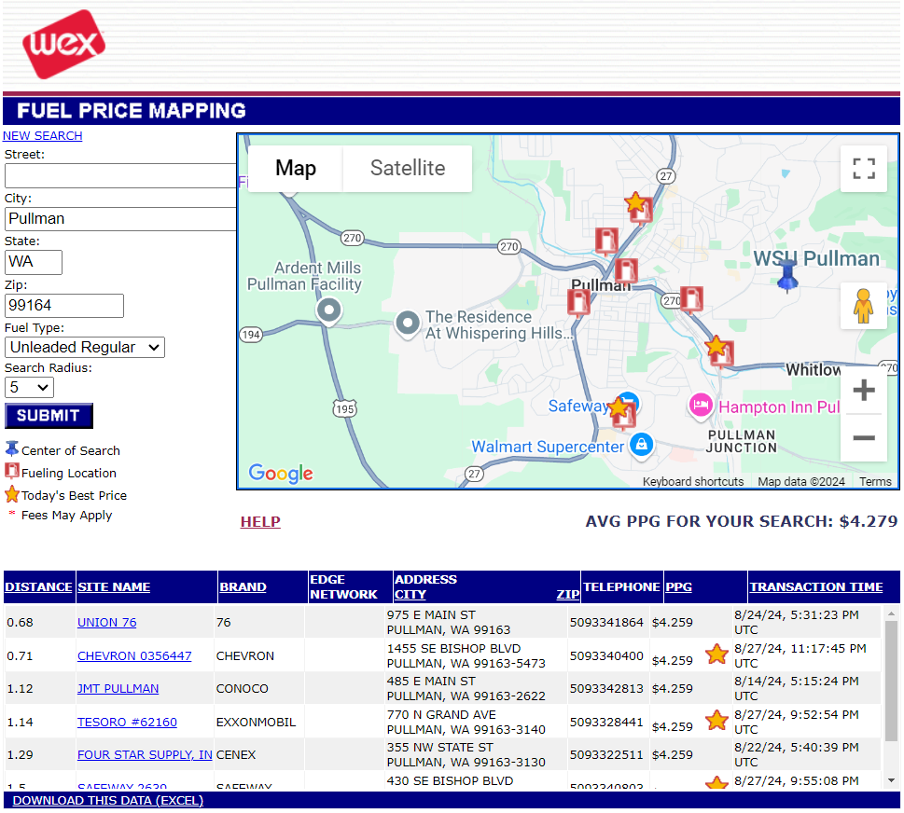

Under: “NEW SEARCH”
Complete the form with:
- Street (optional)
- City
- State
- Zip
Select your: Search Radius

- [ SUBMIT ]

You will see:
- Map of your selected area
- List of locations with pricing
- Select the “SITE NAME” hyperlink (to focus the map on that location)

If you would like:
- [DOWNLOAD THIS DATA (EXCEL)]->

