FUEL CARD CUSTODIAN:
Please login to the online portal at: go.wexonline.com/login
* User registration link sent to you by: OnlineServices@wexinc.com
* No User ID and password? Email: purchasing.card@wsu.edu to request one.

When you login, you will be taken to the portal homepage…

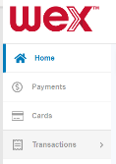
Monthly Transactions Reconciliation:
* To complete your end of month report for
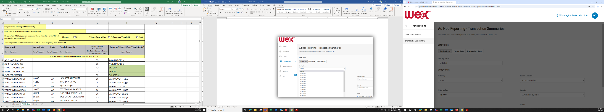
Fuel Card Transactions Reconciliation

STEP 1
In the tool bar on the left Select:

- (Select) “Transactions >”
- “Transaction summary”

Takes you to:

STEP 2
Complete “Ad Hoc Reporting –Transaction Summaries” form

ROW 1:
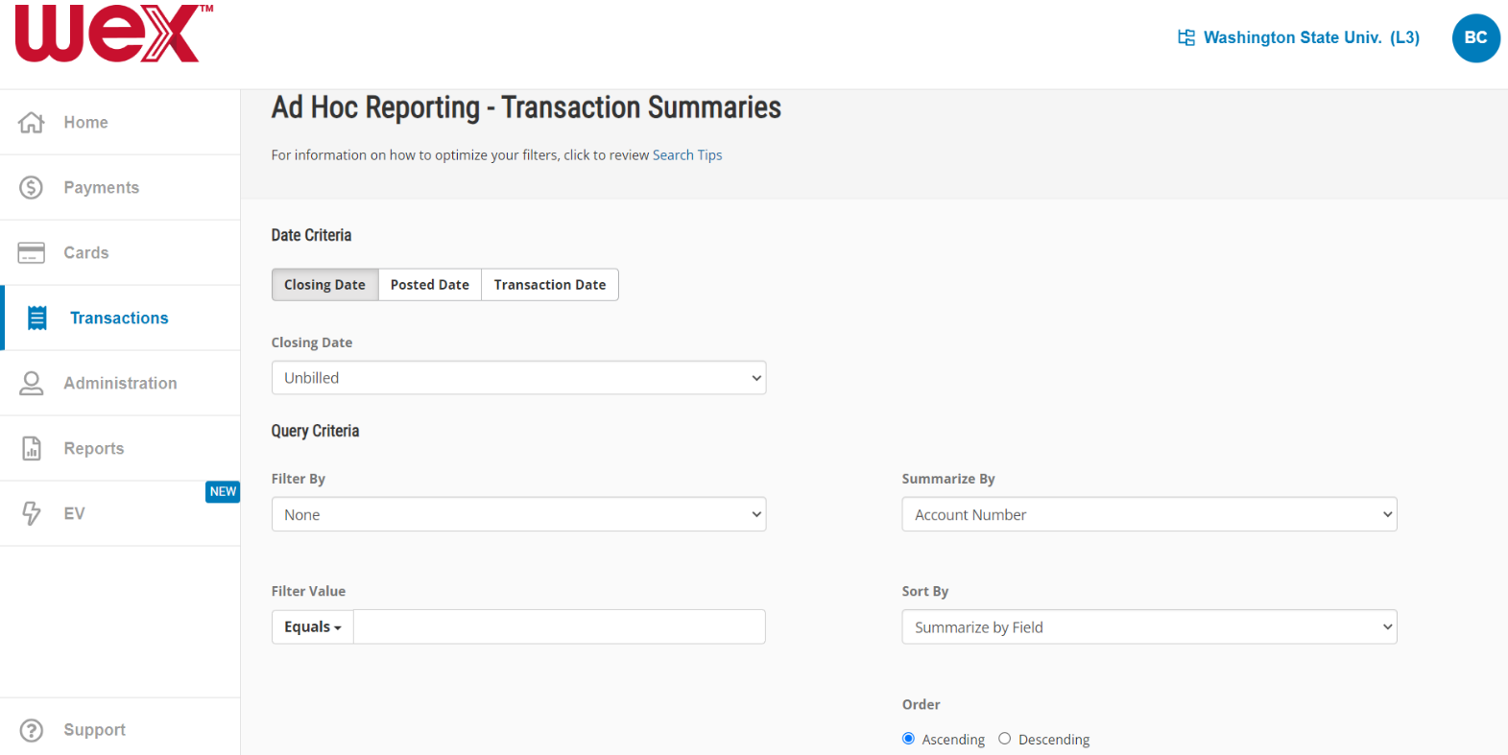
“Date Criteria” Automatically selects “Closing Date” - which is perfect for monthly reconciliation.

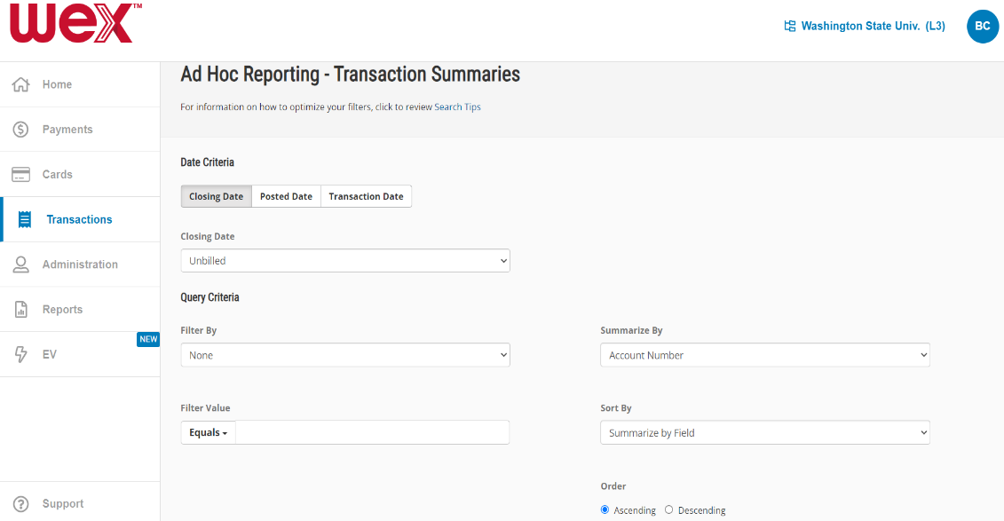
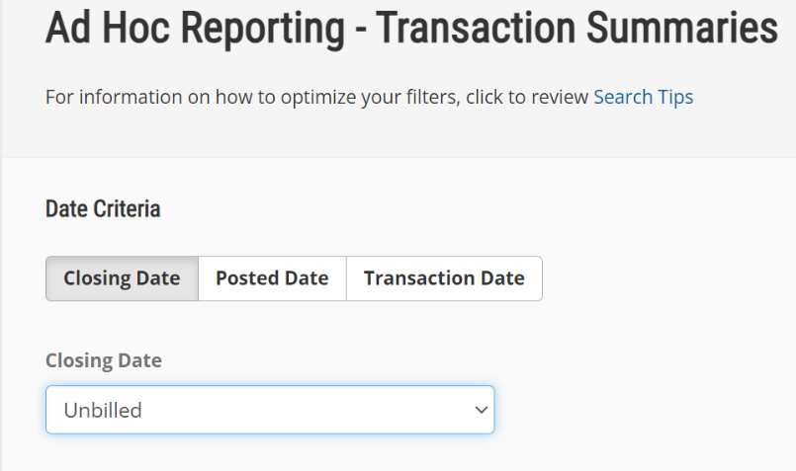
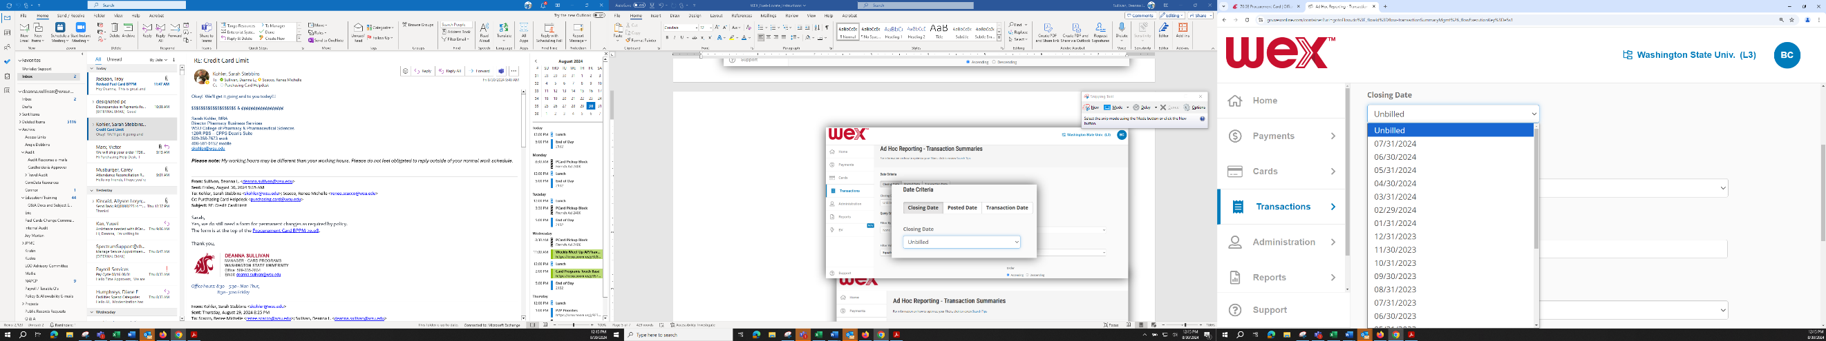

“Closing Date” offers:
- Unbilled
(or drop-down “v”)
- The final date of the Billing Cycle

- Last month’s End Date

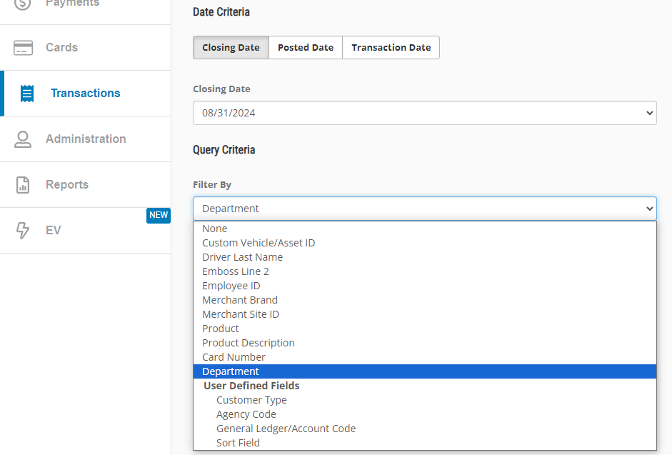

ROW 2:
“Query Criteria”

“Filter By”:

- “Department”

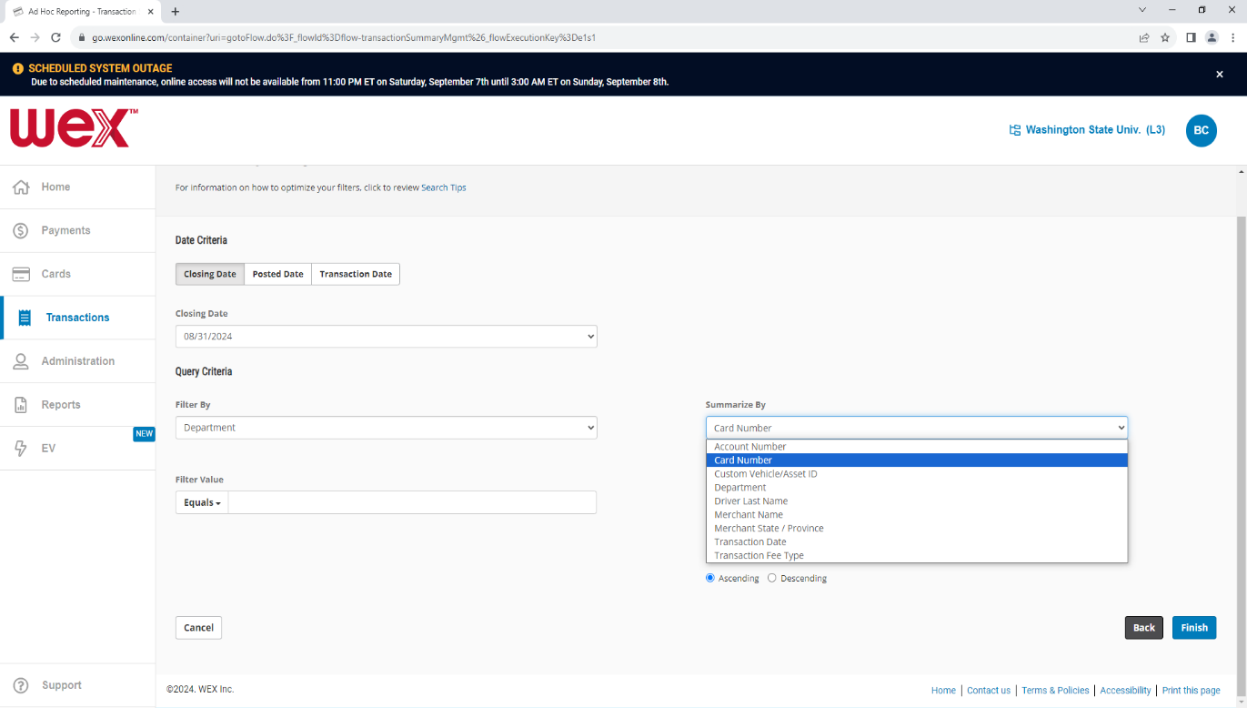
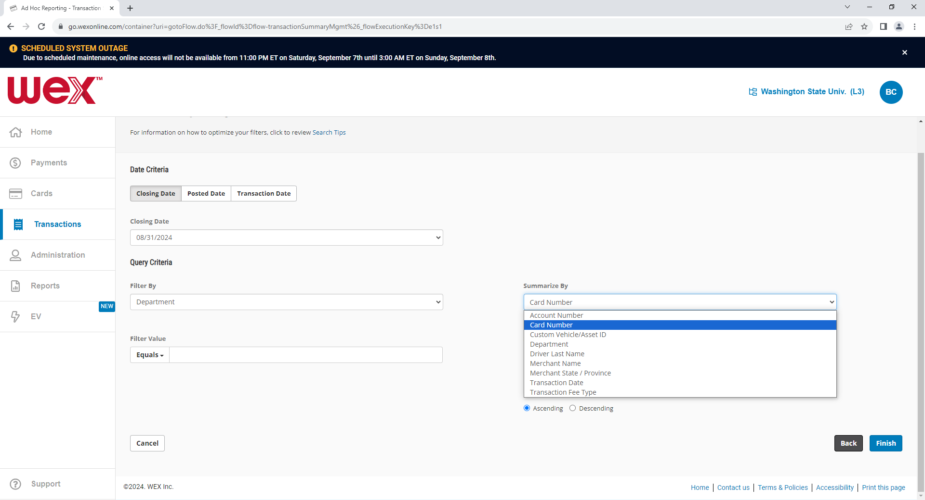

“Summarize By”:

- Custom Vehicle/Asset ID
(for sum of transactions by info
stamped on card)
- “Card Number”
(for sum of transactions by credit card)

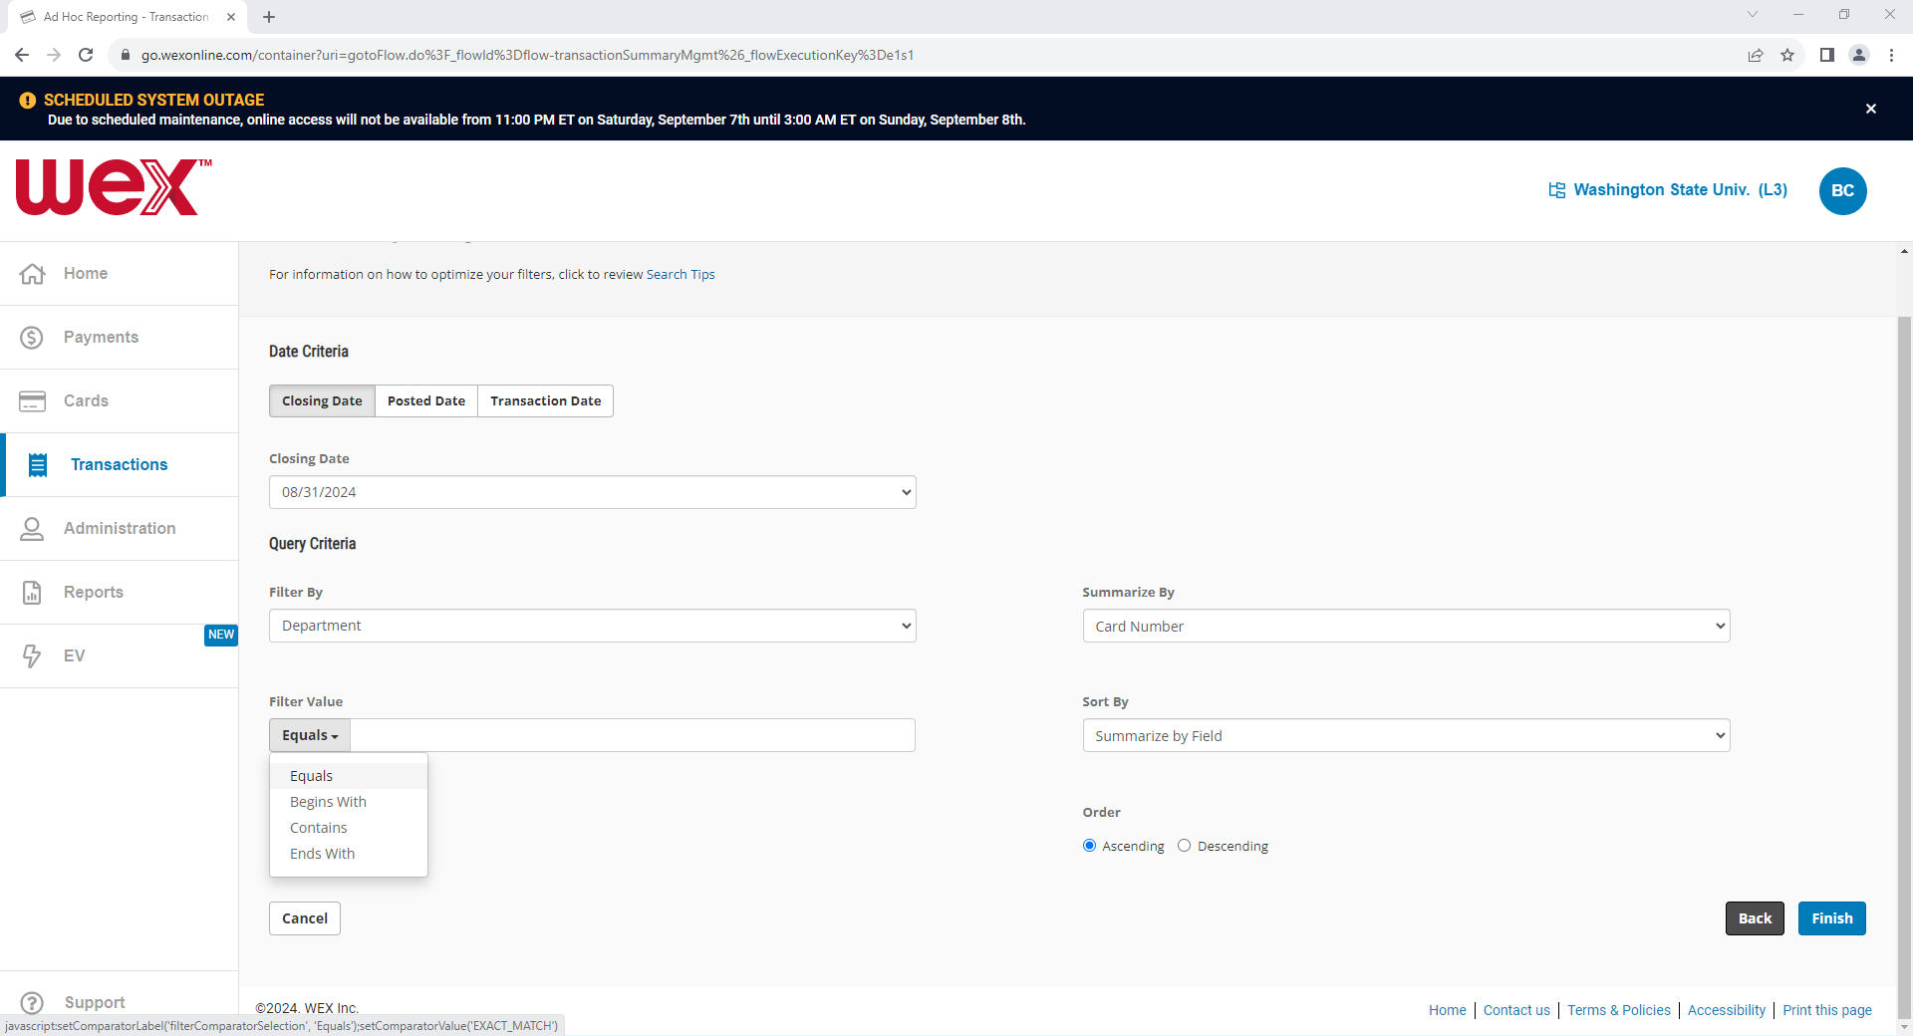
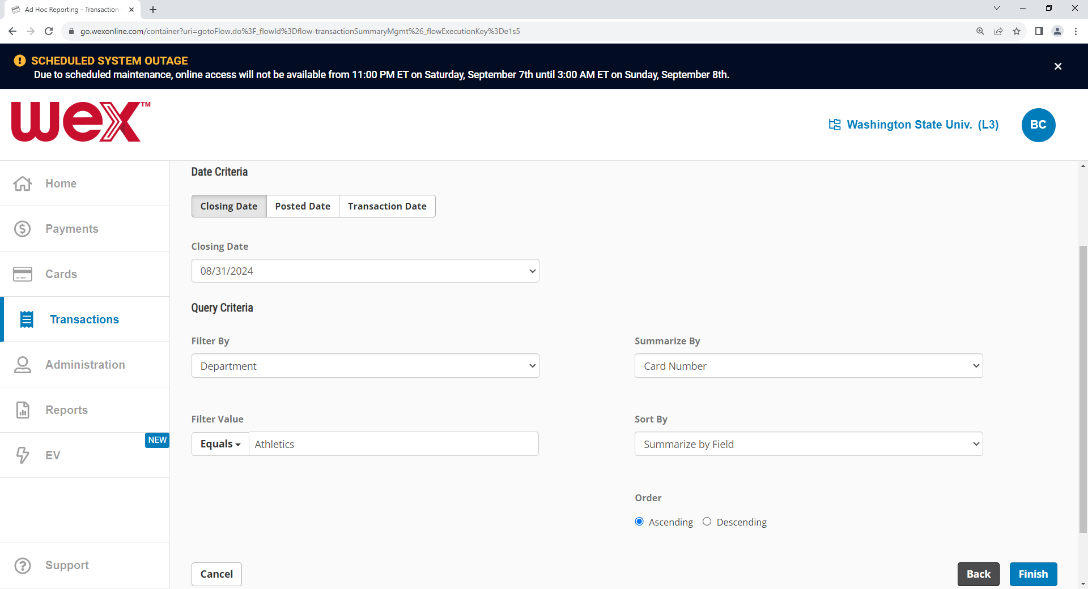

ROW 3:
“Filter Value”:

- “Equals”
- “Begins With”
Or
- “Contains”

Enter Department Name
(as shown in your WEX cards data)
* Butch T Cougar entered
“Athletics”, of course.

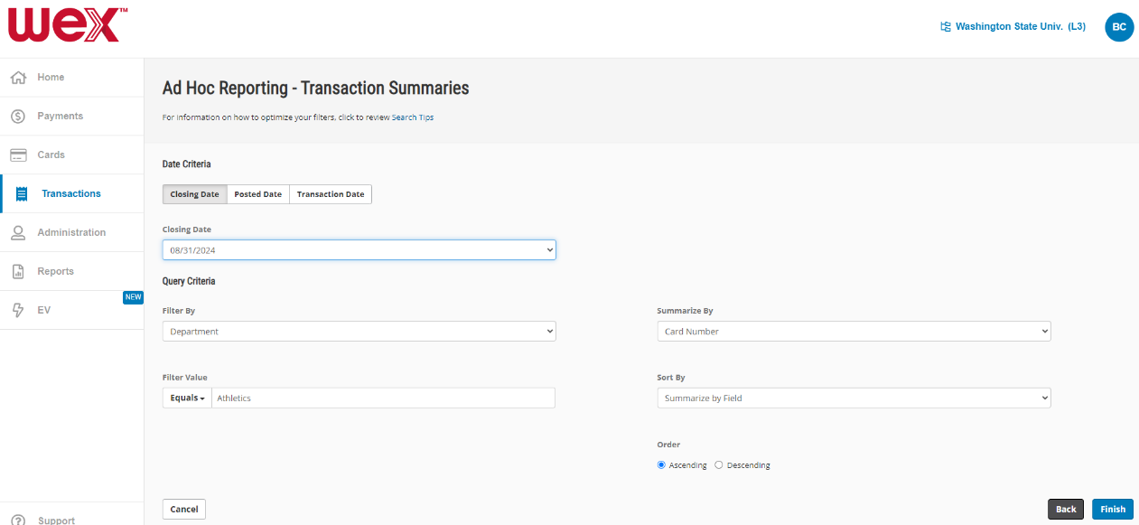
“Sort By:”
Auto-selects:
“Summarize by Field”

- It will sort by the value you selected in the “Summarize by” field above (which is usually the best option).

- Select the “Order” you prefer.

- “[ Finish ]”

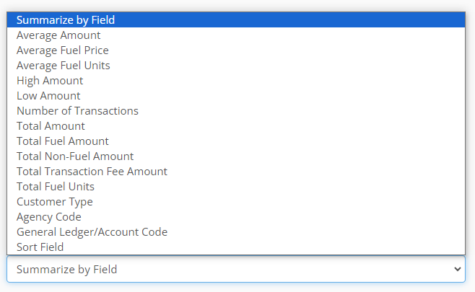
“Sort By:”
Other options are to the right ->

You might want to sort by:
- Total Amount
or by
- Number of Transactions

Many of the options on the right are for data that is not currently included in our accounts on the WEX website.

* We can add your default accounts to WEX if you would like to sort by this data.
New to Process:
EITHER DOWNLOADED AND SAVED ELECTRONICALLY OR PRINTED IN PAPER PACKETS:

For all steps below:
- Download to location shared within your department – Best Options below:
  - Create WEX Cards Monthly Reconciliation Folder – Include:
    - WEX Cards Reconciliations (Year)
      - WEX Reconciliation – Month
      - PDF Receipts for all transactions – Month
      - Approving email
- Printed report, documents, and approvals by year and month in shared departmental file location

STEP 3
Download and Save as PDF or Print Report

STEP 4
Match receipts to each transaction on the previous month’s transactions report

STEP 5
Edit PDF document (to add text) or write on Paper Report - to record the Foundation Data Model (FDM) Worktags for each transaction on the Transaction Summaries report.

STEP 6
Submit the Transaction Summaries report (making available the month’s electronic folder) or paper Transaction Summaries report form (with backup documents) to your expenditure authority(ies) for all accounts to be charged.

STEP 7
Obtain and save electronic or written expenditure authority(ies) approval of the month’s Transaction Summaries Report.

STEP 8
Save or file the report, receipts, expenditures spreadsheet (if used), in the filing location shared within your department – to allow for future review and auditing.

STEP 9
If default budgets have been assigned to your Fuel Charge Cards, communicate any questions, problems, or disputed transactions to Card Programs by emailing: purchasing.card@wsu.edu .

If default budgets have not been assigned to your Fuel Charge Cards, complete a Monthly Fuel Charges Allocations Form (found on the Card Programs - Fuel Card webpage) and submit it to Card Programs for charges entry by emailing: purchasing.card@wsu.edu.

NOTE: All invoices, receipts, and approvals must be maintained within each department’s files as required for Records Retention - either electronically or in paper files.

* These documents are not integrated into Workday and cannot be retained in Workday records.

