FUEL CARD CUSTODIAN:
Please login to the online portal at: go.wexonline.com/login
* User registration link sent to you by: OnlineServices@wexinc.com
* No User ID and password? email purchasing.card@wsu.edu to request one.

When you login, you will be taken to the portal homepage…

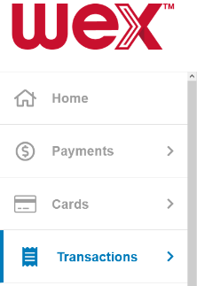
View Transactions and Declines:
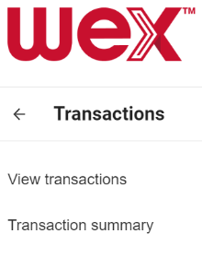
In the tool bar on the left:

- “Transactions >”
- “View transactions”

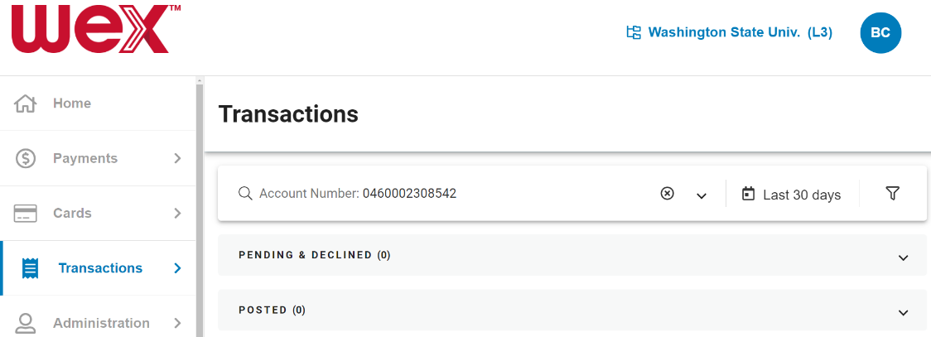

* Your Dashboard will
automatically display
recent transactions
“Pending & Declined”

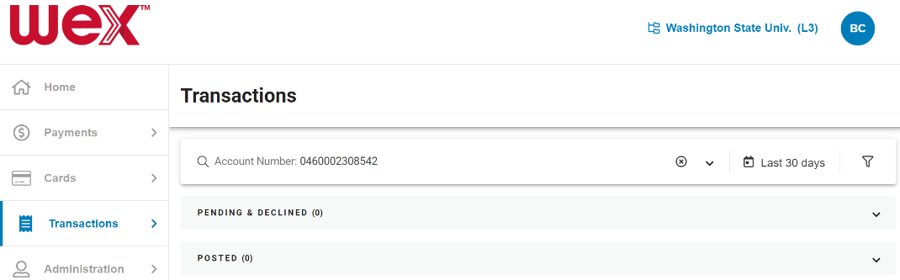
For Just Your Department or Card(s):

- “Account Number…” bar
- select “ v ” (drop down arrow)

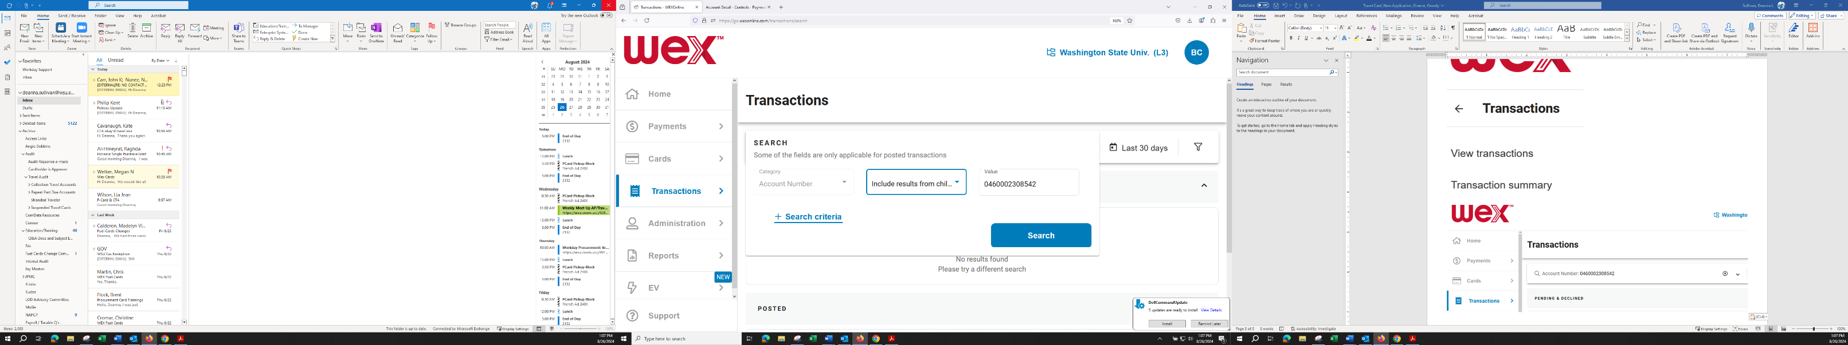
Leaving the first row’s fields
as they are:
(“Category”, “Include…” and “Value”)

- “+ Search criteria” button
(adds a row to enter your
own search options)

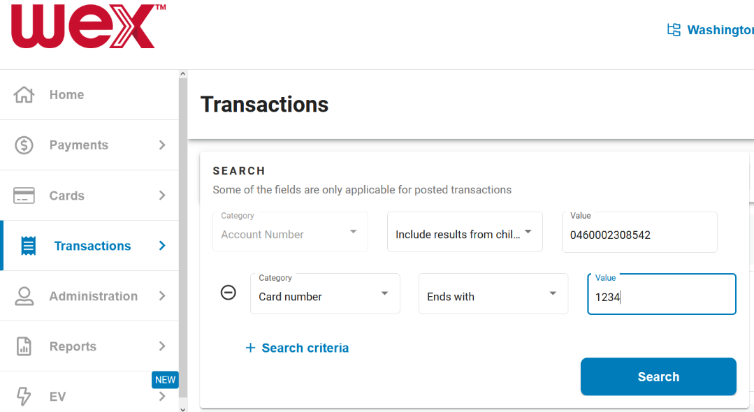

Specific Card?

Leave the Defaults -
“Card number” & “Ends with”

Enter:
Last 4 digits of the Fuel Card

- Select [ Search ]
button

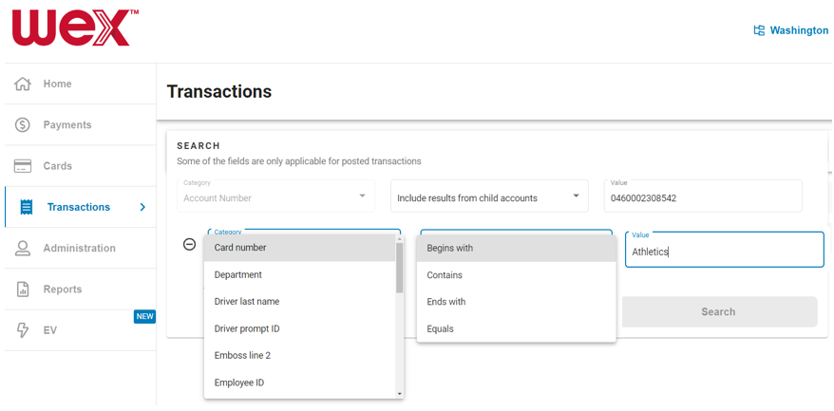
Your full Department?

- “Department”
- “Contains” or “Equals”

Note:
- “Driver Last Name”
is the Department Name
- “Driver prompt ID”
is User ID / Vehicle Identifier (PIN)

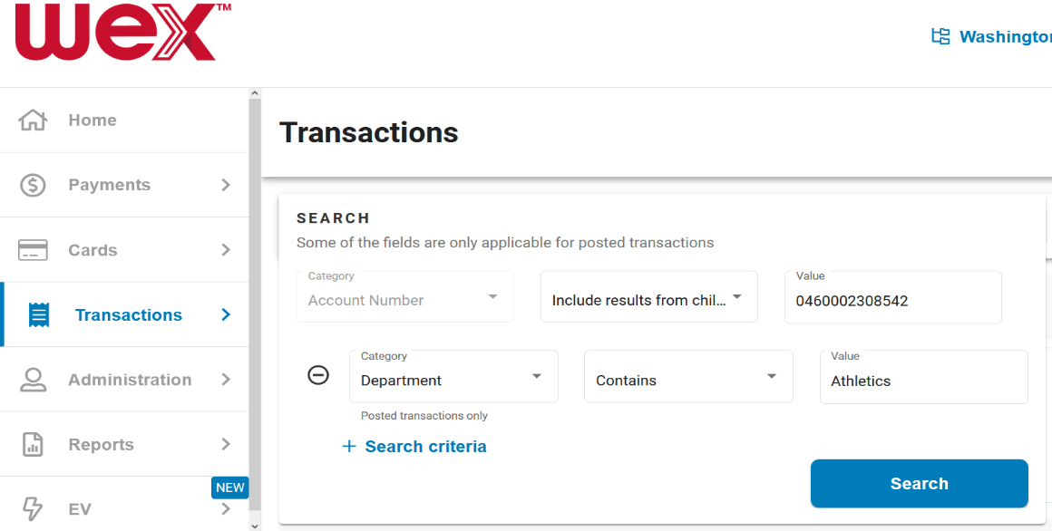
Enter:
All or Part of the Value (Department Name)
you are searching for
(as shown on your WEX
Departmental Cards print-out)

* Butch T Cougar entered
“Athletics” (of course!)

- Select [ Search ]
button

