STANDARD OPERATING PROCEDURES FOR HAZARDOUS AND PARTICULARLY HAZARDOUS CHEMICALS
For
Zinc

1. PROCEDURE /  PROCESS | Zinc is used in Building, Room.  Insert procedure here:
2. CHEMICAL NAME(S)  and associated  PHYSICAL and  HEALTH  HAZARDS | Zinc – CAS# 7440-66-6 also known as blue powder; granular zinc; zinc metal; zinc metal sheets; zinc metal shot; zinc metal strips.  - Flammable powder and dust. Self-heating: may catch fire.  - Keep away from possible contact with water, because of violent reaction and possible flash fire.  - In contact with water releases flammable gases which may ignite spontaneously. Poisonous fumes also produced in fire.  - May cause irritation to the gastrointestinal tract, respiratory tract, skin, and eyes. May be harmful if ingested.  - Inhalation of zinc fumes can cause a flu-like illness called metal fume fever. Repeated inhalation may cause chronic bronchitis.  - Zinc appears to affect the male reproductive system (including sperm count). Further testing is required to assess its potential to cause reproductive harm.  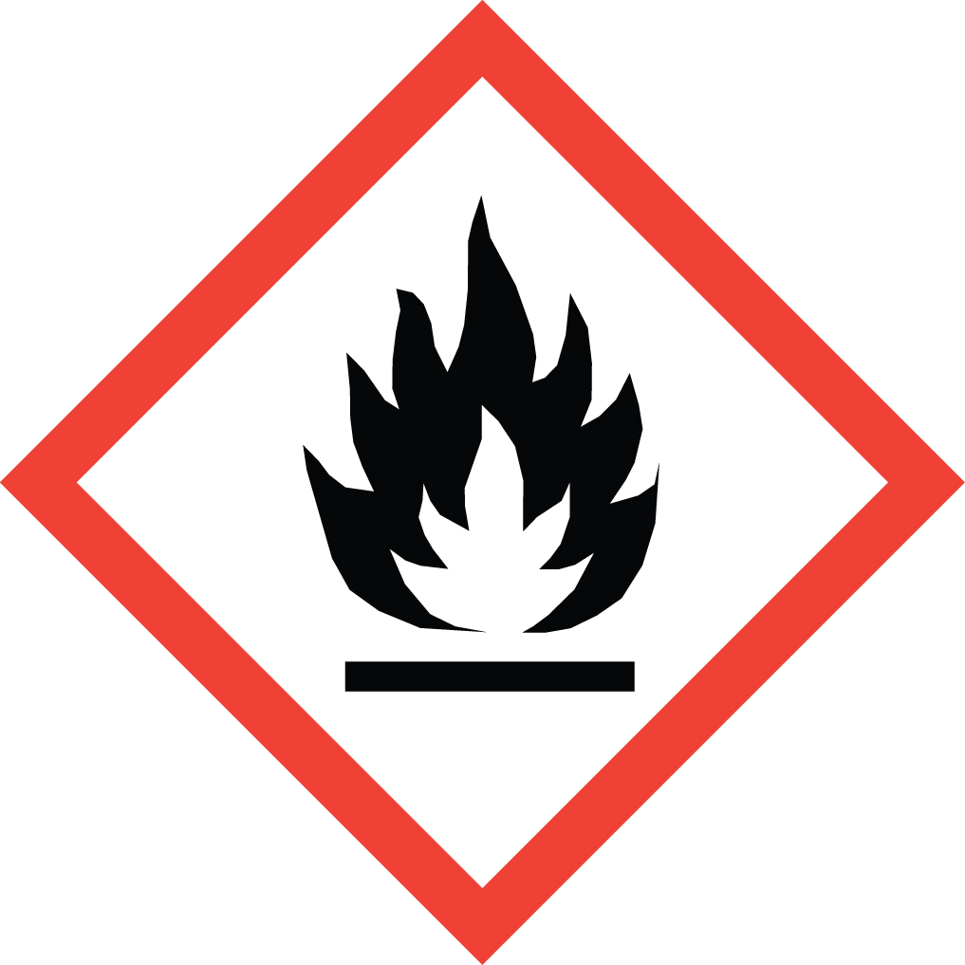 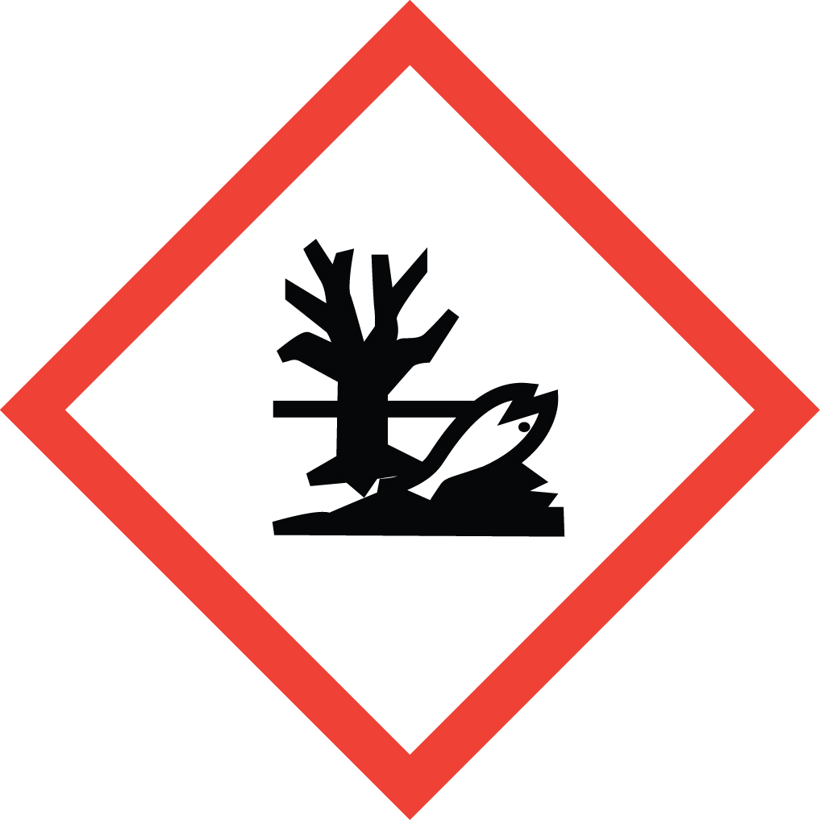 Signal Word: DANGER  Exposure Limits:  - No occupational exposure limits have been established for zinc. However, it may pose a health risk. Always follow safe work practices.  *Always refer to the Safety Data Sheet for the most detailed information*
3. NAME OF TRAINER /  RESOURCE  PERSON | Principal Investigator Name, Building, Room, Phone Number  Secondary contact Name, Building, Room, Phone Number
- LOCATION OF  HEALTH & SAFETY  INFORMATION | The Safety Data Sheet (SDS) for zinc is located in the Laboratory Safety Manual in Building, Room.  Labeling: In addition to the standard label that identifies contents, hazards, precautionary measures, and emergency contact information, containers should also be marked as flammable and water reactive.
5. PROTECTIVE  EQUIPMENT | Wear chemical safety goggles, nitrile rubber gloves, and a fully buttoned lab coat. (Note: Always check the manufacturer’s glove compatibility chart for proper glove selection.) Working within a properly functioning, certified laboratory chemical fume hood is recommended.
- WASTE DISPOSAL  PROCEDURES | Waste Zinc in pure form must be managed as Dangerous Waste. It should be collected in a sealable, compatible waste container. The container should be stored away from incompatible materials such as strong oxidizing agents, acids, bases and water. A completed Dangerous Waste label should be attached when waste is first added to the container. When container is full or no longer being used complete a Chemical Collection Request Form, and deliver to the Waste Accumulation Area Operator at Building, Room, Phone Number.  Waste Zinc solutions greater than 1 ppm must be managed as Dangerous Waste. It should be collected in a sealable, compatible waste container. A completed Dangerous Waste label should be attached when waste is first added to the container. When container is full or no longer being used complete a Chemical Collection Request Form, and deliver to the Waste Accumulation Area Operator at Building, Room, Phone Number. Solutions containing less than 1 ppm zinc may be drain discharged.  Empty zinc containers must be managed as Dangerous Waste. Do not rinse out the container, simply attach a completed Dangerous Waste label, complete a Chemical Collection Request Form, and deliver to the Waste Accumulation Area Operator at Building, Room, Phone Number.
7. DESIGNATED AREA  INFORMATION | The zinc is stored and dispensed in Building, Room.  Use process enclosures, local exhaust ventilation, or other engineering controls to keep airborne levels below recommended exposure limits. If user operations generate dust, fume or mist, use ventilation to keep exposure to airborne contaminants below the exposure limit.  The designated area(s) should be shown on the floor plan in Laboratories Chemical Hygiene Plan.
8. DECONTAMINATION  PROCEDURES | Upon Accidental Exposure:  In case of eye contact, flush eyes with copious amounts of water at an emergency eyewash station for at least 15 minutes and consult a physician.  In case of skin contact, flush skin with copious amounts of water for 15 minutes and consult a physician. For exposure over a large portion of the body, remove clothing and shoes and rinse thoroughly in an emergency shower for at least 15 minutes. Consult a physician.  In case of inhalation, move person to fresh air and consult a physician.  In case of ingestion, consult a physician and follow instructions on SDS.  Upon Accidental Release:  Large Spill: If a large amount of zinc is released, immediately evacuate, secure area and call 911 to contact EH&S.  Small Spill: If a small amount of zinc is released (it can be cleaned up in 10 minutes) and you have been properly trained to clean it up, you may do so. Secure and ventilate the area of leak or spill. Trained workers must wear appropriate personal protective equipment and clothing including fully buttoned lab coat, safety goggles, and nitrile gloves. (Note: Always check the manufacturer’s glove compatibility chart for proper glove selection.)  Additional PPE such as respirators may be necessary depending upon material and concentration. (Note: You must be medically cleared, fit tested and enrolled in WSU’s respiratory protection program to wear a respirator). If it is necessary to use a respirator and personnel are not cleared to wear a respirator and not trained to appropriately clean up the spill, the employee should immediately evacuate, secure area, and call 911 to contact EH&S.  Use appropriate tools to put the spilled solid in a waste disposal container. Ensure all rinsate is also contained and not allowed to go down the drains or into the septic system. Place waste in appropriate containers and dispose of as hazardous waste (see above WASTE DISPOSAL PROCEDURES).  As with all accidents, report any exposure as soon as possible to your Principal Investigator or Supervisor. Additional health and safety information on zinc can be obtained by referring to the Safety Data Sheet or by calling the EH&S Office (335-3041).
- SPECIAL STORAGE  AND HANDLING  PROCEDURES | Store in a tightly closed container in a dry, cool, and well-ventilated place away from sources of heat or ignition and water/moisture. Reacts violently with water. Avoid formation of dust. Containers may explode in fire.  Keep away from incompatible materials such as strong oxidizing agents, acids, bases and water.

Certification of Hazard Assessment

Is this document a certification of Hazard Assessment for the processes identified within? Yes No
If yes, provide the name of the person certifying the Hazard Assessment and the date it was performed:

____________________________________________________________________________________
Name Date

The location of the Hazard Assessment is indicated in the document preceding this form.

Certificate of Employee Training

Name of person providing training for employees working with this process:

___________________________________________________________________________________
The following employees have been trained in when, where and how to use selected PPE, the maintenance, limitations and disposal of the PPE selected, and have demonstrated the correct use of the PPE selected on the reverse of this certification.
Name Date Trained
________________________________________ _______________________________
________________________________________ _______________________________
________________________________________ _______________________________
________________________________________ _______________________________
________________________________________ _______________________________
________________________________________ _______________________________
________________________________________ _______________________________

