STANDARD OPERATING PROCEDURES FOR HAZARDOUS AND PARTICULARLY HAZARDOUS CHEMICALS
For

Trypan Blue

1. PROCEDURE /  PROCESS | Trypan Blue is used in Building, Room.  Insert procedure here:
2. CHEMICAL NAME(S)  and associated  PHYSICAL and  HEALTH  HAZARDS | Trypan Blue – CAS# 72-57-1; also known as Congo Blue 3B; Direct Blue 14  Niagara Blue 3B; 3,3'-[(3,3'-Dimethyl[1,1'-biphenyl]-4,4'-diyl)bis(azo)]bis[5-amino-4-hydroxy-2,7-naphthalenedisulfonic acid] tetrasodium salt  - This substance is suspected of causing cancer. Trypan Blue is classified by IARC as Group 2B: Possibly Carcinogenic to Humans.  - This substance is a skin and eye irritant.  - This substance is a harmful through inhalation and ingestion.  - This substance may be toxic to central nervous system (CNS). Repeated or prolonged exposure to the substance can produce target organs damage.  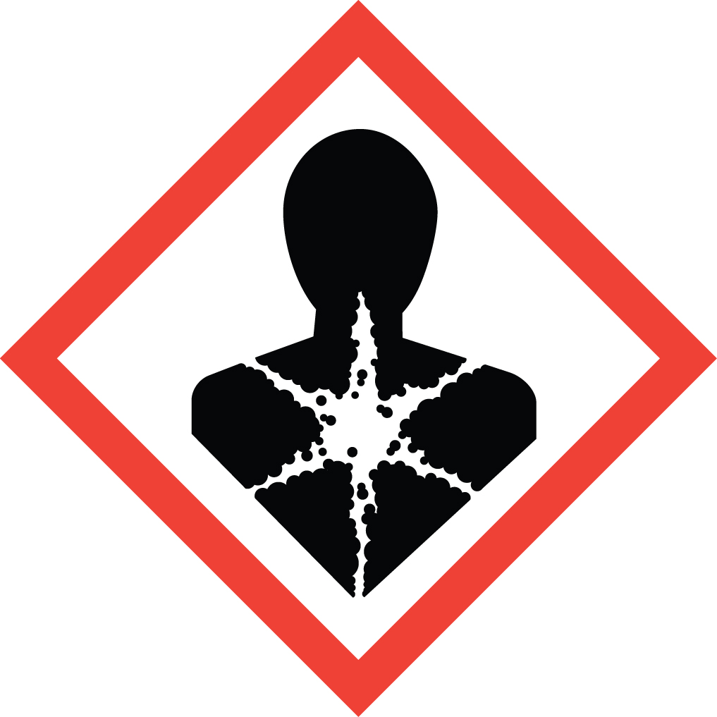 Signal Word: DANGER  Toxicological Information:  ORAL (LD50): 6,200 mg/kg [Rat]  *Always refer to the Safety Data Sheet for the most detailed information*
3. NAME OF TRAINER /  RESOURCE  PERSON | Principal Investigator Name, Building, Room, Phone Number  Secondary contact Name, Building, Room, Phone Number
- LOCATION OF  HEALTH & SAFETY  INFORMATION | The Safety Data Sheet (SDS) for Trypan Blue is located in the Laboratory Safety Manual located in Building, Room.  Labeling: In addition to the standard label that identifies contents, hazards, precautionary measures, and emergency contact information, containers should also be marked as a cancer hazard.
5. PROTECTIVE  EQUIPMENT | Wear chemical safety goggles, nitrile gloves and a fully-buttoned lab coat. Wash hands after removing gloves. Work within a certified laboratory fume hood.
- WASTE DISPOSAL  PROCEDURES | Waste Trypan Blue should be collected in a sealable, airtight, compatible waste container. A completed Dangerous Waste label should be attached when waste is first added to the container. When container is full or no longer being used, complete a Chemical Collection Request Form, and deliver to the Waste Accumulation Area Operator at Building, Room, Phone Number.
7. DESIGNATED AREA  INFORMATION | The trypan blue is stored and dispensed in Building, Room.  The designated area(s) should be shown on the floor plan in Laboratories Chemical Hygiene Plan.
8. DECONTAMINATION  PROCEDURES | Upon Accidental Exposure:  In case of eye contact, flush eyes with copious amounts of water at an emergency eyewash station for at least 15 minutes and consult a physician.  In case of skin contact, flush skin with copious amounts of water for 15 minutes and consult a physician. For exposure over a large portion of the body, remove clothing and shoes and rinse thoroughly in an emergency shower for at least 15 minutes. Seek medical attention.  In case of inhalation, move person to fresh air and immediately seek medical attention.  In case of ingestion, immediately seek medical attention and follow instructions on SDS.  Upon Accidental Release:  If Trypan Blue is released and you have been appropriately trained to clean it up, you may do so. Trained personnel should wear at the minimum nitrile rubber gloves, safety glasses or chemical safety goggles, and a fully-buttoned lab coat.  Additional PPE such as respirators are not necessary but may be desired for nuisance levels of dust. (Note: You must be medically cleared, fit tested and enrolled in WSU’s Respiratory Protection Program to wear a respirator). If you desire to wear a respirator and are not trained, fit tested and medically cleared to wear one, ask another spill trained employee to clean up the spill or call EH&S.  Use appropriate tools and place material in an appropriate waste disposal container (resealable bag, etc.) and dispose of as hazardous waste (see above WASTE DISPOSAL PROCEDURES). Avoid dust formation.  As with all accidents, report any exposure as soon as possible to your Principal Investigator or Supervisor. Additional health and safety information on trypan blue can be obtained by referring to the SDS or by calling the EH&S Office (335-3041).
- SPECIAL STORAGE  AND HANDLING  PROCEDURES | Keep container tightly closed in a cool, dry, and well-ventilated area. Keep away from heat, direct sunlight, sparks, and flame.  Keep away from incompatibles such as strong oxidizing agents.

Certification of Hazard Assessment

Is this document a certification of Hazard Assessment for the processes identified within? Yes No
If yes, provide the name of the person certifying the Hazard Assessment and the date it was performed:

____________________________________________________________________________________
Name Date

The location of the Hazard Assessment is indicated in the document preceding this form.

Certificate of Employee Training

Name of person providing training for employees working with this process:

___________________________________________________________________________________
The following employees have been trained in when, where and how to use selected PPE, the maintenance, limitations and disposal of the PPE selected, and have demonstrated the correct use of the PPE selected on the reverse of this certification.
Name Date Trained
________________________________________ _______________________________
________________________________________ _______________________________
________________________________________ _______________________________
________________________________________ _______________________________
________________________________________ _______________________________
________________________________________ _______________________________
________________________________________ _______________________________

