STANDARD OPERATING PROCEDURES FOR HAZARDOUS AND PARTICULARLY HAZARDOUS CHEMICALS
For

Sodium Fluoride

1. PROCEDURE /  PROCES | Sodium Fluoride is used in Building, Room.  Insert procedure here:
2. CHEMICAL NAME(S)  and associated  PHYSICAL and  HEALTH  HAZARDS | Sodium Fluoride, CAS # 7681-49-4, also known as Natrium Fluoride, Sodium Monofluoride, and Sodium Hydrofluoride. It is a colorless or white, odorless crystal or powder. The pesticide grade is dyed green or blue. It is used to fluoridate water, in chemical cleaning and electroplating, and as an insecticide.  - Highly toxic by inhalation and ingestion. May be fatal if swallowed.  - Very toxic by skin contact. May cause skin irritation and burns.  - May cause serious eye irritation, burns and damage.  - The substance may be toxic to kidneys, lungs, the nervous system, heart, gastrointestinal tract, cardiovascular system, bones, and teeth.  - May damage the developing fetus.  - Inhaling Sodium Fluoride can irritate the nose, throat and lungs.  - Exposure to Sodium Fluoride can cause nausea, vomiting, diarrhea, abdominal pain, and loss of appetite.  - Repeated exposure can cause weakness and muscle twitching, tremors, convulsions, coma and even death.  - Very high exposure to Sodium Fluoride can cause the deposit of Fluoride in the bones and teeth, a condition called Fluorosis. This may cause pain, disability and mottling of the teeth.  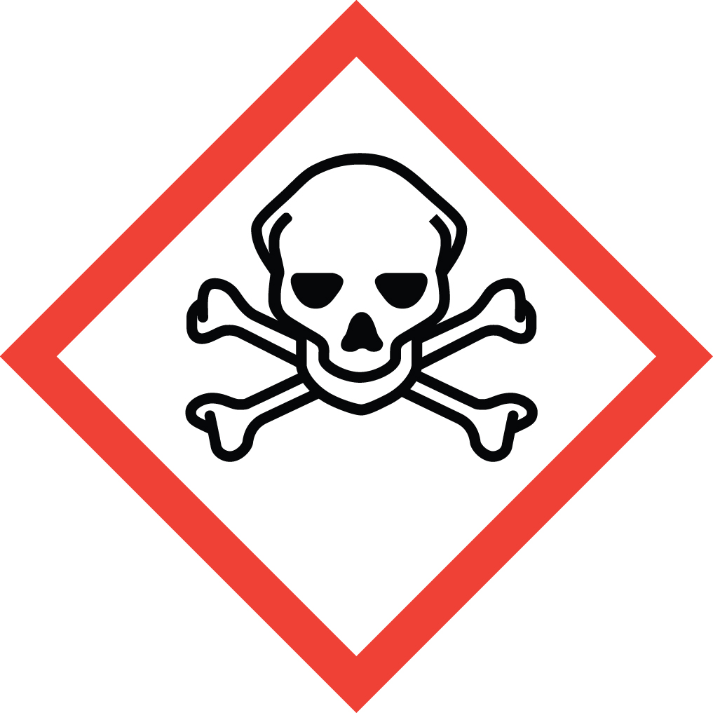 Signal Word: DANGER  Exposure Limits:  OSHA: TWA: 2.5 mg/m³  NIOSH: TWA: 2.5 mg/m³  ACGIH: TWA: 2.5 mg/m³  Toxicological Data:  ORAL (LD50): 52 mg/kg [Rat]. 57 mg/kg [Mouse].  INTRAVENEOUS (LD50): 26 mg/kg [Rat].  *Always refer to the Safety Data Sheet for the most detailed information*
3. NAME OF TRAINER /  RESOURCE  PERSON | Principal Investigator Name, Building, Room, Phone Number  Secondary contact Name, Building, Room, Phone Number
- LOCATION OF  HEALTH & SAFETY  INFORMATION | The Safety Data Sheet (SDS) for sodium fluoride is located in the Laboratory Safety Manual located in Building, Room.  Labeling: In addition to the standard label that identifies contents, hazards, precautionary measures, and emergency contact information, containers should also be marked as acutely toxic.
5. PROTECTIVE  EQUIPMENT | Wear nitrile or neoprene gloves, chemical splash goggles, and a fully buttoned lab coat while handling, dispensing, or during experimental use of sodium fluoride. (Note: Always check the manufacturer’s glove compatibility chart for proper glove selection.) Use of a face shield in addition to chemical goggles is recommended. Always work within the confines of a properly functioning, certified laboratory chemical fume hood.
- WASTE DISPOSAL  PROCEDURES | Waste Sodium Fluoride and its solutions must be managed as Dangerous Waste. It should be collected in a sealable, compatible waste container. The container should be stored away from incompatible materials such as strong acids, strong oxidizers, strong bases and metals.  A completed Dangerous Waste label should be attached when waste is first added to the container. When container is full or no longer being used complete a Chemical Collection Request Form, and deliver to the Waste Accumulation Area Operator at Building, Room, Phone Number.
7. DESIGNATED AREA  INFORMATION | Sodium fluoride is stored and used in Building, Room.  Sodium Fluoride is used within a properly functioning, certified laboratory chemical fume hood.  The designated area(s) should be shown on the floor plan in Laboratories Chemical Hygiene Plan.
8. DECONTAMINATION  PROCEDURES | Upon Accidental Exposure:  In case of eye contact, flush eyes with copious amounts of water at an emergency eyewash station for at least 15 minutes and immediately seek medical attention. Do not use calcium gluconate gel skin burn treatment on the eyes.  In case of skin contact, flush skin with copious amounts of water for 15 minutes and seek medical attention. For exposure over a large portion of the body, remove clothing and shoes and rinse gently but thoroughly in an emergency shower for at least 15 minutes. After thorough washing, a 2.5% calcium gluconate gel, if available, should be continuously massaged into the affected area until medical help arrives. Calcium gluconate must be kept on hand at all times. Replace annually if not previously used. Before using sodium fluoride, make sure the antidote and first aid attendant are available in case of exposure. Seek medical attention immediately.  In case of inhalation, move person to fresh air and immediately seek medical attention.  WARNING: It may be hazardous to the person providing aid to give mouth-to-mouth resuscitation when the inhaled material is toxic, infectious or corrosive.  In case of ingestion, immediately seek medical attention and follow instructions on SDS.  Upon Accidental Release:  Large Spill: If a large amount of sodium fluoride is released outside the fume hood, immediately evacuate, secure the area and call 911  Small Spill: If a small amount is released (it can be cleaned up in 10 minutes) and you are appropriately trained to clean up the spill, you may do so. Use appropriate PPE including nitrile or neoprene gloves, chemical splash goggles, and a fully buttoned lab coat (Note: Always check the manufacturer’s glove compatibility chart for proper glove selection).  Additional PPE such as respirators may be necessary depending upon material and concentration. (Note: You must be medically cleared, fit tested and enrolled in WSU’s respiratory protection program to wear a respirator). If it is necessary to use a respirator and personnel are not cleared to wear a respirator and not trained to appropriately clean up the spill, the employee should immediately evacuate, secure area, and call 911 to contact EH&S.  Absorb or pick up the spilled material using appropriate tools, clean the area and place cleanup materials in appropriate containers, and dispose of as dangerous waste (see above WASTE DISPOSAL PROCEDURES). Prevent entry into sewers, basements or confined areas; dike if needed.  As with all accidents, report any exposure as soon as possible to your Principal Investigator or Supervisor. Additional health and safety information on sodium fluoride can be obtained by referring to the SDS or by calling the EH&S Office (335-3041).
- SPECIAL STORAGE  AND HANDLING  PROCEDURES | Keep secured and store in a tightly closed, dry container in a cool, dry, ventilated area away from sources of heat, ignition, water, and moisture. Store in secondary containment such as Nalgene/polypropylene tub. This material is moisture sensitive. Avoid dust formation.  Keep away from incompatibles such as strong acids, strong oxidizers, strong bases and metals. Sodium Fluoride reacts with strong acids (such as hydrochloric, sulfuric and nitric) to form toxic Hydrogen Fluoride gas.

Certification of Hazard Assessment

Is this document a certification of Hazard Assessment for the processes identified within? Yes No
If yes, provide the name of the person certifying the Hazard Assessment and the date it was performed:

____________________________________________________________________________________
Name Date

The location of the Hazard Assessment is indicated in the document preceding this form.

Certificate of Employee Training

Name of person providing training for employees working with this process:

___________________________________________________________________________________
The following employees have been trained in when, where and how to use selected PPE, the maintenance, limitations and disposal of the PPE selected, and have demonstrated the correct use of the PPE selected on the reverse of this certification.
Name Date Trained
________________________________________ _______________________________
________________________________________ _______________________________
________________________________________ _______________________________
________________________________________ _______________________________
________________________________________ _______________________________
________________________________________ _______________________________
________________________________________ _______________________________

