STANDARD OPERATING PROCEDURES FOR HAZARDOUS AND PARTICULARLY HAZARDOUS CHEMICALS
For
SYBR Safe DNA Gel Stain 10,000x Concentrate in Dimethyl Sulfoxide (DMSO)

1. PROCEDURE /  PROCESS | SYBR Safe DNA Gel Stain (10,000x Concentrate in DMSO) is used in Building, Room.  Insert procedure here:
2. CHEMICAL NAME(S)  and associated  PHYSICAL and  HEALTH  HAZARDS | SYBR Safe DNA Gel Stain (10,000x Concentrate in DMSO)  (SYBR Safe Stain – No CAS No.; Dimethyl Sulfoxide – CAS No. 67-68-5)  - May cause skin irritation. May be absorbed through the skin.  - May cause eye irritation and eye damage.  - May be harmful if swallowed.  - May be hazardous in case of inhalation. May cause irritation of the respiratory tract and lungs.  - Combustible liquid.  - DMSO may be toxic to blood, kidneys, liver, mucous membranes, skin, eyes. Repeated or prolonged exposure to the substance can produce target organs damage.  - DMSO is mutagenic for mammalian somatic cells and for bacteria and/or yeast.  - Based on animal data, DMSO may be carcinogenic and a reproductive toxin to humans.  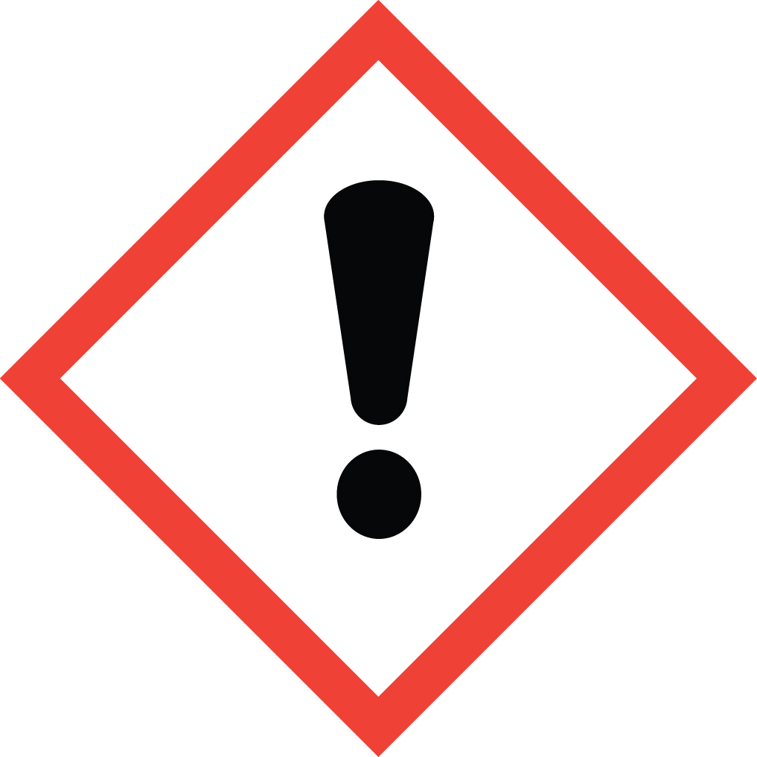 Signal Word: WARNING  Toxicological Data for Dimethyl Sulfoxide (DMSO):  ORAL (LD50): 14,500 mg/kg [Rat]. 7,920 mg/kg [Mouse].  DERMAL (LD50): 40,000 mg/kg [Rat]  INHALATION (LC50): 40,250 ppm [Rat – 4 hour]  *Always refer to the Safety Data Sheet for the most detailed information*
3. NAME OF TRAINER /  RESOURCE  PERSON | Principal Investigator Name, Building, Room, Phone Number  Secondary contact Name, Building, Room, Phone Number
- LOCATION OF  HEALTH & SAFETY  INFORMATION | The Safety Data Sheet (SDS) for SYBR Safe DNA Gel Stain (10,000x Concentrate in DMSO) is located in the Laboratory Safety Manual in Building, Room.  Labeling: Containers shall either have original warning label affixed or a label identifying the contents and hazards.
5. PROTECTIVE  EQUIPMENT | Wear butyl rubber gloves, chemical splash goggles, and a fully buttoned lab coat. Wash hands after removing gloves. Work within a properly functioning certified laboratory chemical fume hood.  Note: According to the SDS, nitrile gloves are not recommended due to the short breakthrough times of many brands of nitrile gloves.
- WASTE DISPOSAL  PROCEDURES | SYBR Safe DNA Gel Stain (10,000x Concentrate in DMSO) and solutions are not regulated as a Dangerous Waste. However, WSU’s wastewater permit does not allow dyes to be drained discharged. Therefore the solution must be collected and EH&S will properly dispose of solution. When the waste container is full or no longer being use complete and submit a Chemical Collection Request form. Although this material is not regulated this will schedule a pickup.
7. DESIGNATED AREA  INFORMATION | SYBR Safe DNA Gel Stain (10,000x Concentrate in DMSO) is stored and used in Building, Room.  Work within the confines of a properly functioning, certified laboratory chemical fume hood.  The designated area(s) should be shown on the floor plan in Laboratories Chemical Hygiene Plan.
8. DECONTAMINATION  PROCEDURES | Upon Accidental Exposure:  In case of eye contact, flush eyes with copious amounts of water at an emergency eyewash station for at least 15 minutes. Consult a physician.  In case of skin contact, flush skin with copious amounts of water for 15 minutes. For exposure over a large portion of the body, remove clothing and shoes and rinse thoroughly in an emergency shower for at least 15 minutes. Consult a physician.  In case of inhalation, move person to fresh air and consult a physician.  In case of ingestion, immediately seek medical attention and follow instructions on SDS.  Upon Accidental Release:  Large Spill: If a large amount of SYBR Safe DNA Gel Stain (10,000x Concentrate in DMSO) is released, immediately evacuate, secure area and call 911 to contact EH&S.  Small Spill: If a small amount of SYBR Safe DNA Gel Stain (10,000x Concentrate in DMSO) is released (it can be cleaned up in 10 minutes) and you have been appropriately trained to clean it up, you may do so. Trained personnel should wear at the minimum butyl rubber gloves, chemical splash goggles, and a fully buttoned lab coat.  Additional PPE such as respirators may be necessary depending upon material and concentration. (Note: You must be medically cleared, fit tested, and enrolled in WSU’s respiratory protection program to wear a respirator). If it is necessary to use a respirator and personnel are not cleared to wear a respirator and not trained to appropriately clean up the spill, the employee should immediately evacuate, secure area, and call 911 to contact EH&S.  As with all accidents, report any exposure as soon as possible to your Principal Investigator or Supervisor. Additional health and safety information on SYBR Safe DNA Gel Stain (10,000x Concentrate in DMSO) can be obtained by referring to the SDS or by calling the EH&S Office (335-3041).
- SPECIAL STORAGE  AND HANDLING  PROCEDURES | Store in a cool, dry, well-ventilated area away from sources of heat or ignition. Keep container tightly closed.  Keep away from incompatible materials such as acid chlorides, phosphorus halides, strong acids, strong oxidizing agents, strong reducing agents and alkalis.

Certification of Hazard Assessment

Is this document a certification of Hazard Assessment for the processes identified within? Yes No
If yes, provide the name of the person certifying the Hazard Assessment and the date it was performed:

____________________________________________________________________________________
Name Date

The location of the Hazard Assessment is indicated in the document preceding this form.

Certificate of Employee Training

Name of person providing training for employees working with this process:

___________________________________________________________________________________
The following employees have been trained in when, where and how to use selected PPE, the maintenance, limitations and disposal of the PPE selected, and have demonstrated the correct use of the PPE selected on the reverse of this certification.
Name Date Trained
________________________________________ _______________________________
________________________________________ _______________________________
________________________________________ _______________________________
________________________________________ _______________________________
________________________________________ _______________________________
________________________________________ _______________________________
________________________________________ _______________________________

