STANDARD OPERATING PROCEDURES FOR HAZARDOUS AND PARTICULARLY HAZARDOUS CHEMICALS
For

Perchloric Acid

1. PROCEDURE /  PROCESS | Perchloric Acid is used in Building, Room.  Insert procedure here:  REMEMBER! Always add acid to water to limit exothermic reactions such as splatter, bubbling and fuming.  A large amount of heat is generated when strong acids are mixed with water. Adding more acid releases more heat. Adding water to acid forms an extremely concentrated solution of acid. Heat causes the solution to boil violently, splashing concentrated acid out of the container.  Adding acid to water, the resulting solution is dilute and the heat released is absorbed by the water.  Always Add Acid to water.
2. CHEMICAL NAME(S)  and associated  PHYSICAL and  HEALTH  HAZARDS | Perchloric Acid - CAS# 7601-90-3; also known as PCA, is the inorganic compound with the formula HClO4. Usually encountered as an aqueous solution, this colorless compound is a strong acid comparable in strength to sulfuric acid and nitric acid. It is useful for preparing perchlorate salts, especially ammonium perchlorate, an important rocket fuel. Perchloric acid is also dangerously corrosive and readily forms explosive mixtures.  - DANGER! Perchloric acid is a strong oxidizer, contact with other material may cause fire or explosion. Heating may cause an explosion.  - Higher concentrations (over 70%) are increasingly unstable and reactive.  - Corrosive chemical. Causes severe skin burns and eye damage. Causes digestive and respiratory tract burns.  - Corrosive to metal.  - Affects eyes, thyroid, skin, and mucous membranes.  - Perchloric acid mist and vapor can condense in ventilation systems to form metallic perchlorates, which are shock sensitive and explosive.  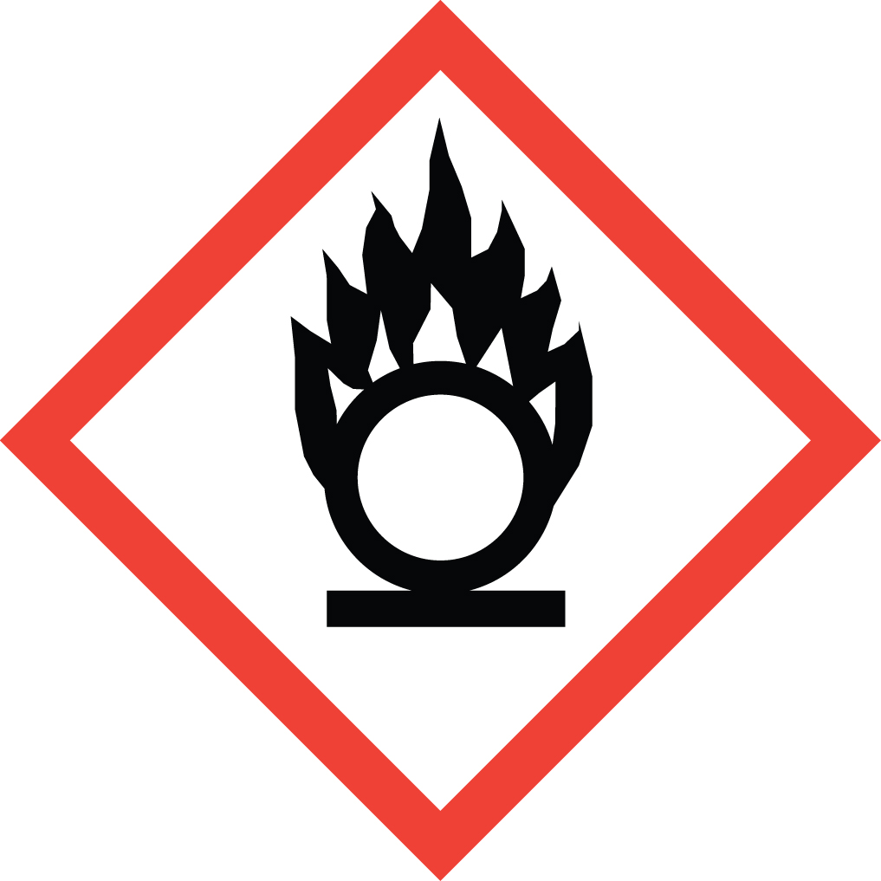 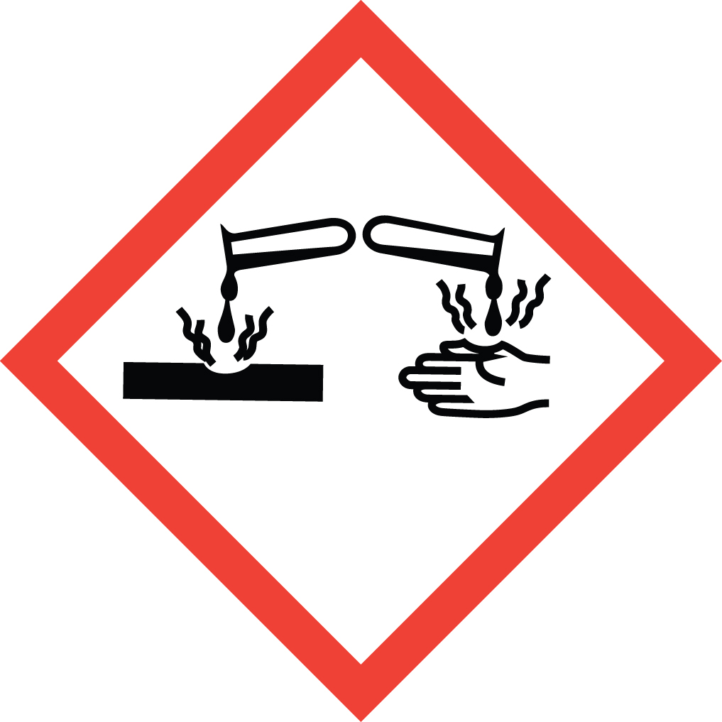 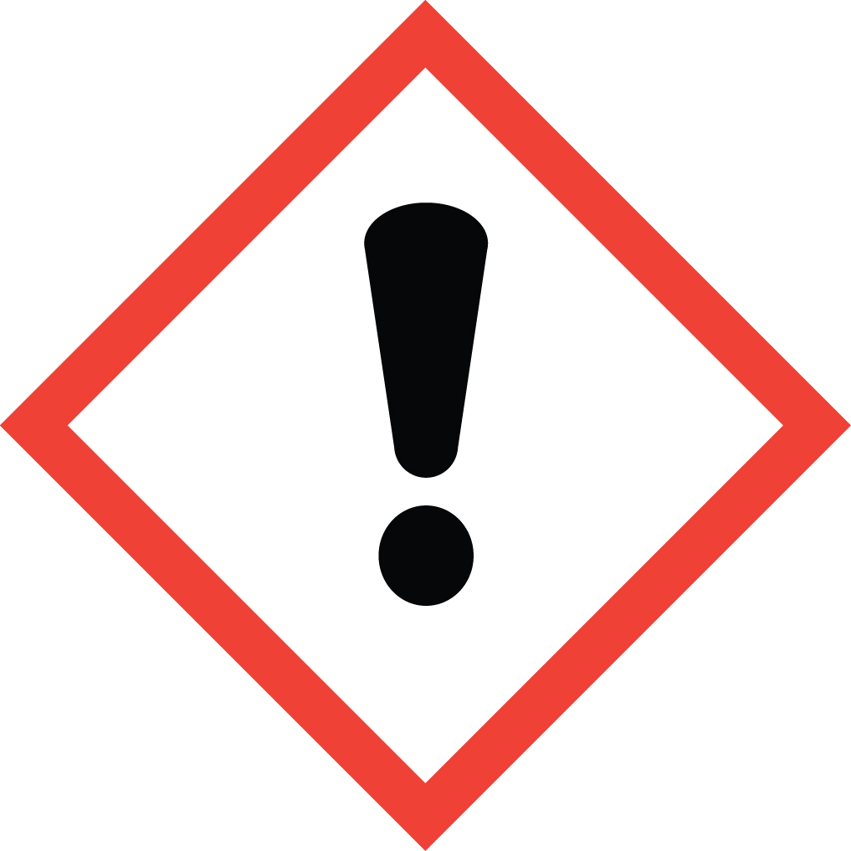 Signal Word: DANGER  Exposure Limits:  - No occupational exposure limits have been established for Perchloric acid. However, it may pose a health risk. Always follow safe work practices.  *Always refer to the Safety Data Sheet for the most detailed information*
3. NAME OF TRAINER /  RESOURCE  PERSON | Principal Investigator Name, Building, Room, Phone Number  Secondary contact Name, Building, Room, Phone Number
- LOCATION OF  HEALTH & SAFETY  INFORMATION | The Safety Data Sheet (SDS) for Perchloric Acid is located in the Laboratory Safety Manual in Building, Room  Labeling: Containers shall either have original warning label affixed or a label identifying the contents and hazards, including identifying it as a strong oxidizer/explosion hazard and corrosive.
5. PROTECTIVE  EQUIPMENT | Wear at the minimum nitrile, neoprene, PVC or natural rubber gloves, chemical splash goggles, and a fully buttoned lab coat. (Note: Always check the manufacturer’s glove compatibility chart for proper glove selection.) Wash hands after removing gloves. A face shield is also recommended.  Always work within a properly functioning, certified laboratory chemical fume hood designed for perchloric acid use. No organic materials should be stored in the perchloric acid hood.
- WASTE DISPOSAL  PROCEDURES | Waste Perchloric Acid and its solutions must be collected in a compatible container with a vented lid designed for storage of acids and bases. The container should be stored away from incompatible materials such as metals, strong reducing agents, bases, acids, acetic anhydride, alcohols, dimethyl sulfoxide, fluorine, diethyl ether, hypophosphites, phosphorus pentoxide, amines, organic materials, ketones, wood, and combustible materials.  A completed Dangerous Waste label should be attached when waste is first added to the container. When container is full or no longer being used complete a Chemical Collection Request Form, and deliver to the Waste Accumulation Area Operator at Building, Room, Phone Number.
7. DESIGNATED AREA  INFORMATION | The Perchloric acid is stored and dispensed in Building, Room.  Diluted acid solutions using this chemical are prepared immediately prior to use in Building, Room.  Confine all work with Perchloric acid to a properly functioning certified laboratory chemical fume hood designed for the use of Perchloric acid. Perchloric acid fume hoods are designed with a built in wash down system to prevent the buildup of explosive perchlorate salts. Do not use or store organic materials in the Perchloric acid hood.  The designated area(s) should be shown on the floor plan in Laboratories Chemical Hygiene Plan.
8. DECONTAMINATION  PROCEDURES | Upon Accidental Exposure:  In case of eye contact, flush eyes with copious amounts of water at an emergency eyewash station for at least 15 minutes and seek medical attention.  In case of skin contact, flush skin with copious amounts of water for 15 minutes and seek medical attention. For exposure over a large portion of the body, remove clothing and shoes and rinse thoroughly in an emergency shower for at least 15 minutes. Seek medical attention.  In case of inhalation, move person to fresh air and seek medical attention.  In case of ingestion, immediately seek medical attention and follow instructions on SDS.  Upon Accidental Release:  Large Spill: If a significant amount of Perchloric acid is released outside the fume hood, immediately evacuate, secure area and call 911 to contact EH&S.  Small Spill: If a small amount of Perchloric acid is released (it can be cleaned up in 10 minutes) and you have been appropriately trained to clean it up, you may do so. Trained personnel should wear at the minimum nitrile, neoprene, PVC or natural rubber gloves, chemical splash goggles, and a fully-buttoned lab coat. (Note: Always check the manufacturer’s glove compatibility chart for proper glove selection.)  Additional PPE such as respirators may be necessary depending upon material and concentration. (Note: You must be medically cleared, fit tested and enrolled in WSU’s respiratory protection program to wear a respirator). If it is necessary to use a respirator and personnel are not cleared to wear a respirator and not trained to appropriately clean up the spill, the employee should immediately evacuate, secure area, and call 911 to contact EH&S.  Absorb with an inert dry material and place material in an appropriate waste disposal container (resealable bag, etc.) and dispose of as hazardous waste (see above WASTE DISPOSAL PROCEDURES). Paper towels or similar materials should not be used because perchloric acid can react with flammable materials creating a fire  Please do not use a neutralizer to clean up spill unless you are currently in the respiratory protection program and have been properly trained. (Note: You must be medically cleared, fit tested and enrolled in WSU’s respiratory protection program to wear a respirator).  As with all accidents, report any exposure as soon as possible to your Principal Investigator or Supervisor. Additional health and safety information on perchloric acid can be obtained by referring to the SDS or by calling the EH&S Office (335-3041).
- SPECIAL STORAGE  AND HANDLING  PROCEDURES | - Store in a tightly closed container in a secured, cool and well-ventilated area away from direct sunlight, heat, sparks, flame, and other sources of ignition.  - Store segregated from organic chemicals and any combustible material.  - Shelf and floor materials should be non-combustible and acid-resistant (do not store on wood shelves).  - Store in secondary containment such as a Nalgene or polypropylene tub.  - Keep away from incompatibles such as: Metals, strong reducing agents, bases, acids, acetic anhydride, alcohols, dimethyl sulfoxide, fluorine, diethyl ether, hypophosphites, phosphorus pentoxide, amines, organic materials, ketones, wood, and combustible materials.  - Do not allow perchloric acid to come into contact with strong dehydrating agents (concentrated sulfuric acid, anhydrous phosphorous pentoxide, etc.).  - Keep the quantities of perchloric acid handled at the bare minimum for safety. Storage for long periods of time can result in the formation of perchlorate crystals in the bottle or around the cap.  - Procedures involving perchloric acid must be conducted in a perchloric acid fume hood with a built in wash down system.  - No organic materials should be stored in the perchloric acid hood.  - Perchloric acid mist and vapor can condense in ventilation systems to form metallic perchlorates, which are shock sensitive and explosive.  - Perchloric acid should be handled in a masonry building with concrete or tile floors. Handling acid on wooden floors is dangerous, especially after the acid has dried. The wooden floor will then become sensitive to ignition by friction.

Certification of Hazard Assessment

Is this document a certification of Hazard Assessment for the processes identified within? Yes No
If yes, provide the name of the person certifying the Hazard Assessment and the date it was performed:

____________________________________________________________________________________
Name Date

The location of the Hazard Assessment is indicated in the document preceding this form.

Certificate of Employee Training

Name of person providing training for employees working with this process:

___________________________________________________________________________________
The following employees have been trained in when, where and how to use selected PPE, the maintenance, limitations and disposal of the PPE selected, and have demonstrated the correct use of the PPE selected on the reverse of this certification.
Name Date Trained
________________________________________ _______________________________
________________________________________ _______________________________
________________________________________ _______________________________
________________________________________ _______________________________
________________________________________ _______________________________
________________________________________ _______________________________
________________________________________ _______________________________

