STANDARD OPERATING PROCEDURES FOR HAZARDOUS AND PARTICULARLY HAZARDOUS CHEMICALS
For

Hydrogen Peroxide

1. PROCEDURE /  PROCESS | Hydrogen Peroxide is used in Building, Room.  Insert procedure here:
2. CHEMICAL NAME(S)  and associated  PHYSICAL and  HEALTH  HAZARDS | Hydrogen Peroxide- CAS # 7722-84-1; also known as Hydrogen Peroxide 30%.  - Highly corrosive chemical.  - May cause skin irritation and severe skin burns  - May cause eye irritation and irreversible eye damage.  - This substance is a strong oxidizer. It may cause fire or explosion when in contact with incompatible materials.  - This substance is harmful if swallowed. It can cause severe burns to the digestive tract.  - This substance is hazardous in case of inhalation. It can cause severe burns to the respiratory tract.  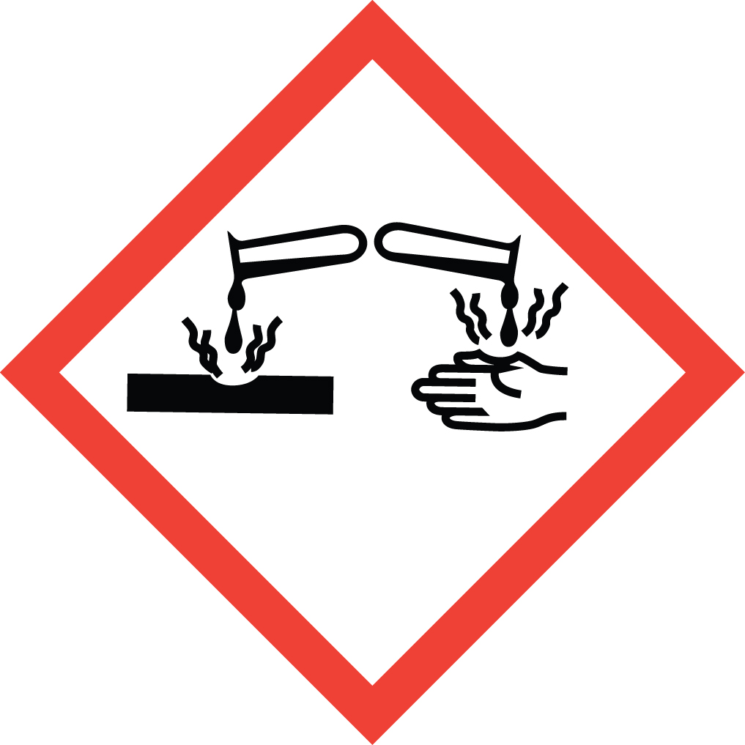 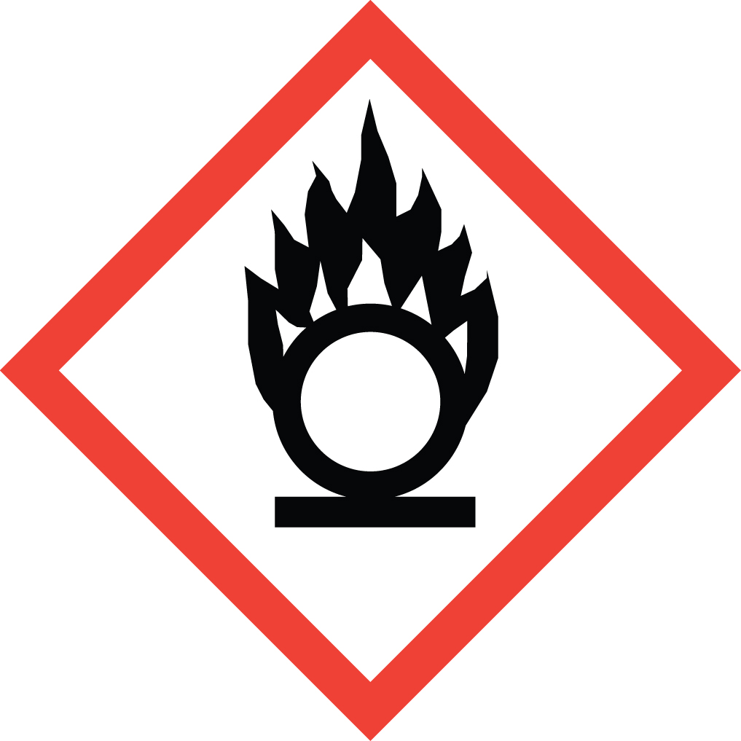 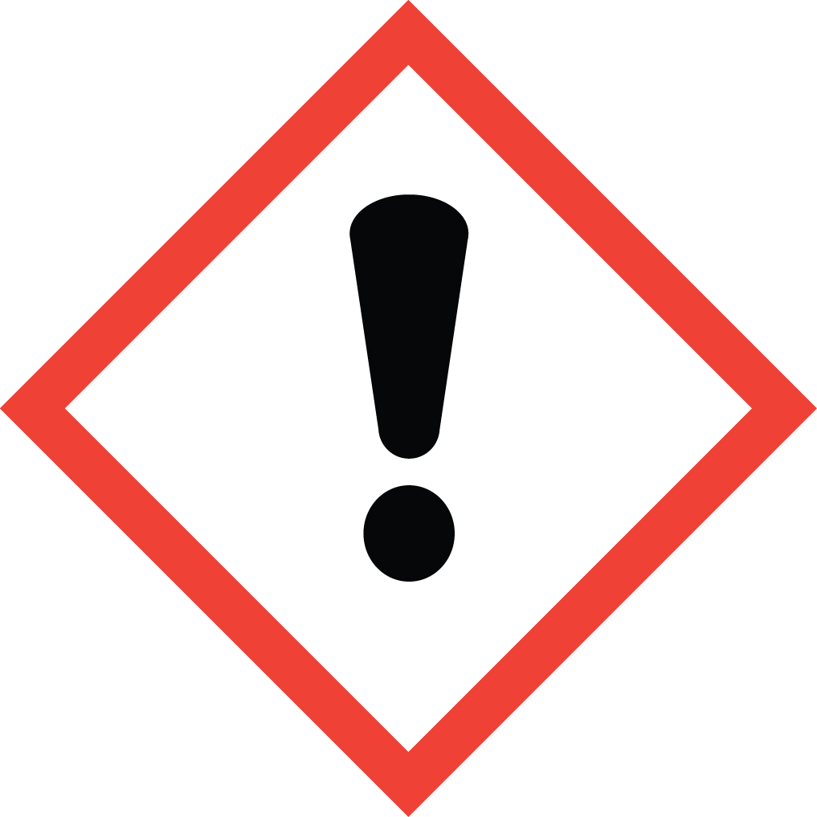 Signal Word: DANGER  Exposure Limits:  DOSH: TWA: 1 ppm; STEL: 3 ppm  NIOSH/ACGIH: TWA: 1 ppm  Toxicological Data:  ORAL (LD50): 2,000 mg/kg [Mouse].  DERMAL (LD50): 4,060 mg/kg [Rat]; 2,000 mg/kg [Pig].  INHALATION (LC50): 2,000 mg/m 4 hours [Rat].  *Always refer to the Safety Data Sheet for the most detailed information*
3. NAME OF TRAINER /  RESOURCE  PERSON | Principal Investigator Name, Building, Room, Phone Number  Secondary contact Name, Building, Room, Phone Number
- LOCATION OF  HEALTH & SAFETY  INFORMATION | The Safety Data Sheet (SDS) for Hydrogen Peroxide is located in the Laboratory Safety Manual in Building, Room  Labeling: Containers shall either have original warning label affixed or a label identifying the contents and hazards.
5. PROTECTIVE  EQUIPMENT | Wear nitrile, neoprene, or Viton gloves, chemical splash goggles, and fully buttoned lab coat. A face shield is also recommended for highly corrosive chemicals. Wash hands after removing gloves. Work within a properly functioning certified laboratory chemical fume hood.
- WASTE DISPOSAL  PROCEDURES | Waste Hydrogen Peroxide must be collected in a compatible container. The container should be stored away from incompatible materials such as combustible materials, acids, alkalis, oxidizable material, alcohols, permanganates, zinc, powdered metals, iron, copper, nickel, brass, iron and iron salts. A completed Dangerous Waste label should be attached when waste is first added to the container. When container is full or no longer being used complete a Chemical Collection Request Form, and deliver to the Waste Accumulation Area Operator at Building, Room, Phone Number.
7. DESIGNATED AREA  INFORMATION | The Hydrogen Peroxide is stored and dispensed in Building, Room.  Always work in a properly functioning, certified laboratory chemical fume hood.  The designated area(s) should be shown on the floor plan in Laboratories Chemical Hygiene Plan.
8. DECONTAMINATION  PROCEDURES | Upon Accidental Exposure:  In case of eye contact, flush eyes with copious amounts of water at an emergency eyewash station for at least 15 minutes and seek medical attention.  In case of skin contact, flush skin with copious amounts of water for 15 minutes and seek medical attention. For exposure over a large portion of the body, remove clothing and shoes and rinse thoroughly in an emergency shower for at least 15 minutes. Seek medical attention.  In case of inhalation, move person to fresh air and immediately seek medical attention.  In case of ingestion, immediately seek medical attention and follow instructions on SDS.  Upon Accidental Release:  Large Spill: If a significant amount of hydrogen peroxide is spilled outside the fume hood, immediately evacuate, secure area and call 911 to contact EH&S.  Small Spill: If a small amount of hydrogen peroxide is spilled (it can be cleaned up in 10 minutes) and you have been appropriately trained to clean it up, you may do so. Trained personnel should wear at the minimum nitrile, neoprene, or Viton gloves, chemical splash goggles, and a fully-buttoned lab coat. A face shield is also recommended.  Additional PPE such as respirators may be necessary depending upon material and concentration. (Note: You must be medically cleared, fit tested and enrolled in WSU’s respiratory protection program to wear a respirator). If it is necessary to use a respirator and personnel are not cleared to wear a respirator and not trained to appropriately clean up the spill, the employee should immediately evacuate, secure area, and call 911 to contact EH&S.  Absorb with an inert dry material and place material in an appropriate waste disposal container (resealable bag, etc.) and dispose of as hazardous waste (see above WASTE DISPOSAL PROCEDURES).  As with all accidents, report any exposure as soon as possible to your Principal Investigator or Supervisor. Additional health and safety information on hydrogen peroxide can be obtained by referring to the SDS or by calling the EH&S Office (335-3041).
- SPECIAL STORAGE  AND HANDLING  PROCEDURES | Keep container in a cool, dry, and well-ventilated area. Keep container tightly closed and sealed until ready for use. Store segregated from incompatible chemicals (below). Hydrogen peroxide is an oxidizer. Keep away from combustibles, heat, sunlight, and other sources of ignition. Recommended storage temperature is 2-8 °C  Keep away from incompatibles such as combustible materials, acids, alkalis, oxidizable material, alcohols, permanganates, zinc, powdered metals, iron, copper, nickel, brass, iron and iron salts.

Certification of Hazard Assessment

Is this document a certification of Hazard Assessment for the processes identified within? Yes No
If yes, provide the name of the person certifying the Hazard Assessment and the date it was performed:

____________________________________________________________________________________
Name Date

The location of the Hazard Assessment is indicated in the document preceding this form.

Certificate of Employee Training

Name of person providing training for employees working with this process:

___________________________________________________________________________________
The following employees have been trained in when, where and how to use selected PPE, the maintenance, limitations and disposal of the PPE selected, and have demonstrated the correct use of the PPE selected on the reverse of this certification.
Name Date Trained
________________________________________ _______________________________
________________________________________ _______________________________
________________________________________ _______________________________
________________________________________ _______________________________
________________________________________ _______________________________
________________________________________ _______________________________
________________________________________ _______________________________

