STANDARD OPERATING PROCEDURES FOR HAZARDOUS AND PARTICULARLY HAZARDOUS CHEMICALS
For

Ethyl Ether

1. PROCEDURE /  PROCESS | Ethyl Ether is used in Building, Room.  Insert procedure here:
2. CHEMICAL NAME(S)  and associated  PHYSICAL and  HEALTH  HAZARDS | Ethyl Ether – CAS# 60-29-7; also known as Diethyl Ether and Ether.  - EXTREMELY FLAMMABLE liquid and vapor. May form explosive mixtures in air.  - May form EXPLOSIVE PEROXIDES which are contact explosives when dry.  - Causes irritation to the skin, eyes, and respiratory tract.  - Repeated exposure may cause skin dryness or cracking.  - Harmful if inhaled. Vapors may cause drowsiness, dizziness, excitement, vomiting, irregular breathing, and increased saliva. High exposure can cause unconsciousness and even death.  - The substance may be toxic to central nervous system (CNS) and kidneys. Repeated or prolonged exposure to the substance can produce target organs damage.  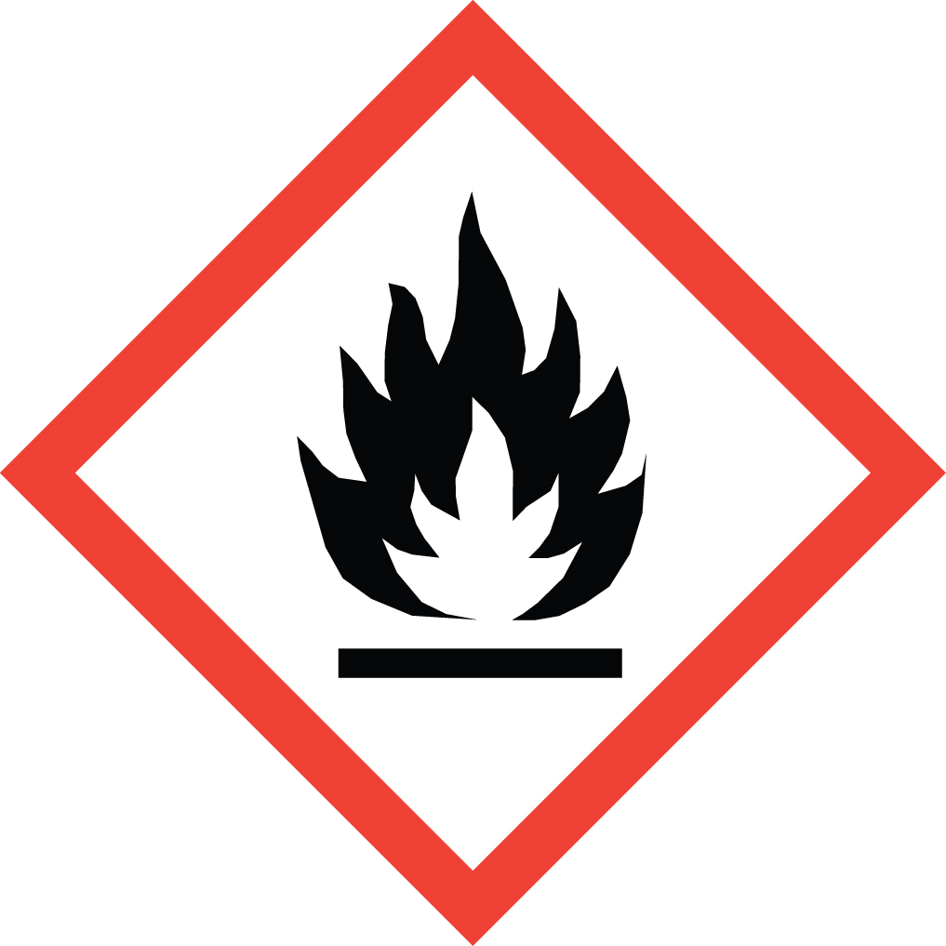 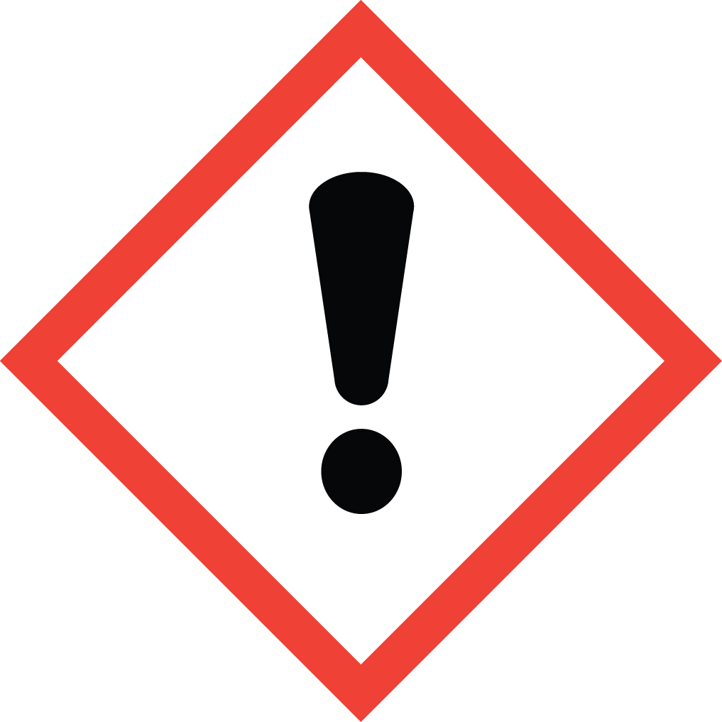 Signal Word: DANGER  Exposure Limits:  DOSH: TWA: 400 ppm; STEL: 500 ppm  ACGIH: TWA: 400 ppm; STEL: 500 ppm  Toxicological Data:  ORAL (LD50): 1,215 mg/kg [Rat]; 1,760 mg/kg [Mouse]  DERMAL (LD50): >14.2 g/kg [Rabbit]  INHALATION (LC50): 32,000 ppm [Rat] 4 hours; 31,000 ppm [Mouse] 30 mins  *Always refer to the Safety Data Sheet for the most detailed information*
3. NAME OF TRAINER /  RESOURCE  PERSON | Principal Investigator Name, Building, Room, Phone Number  Secondary contact Name, Building, Room, Phone Number
- LOCATION OF  HEALTH & SAFETY  INFORMATION | The Safety Data Sheet (SDS) for Ethyl Ether is located in the Laboratory Safety Manual located in Building, Room.  Labeling: In addition to the standard label that identifies contents, hazards, precautionary measures, and emergency contact information, containers should have a Peroxidizable Compound or Potentially Explosive Chemical label.
5. PROTECTIVE  EQUIPMENT | Wear chemical safety goggles, nitrile, PVA or laminate film gloves and a fully-buttoned lab coat. Wash hands after removing gloves. Always work with ethyl ether within a properly functioning certified laboratory fume hood.
- WASTE DISPOSAL  PROCEDURES | Waste Ethyl Ether must be collected in its pure form and solutions. It should be collected in a sealable, airtight, compatible waste container. Placing waste container in secondary containment is recommended. The container should be stored away from incompatible materials such as strong oxidizing agents, strong acids, halogens, interhalogens, sulfur and sulfur compounds  A completed Dangerous Waste label should be attached when waste is first added to the container. When container is full or no longer being used, complete a Chemical Collection Request Form, and deliver to the Waste Accumulation Area Operator at Building, Room, Phone Number.  Do not allow any container to evaporate to dryness. Triple rinse empty containers with water and dispose of the rinsate as waste. Rinsed glassware may then be disposed of as glass waste.
7. DESIGNATED AREA  INFORMATION | The Ethyl Ether is stored and dispensed in Building, Room.  Always work in a properly functioning, certified laboratory chemical fume hood.  The designated area(s) should be shown on the floor plan in Laboratories Chemical Hygiene Plan.
8. DECONTAMINATION  PROCEDURES | Upon Accidental Exposure:  In case of eye contact, flush eyes with copious amounts of water at an emergency eyewash station for at least 15 minutes and seek medical attention.  In case of skin contact, flush skin with copious amounts of water for 15 minutes and seek medical attention. For exposure over a large portion of the body, remove clothing and shoes and rinse thoroughly in an emergency shower for at least 15 minutes. Seek medical attention.  In case of inhalation, move person to fresh air and immediately seek medical attention.  In case of ingestion, immediately seek medical attention and follow instructions on SDS. Do not induce vomiting.  Upon Accidental Release:  Large Spill: If a large amount of Ethyl Ether is spilled outside the fume hood, immediately evacuate and secure area and call 911 to contact EH&S.  Small Spill: If a small amount of Ethyl Ether is spilled (it can be cleaned up in 10 minutes) and you have been appropriately trained to clean it up, you may do so. Trained personnel should wear at the minimum nitrile rubber, PVA, or laminate film gloves, chemical safety goggles, and a fully-buttoned lab coat.  Additional PPE such as respirators may be necessary depending upon material and concentration. (Note: You must be medically cleared, fit tested and enrolled in WSU’s respiratory protection program to wear a respirator). If it is necessary to use a respirator and personnel are not cleared to wear a respirator and not trained to appropriately clean up the spill, the employee should immediately evacuate, secure area, and call 911 to contact EH&S.  Absorb with an inert dry material and place material in an appropriate waste disposal container (resealable bag, etc.) and dispose of as hazardous waste (see above WASTE DISPOSAL PROCEDURES).  As with all accidents, report any exposure as soon as possible to your Principal Investigator or Supervisor. Additional health and safety information on Ethyl Ether can be obtained by referring to the SDS or by calling the EH&S Office (335-3041).
- SPECIAL STORAGE  AND HANDLING  PROCEDURES | Handling: Make sure there are no white crystals forming on the outside of the bottle. Work in a properly functioning, certified chemical fume hood. When handling the chemical, use it away from shock, friction, and open flames. Prevent electric static build-up with a grounding cable when transferring ethyl ether. Wash thoroughly after handling.  Storage: It is advised to purchase Ether in the smallest quantity possible and also ether that contains inhibitors that hinder the formation of peroxides. Please label the date received and the date opened, prior to working with ethyl ether. Storage time should never exceed the manufacturer’s recommendations. The general storage time for ethyl ether is 12 months.  If there are white crystals around the cap of the bottle, do not attempt to move the bottle and call EH&S immediately. The white crystals are a sign of explosive peroxide formation and needs to be removed from the lab by a professionally trained person.  Keep the chemical in a tightly sealed container in dry and well-ventilated area. Store segregated from incompatible chemicals (below). Suitable storage locations include flammable storage cabinets or intrinsically safe refrigerators or freezers. Do not store in containers with glass stoppers or metal lids. Containers of ethyl ether should be protected from physical damage, direct sunlight, and ignition sources.  Containers should be stored separately from strong oxidizing agents, strong acids, halogens, interhalogens, sulfur and sulfur compounds. Segregate the chemical and store in secondary containment. Label the bottle, secondary containment, and storage cabinet as “Potentially Explosive Chemical.” Inventory and inspect for peroxide formation every three months.

Certification of Hazard Assessment

Is this document a certification of Hazard Assessment for the processes identified within? Yes No
If yes, provide the name of the person certifying the Hazard Assessment and the date it was performed:

____________________________________________________________________________________
Name Date

The location of the Hazard Assessment is indicated in the document preceding this form.

Certificate of Employee Training

Name of person providing training for employees working with this process:

___________________________________________________________________________________
The following employees have been trained in when, where and how to use selected PPE, the maintenance, limitations and disposal of the PPE selected, and have demonstrated the correct use of the PPE selected on the reverse of this certification.
Name Date trained
________________________________________ _______________________________
________________________________________ _______________________________
________________________________________ _______________________________
________________________________________ _______________________________
________________________________________ _______________________________
________________________________________ _______________________________
________________________________________ _______________________________

