STANDARD OPERATING PROCEDURES FOR HAZARDOUS AND PARTICULARLY HAZARDOUS CHEMICALS
For

Bromine

1. PROCEDURE /  PROCESS | Bromine is used in Building, Room.  Insert procedure here:
2. CHEMICAL NAME(S)  and associated  PHYSICAL and  HEALTH  HAZARDS | Bromine - CAS# 7726-95-6  - Strong oxidizer. Contact with combustible and organic material may cause or intensify fire.  - Corrosive. Causes severe skin burns and eye damage.  - May cause severe respiratory tract irritation with possible burns.  - May cause severe digestive tract irritation with possible burns.  - Lachrymator (substance which increases the flow of tears).  - May cause central nervous system effects.  - May cause cardiac disturbances.  - May cause liver and kidney damage.  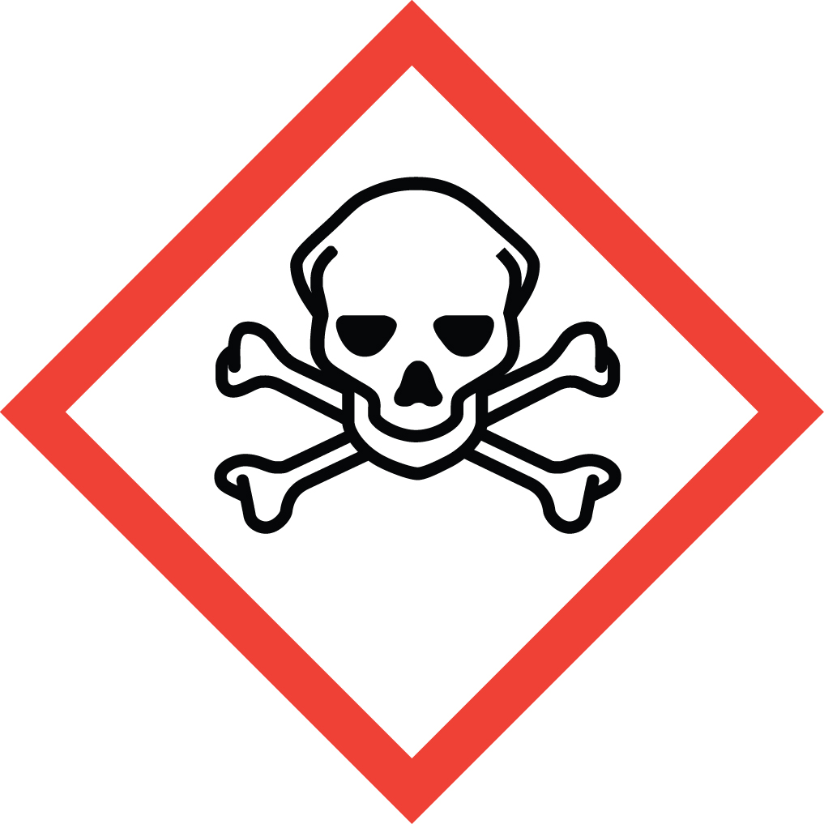 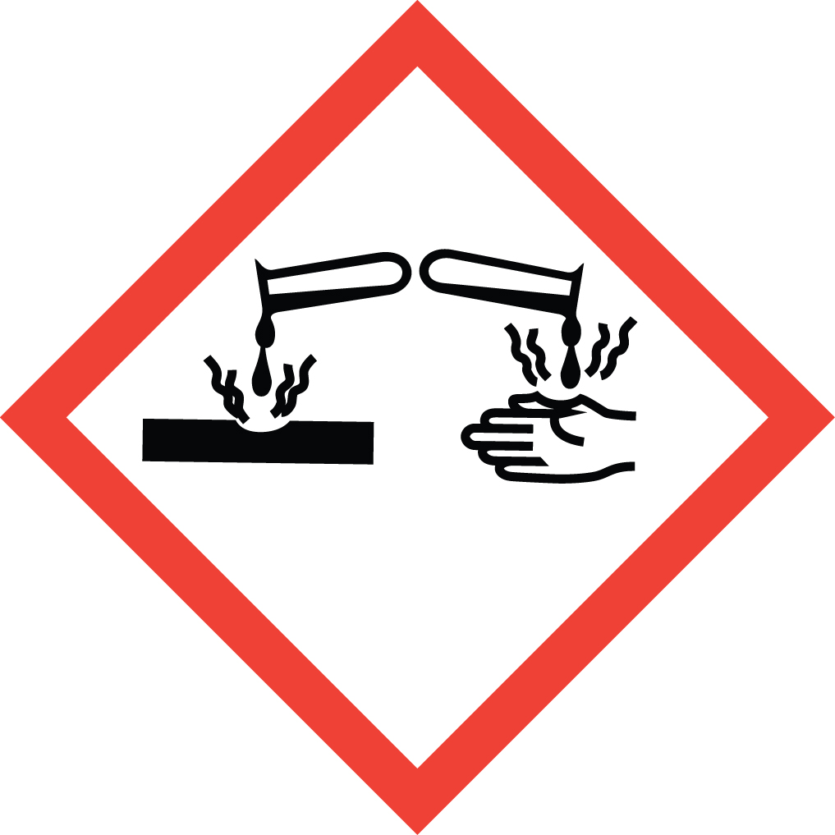 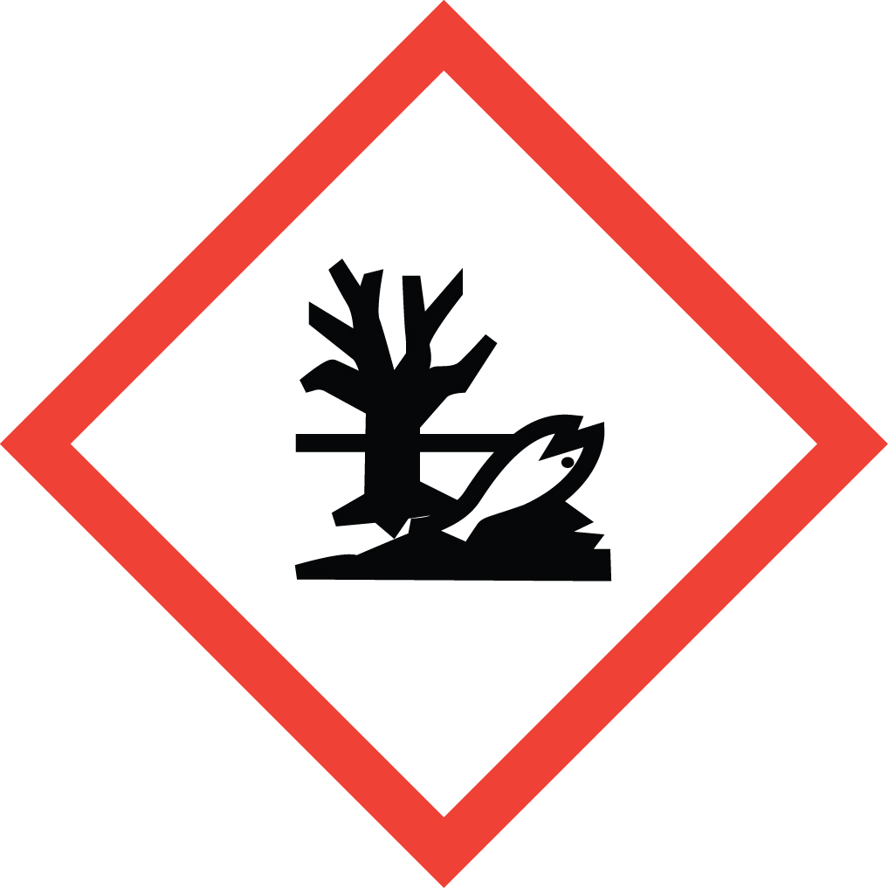 Signal Word: DANGER  Exposure Limits:  DOSH: TWA: 0.1 ppm; STEL: 0.3 ppm  NIOSH: TWA: 0.1 ppm; STEL: 0.3 ppm  ACGIH: TWA: 0.1 ppm; STEL: 0.2 ppm  Toxicological Data:  ORAL (LD50): 2,600 mg/kg [Rat]; 3,100 mg/kg [Mouse]; 4,160 mg/kg [Rabbit].  *Always refer to the Safety Data Sheet for the most detailed information*
3. NAME OF TRAINER /  RESOURCE  PERSON | Principal Investigator Name, Building, Room, Phone Number  Secondary contact Name, Building, Room, Phone Number
- LOCATION OF  HEALTH & SAFETY  INFORMATION | The Safety Data Sheet (SDS) for Bromine is located in the Laboratory Safety Manual in Building, Room  Labeling: Containers shall either have original warning label affixed or a label identifying the contents and hazards.
5. PROTECTIVE  EQUIPMENT | Wear at the minimum nitrile or neoprene gloves, chemical splash goggles, and a fully buttoned lab coat. (Note: Always check the manufacturer’s glove compatibility chart for proper glove selection.) Wash hands after removing gloves. Always work within a properly functioning, certified laboratory chemical fume hood. A face shield is also recommended when working with corrosive substances.
- WASTE DISPOSAL  PROCEDURES | Waste Bromine must be collected in its pure form and solutions. It should be collected in a sealable, airtight, compatible waste container. The container should be stored away from incompatible materials such as reducing agents, alkali metals, powdered metals, aluminum, stainless steel, iron, copper, organic materials, aldehydes, ketones, arsenic powder, amines, amides, phenols, alcohol, ammonia, azides, and ozone. Bromine will attack some types of plastics, rubber, and coatings.  A completed Dangerous Waste label should be attached when waste is first added to the container. When container is full or no longer being used, complete a Chemical Collection Request Form, and deliver to the Waste Accumulation Area Operator at Building, Room, Phone Number.
7. DESIGNATED AREA  INFORMATION | The bromine is stored and dispensed in Building, Room.  Confine all work with bromine to a properly functioning certified laboratory chemical fume hood.  The designated area(s) should be shown on the floor plan in Laboratories Chemical Hygiene Plan.
8. DECONTAMINATION  PROCEDURES | Upon Accidental Exposure:  In case of eye contact, flush eyes with copious amounts of water at an emergency eyewash station for at least 15 minutes and seek immediate medical attention.  In case of skin contact, flush skin with copious amounts of water for 15 minutes and seek medical attention. For exposure over a large portion of the body, remove clothing and shoes and rinse thoroughly in an emergency shower for at least 15 minutes. Seek immediate medical attention.  In case of inhalation, move person to fresh air and seek immediate medical attention.  In case of ingestion, immediately seek immediate medical attention and follow instructions on SDS.  Upon Accidental Release:  Large Spill: If a significant amount of bromine is released outside the fume hood, immediately evacuate, secure area and call 911 to contact EH&S.  Small Spill: If a small amount of bromine is released (it can be cleaned up in 10 minutes) and you have been appropriately trained to clean it up, you may do so. Trained personnel should wear at the minimum nitrile or neoprene gloves, chemical splash goggles, and a fully-buttoned lab coat. (Note: Always check the manufacturer’s glove compatibility chart for proper glove selection.)  Additional PPE such as respirators may be necessary depending upon material and concentration. (Note: You must be medically cleared, fit tested and enrolled in WSU’s respiratory protection program to wear a respirator). If it is necessary to use a respirator and personnel are not cleared to wear a respirator and not trained to appropriately clean up the spill, the employee should immediately evacuate, secure area, and call 911 to contact EH&S.  Absorb with an inert dry material and place material in an appropriate waste disposal container (resealable bag, etc.) and dispose of as hazardous waste (see above WASTE DISPOSAL PROCEDURES).  As with all accidents, report any exposure as soon as possible to your Principal Investigator or Supervisor. Additional health and safety information on bromine can be obtained by referring to the SDS or by calling the EH&S Office (335-3041).
- SPECIAL STORAGE  AND HANDLING  PROCEDURES | Keep container tightly closed in a cool, dry, and well-ventilated area. Opened containers must be carefully resealed and kept upright to prevent leakage. Do not store in polyethylene containers. Handle and open with care. Do not store in direct sunlight. Store in corrosives area.  Keep away from incompatibles such as reducing agents, alkali metals, powdered metals, aluminum, stainless steel, iron, copper, organic materials, aldehydes, ketones, arsenic powder, amines, amides, phenols, alcohol, ammonia, azides, and ozone. Bromine will attack some types of plastics, rubber, and coatings.
Certification of Hazard Assessment

Is this document a certification of Hazard Assessment for the processes identified within? Yes No
If yes, provide the name of the person certifying the Hazard Assessment and the date it was performed:

____________________________________________________________________________________
Name Date

The location of the Hazard Assessment is indicated in the document preceding this form.

Certificate of Employee Training

Name of person providing training for employees working with this process:

___________________________________________________________________________________
The following employees have been trained in when, where and how to use selected PPE, the maintenance, limitations and disposal of the PPE selected, and have demonstrated the correct use of the PPE selected on the reverse of this certification.
Name Date Trained
________________________________________ _______________________________
________________________________________ _______________________________
________________________________________ _______________________________
________________________________________ _______________________________
________________________________________ _______________________________
________________________________________ _______________________________
________________________________________ _______________________________

