STANDARD OPERATING PROCEDURES FOR HAZARDOUS AND PARTICULARLY HAZARDOUS CHEMICALS
For
2-Propanol

1. PROCEDURE /  PROCESS | 2-Propanol is used in Building, Room.  Insert procedure here:
2. CHEMICAL NAME(S)  and associated  PHYSICAL and  HEALTH  HAZARDS | 2-Propanol CAS# 67-63-0; also known as Isopropyl alcohol, Isopropanol, and sec-Propyl alcohol  - Highly Flammable liquid and vapor.  - Causes serious eye irritation.  - Target Organ Toxicity (Central nervous system).  - Causes respiratory tract irritation.  - Aspiration hazard if swallowed. Can enter lungs and cause damage.  - Causes eye irritation.  - Breathing vapors may cause drowsiness and dizziness.  - Prolonged or repeated contact causes defatting of the skin with irritation, dryness, and cracking.  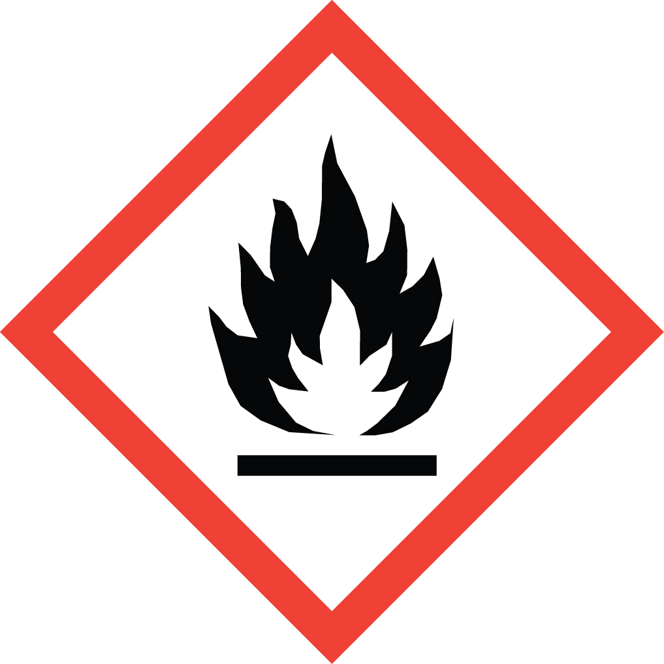 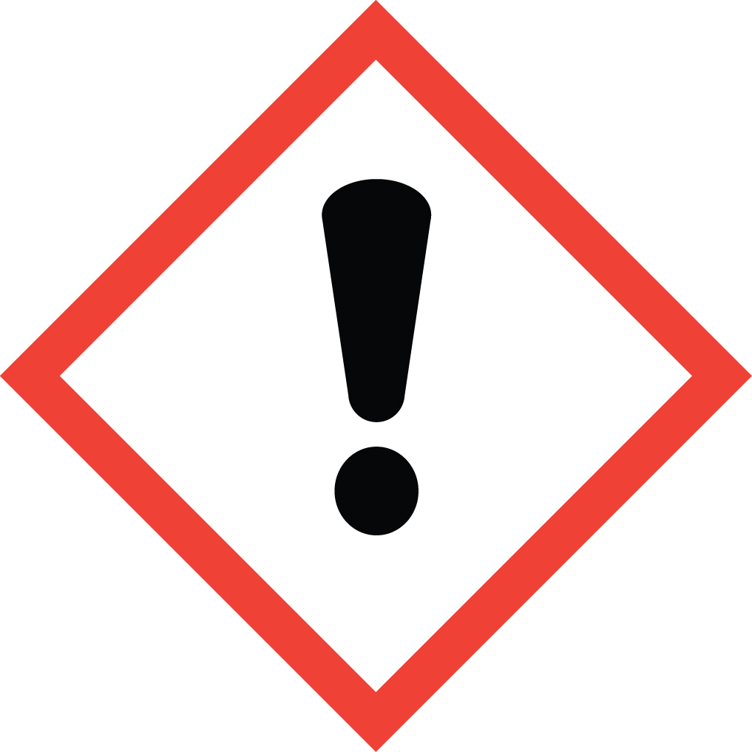 Signal Word: DANGER  Exposure Limits:  DOSH: TWA: 400 ppm; STEL: 500 ppm  NIOSH: TWA: 400 ppm; STEL: 500 ppm  ACGIH: TWA: 200 ppm; STEL: 400 ppm  Toxicological Data:  ORAL (LD50): 5,045 mg/kg [Rat]; 3,600 mg/kg [mouse]; 6,410 mg/kg [Rabbit]  DERMAL (LD50): 12,800 mg/kg [Rabbit]  INHALATION (LC50): 16,000 ppm 8 Hour [Rat]  *Always refer to the Safety Data Sheet for the most detailed information*
3. NAME OF TRAINER /  RESOURCE  PERSON | Principal Investigator Name, Building, Room, Phone Number  Secondary contact Name, Building, Room, Phone Number
- LOCATION OF  HEALTH & SAFETY  INFORMATION | The Safety Data Sheet (SDS) for 2-Propanol is located in the Laboratory Safety Manual in Building, Room.  Labeling: Containers shall either have original warning label affixed or a label identifying the contents and hazards.
5. PROTECTIVE  EQUIPMENT | Wear chemical safety goggles, nitrile gloves, and a fully-buttoned lab coat. Wash hands after removing gloves. Other suitable gloves include butyl, Viton, and neoprene. Work within a properly functioning, certified laboratory chemical fume hood.
- WASTE DISPOSAL  PROCEDURES | Waste 2-Propanol is to be collected in a compatible waste container. The container should be stored away from incompatible material such as oxidizing agents, acid anhydrides, aluminium, halogenated compounds, and acids. A completed Dangerous Waste label should be attached when waste is first added to the container. When full the container must be accompanied by a completed Chemical Collection Request Form, and delivered to the Waste Accumulation Area Operator at Building, Room, Phone Number
7. DESIGNATED AREA  INFORMATION | The 2-propanol is stored and dispensed in Building, Room.  Confine all work with 2-Propanol to a properly functioning certified laboratory fume hood.  The designated area(s) should be shown on the floor plan in Laboratories Chemical Hygiene Plan.
8. DECONTAMINATION  PROCEDURES | Upon Accidental Exposure:  In case of eye contact, flush eyes with copious amounts of water at an emergency eyewash station for at least 15 minutes and consult a physician.  In case of skin contact, flush skin with copious amounts of water for at least 15 minutes. Consult a physician. For exposure over a large portion of the body, remove clothing and shoes and rinse thoroughly in an emergency shower for at least 15 minutes. Consult a physician.  In case of inhalation, move person to fresh air and consult a physician.  In case of ingestion, immediately seek medical attention and follow instructions on SDS.  Upon Accidental Release:  Large Spill: If a large amount of 2-Propanol is spilled outside the fume hood, immediately evacuate, secure area and call 911 to contact EH&S.  Small Spill: If a small amount of 2-Propanol is spilled (it can be cleaned up in 10 minutes) and you have been appropriately trained to clean it up, you may do so. Trained personnel should wear at the minimum nitrile, butyl, Viton, or neoprene gloves, chemical splash goggles, and a fully-buttoned lab coat.  Additional PPE such as respirators may be necessary depending upon material and concentration. (Note: You must be medically cleared, fit tested and enrolled in WSU’s respiratory protection program to wear a respirator). If it is necessary to use a respirator and personnel are not cleared to wear a respirator and not trained to appropriately clean up the spill, the employee should immediately evacuate, secure area, and call 911 to contact EH&S.  Absorb with an inert dry material and place in an appropriate waste disposal container and dispose of as dangerous waste (see above WASTE DISPOSAL PROCEDURES).  As with all accidents, report any exposure as soon as possible to your Principal Investigator or Supervisor. Additional health and safety information on 2-Propanol can be obtained by referring to the SDS or by calling the EH&S Office (335-3041).
- SPECIAL STORAGE  AND HANDLING  PROCEDURES | Store in a cool, dry, well-ventilated area away from heat, sparks, flame, or other sources of ignition. Store segregated from incompatible chemicals (below). Store in a tightly closed container. Ground all equipment containing the material.  Keep away from incompatible chemicals such as oxidizing agents, acid anhydrides, aluminium, halogenated compounds, and acids.

Certification of Hazard Assessment

Is this document a certification of Hazard Assessment for the processes identified within? Yes No
If yes, provide the name of the person certifying the Hazard Assessment and the date it was performed:

____________________________________________________________________________________
Name Date

The location of the Hazard Assessment is indicated in the document preceding this form.

Certificate of Employee Training

Name of person providing training for employees working with this process:

___________________________________________________________________________________
The following employees have been trained in when, where and how to use selected PPE, the maintenance, limitations and disposal of the PPE selected, and have demonstrated the correct use of the PPE selected on the reverse of this certification.
Name Date Trained
________________________________________ _______________________________
________________________________________ _______________________________
________________________________________ _______________________________
________________________________________ _______________________________
________________________________________ _______________________________
________________________________________ _______________________________
________________________________________ _______________________________

