STANDARD OPERATING PROCEDURES FOR HAZARDOUS AND PARTICULARLY HAZARDOUS CHEMICALS
For

2-Mercaptoethanol

1. PROCEDURE /  PROCES | 2-Mercaptoethanol is used in Building, Room.  Insert procedure here:
2. CHEMICAL NAME(S)  and associated  PHYSICAL and  HEALTH  HAZARDS | 2-Mercaptoethanol, CAS # 60-24-2  Also known as 1-Ethanol-2-thiol; 2-Hydroxy-1-ethanethiol; 2-Hydroxyethyl mercaptan; 2-Thioethanol; beta-Mercaptoethanol; Mercaptoethanol; Thioethylene glycol; Monothioethyleneglycol; Thiomonoglycol; Ethanol, 2-mercapto-; Thioglycol; BME  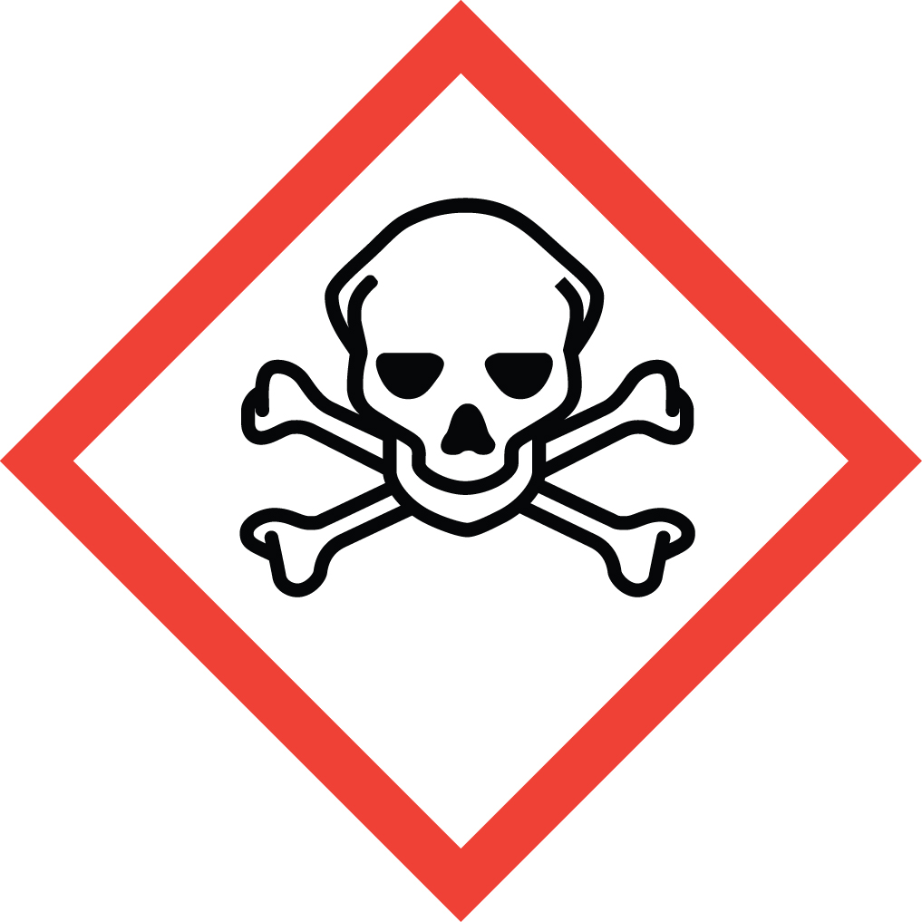 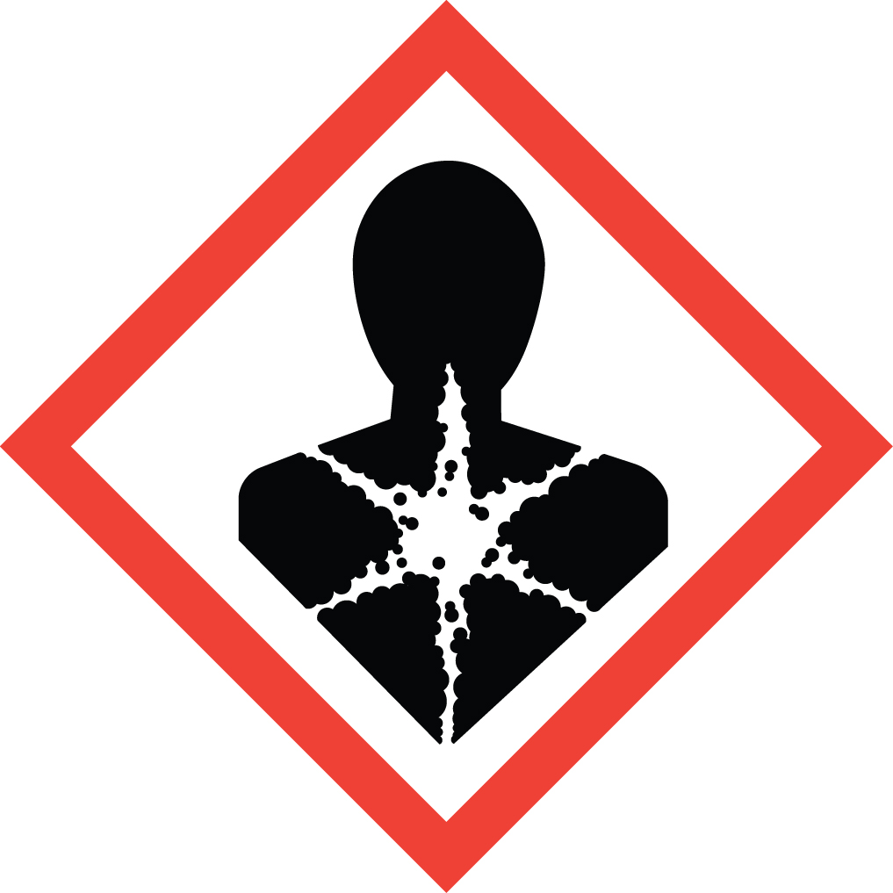 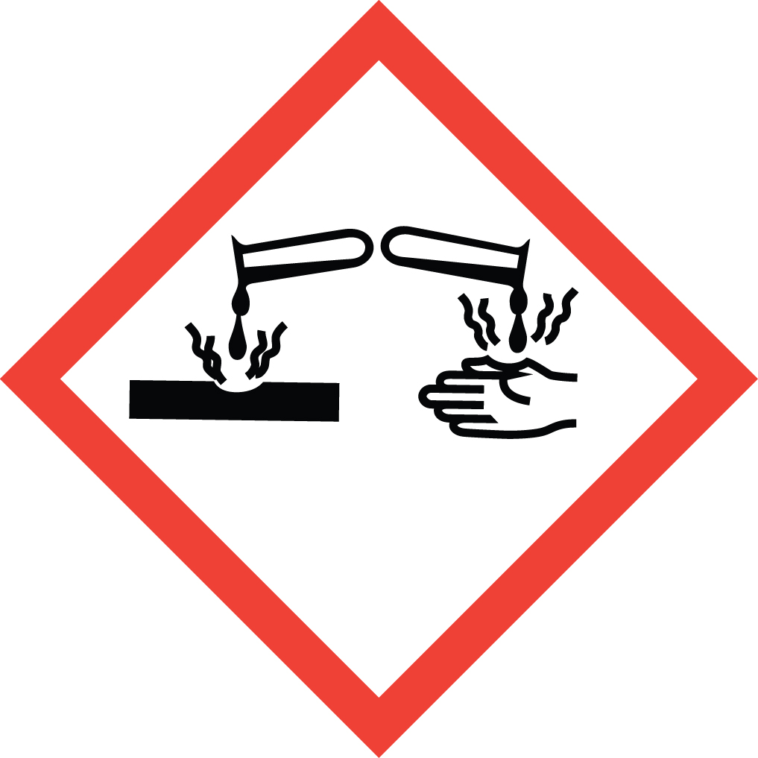 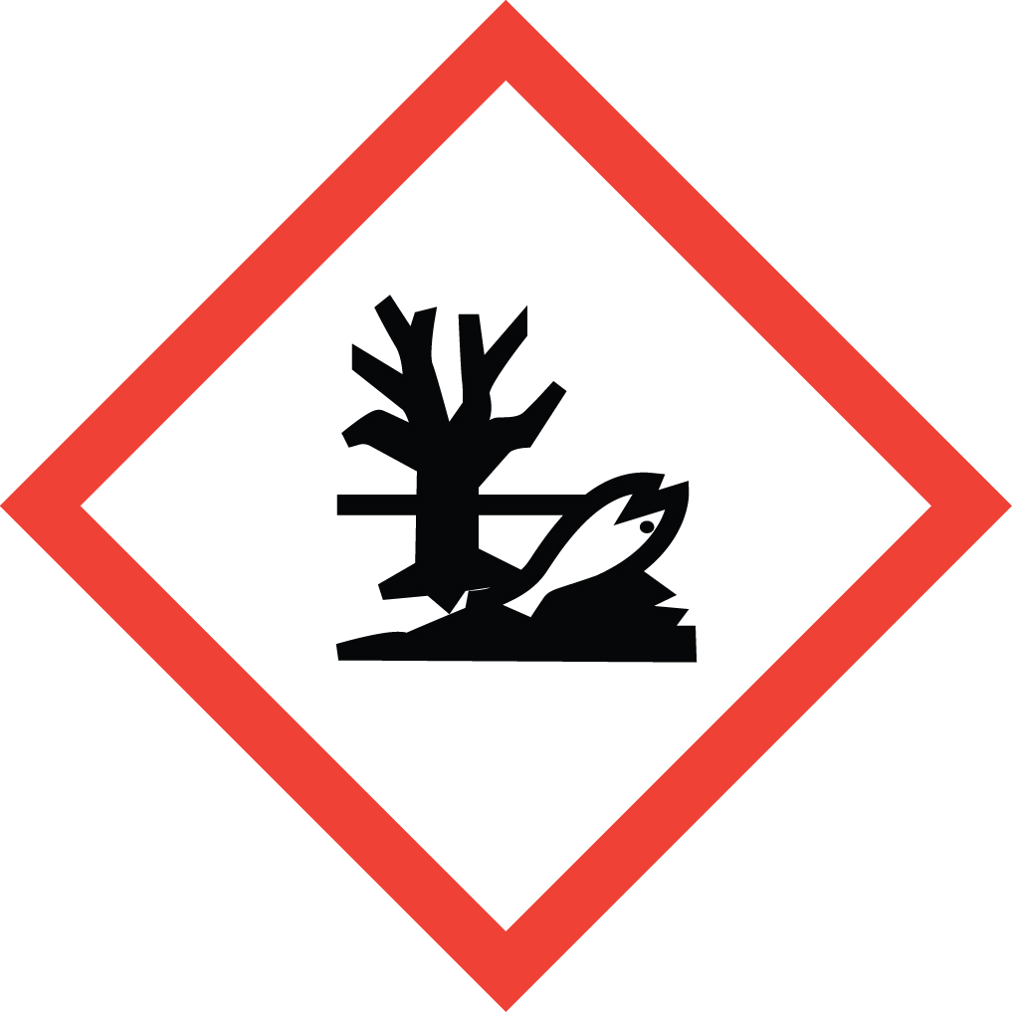 Signal Word: DANGER  Acute Potential Health Effects:  Very hazardous in case of skin contact. May be fatal if absorbed through skin. Causes severe eye irritation. May cause skin and respiratory tract irritation. Do not inhale. It is toxic if swallowed. Severe over-exposure can result in death. Combustible liquid and vapor.  Chronic Potential Health Effects:  Prolonged or repeated ingestion may affect behavior/central nervous system. It is toxic to the following organs: liver, heart, blood, lungs, the nervous system, mucous membranes. It may be mutagenic. Very toxic to aquatic life with long lasting effects.  Toxicological Data:  ORAL (LD50): 244 mg/kg [Rat]. 190 mg/kg [Mouse].  DERMAL (LD50): 300 ul/kg [Guinea pig Rabbit]. 150 ul/kg [Rabbit].  INHALATION (LC50): 2 mg/l; 625 ppm 8 Hours [Rat].  *Always refer to the Safety Data Sheet for the most detailed information*
3. NAME OF TRAINER /  RESOURCE  PERSON | Principal Investigator Name, Building, Room, Phone Number  Secondary contact Name, Building, Room, Phone Number
- LOCATION OF  HEALTH & SAFETY  INFORMATION | The Safety Data Sheet (SDS) for 2-mercaptoethanol is located in the Laboratory Safety Manual located in Building, Room.  Labeling: In addition to the standard label that identifies contents, hazards, precautionary measures, and emergency contact information, containers should also be marked as a highly toxic.
5. PROTECTIVE  EQUIPMENT | Wear chemical safety goggles, nitrile gloves and a fully-buttoned lab coat. If gloves are contacted, replace them immediately. For more than incidental splash contact, wear butyl or Viton gloves. Wash hands after removing gloves. Always work within a properly functioning certified laboratory fume hood.
- WASTE DISPOSAL  PROCEDURES | Waste 2-mercaptoethanol and its solutions should be kept in an airtight compatible container. A completed Dangerous Waste label should be attached when waste is first added to the container. When container is full or no longer being used complete a Chemical Collection Request Form, and deliver to the Waste Accumulation Area Operator at Building, Room, Phone Number. Before moving container ensure there is no material on the outside of the container, because of the extremely low odor threshold.  Although solutions containing less than 0.1% or 1000 ppm of 2-mercaptoethanol are not regulated as Dangerous Waste it is recommended that all solutions are collected and disposed of through EH&S because of the extremely low odor threshold.  Solids that have been in contact with 2-mercaptoethanol (paper towels, empty pipette tips, etc.) should be double bagged on of which being a resealable bag, because of the extremely low odor threshold, and placed into the garbage.
7. DESIGNATED AREA  INFORMATION | 2-mercaptoethanol is stored and used in Building, Room.  Always work in a properly functioning, certified laboratory chemical fume hood.  The designated area(s) should be shown on the floor plan in Laboratories Chemical Hygiene Plan.
8. DECONTAMINATION  PROCEDURES | Upon Accidental Exposure:  In case of eye contact, flush eyes with copious amounts of water at an emergency eyewash station for at least 15 minutes and seek medical attention.  In case of skin contact, flush skin with copious amounts of water for at least 15 minutes and seek medical attention. For exposure over a large portion of the body, remove clothing and shoes and rinse thoroughly in an emergency shower for at least 15 minutes. Seek medical attention.  In case of inhalation, move person to fresh air and seek immediate medical attention.  In case of ingestion, immediately seek medical attention and follow instructions on SDS. Do NOT induce vomiting. If person is conscious, rinse mouth with water. Never give anything by mouth to an unconscious person.  Upon Accidental Release:  Large Spill: If a large amount of 2-mercaptoethanol is released outside the fume hood, immediately evacuate, secure the area and call 911.  Small Spill: If a small amount of 2-mercaptoethanol is released (it can be cleaned up in 10 minutes) and you are appropriately trained to clean up the spill, you may do so.  Trained personnel should wear at the minimum nitrile, butyl or Viton gloves, chemical splash goggles, fully buttoned lab coat and a half mask or powered air purifying respirator equipped with organic vapor cartridges and a high efficiency dust/mist filter (Note: You must medically cleared, fit tested and enrolled in WSU’s respiratory protection program to wear a respirator). If it is necessary to use a respirator and personnel are not cleared to wear a respirator and not trained to appropriately clean up the spill, the employee should immediately evacuate, secure area, and call 911 to contact EH&S.  Absorb the spilled material, clean the area and place cleanup materials in appropriate containers and dispose of as Dangerous Waste (see above WASTE DISPOSAL PROCEDURES).  As with all accidents, report any exposure as soon as possible to your Principal Investigator or Supervisor. Additional health and safety information on 2-mercaptoethanol can be obtained by referring to the SDS or by calling the EH&S Office (335-3041).
- SPECIAL STORAGE  AND HANDLING  PROCEDURES | Keep secured and store in a tightly closed container in a cool, dry, ventilated area away from sources of sunlight, heat, sparks, flame or other sources of ignition. Ground all equipment containing material. Recommended storage temperature is 2-8 °C.  Keep away from incompatibles such as oxidizing agents, reducing agents, metals, and alkalis. When heated to decomposition it emits toxic fumes.  Fire or contact with water may produce irritating, toxic and/or corrosive gases. Vapor may travel considerable distance to source of ignition and flash back.

Certification of Hazard Assessment

Is this document a certification of Hazard Assessment for the processes identified within? Yes No
If yes, provide the name of the person certifying the Hazard Assessment and the date it was performed:

____________________________________________________________________________________
Name Date

The location of the Hazard Assessment is indicated in the document preceding this form.

Certificate of Employee Training

Name of person providing training for employees working with this process:

___________________________________________________________________________________
The following employees have been trained in when, where and how to use selected PPE, the maintenance, limitations and disposal of the PPE selected, and have demonstrated the correct use of the PPE selected on the reverse of this certification.
Name Date Trained
________________________________________ _______________________________
________________________________________ _______________________________
________________________________________ _______________________________
________________________________________ _______________________________
________________________________________ _______________________________
________________________________________ _______________________________
________________________________________ _______________________________

