Version April 2013



Washington State University
Environmental Management System

Washington State University
Environmental Management System

Table of Contents

Introduction...........................................................................................................................4

1. Scope.................................................................................................................................5

2. Normative References.......................................................................................................5

3. Terms and Definitions......................................................................................................5

4. Environmental Management System Requirements

4.1. General Requirements. ……………………………………………………….5

4.2. Environmental Policy ………………………………………………………...6

4.3. Plan- EMS Planning ...………………………………………………………7

4.3.1. Environmental Aspects and Significant Impacts…………………...7
4.3.2. Legal and Other Requirements ………………….…………………8
4.3.3. Objectives and Targets……………………………………………..8
4.3.4. EMS Environmental Programs…………………………………......9

4.4. Do- EMS Implementation and Operation

4.4.1. Structure and Responsibility……………………………………….10
4.4.2. Competence, Training and Awareness……………………………..10
4.4.3. Communication…………………………………………………….12
4.4.4. EMS Documentation and Document Control………………………12
4.4.5. Operational Control………………………………………………...13
4.4.6. Emergency Preparedness and Response……………………………13

4.5. Check and Advance – Monitoring, Auditing, and Improving

4.5.1. Monitoring and Measurement...........................................................14
4.5.2. Evaluation of Compliance.................................................................14
4.5.2.1. Compliance with legal requirements………………………14
4.5.2.2 Compliance with other requirements……………………....14
4.5.3 Nonconformity, Corrective Action and Preventive Action………....14
4.5.4 Control of Records…………………………………………………..15
4.5.5 Internal Audits………………………………………………………15

4.6 Management Review…………………………………………………………16
Appendix 1 EMS Organizational Chart……………………………………………17
Appendix 2 Aspect and Impact Evaluation Worksheet……………………………18
Appendix 3 EMS Regulatory Resources…………………………………………..19
Introduction

WSU implemented Pollution Prevention Program in ??? and established its Environmental Management System (EMS) in 1999. WSU’s EMS is structured after the ISO 14001 and Washington Department of Ecology EMS models. The EMS documents WSU’s attempts to continuously improve its operations (facilities design, operation, maintenance, waste management, energy management, etc.), products, services, and related environmental programs. The WSU EMS supports, but does not directly address traditional university environmental research, education, or extension programs at WSU. However, the EMS may coordinate activities with these other traditional programs as it relates to WSU operations, products and services and related environmental programs. Please see Appendix 1 for a WSU EMS organizational chart.

The EMS for WSU operations is also linked to traditional research, education and extension programs through the institution’s Sustainability Initiative, Executive Policy # 24. EMS and Sustainability efforts at WSU are integrated and coordinated by the WSU Sustainability and the Environment Committee (SEC). The committee consists of four faculty, four students and four staff that are active in sustainability and environmental programs and departments at WSU. This committee has been established to coordinate sustainability and environmental activities between faculty, staff, and students and to ensure WSU maintains its position as an environmental leader as it meets its educational, research, and extension missions, and its operations. The committee, executive policy # 24, and EMS support WSU’s strategic goals.

This EMS currently applies only to the Pullman Campus non-academic units.

WSU’s EMS has been developed and is implemented by professionals having expertise in vital areas (aspects) of the University’s operations. These experts are Aspect Coordinators who oversee and coordinate efforts within the departments. Aspect Coordinators are responsible for identification of aspects of their operations activities, products and services’ that have environmental and energy impacts. They identify and document objectives and targets to improve their program’s environmental and energy performance for their category.

The aspects and their respective coordinators are:

- Air – Air Quality Program Coordinator , Environmental Health and Safety (EH&S)
- Energy – Director Energy Systems and Operations, Facilities Operations (FO)
- Facility Design, Construction and Maintenance – EH&S Capital Services Coordinator
- Food – Director, Dining Services
- Hazardous Materials – Environmental Services Manager, EH&S
- Procurement – Associate Director, Purchasing Services
- Waste Management – Manager, Waste Management Services(FO)
- Water – Water Quality Program Coordinator, EH&S
- Transportation – Parking and Transportation Services Director

1 Scope

Non-academic unit operation’s activities, services, products, and environmental programs on the main Pullman Campus fall within the scope of this WSU Environmental Management System (EMS). All other WSU operations, activities, products and environmental programs at other WSU locations are excluded as are tenant operations and activities.

2 Normative References

Unless otherwise stated, all references sited within this EMS refer to the most recent versions of the separate documents.

3 Terms and Definitions

Terms and definitions shall consist of those terms and definitions in the most recent ISO 14001 unless otherwise noted in this WSU EMS Program Document. For clarification of several frequently used terms in WSU’s EMS the following definitions will be used.

Aspect – element of WSU’s activities, services, products, or facilities that can interact with the environment

Impact – any change to the environment, whether adverse or beneficial, wholly or partially resulting from WSU’s activities, services, products, or facilities

Operations – activities, products and services

4 Environmental Management System Requirements

4.1 General Requirements

This EMS Program Document, documents WSU Pullman’s Operations attempts to continuously improve environmental performance using a plan, do, check, and advance model for its operation’s activities, products and services and environmental programs at the WSU Pullman campus.

The EMS documents organizational structure, planning activities, responsibilities, practices, procedures, processes and resources for developing, implementing, achieving, reviewing, maintaining and improving its Operations with environmental impacts and environmental programs at WSU.

4.2 WSU EMS Environmental Policy
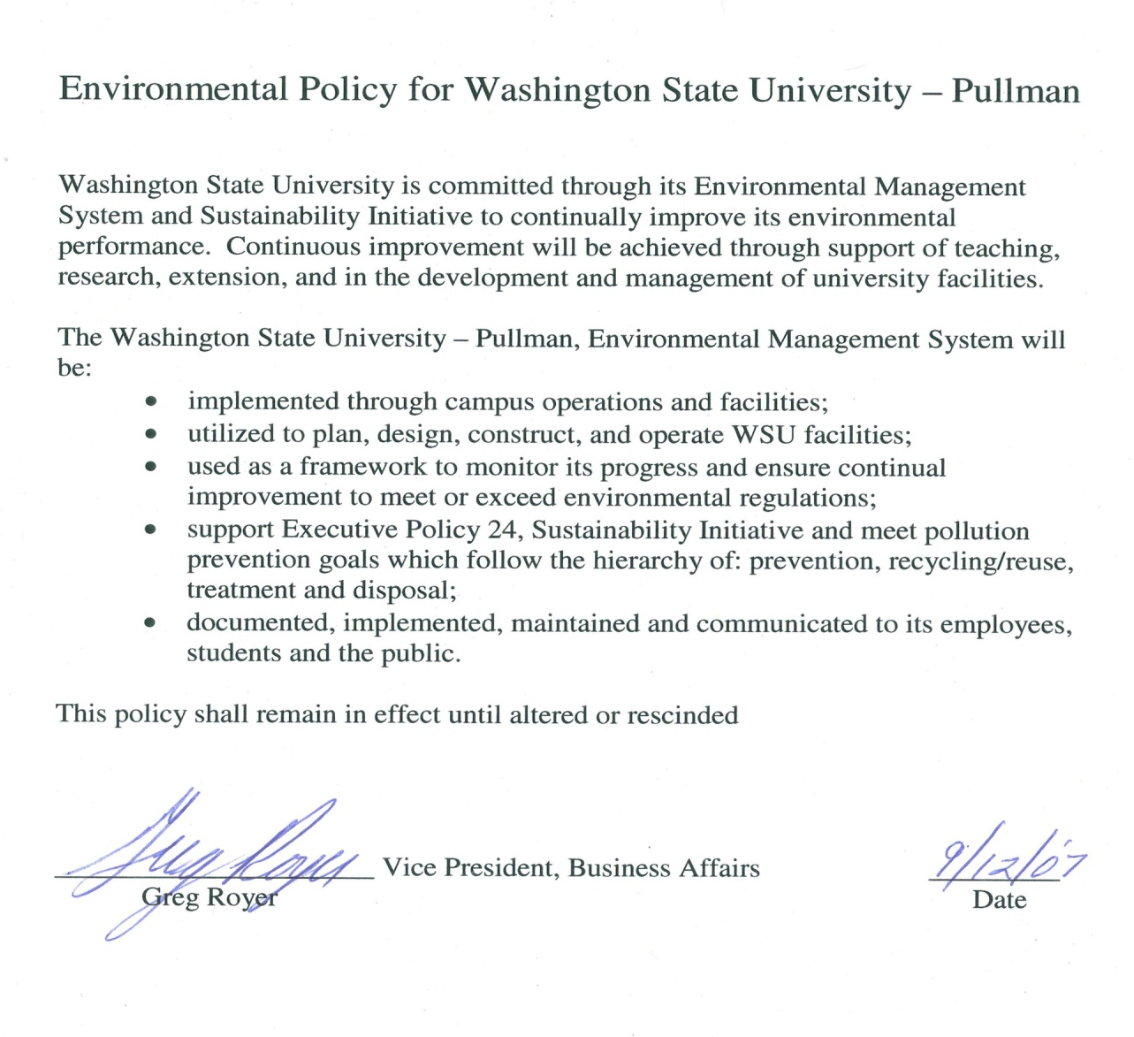

4.3 Planning-EMS Planning

The process and procedure to identify WSU operation’s environmental aspects (element of WSU’s activities, products or services that significantly interact with (impact) the environment) is limited to those that it can control. WSU Pullman has identified categories of its operations that meet these criteria using inputs from administrators, faculty, staff, students, regulators, and the general public

4.3.1 Environmental Aspects and Significant Impacts

Environmental Aspects

WSU is committed to identifying and reasonably minimizing negative environmental impacts and enhancing positive environmental impacts of its environmental aspects. The activities, services, products, and facilities that impact the environment in this EMS are those which WSU can reasonably control and influence.

The identification of environmental aspects and their impacts on the environment is an ongoing process. This process includes the identification of new or remodeled university facilities and changing university activities, services or products and their impacts on the environment

Significant Environmental Impacts

The identification of significant environmental impacts is an ongoing process. This process includes the identification of new or remodeled university facilities, and changing university activities.

EMS aspect coordinators review and revise the list of environmental impacts as needed. EH&S coordinates this effort with University Administrative Officials, University committees and the general public.

Environmental Aspect/Impact Evaluation Worksheet

Each EMS aspect coordinator, with assistance from EH&S, periodically reviews and revises their environmental aspect/impact evaluation worksheet. EH&S coordinates this effort with University Administrative Officials, University committees, and the general public. These worksheets are summaries of the positive and negative impacts environmental aspects have or may have on the environment.

It allows WSU to compare and prioritize which facilities or activities have the most negative or potentially most positive environmental impacts. The worksheets are a tool to identify priorities for EMS objectives and targets, the allocation of limited resources to improve environmental performance, promote sustainability, and maintain regulatory compliance.

The Environmental Aspect and Impact Evaluation Template Worksheet is Appendix 2.

4.3.2 Legal and Other Requirements

WSU uses several resources to monitor new and changes to relevant environmental laws and regulations. See Appendix 3.

WSU identifies and communicates applicable environmental laws, regulations, and other requirements to students, faculty, and staff using WSU Safety Policy and Procedures, WSU web sites, WSU Announcements (daily e-mail broadcast), live and webcast training sessions, and other means, as appropriate.

EH&S, at least annually, reviews environmental laws and regulations and provides information regarding updates and changes to aspect coordinators.

4.3.3 Objectives and Targets

EMS objectives are environmental goals that WSU sets annually.

EMS targets are steps to achieve those objectives within a specified time-frame. EMS targets are specific and measurable.

WSU reviews and revises environmental objectives and targets annually for each EMS aspect. EH&S coordinates this effort with University Administrative Officials, University committees, and the general public

The environmental objectives and targets are consistent with the environmental policy, including the commitments to continual improvement, pollution prevention, and compliance with environmental laws and regulations. When establishing and reviewing its environmental objectives and targets, Washington State University considers:

- environmental concerns of staff, faculty, students and other interested parties
- significant environmental aspects and their environmental impacts
- technological, financial, operational, and other university requirements
- legal and other requirements

Environmental objectives and targets are developed based on the results of completing the Environmental Aspects and Impacts Worksheet Appendix 4.

Collaborating with University Administrative Officials, university committees and the general public, environmental objectives and targets are developed and are included in each annual report.

4.3.4 EMS Environmental Programs
Environmental management programs at WSU work together as a team to achieve EMS objectives and targets. The roles and responsibilities of these departments are listed below.

Department Farms
(each department responsible
For own procedures) Animal waste management

Dining Services Sustainable food procurement
Sustainable food production program

Environmental Health and Safety Air quality program
Water quality program
Hazardous materials management program
Hazardous waste management program
Universal waste management program
Public health biological safety
Environmental management system/sustainability coordination

Facilities Services-Capital
Planning and Development Building construction and major remodels
Stormwater runoff control from construction sites
Environmental assessments and impact statements

Facilities Services-Facilities
Operations Minor building remodels
Operate potable and non potable water system
Maintain sanitary and storm sewer system
Operate steam and chiller plants
Energy management program
Road Maintenance
Operate and maintain campus fleet
Maintain facilities and equipment

Facilities Services-Waste
Management Recycling
Composting
Medical/pathological waste management
Solid waste management
Surplus material sales and disposal

Parking and Transportation
Services Alternate transportation options

Procurement Green purchasing options

Radiation Safety Radioactive waste management

4.4 Do – EMS Implementation and Operation

4.4.1 Structure and Responsibility

Environmental management roles, responsibilities, and authority at WSU are defined, documented and communicated in the WSU Safety Policy and Procedures Manual, Business Policies and Procedures Manual, and Executive Policy 24.

WSU management provides resources essential to the implementation and control of the EMS. Resources include human resources and specialized skills, technology, and financial resources.

The Executive Director of EH&S serves as the EMS Management Representative and Coordinator. The EMS Management Representative and Coordinator is responsible and has the authority to:

- Ensure WSU’s EMS is established implemented, maintained, in accordance with reasonable and applicable standards and regulations;
- Reporting on the performance of the EMS to WSU’s top management including
recommendations for improvement;
- Working with others to continuously improve the EMS.

4.4.2 Competence, Training, and Awareness

Competence:

Personnel performing tasks which may cause significant environmental impacts shall be competent on the basis of appropriate education, training and/or experience. Department Chairs and Directors shall determine the level of experience, competence, and training necessary to ensure the capability of personnel carrying out the performance of tasks that have or may be reasonably expected to have significant environmental impacts.

Training:

Training requirements are based on environmental program responsibilities. See Section 4.3.4.

WSU has identified training needs for the EMS and personnel associated with environmental aspects whose work may create a significant impact upon the environment and has retained or has access to associated records. Those records are maintained at several locations at WSU Pullman.

Awareness:

EMS Awareness for students, faculty, staff and Local Stakeholders:

A. EMS awareness is made available to employees on the EH&S website. The website provides the EMS Program Document and through the annual reports a summary of past and future goals (objectives and targets), and recent accomplishments that have improved WSU’s environmental performance.

B. EMS awareness also occurs in classes such as ESRP 490/590 Environmental Management Systems and Sustainability, and during the Sustainability and the Environment Committee meetings.
C. Students, faculty, staff and local stakeholders are encouraged to provide environmental concerns and/or suggestions for environmental improvement(s).

EMS aspect coordinators and EH&S establish, implement, and maintain procedures for WSU to ensure contractors are aware of:
- the importance of following environmental policies, procedures, and requirements of the EMS;
- actual or potential environmental impacts of their work activities and the environmental benefits of improved performance;
- their roles and responsibilities in achieving conformance with the environmental policy and procedures and with the requirements of the EMS, including emergency preparedness and response; and
- potential consequences of departure from specified operating procedures.

4.4.3 Communication

WSU provides internal communication regarding its EMS and provides a procedure for receiving, documenting, and responding to relevant communication from external interested parties.

Internal Communication Procedures

Internal communication procedures regarding environmental aspects and the EMS include:

- WSU EH&S website
- The WSU Sustainability and Environment Committee
- Classes (e.g. ES/RP 490/590 – EMS and sustainability

External Communication Procedures

When Aspect Coordinators and EH&S receive communication about the EMS from external interested parties they will respond and document the communication. Those files will be kept at each coordinator’s office.

4.4.4 EMS Documentation and EMS Document Control

Washington State University’s EH&S maintains information, in paper and electronic form.

WSU EMS documentation has four types of records:

1. WSU EMS Program Document

The WSU EMS Program Document is available on the WSU EH&S website and working revisions are available at the WSU EH&S building.

2. WSU EMS Annual Reports

WSU EMS Annual Reports are on the WSU EH&S website.

The WSU EMS Annual Reports contain WSU EMS objectives and targets. EH&S coordinates with EMS Aspect Coordinators to develop and submit the annual report to ensure it meets the Washington Department of Ecology EMS annual reporting requirements.

3. WSU Safety Policies and Procedures Manual and Business Policies and Procedures Manual

WSU EMS Safety Policies and Procedures Manual and Business Policies and Procedures Manual are located at http://www.wsu.edu/~forms/manuals.html

4. EMS Audit Report Records

Internal and external EMS audit report records will be kept at the Environmental Health and Safety Building.

4.4.5 Operational Control

WSU has identified and planned its Operations potential for significant environmental impacts so they are consistent with the EMS environmental policy, objectives and targets. This is accomplished by establishing and maintaining documented procedures to cover situations where their absence could lead to deviations from the EMS and determining which Operations should be covered by documented procedures and how those Operations should be controlled.

The Operations that have significant environmental impacts are documented in Section 4.3.4.

4.4.6 Emergency Preparedness and Response

WSU has identified potential accidents and emergency situations to establish and maintain procedures to prevent, respond to, mitigate and recover from the environmental impacts that may be associated with them.

Emergency plans and procedures have been developed at WSU to respond to abnormal operating conditions, accidents and emergencies. These plans and procedures comply with applicable regulatory requirements by minimizing and mitigating environmental impacts that may be associated with the incidents. WSU emergency management plans include:

- WSU’s Emergency Response Plan (contact public safety 5-5524 for a template)
- WSU’s Safety Policies and Procedures Manual/Business Policies and Procedures Manual
- WSU’s Office of Emergency Management website – http://oem.wsu.edu/
- Preparedness and Prevention and Contingency Plan
- Departmental Emergency Response Plan and Continuity of Operations Program Template
- Dangerous Waste Generator Personnel Training Program
- Emergency Response Procedures for EH&S Personnel
- Spill Prevention Control and Countermeasure oil handler training
- Laboratory Safety Manual

4.5 Check and Advance – Monitoring, Auditing, and Improving

4.5.1 Monitoring and Measurement

Procedures to monitor and measure Operations which potentially have significant environmental impacts have been developed and are reviewed periodically. These documented procedures:

- monitor the key characteristics of the various Operations
- track progress on objectives and targets (Section 4.3.3)
- ensure proper calibration and maintenance of monitoring equipment

Aspect Coordinators are responsible for coordinating and evaluating monitoring and measuring efforts for their respective categories. For information on the EMS Environmental Programs that have significant environmental impacts, please refer to Section 4.3.4. Each Environmental Program is responsible for the calibration and maintenance of their monitoring and measuring equipment.

Attributes of an effective monitoring and measuring program:
- simple
- flexible
- consistent
- ongoing
- produce reliable data
- communicate results

4.5.2 Evaluation of Compliance

4.5.2.1 Compliance with legal requirements

EH&S uses a compliance calendar to evaluate and maintain compliance with environmental permits and other regulatory reporting requirements. The calendar is kept at the EH&S building and is available upon request.

4.5.2.2 Compliance with other requirements

Compliance with voluntary standards and certifications will be verified through annual internal audits (Section 4.5.5) and various reporting requirements.

4.5.3 Nonconformity, Corrective Action and Preventive Action

- Environmental program personnel are responsible for identifying and managing nonconformities, corrective and preventive actions in their categories. Personnel make a written record of nonconformance(s) and corrective/preventive actions which are tracked until completion. It is not required to act immediately to each nonconformity. WSU will take action appropriate to the magnitude of the problem(s) or improvement opportunities and commensurate with the environmental impacts encountered.

- Personnel assigned investigation responsibility will work to determine the cause of the problem or improvement opportunity.

- If it is determined that action is warranted, then the environmental program personnel for the programs identified in Section 4.3.4 will have the responsibility for ensuring effective development and implementation for that corrective/preventive action or implementation.

- Once the action is implemented, the program personnel have the responsibility to verify that the proposed action was taken and to assess the effectiveness of that action. If the action is determined ineffective, then the action will be reviewed, and any changes should be made in order to increase chances of successfully resolving the original problem.

4.5.4 Control of Records

Procedures for the identification, maintenance and management of environmental records, including training records, and the results from audits and management reviews are the responsibility of EH&S.

Environmental records will be legible, identifiable, and traceable to the activity and/or service involved. The environmental records will be stored and maintained in such a way that they are readily retrievable and protected against damage, deterioration or loss. Records are retained in accordance with policies set forth at the WSU Business Policies and Procedures Manual, Section 90.01.

4.5.5 Internal Audits

WSU conducts an internal audit of the EMS at least once every 5 years, preferably once every three years. Audits are conducted by a team consisting of environmental management professionals and others as appropriate. This ensures that the team has sufficient technical expertise, familiarity with the EMS and that the process is impartial. In lieu of an internal audit, an external audit may be performed as resources allow.

Audits are conducted to determine if the EMS:
- conforms to the EMS Program Document and applicable State of Washington Department of Ecology requirements
- has been properly implemented and maintained

Audit findings are reported to management.

Audits are planned and conducted taking into consideration the environmental importance of the Operations within the scope of the EMS and the results of previous audits.

Audit procedures address:

- the responsibilities and requirements for planning and conducting audits, reporting results and retaining associated records
- the determination of audit criteria, scope, frequency and methods

4.6 Management Review

Top management reviews the EMS periodically, to ensure its continuing suitability, adequacy and effectiveness.

The management review addresses:

- policy
- results of internal audits and evaluation of compliance with legal and other requirements to which the University subscribes
- external communications
- the University’s environmental performance
- progress toward and/or accomplishment of environmental objectives and targets
- the status of corrective and preventive actions
- follow-up from previous management review(s)
- emerging issues and changes in legal and other requirements related WSU’s environmental aspects, and
- recommendations for improvement

This review will be documented in accordance with Section 4.5.4 – “Control of Records”.

Appendix 1
EMS Organizational Chart
2008
Academic Units
Vice Provost for Student Affairs
Vice Provost for Research
Vice Provost for Academic Affairs
Risk Management
Parking and Transportation Services
Facilities Operations
f
Environmental Health and Safety
Dining Services
Capital Planning and Development
Provost and Academic Vice President
Vice President, Business and Finance
Sustainability and the Environment Committee
President

Appendix 2 Aspect and Impact Evaluation Worksheet

- Rank each Impact (1 – 5) relative to each Aspect* with a ranking of “1” meaning the impact is the least important consideration for that aspect and a ranking of “5” meaning it is the most important, using each value only once per impact.
- Total the columns.
- Scores shall be utilized as a factor in determining project priority.

Category: ____________________________________________________________
Aspect
 | Acquisition | Transportation | Storage | Use | Disposal
Human Health
Air
Water
Soil
Regulations
Score

*This matrix is provided as a guideline and customizable template for Category Coordinators. Aspects and impacts listed on this matrix should be considered when designing category specific documents. Non-applicable items may be deleted and appropriate items added as needed.

Appendix 3

EMS Regulatory Resources

Legal and other Requirements Resources | WSU’s access to resource
Government publications (e.g. Federal Registrar, Code of Federal Regulations, Registered Code of Washington Administrative Code, and local ordinances | - Monitor and evaluate the Federal Register, Code of Federal Regulations, Revised Code of Washington, Washington Administrative Code and local ordinances on line.  - Current hardcopies are monitored and maintained by EH&S if not available on line.
Newsletters / Magazines | - Subscriptions to environmental newsletters such as Environmental Managers Compliance Advisor, Safety and Health NSC, and DOE WAC Track.  - WSU EH&S Notes newsletter is circulated throughout the university.
Trade Groups / Associations / Committees | - EH&S Director:  - Campus Safety Health Env. Management Association  - Secretary of University-wide Health and Safety Committee  - Risk-management Committee  - EH&S Program Area Managers are affiliated with various environmental associations and committees.
Commercial Services | - Consultants and vendors provide regulatory updates in their marketing materials
The Internet | - EH&S Director and Program Area Managers monitor a variety of list serves, such as Dept. of Health and Dept. of Ecology.  - EH&S staff accesses to retrieve relevant environmental laws and regulations
Public Libraries | - EH&S staff access various sources and records
Seminars and Courses | - Continual training provided by regulatory agencies and commercial sources (see section 4.4.2 – Training and Competence)

