Methanol
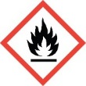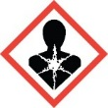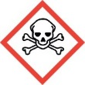

DANGER

Highly flammable liquid and vapor.
Toxic if swallowed, in contact with skin or if inhaled.
Causes damage to organs.

Transferred By: | Date Transferred:

