MgtOp 470

Professor Munson

Topic 3

VBA Programming in Excel for
Decision Support Systems

(Set 3—Control Logic and Loops, Worksheets, Calling Subs & Passing Arguments, Global vs. Local Variables)

“The programming tools discussed in [chapter 7] are arguably the most important tools in VBA or any other programming language.”

Albright, S. Christian, VBA for Modelers, 5th Ed., Cengage Learning, 2016, p. 143
Control Logic and Loops

Control logic instructs the program to perform a task or tasks based on one or more conditions

1. If Construction
Redirects the program when a condition holds

2. Case Construction
Redirects the program based on multiple mutually exclusive conditions (cases)

“Looping” instructs the program to perform a repetitive task potentially many times. In VBA, we use FOR and DO.

1. For Loop
Performs a specified number of iterations using a counting variable to keep track

2. For Each Loop
Performs an iteration for every object in a collection (e.g., for each cell in a range)

3. Do Loop
Performs an iteration either while some condition holds or until some condition occurs

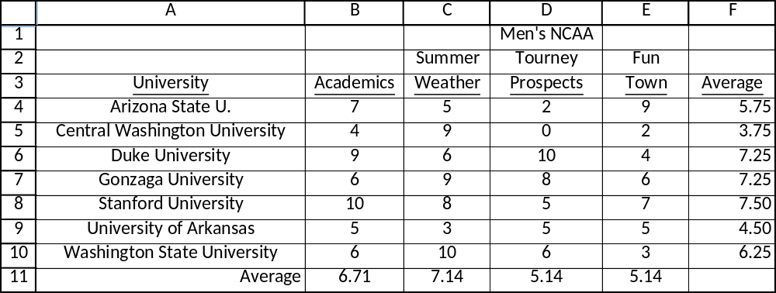

If Construct

Provides instruction based on whether or not a condition holds. A condition is any expression that is either true or false.

Four Versions
1. Single-line
Ex: If Range(“D4”).Value < 4 Then Range(“D4”).Font.Color = vbRed
These can include an optional Else condition:
If Range(“F9”).Value < 5 Then Range(“A9”).Font.Strikethrough _
= True Else Range(“A9”).Interior.Color = vbYellow

2. If-Then-Else-End
Ex: If Range(“F4”).Value > Range(“F5”).Value Then
Range(“A5:F5”).Font.Strikethrough = True
Else
Range(“A4:F4”).Font.Strikethrough = True
End If
3. If-Then-ElseIf-Else-End
Ex: Dim max As Double
max = WorksheetFunction.MAX(Range(“F4:F10”))
If Range(“F4”).Value = max Then
MsgBox “I’m going to Arizona State!”
ElseIf Range(“F5”).Value = max Then
MsgBox “I’m going to CWU!”
ElseIf Range(“F6”).Value = max Then
MsgBox “I’m going to Duke!”
ElseIf Range(“F7”).Value = max Then
MsgBox “I’m going to Gonzaga!”
ElseIf Range(“F8”).Value = max Then
MsgBox “I’m going to Stanford!”
ElseIf Range(“F9”).Value = max Then
MsgBox “I’m going to Arkansas…Whooo Pig Sooey!”
Else
MsgBox “I’m gonna be a Coug, baby!”
End If

4. Nested If statements
Ex: Dim maxi As Double
maxi = WorksheetFunction.MAX(Range(“F4:F10”))
If Range(“F4”).Value = maxi Or Range(“F6”).Value = maxi Then
If Range(“D4”).Value > Range(“D6”).Value Then
MsgBox “I’m going to Arizona State!”
Else
MsgBox “I’m going to Duke!”
End If
Else
MsgBox “I’m gonna be a Coug, baby!”
End If

Case Constructions

When there are more than two alternative values for a variable, the case construction may be more efficient than using multiple ElseIf statements. The first line starts with Select Case, followed by the variable name. The construction must end with End Select. And every “case” in the middle must start with Case.

Possible Ways to Express the Case
- Case 7 (the value of the variable equals 7)

- Case 3 to 12 (the value of the variable is anything between 3 and 12 inclusive)

- Case Is >= 15 (the value of the variable is ≥ 15)

- Case Else (the value of the variable is something other than all the possibilities described in the preceding cases)

Another way to write the If-Then-ElseIf-Else-End example:

Ex: Dim max As Double
Dim ASU As Double, CWU As Double, DUKE As Double
Dim ZAGS As Double, STAN As Double, HOGS As Double
max = WorksheetFunction.max(Range("F4:F10"))
ASU = Range("F4").Value
CWU = Range("F5").Value
DUKE = Range("F6").Value
ZAGS = Range("F7").Value
STAN = Range("F8").Value
HOGS = Range("F9").Value

Select Case max
Case ASU
MsgBox "I'm going to Arizona State!"
Case CWU
MsgBox "I'm going to CWU!"
Case DUKE
MsgBox "I'm going to Duke!"
Case ZAGS
MsgBox "I'm going to Gonzaga!"
Case STAN
MsgBox "I'm going to Stanford!"
Case HOGS
MsgBox "I'm going to Arkansas…Whooo Pig Sooey!"
Case Else
MsgBox "I'm gonna be a Coug, baby!"
End Select
For Loops

For loops will repeat a set of statements n times. A counter (usually) starts at 1 and increases by 1 at the start of each iteration. The counter variable itself is often used in the statement logic. The loop must start with For and end with Next.

The following example computes the sum of the first 1000 positive integers:
Ex: Dim sum As Long
Dim i as Long
sum = 0
For i = 1 to 1000
sum = sum + i
Next
MsgBox “The sum of the first 1000 positive integers is ” _
& sum & “.”

Exercise A
Have the user enter which first n integers to add.

Exercise B
Create a function that returns the sum of the first n positive integers.

The following example computes the number of schools with an “Academics” score ≥ 6:
Ex: Dim totalHigh As Integer
Dim i As Integer
totalHigh = 0
With Range(“B3”)
For i = 1 to 7
If .Offset(i,0) >= 6 Then totalHigh = totalHigh + 1
Next
End With
MsgBox “There are “ & totalHigh & _
“ schools with an Academics score >= 6.”

Nested For Loops (especially useful for rectangular ranges)
Ex: Dim totalHigh As Integer
Dim i As Integer
Dim j As Integer
totalHigh = 0
With Range(“A3”)
For i = 1 to 7
For j = 1 to 4
If .Offset(i,j) >= 6 Then totalHigh = totalHigh + 1
Next
Next
End With
MsgBox “There are “ & totalHigh & “ instances with a score >= 6.”
Exercise C: Use the Cells property and nested For Loops to build a 10×10 multiplication table.
For Each Loops

Use these to loop through all objects in a collection. You don’t even have to know how many objects there are!

Applications
looping through all cells in a range
looping through all worksheets in a workbook
looping through all chart sheets in a workbook
looping through all worksheets and charts in a workbook
looping through all range names
and many more!

Ex: Dim entry As Range
Dim counter As Long
counter = 0
For Each entry in Range(“B4:E10”)
If entry.value >= 7 Then counter = counter + 1
Next
MsgBox “There are “ & counter & “ scores >= 7.”

Ex: Dim entry As Range
For Each entry in Range(“F4:F10”)
If entry.value >= 7 Then entry.font.color = vbBlue
Next

Do Loops

Four Variations
Check Before Looping:
1. Do Until...Loop

Ex: Dim total As Double
total = 2
Do Until total >= 20
total = total^2
Loop
MsgBox “The smallest value is ” & total & “.”

2. Do While...Loop

Ex: Dim total As Double
total = 2
Do While total < 20
total = total^2
Loop
MsgBox “The smallest value is ” & total & “.”

Check After Looping:
1. Do...Loop Until

Ex: Dim total As Double
total = 2
Do
total = total^2
Loop Until total >= 20
MsgBox “The smallest value is ” & total & “.”

2. Do...Loop While

Ex: Dim total As Double
total = 2
Do
total = total^2
Loop While total < 20
MsgBox “The smallest value is ” & total & “.”
Example of a Do Loop:
Applying an action to a list of unknown size

Suppose that there is a list of numbers in column A starting with Cell A1, and you want to grow each of those numbers by 10%.

Range(“A1”).Select
Do Until ActiveCell.Value = ""
ActiveCell.Value = ActiveCell.Value*1.10
ActiveCell.Offset(1,0).Select
Loop

Other Issues with Control Logic & Loops

Compound Conditions
Use And and/or Or to create compound conditions.
Ex: If entry >2 And entry <> 6
Ex: If entry >2 Or entry < -9
Ex: If (entry >2 And entry < 9) Or entry < -3
The following will not work:
Ex: If entry >2 And < 9

Exiting a Loop
- To break out of an infinite loop, press <Ctrl><Break>
- To intentionally exit a For (or For Each) loop based on the satisfaction of some condition:
Exit For
- To intentionally exit a Do loop based on the satisfaction of some condition:
Exit Do

Capitalization: Checking for Matching Strings
To check for a matching string without needing the capitalizations to match, convert the string variable to all capital letters using:
UCase(variablename)

Iterations with For Loops
For loops may begin with any starting value. A variable may determine what value to start and/or end with. Finally, the iteration step does not have to equal 1.
Ex: For i = 2 to 10 Step 2

And to count backwards:
For i = numberOfstudents to 1 Step -1

Counting an Unknown No. of Columns in a Data Set
Assuming that the first column is a label of names and subsequent columns represent monthly data, but we don’t know how many months ahead of time:
With Range(“A1”)
nMonths = Range(.Offset(0,1), .Offset(0,1).End(xlToRight)).Columns.Count
End With

Then, for example, one could add a “Total” label in a new column:
Range(“A1”).Offset(0, nMonths + 1).Value = “Total”

Also, one might loop through each column to perform some statements:
For i = 1 to nMonths
Statements (that include reference to i)
Next
Working with Worksheets

The worksheets of a workbook are contained in the Worksheets collection. Any member can be specified with its name:
Ex: Worksheets(“WSU”)

The preceding example applies to the active workbook. To access a sheet from a different (open) workbook:
Ex: Workbooks(“Cougs.xlsm”).Worksheets(“WSU”)

Counting
To count the number of worksheets:
Ex: Worksheets.Count

Adding a Worksheet
To create a new worksheet in the workbook:
Ex: Worksheets.Add
ActiveSheet.Name = “CougsRule”

Having a Button Send User to a Specific Sheet
Sub GoToLists()
Worksheets(“Lists”).Activate
End Sub
Referencing Worksheets
Can refer to the “code names” of worksheets (and chart sheets).

Every worksheet has two “name” properties:
(1) Name—the name shown on the sheet tab
(2) CodeName—the name used by VBA

Set the CodeName using the “(Name)” property in the worksheet dialog box.

The following sheet has been named “Calculations” by the user (that shows up in the worksheet tab within Excel), while it has been given the CodeName “wsCalcs”.
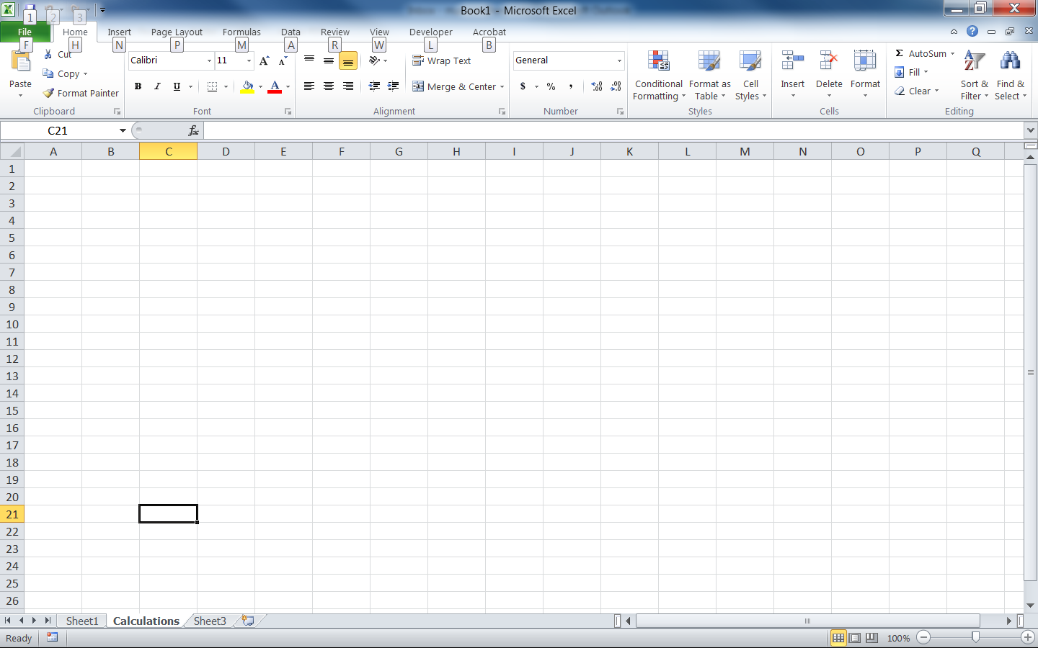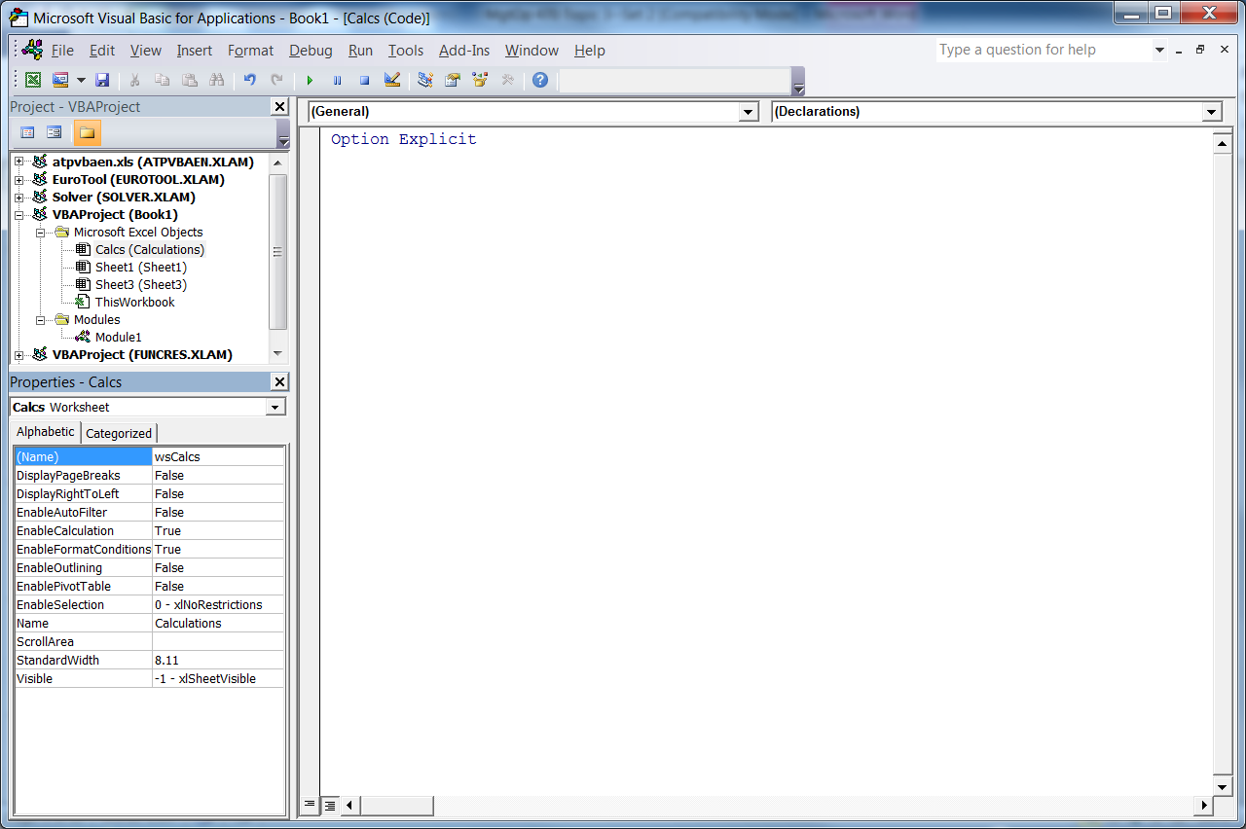

Then you can refer to Cell B6 of “Calculations” as:
wsCalcs.Range(“B6”)
Looping through the Worksheets
You can loop through all worksheets in a workbook and do the same thing to each:
Ex: Dim ws As Worksheet
For Each ws in Worksheets
[statements]
Next

Referring to Sheets by Number Instead of Name
Worksheets can be referenced based on their relative sequence in the list of sheets:
Ex: Worksheets(3) [refers to the 3rd worksheet]

Copying Worksheets
You can copy a sheet and place it anywhere in the list of sheets (using either After or Before). The following example copies the fourth worksheet to a new sheet and places the new sheet at the very end of the list of sheets:
Ex: Worksheets(4).Copy after:=Worksheets(Worksheets.Count)

Alphabetizing the Sheets
Example 8.8 shows one way to rearrange the sheets in alphabetical order.
Sub Control

Subs can “call” other subs and pass arguments back and forth. This is very useful for modularizing programs, which makes it easier to use certain modules in completely different programs.

Calling Subs
To call (run) another sub, use the Call command. Once finished, control will return to the original Sub.
Ex: Sub Main()
Call CalcCost
MsgBox “I’m finished!”
End Sub

Global vs. Local Variables
A variable defined within a Sub is “local” (otherwise known as “Private”), that is, it is only recognized within that particular Sub. To have a variable be recognized in multiple Subs, it should be defined as “global,” otherwise known as “Public”. To define a variable as global, define it at the top of the module, before any Subs. If preceded with the word Public, the variable will apply to all modules in the entire project. Note: A local variable overrides a global variable.

Running a Sub When a Workbook Opens
Use a Private Sub called Workbook_Open saved under the “ThisWorkbook” item in Project Explorer to have code automatically run when the file is opened. For example, to ensure that the file always opens in a specific worksheet called “Explanation”:
Ex: Private Sub Workbook_Open()
Worksheets(“Explanation”).Activate
End Sub

