MgtOp 470

Professor Munson

Topic 3

VBA Programming in Excel for
Decision Support Systems

(Set 1—VBA Basics, Input/Message Boxes, Interacting with the Spreadsheet, VBA Constants, Using Excel Functions in VBA, String Functions and User-Defined Functions)

“VBA is a relatively easy programming language to master. This makes it accessible to a large number of nonprofessional programmers in the business world—including you.”
Albright, S. Christian, VBA for Modelers, 5th Ed., Cengage Learning, 2016, p. 9
Decision Support System (DSS)

For modeling, a DSS represents a user-friendly application.

Front end—dialog boxes for users to insert data

Model—may be hidden to the user

Back end—nontechnical report of results

Visual Basic for Applications
Recorded macros work well for certain tasks, but cannot perform others (such as loops). In general, the more user interaction there is, the more likely VBA code might be worthwhile.

Note that VBA is similar, but not equivalent to, Visual Basic. VBA applies directly to features of an application such as Excel. VBA code can be written for Microsoft Word as well.

VBA applies logic behind the scenes.
Files
Must be saved as macro-enabled workbooks (.xlsm as opposed to .xlsx)

Enable macros by selecting
→File→Options→Trust Center→Trust Center Settings→
Macro Settings

Definitions
Objects correspond to nouns, properties correspond to adjectives, methods correspond to verbs, and arguments correspond to adverbs.

Collection objects (these are plural) contain all individual objects of a certain type

The Visual Basic Editor (VBE)
The VBE is the programming workspace. It’s easy to toggle back and forth (<ALT>< F11>) between the Excel worksheets and the VBE.

Help
Object Browser (<F2>)
Lists all objects, properties, and methods

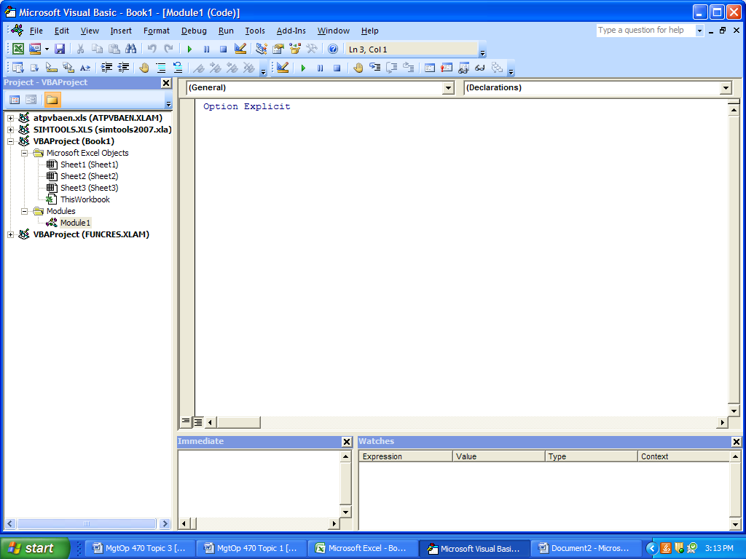
Quick Watch
Selects a variable to display value in the Watch Window
Immediate Window
Lets you enter and test a single line of code outside of the SUB
Locals Window
Displays values
of all variables

Code is stored in a module. →Insert→Module
Start a SUB (subroutine)
→Insert→Procedure [type in a name] →OK
(the name must be a single word)
Put all commands between:
“Public Sub name()” and
“End Sub”
In general, have separate SUBS for separate tasks (a macro is a SUB).
To run a SUB, press <F5>.
To step through 1 line at a time, press <F8>
Setup
Check:
→Tools→Options→Editor→Require Variable Declaration

Uncheck:
→Tools→Options→Editor→Auto Syntax Check

Typing
Indent for readability (use the <Tab> key or
→Edit→Indent). To remove an indentation, use <Shift><Tab> or →Edit→Outdent)
Add blank spaces for readability
To wrap a line, insert a blank then an underscore _
Otherwise, each new line is considered to be a separate command
Insert comments with a single quotation mark
Red color: you typed something wrong
Blue color: for all keywords (Sub, End, For)
Green color: for all comments

SAVE OFTEN!
Variables
Variables contain values or strings of text and can be modified during the course of a program.

They must be declared with a Dim statement:
Dim [variable name] As [type of variable]

Rules for Variable Names
1. Begin the name with letter
2. The name cannot contain spaces
3. Needs to be different than the name of the SUB

Most Common Variable Types
- String (for text such as “Bob”)
- Long (for integers) [Use Variant if > 2.1 billion]
- Double (for decimal numbers)
- Boolean (for variables that can be True or False)

If a variable appears to the left of an equals sign, then its new value in memory becomes whatever is on the right of the equals sign.
To assign a value to a variable:
unitCost = 1.20
unitsSold = 20
totalCost = unitCost * unitsSold
totalCost = totalCost + 20
TeamName = “Tigers”
Input Boxes and Message Boxes
Two VBA built-in functions:
InputBox(prompt to user in quotes, title in quotes)
(the title is optional)

The following creates an input box called “Selling price” that asks the user to “Enter the product’s unit price.” The value is stored in the variable called “price”.

price = InputBox(“Enter the product’s unit price.”, “Selling price”)

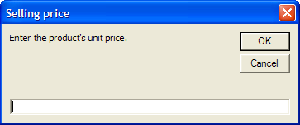

MsgBox(statement in quotes, button, title in quotes)
(the button indicator and title are optional)

The following creates a message box called “Selling price” that states the price and includes an “information” button.

MsgBox “The product’s unit price is $2.40.”, vbInformation, “Selling price”

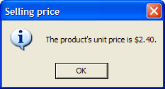

Note: No parenthesis around the message box command that simply displays the box.
Yes-No Input
To create a Yes-No box for user input into a box labeled “Chance to quit” that would store either vbYes (6) or vbNo (7) in the Long (not Boolean) variable “result”, use the following message box (not input box) command:

result = MsgBox(“Do you want to continue?”, vbYesNo, “Chance to quit”)

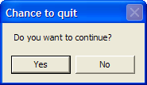
Other options:
vbOKCancel, vbAbortRetryIgnore, vbRetryCancel, vbYesNoCancel, vbOKOnly

You can use the InputBox and MsgBox functions in the same line, as in:

MsgBox InputBox(“Type your name”, “User’s name”), vbExclamation, “User’s Name”

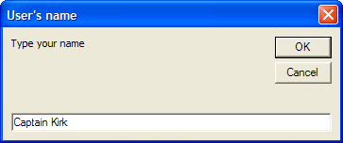

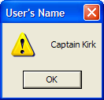
Strings
A string is simply text, surrounded by double quotes.

To concatenate two strings together, use the ampersand (&).

The following SUB gets a product’s name and then displays it in a message box:
Sub GetProductName()
Dim product As String
product = InputBox("Enter the product's name.")
MsgBox "The product's name is " & product & ".", vbInformation
End Sub

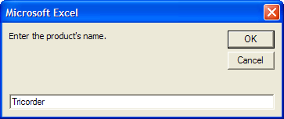

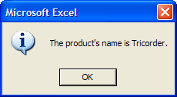

To insert a carriage return (start on a new line) in a message box, put the following between the first line and the second line: & vbNewLine &
Exercise 1
Open a new workbook and save it as Input Output 1.xlsm. Then create a SUB called RevenueCalc that does the following: (1) It asks the user for the unit price of some product and stores it in the variable unitPrice, defined as Double type; (2) it asks the user for the number of items sold and stores it in the variable quantitySold, defined as Long type; (3) it calculates the revenue from this product and stores it in the variable revenue, defined as Double type; and (4) it displays a message such as “The revenue from this product was $380.”

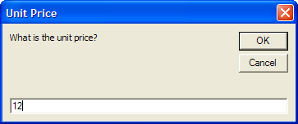

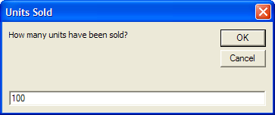

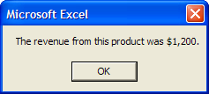
Exercise 2
Return to Exercise 1 and save your new program as
Input Output 2.xlsm. Start by using an input box to get the product’s name. Then use input boxes to get the product’s unit price and the quantity sold, and include the product’s name in the prompts for these inputs. For example, a prompt might be “Enter the unit price for LaserJet 1100.” Next, calculate the revenue. Finally display a message that contains all of the information, something like, “For the LaserJet 1100, the unit price is $500, the quantity sold is 25, and the revenue is $12,500.”

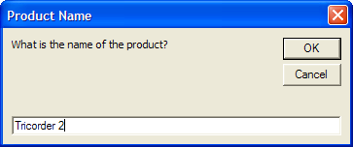
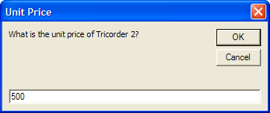
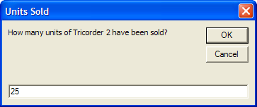

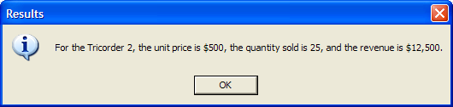
Interacting with the Spreadsheet
The following puts the string “Sales for March”
into Cell A1:
Range(“A1”).Value = “Sales for March”

The following puts the number 10 into each cell in the range B2:D6:
Range(“B2:D6”).Value = 10

The following enters the Excel formula into Cell A4 to sum columns B through D of row 4:
Range(“A4”).Value = “=SUM(B4:D4)”

The following retrieves the value from a cell and stores it in the string variable “title”:
Dim title as string
title = Range(“A1”).Value

Then to place “title” into Cell A8:
Range(“A8”).Value = title

To copy from A3:B4 to D3:E4 type:
Range(“A3:B4”).Copy Range(“D3:E4”)

To copy the value from A3:B4 to D6:E7 type:
Range(“D6:E7”).Value = Range(“A3:B4”).Value

Activation Button:
Insert a Button Form Control (under
Developer →Controls→Insert→Form Controls)
and select the SUB that you want the button to activate (just like creating one for a macro).
Exercise 3
The file Input Output 3_1.xlsx (on the course website) is a template for calculating the total order cost for ordering a product with quantity discounts. The table (range-named LTable) in the range A4:C8 contains unit costs for various order quantity intervals. The range B11:B13 contains a typical order cost calculation, where the input is the order quantity in Cell B11 and the ultimate output is the total cost in Cell B13. Take a look at this file to see how a VLOOKUP function is used to calculate the appropriate unit cost in Cell B12.

Write two SUBS called CreateTable and ClearTable, which will eventually be attached to buttons. The CreateTable SUB should prompt the user for three different order quantities. It should then place these quantities, along with their corresponding total costs, into Cells D12:E14. Basically, the program will plug each potential order quantity into Cell B11 and then transfer the corresponding total cost from Cell B13 to Column E of the table. The ClearTable button will simply erase the entries created by CreateTable.
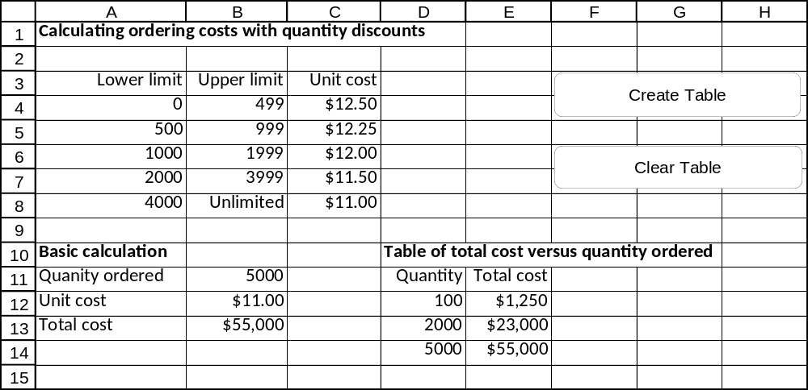
Built-In Constants in VBA

Arrow Keys
xlDown, xlUp, xlToRight, and xlToLeft

Horizontal Alignment
xlRight, xlLeft, and xlCenter

Colors
vbBlack, vbBlue, vbCyan, vbGreen,
vbMagenta, vbRed , vbWhite, and vbYellow

Message Box Icons
- vbInformation
- vbExclamation
- vbQuestion
- vbCritical

Using Excel Functions in VBA

You can use certain regular Excel functions in VBA code (not including the natural log, square root, random number, Today(), and IF) by preceding the function with:

WorksheetFunction.

As soon as you type the last period, a list of most Excel functions appears from which you can select.

Examples

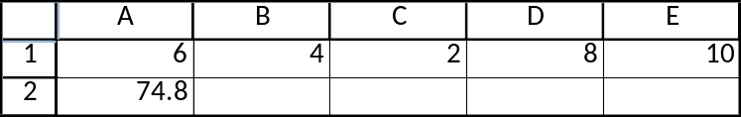

WorksheetFunction.MAX(Range(“A1:E1”))
WorksheetFunction.SUM(Range(“A1:E1”))
WorksheetFunction.AVERAGE(Range(“A1:E5”))
WorksheetFunction.FLOOR(Range(“A2”),1)
WorksheetFunction.RANDBETWEEN(1,6)

The IF Function in VBA
The IIf function in VBA uses the same syntax as the IF function in Excel (but ranges must be specified with VBA syntax such as )
Warning: A few Excel functions are different in VBA than in Excel. In particular:

Natural logarithm of 20 = log(20), not LN(20)

Square root of 20 = sqr(20), not SQRT(20)

Uniform (0, 1) random number = rnd, not RAND()

Today’s date = Date, not Today()

VBA’s Count property counts all cells (even empty ones), while Excel’s “Count” function only counts cells containing numbers.

String function names (see next page) are equivalent in VBA and Excel, so WorksheetFunction is not needed for string functions. It’s also not needed for INT.

Warning: Entering a formula into Excel is different than entering the result of a formula
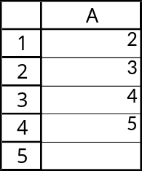
Range(“A5”).Value = “=SUM(A1:A4)”
will enter the actual SUM formula into Cell A5 (the value 14 will appear in Cell A5, but the SUM formula will appear in the formula box)

Range(“A5”).Value = WorksheetFunction.SUM(Range(“A1:A4”))
will first calculate the sum of A1:A4 within VBA and then enter the number 14 into Cell A5
String Functions

Left(string, n)—returns the first n characters of string
Example: Left(“Mr. Spock”, 5)
Result = “Mr. S”

Right(string, n)—returns the last n characters of string
Example: Right(“Vulcans Rule”, 4)
Result = “Rule”

Mid(string, n1, n2)—starting a character n1 of string, returns the first n2 characters
Example:
Mid(“Amok Time makes Vulcans crazy.”, 6, 18)
Result = “Time makes Vulcans”

Omitting n2 returns the rest of the string:
Mid(“Amok Time makes Vulcans crazy.”, 6)
Result = “Time makes Vulcans crazy.”

Len(string)—returns the number of characters in string
(spaces count)
Example:
Len(“Captain Picard rocks!”)
Result = 21

Replace(string, substring to replace, replace with)—replaces a portion of a string with something new
Example:
Replace(“The month is Jan.”,“Jan.”,“Feb.”)
Result = “The month is Feb.”

StrReverse(string)—reverses the string
Example:
StrReverse(“Counselor Troy knows all.”)
Result = “.lla swonk yorT rolesnuoC”
User-Defined Functions

Excel provides a host of built-in functions. However, sometimes programmers wish to create their own functions for use in later applications, rather than retyping the formula every time that they want to make a specific calculation.

A function takes one or more arguments & returns a value (into that cell or broader formula).

The code looks very similar to the code for a SUB. As with SUBs:
Code is stored in a module. →Insert→Module
Start a Function
→Insert→Procedure [type in a name] →[Click on Function]OK
(the name must be a single word)
Place the arguments [defined As Type between the ()]
Put As Type after the parenthesis (where type is the variable type of the returned value)

Put all other commands between:
“Public Function name()” and
“End Function”
A function subroutine can be used in one of two ways. It can be called by another SUB (or even another function subroutine), or it can be used as a new function in an Excel formula.

To make your function available in all future workbooks, save it in your Personal.xlsb library file.

Examples
1. Function for the maximum of two numbers

Public Function Larger(number1 As Double, number2 as Double) As Double
If number1 >= number2 Then
Larger = number1
Else
Larger = number2
End If
End Function

2. Function to take the first 5 characters from a name

Public Function Abb(name As String) As String
Abb = Left(name, 5)
End Function

3. Economic Order Quantity

Public Function EOQ(SetupCost as Double, Demand as Long, HoldingCost as Double) as Double

EOQ = SQR(2*SetupCost*Demand / HoldingCost)

End Function
Code for the Exercises

Exercise 1
Public Sub RevenueCalc()

Dim unitPrice As Double
Dim quantitySold As Long
Dim revenue As Double

unitPrice = InputBox("What is the unit price?", "Unit Price")
quantitySold = InputBox("How many units have been sold?", "Units Sold")
revenue = unitPrice * quantitySold
MsgBox "The revenue from this product was " & FormatCurrency(revenue, 0) & "."

End Sub

Exercise 2
Public Sub RevenueCalc2()

Dim productName As String
Dim unitPrice As Double
Dim quantitySold As Long
Dim revenue As Double

productName = InputBox("What is the name of the product?", "Product Name")
unitPrice = InputBox("What is the unit price of " & productName & "?", "Unit Price")
quantitySold = InputBox("How many units of " & productName & " have been sold?", _ "Units Sold")
revenue = unitPrice * quantitySold
MsgBox "For the " & productName & ", the unit price is " & FormatCurrency(unitPrice, 0) _
& ", the quantity sold is " & quantitySold & ", and the revenue is " _
& FormatCurrency(revenue, 0) & ".", vbInformation, "Results"

End Sub

Exercise 3
Public Sub Create()

Dim Q1 As Long
Dim Q2 As Long
Dim Q3 As Long
Q1 = InputBox("Enter the first order quantity.")
Q2 = InputBox("Enter the second order quantity.")
Q3 = InputBox("Enter the third order quantity.")
Range("B11").Value = Q1
Range("D12").Value = Q1
Range("E12").Value = Range("B13").Value
Range("B11").Value = Q2
Range("D13").Value = Q2
Range("E13").Value = Range("B13").Value
Range("B11").Value = Q3
Range("D14").Value = Q3
Range("E14").Value = Range("B13").Value
End Sub

Public Sub ClearTable()
Range("D12:E14").ClearContents
End Sub
Some Fundamental VBA Commands
<F2>
brings up the object browser
<F5>
runs a subroutine
<F8>
steps through a subroutine one line at a time
<Ctrl><F8>
runs a subroutine to the point of the cursor
<F9>
inserts a breakpoint into the code that pauses execution
Application.CutCopyMode = False
presses the Escape key when a selection is surrounded by a dancing box after having pressed the copy button
Const name = value
defines a constant called name and sets it equal to value
(can be used for parameters that never change; the name does not need to be defined with a Dim statement)
Dim variable name As type of variable
defines the variable variable name as type type of variable
FormatCurrency(value, #)
formats a number as currency formatting with # decimal places
Example: FormatCurrency(1500.67,1) displays $1,500.7
FormatNumber(value, #)
formats a number with commas and # decimal places
Example: FormatNumber(1500.67,1) displays 1,500.7
Range(rangename).ClearContents
erases contents in the range called rangename
vbNewLine (also vbCrLf)
inserts a carriage return (start on a new line) within a message box [be sure to put an “&” sign before and after]
vbTab
inserts a tab within a message box [be sure to put an “&” sign before and after]

