MgtOp 470

Professor Munson

Topic 1

Basic Excel Skills

“Sitting there [in MBA class at Harvard] in the spring of 1978, I came up with the idea of the electronic spreadsheet...I wanted to keep the calculations and just erase one number on my paper and have everything recalculated.”
Dan Bricklin, inventor of the spreadsheet, The Computer Museum Report, Summer 1986, p. 8

“A good working knowledge of Excel is a requirement for many professional positions. Many a student has obtained a good summer job just on the basis of expertise with Excel. Learning Excel is an important skill you will be able to use the rest of your life.”
James Gips, Mastering Excel 2007: A Problem-Solving Approach, 2007, p. 6
Table of Contents for Topic 1

I. Organization…5
II. Movement and Cell Entries…5
A. Movement…5
B. Data entry…5
C. Entering formulas…6
D. Editing cell entries…7
E. Entering a series of data…7
F. Exercise 1—Data and Formula Entry…9
III. Spreadsheet Window…10
A. Descriptions of spreadsheet view…10
B. Zoom view…10
C. Window splitting and freezing…10
D. Formula displaying and auditing…10
E. Create a new sheet…11
F. Range names…12
G. Goto command (F5)…12
IV. Formatting…13
A. Cell formatting…13
B. Justification buttons…13
C. Number formatting (decimal buttons)…14
D. Font, color, etc. (including buttons)…14
E. Borders (including color)…14
F. Format painter…15
G. Wrapping text…15
H. Column and row widths and heights…15
I. Selecting column or row or noncontiguous ranges…16
J. Inserting/deleting columns, rows, cells, and cell contents…16
K. Page and print formatting…18
V. Copying and Moving Cell Contents…18
A. Background…18
B. Copying a value from a single cell…18
C. Copying from multiple contiguous cells…19
D. Copying a formula…19
E. Copying between worksheets…20
F. Moving cell contents…20
G. Copying as a picture…20
H. Exercise 2—A Table of Factors for Learning Curves…21
VI. Functions and the Function Wizard…22
A–D. Introduction to Functions…22
E. Conditional functions…23
F. Functions that exclude blanks…23
G. Rounding functions…24
H. Other mathematical functions…24
I. NOW() function…24
J. Exercise 3—Functions & Copying: Creating a Loan Table…25
VII. Random Numbers…26
VIII. Creating Charts…27
A–D. Introduction to charts…27
E. Exercise 4—Creating Charts…28
IX. Excel Quick Reference Guide…29
X. Dice Game Simulation from The Goal…30
Excel is used to manipulate numbers and create visual displays of information. It is available at nearly everyone’s desk in the business world. The biggest benefit of the program is that when one number is changed, everything is recalculated automatically.

I. Organization
A. Files are saved as “Workbooks” (like a notebook full of paper)
B. Each workbook can have multiple “sheets” (of paper)
C. Each sheet has up to 1,048,576 rows and 16,384 columns (A to XFD).
D. Each cell is labeled: e.g. A6

II. Movement and Cell Entries
A. Movement
- Arrows keys move one cell at a time up, down, left, or right
- Use the mouse to go to a cell directly
- <End><Arrow> takes you to the next change of cell contents (empty or filled) in the column or row
Example when Pressing <End><Right Arrow>)

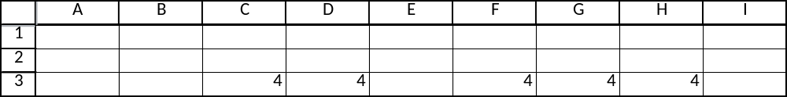
Starting Cell Ending Cell Explanation
A3 C3 Next non-empty cell
C3 D3 Last non-empty cell in this series
D3 F3 Next non-empty cell
F3 H3 Last non-empty cell in this series
H3 XFD3 Last cell (all in between were empty)

- To select a block of cells: Click and drag using the mouse or use
<Shift> <End> <Arrow>
- <Home> Takes the cursor to column A in the current row
- <Ctrl><Home> Takes the cursor to cell A1 (upper left of spreadsheet)
- <End><Home> Takes the cursor to the bottom right of the spreadsheet for the last row and column containing any entries
- <Page Up> Moves the view to the set of rows just above the currently viewed set of rows
- <Page Down> Moves the view to the set of rows just below the currently viewed set of rows
B. Data entry
- Can enter text or data into a cell
- Just type the entry into the cell and press <Enter> or an arrow key
- By default, text will be left-justified while numbers will be right-justified
- Excel has a spell-checker: →Review→Proofing: →Spelling, or press <F7>
C. Entering formulas
1. An equals sign signals that a formula is to follow
2. The formula is contained in the cell, but the value shown on the screen is the resulting computation of the formulas, e.g., =3+4 would show the number 7 in the cell
3. Other cells can be referenced, e.g., (=C3+8) adds the value in cell C3 to the number 8 and shows the sum in the current cell
4. Cell references can be entered by typing directly, using the arrow keys while typing the formula, or clicking on the cell with the mouse
5. Symbols for mathematical operations: + (plus), - (minus), * (times),
/ (divided by), ^ (raised to the power)
6. Arithmetic precedence (-, ^, * and /, + and -, then left to right)
a. =3+5*2 = 3+10 = 13; =(3+5)*2 = 8*2 = 16
b. =8+10/2+4 = 8+5+4=17; =(8+10)/(2+4) = 18/6 = 3
c. =-4^2 = 16; =-(4^2) = -16
7. Examples

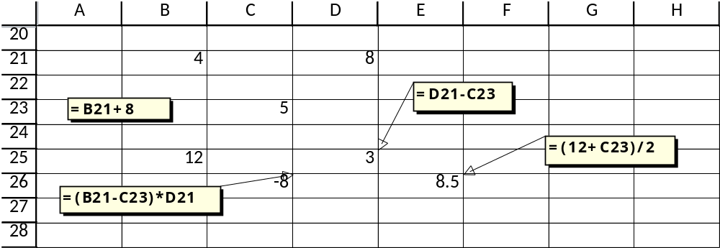

8. Excel uses full precision unless values are rounded

Example:

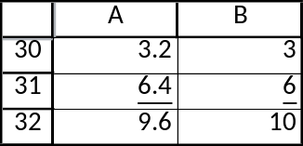

The values in column A are the correct original ones, and cell A32 simply adds A30 to A31. Column B has the same numbers, but “formats” them (see Section IV below) to display on the screen with 0 decimal places. The results look odd, however, because they suggest that 3 + 6 = 10. If the numbers truly need to be rounded before applied to a computation, then the ROUND function should be used (see the Excel Quick Reference Guide at the back of these notes).
9. Can cell reference other worksheets (e.g., =Sheet1!C3 will take the value from cell C3 in Sheet 1)
D. Editing cell entries
1. Either (1) press <F2> to begin editing within the cell itself, or (2) put the cursor in the formula bar and type in there (in either case, the right/left arrow keys can be used to move back and forth or the mouse can be used for direct placement of the cursor).
2. When editing a formula containing cell references, color-coding automatically matches the cell reference to the cell itself.

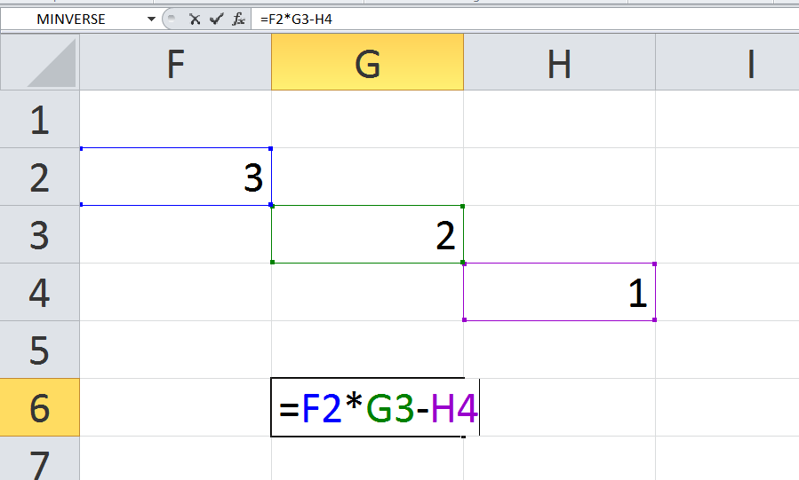

E. Entering a series of data
1. →Home→Editing:→Fill→Series

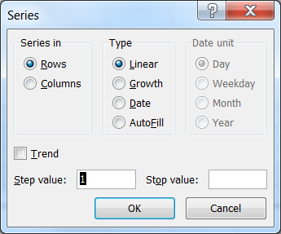

2. Quick, method: Enter two values in consecutive cells. Select the two cells with the mouse. Use the Fill Handle (the small square on the bottom right of the cell cursor) to create the rest of the (linear) series by dragging.
a. Example: A series starting with 4 and adding 3 each time

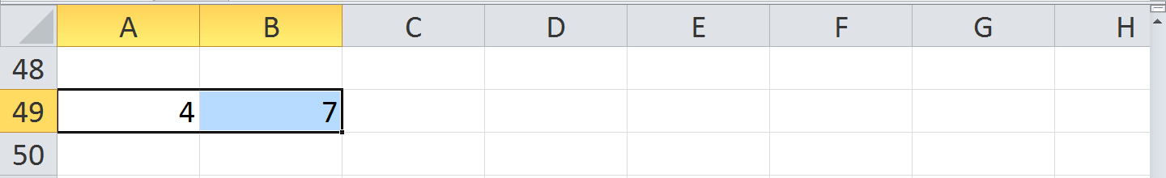
Click and drag the fill handle

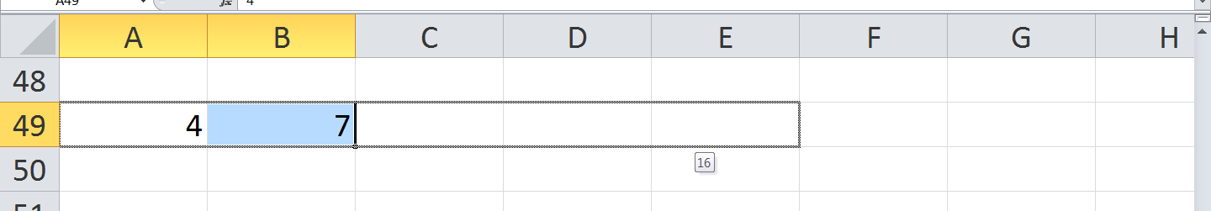

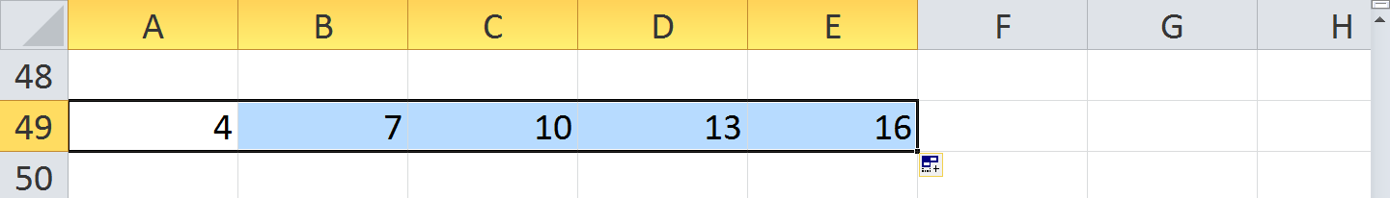

b. Example: A series entering months April through September

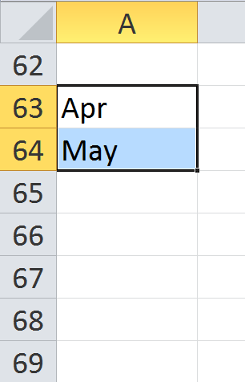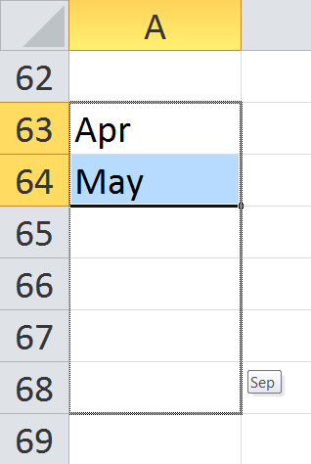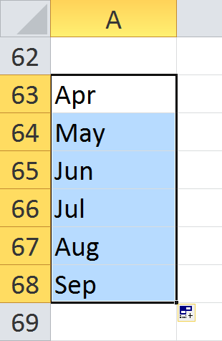
Drag down

3. Can also fill for days of week, hours of the day, etc.

F. Exercise 1—Data and Formula Entry (see next page)

Exercise 1—Data and Formula Entry

1. Enter the heading.
a. Select cell B2.
b. Type First Quarter Output and press <Enter>. (Notice that “First Quarter Output” is wider than a single cell. The text will spill over into the next cell if it’s vacant. If the adjacent cell is not vacant, the text will be truncated.)
2. Enter the months of the first quarter.
a. Select cell C4 and type Jan and press <Right Arrow>.
b. Type Feb and press <Right Arrow>.
c. Type Mar and press <Right Arrow>.
3. Enter the sales regions.
a. Select cell B5.
b. Type North and press <Down Arrow>.
c. Type South and press <Down Arrow>.
d. Type East and press <Down Arrow>.
e. Type West and press <Down Arrow>.
4. Enter the data as shown below.
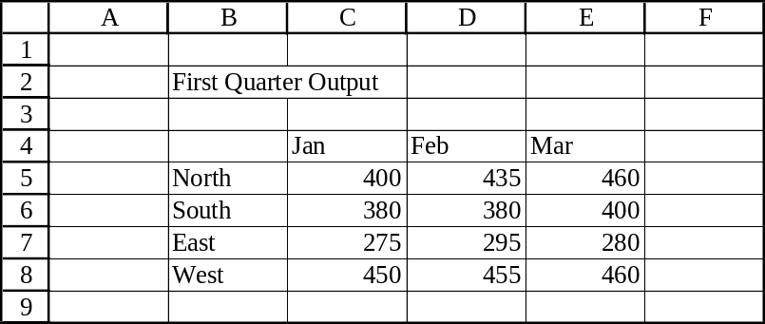

5. Save your work.
a. →File→Save as…
b. Pick a directory and type Exercise 1 in the text box.
c. Click <Save>.
6. Adding formulas.
a. Add the numbers in column C.
1. Click on cell B10 and type Total in the cell.
2. Click on cell C10.
3. Type =C5+C6+C7+C8 and press <Enter>.
b. Take the average of the numbers in row 5.
1. Click on cell G4 and type Average in the cell.
2. Click on cell G5.
3. Type =(C5+D5+E5)/3 and press <Enter>.
7. Changing the data.
a. Type 600 in cell C5 and watch the formula values change.
III. Spreadsheet Window
A. See screen shot of descriptions

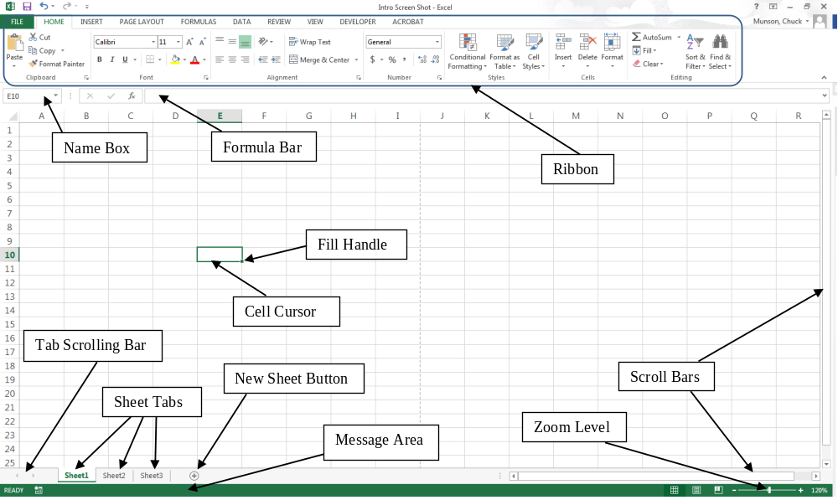

B. Zoom view: Use to make the cells larger on the screen

C. Window splitting (→View→Window:→Split). This can be useful if you want to see non-contiguous data simultaneously, e.g., you want to see the column headers but you’re working in row 854. The screen can be split into two sections (either horizontal or vertical) or four sections. Click and drag on the split to move it.

Window freezing (→View→Window:→Freeze Panes). Similar to window splitting, but you cannot move the frozen sections. The “Freeze Panes” option freezes all rows above and all columns to the left of the current location of the cursor. There are also options to freeze either just Row 1 or just Column A.

D. Formula displaying and auditing
1. Displaying formulas: CTRL ` (this shows the formula in all cells instead of the results of the formulas). Alternatively, press
→Formulas→Formula Auditing:→Show Formulas
2. To get a visual representation of the location of cells used in a formula, place the cursor on the cell and:
→Formulas→Formula Auditing:→Trace Precedents

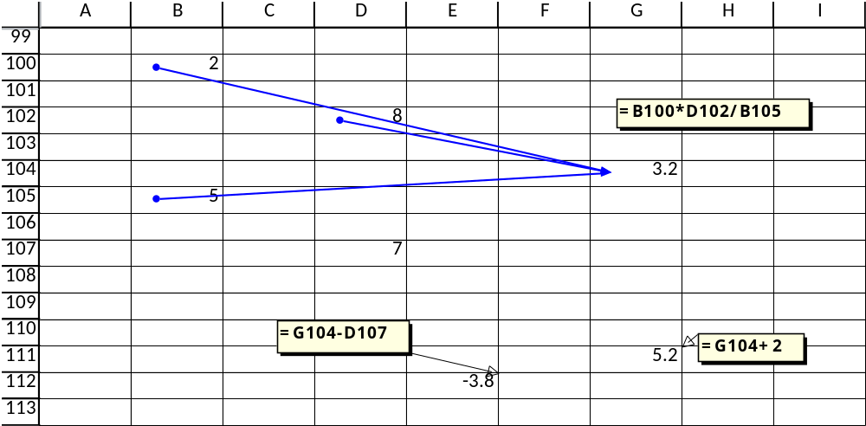

3. To get a visual representation of the location of cells that reference the current cell, place the cursor on the cell and:
→Formulas→Formula Auditing:→Trace Dependents

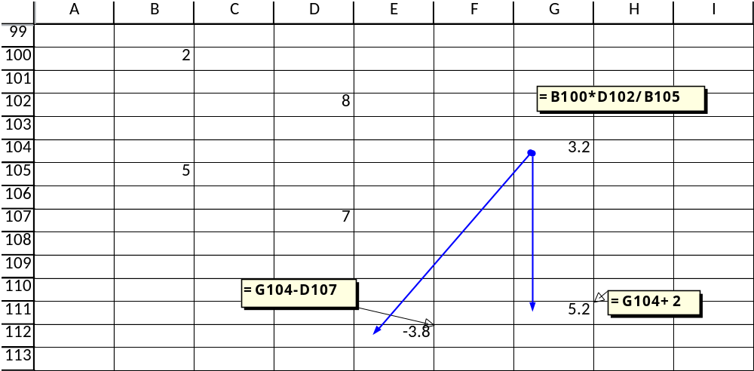

E. Create new sheet (→Home→Cells:→Insert→Insert Sheet or click the New Sheet button). Rename by right clicking the sheet tab.

F. Range names
1. Can identify a specific cell (e.g., “profit”) or a block of cells
2. Very useful for quick navigation around a large spreadsheet or quick selection of a range (e.g., selecting a table to print)
3. Very useful as used in formulas in place of actual cell labels—more descriptive
4. Can create by selecting the cells and typing the name in the Name Box (input section located above Column A)
5. For more options in creating and managing your range names, including assigning the scope of the name to a specific worksheet instead of the entire workbook or creating comments for a name, you can invoke the Name Manager: (→Formulas→Defined Names:→Name Manager)

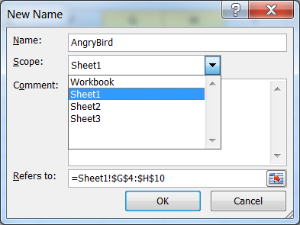

G. Goto command (F5)
1. Can type in the exact cell that you want to go to

2. Includes the set of range names, so any those can be directly selected

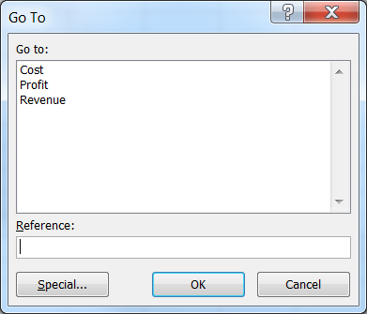
IV. Formatting
A. Cells and ranges of cells can be formatted in a wide variety of ways. There are options for justification; how numbers are displayed; font style, size, and color; background color of cells; borders around any of the cell walls; row heights and column widths. The Home ribbon has several buttons for quick access to formatting. Alternatively, the font dialog box, containing the full range of many of these options, can be accessed by clicking on the arrow box in the bottom right of the Font tab under the Home ribbon.

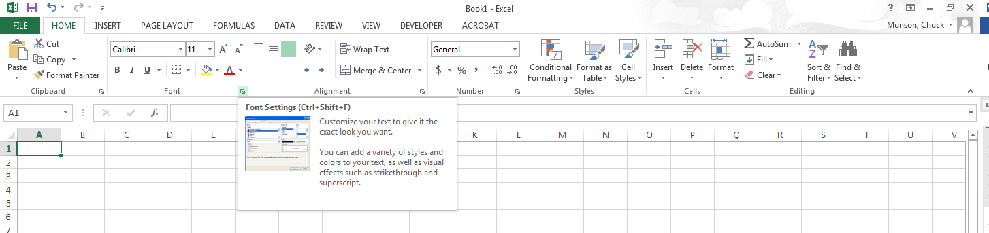

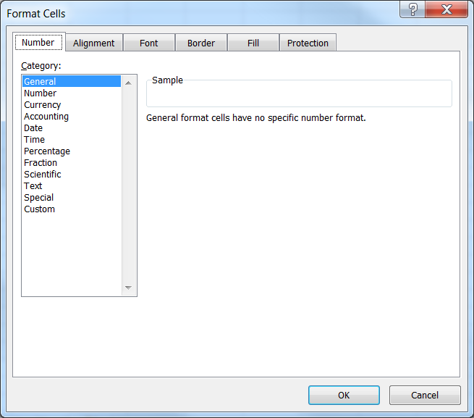

B. Justification buttons

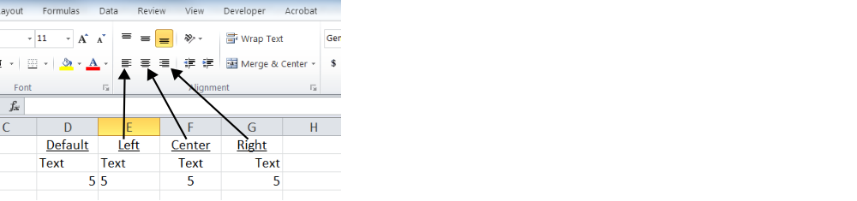
C. Number formatting (decimal buttons)

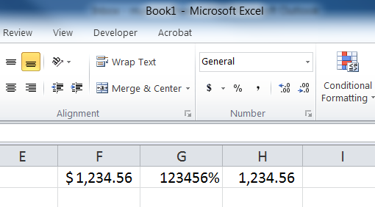
Use these to increase or decrease the number of decimal places displayed.

Reminder: number formatting only affects what is displayed on the screen. Formatting will not actually round the number stored in memory. The unrounded number can be brought back by formatting to more decimal places.
D. Font, color, etc. (including buttons)

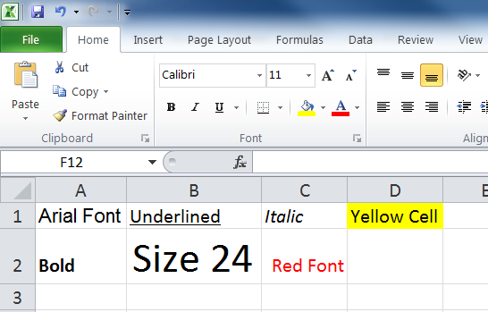

E. Borders (including color)
1. There is a border button for common border styles
2. The Border tab within the font dialog box contains all options

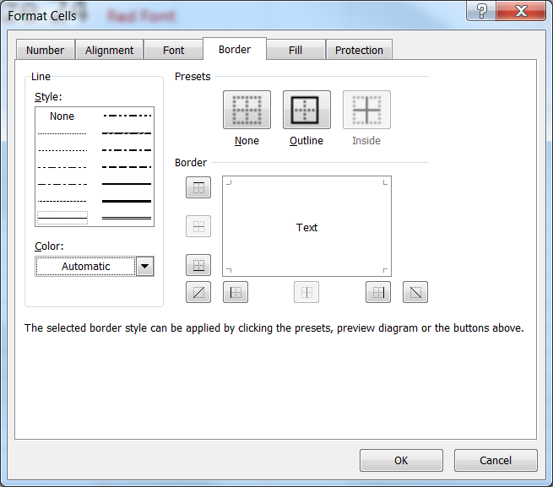
F. Format painter
1. Copies the formatting of a range to another range in the workbook.
2. First select the range from which you want to copy the formatting. Then click on →Home→Clipboard:→Format Painter. Then click on the upper-left cell of the range that you want the formatting copied to.
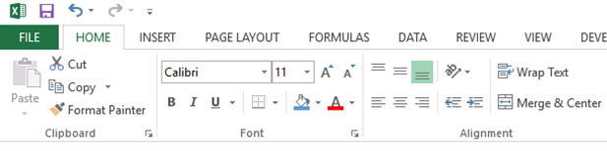

G. Wrapping text
1. Click →Home→Alignment:→Wrap Text to have text automatically wrap within a cell (instead of bleeding into the next column to the right). The row height should adjust automatically.
2. To manually begin a new line of text within a cell, press <Alt><Enter>.

H. Column and row widths and heights
1. →Home→Cells:→Format→Column Width... (or Row Height…)
2. Alternatively, the cursor can be placed over the edge of a column label and the size can be increased or decreased by pressing the left mouse button, dragging, and releasing. (Similar for rows.)

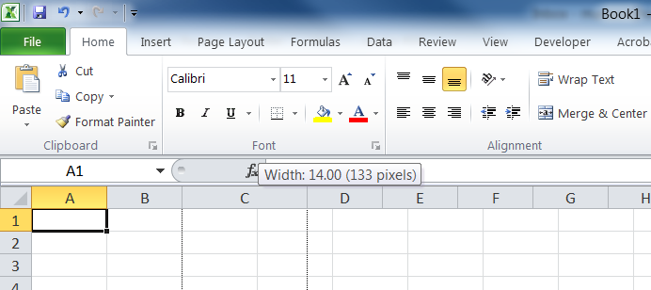
Drag from here.

3. To find the best fit of a column, place the cursor on the right wall of the column label, and double click. (Similar for rows.)
4. To set global column widths (applies to all columns not specifically set with their own respective sizes):
→Home→Cells:→Format→Default Width...

I. Selecting column or row or noncontiguous ranges
1. An entire column can be selected by clicking on the label for that column. (Similar for rows.)
2. Contiguous columns can be selected by clicking and dragging on column labels. (Similar for rows.)

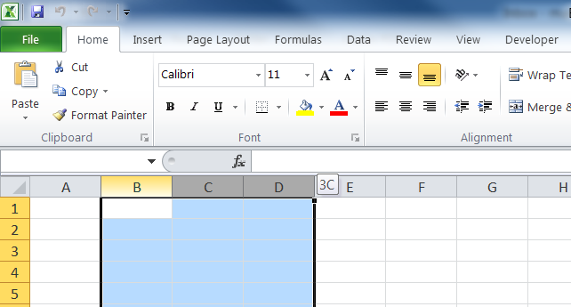

3. Select the entire spreadsheet by clicking on the corner box connecting the column and row labels.
4. To select ranges of cells that are not connected, select the first set using the mouse, then press <CTRL> while selecting the next set. Continue until all sets are selected.

J. Inserting/deleting columns, rows, cells, and cell contents
1. The quickest way to insert a column is to select the column to the right of the new one and press the diagram on top of the Insert button in the Cells tab under the Home ribbon. (Similar for rows.)
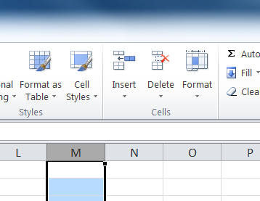
2. The quickest way to delete a column is to select the column and press the diagram on top of the Delete button in the Cells tab under the Home ribbon. (Similar for rows.) Multiple columns (rows) can be deleted at the same time by selecting all columns (rows) desired for deletion first.
3. Multiple columns can be inserted by selecting the number of columns equal to the number of newly desired columns, starting with the column just to the right of the new ones. Then press the diagram on top of the Insert button in the Cells tab under the Home ribbon. (Similar for rows.) The following example would insert 4 rows between current rows 2 and 3.

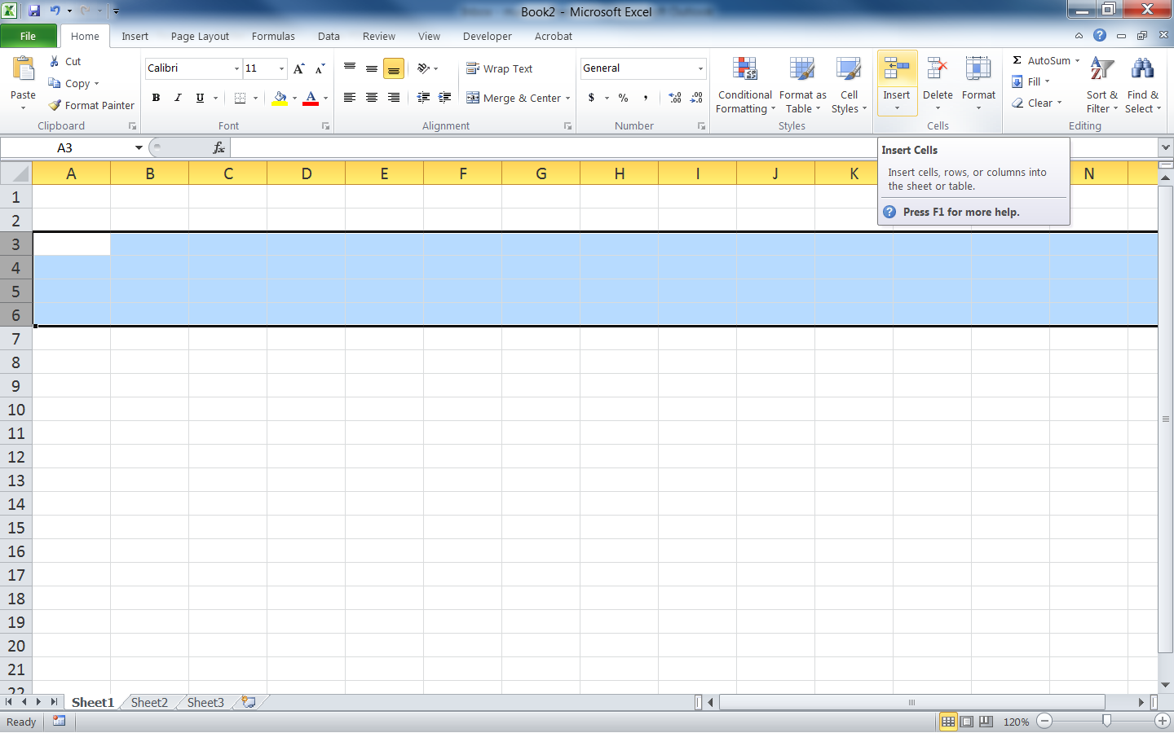

4. The Insert and Delete buttons in the Cells tab under the Home ribbon have options for inserting or deleting specific cells, columns, rows, or worksheets. If specific cells are inserted or deleted from a spreadsheet, the user must fill in the holes by choosing to shift cells over or insert or remove the entire row or column.
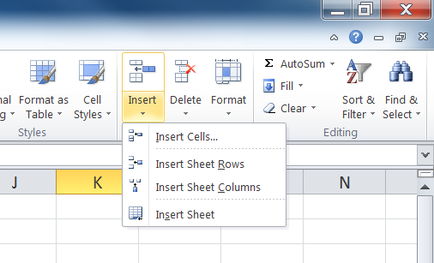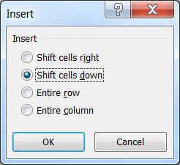
5. Note that pressing the <Delete> button on the keyboard will erase the contents of the cell, but it will not delete the cell itself (or the cell formatting). For other deletion options within a cell, press
→Home→Editing:→Clear

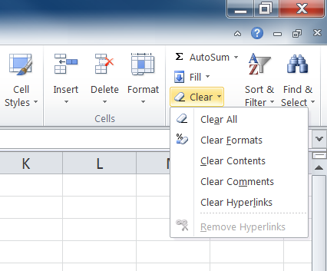

K. Page and print formatting
Use the Page Setup and Sheet Options tabs within the Page Layout ribbon to specify items such as page margin sizes, print orientation (portrait vs. landscape), and whether or not gridlines and column and row headings will display on the printout.

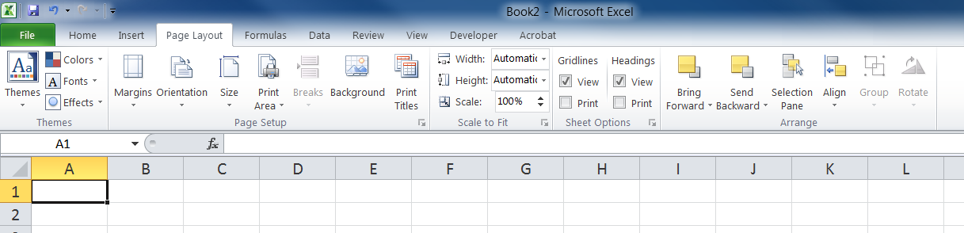

V. Copying and Moving Cell Contents
A. Background
One of the most powerful and most used Excel features is the ability to copy cell contents to one or more other cells. This is particularly valuable for formulas that must be repeated many times.

B. Copying a value from a single cell.
1. To copy a value (either text or numbers) from a cell, simply place the cell cursor in that cell and press the →Home→Clipboard:→Copy button. This leaves a dashed rectangle around the cell, designating that its contents are on the clipboard. Next place the cell cursor in the destination cell and press <Enter>. This copies the contents along with the cell-specific formatting.
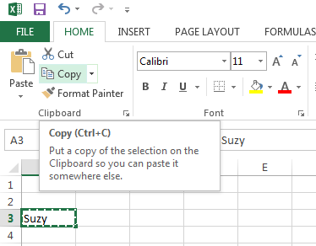

2. To copy to multiple cells, use the <Paste> button each time instead of the <Enter> key (this keeps the dashed rectangle active). (The dashed rectangle can be removed by pressing <Esc>.) To copy to a block of consecutive cells, select that block before pressing <Paste> (or <Enter>).
3. Numerous pasting options are available (e.g., values only, formatting only, etc.) by pressing on the arrow just below the <Paste> button, instead of pressing the <Paste> button itself.

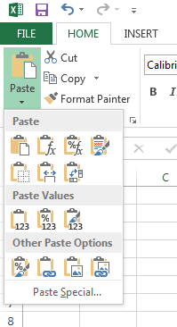

C. Copying from multiple contiguous cells
Simply select the range to be copied and follow the procedures described above. To select the destination, place the cursor cell in the upper left cell of the destination range before pressing <Paste> (or <Enter>).

D. Copying a formula
1. The mathematical symbols and numbers contained in formulas will copy directly. However, cell references are treated differently. Default cell referencing in formulas is actually recorded as distance relative to the current cell, as opposed to being recorded as an actual (unchanging) absolute cell name. For example, suppose that the formula in cell B4 is “=A2+6”. Excel actually reads that formula as “Take the value from the cell located one column to the left and two rows above, and add that to the number 6.” Thus, if cell B4 were then copied to cell D7, the new formula in cell D7 would be “=C5+6”. In other words, the new cell referencing has the same relative distance as it did in the original cell. This type of feature is very useful, for example, with a table containing 12 columns representing each month and the formula at the bottom of each column sums the numbers in that respective column. In this case, the user would simply have to enter the formula once and then copy it over 11 times.
2. There are cases where the user desires absolute, as opposed to, relative cell referencing for copying. An example might be a net present value analysis that references the same rate of return for each period. The user would prefer to just enter the rate of return once and have all copied formulas continue to reference that cell. To create absolute referencing, place a dollar sign ($) in front of the column and row label within the formula. (This is called “anchoring” the cell.) For example, if the formula in cell B4 is “=$A$2+6”, then when the formula is copied to cell D7 is will still be “=$A$2+6”. Note that it is also possible to anchor only the column or only the row. To complete the example, if the formula in cell B4 is “=$A2+6”, then when the formula is copied to cell D7 it will become “=$A5+6”. Alternatively, if the formula in cell B4 is “=A$2+6”, then when the formula is copied to cell D7 it will become “=C$2+6”. Finally, especially for long formulas with several cell references, anchoring can quickly be added to certain cell references by editing the formula (<F2>), placing the cursor over the applicable cell reference, and pressing the <F4> key. The anchoring will toggle among the four options (full cell, row only, column only, and no anchoring).
E. It is possible to copy between worksheets of the same workbook. Simply copy the original cell, click on the appropriate sheet tab, go to the destination cell within that new sheet, and paste the results.
F. To move cell contents and formatting, the “cut and paste” feature may be used. Press the →Home→Clipboard:→Cut button instead of the <Copy> button. (Note that a cell or range of cells can only be “moved” once, so the dashed rectangle will disappear even if the <Paste> button is used.)
G. It is possible to copy a section from a worksheet as a picture, which can then be inserted into worksheets, workbooks, or even other applications such as Microsoft Word. To do so, select the range to be copied and press the arrow key to the right of the <Copy> button. Then select the Copy as Picture… option. You can then choose to copy it as shown on the screen or as printed on a page.

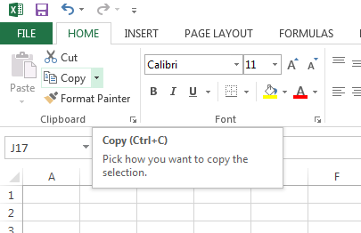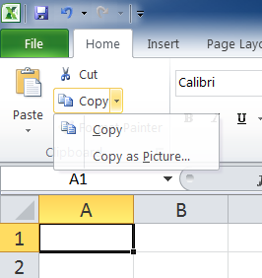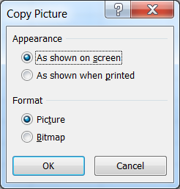

H. Exercise 2—A Table of Cumulative Factors for Learning Curves (see next page)
Exercise 2—A Table of Cumulative Factors for Learning Curves

Learning curves are a mathematical representation of the phenomenon of “practice makes perfect,” i.e., people tend to work faster or a process tends to cost less as tasks are repeated and experience accumulates. The learning rate, r, is the percentage of cost or time every time that production is doubled. For example, if the first unit took 120 minutes to produce and we expect an 80% learning curve, then the second unit should take 120(.8) = 96 minutes, the fourth unit should take 96(.8) = 76.8 minutes, the eighth unit should take 76.8(.8) = 61.44 minutes, etc. A table of cumulative learning curve factors can be used to quickly determine the total time (or cost) to produce a certain number of units, given a learning rate. The total time (cost) equals the time (cost) of the first unit times the cumulative learning curve factor for the total number of units desired. A table of such factors can be quickly created using Excel. With proper anchoring, only one formula needs to be entered.

For a given r, the value V_{n} for the cumulative learning curve factor for cumulative unit n is: V_{n−1} + n^{[ln(r) / ln(2)]}.

1. Type the title and headings.
a. Use 8 point, Times New Roman font, and column widths of 10 for the whole worksheet.
b. Type Table of Cumulative Factors for Learning Curves in cell A1.
c. Type and center Cumulative in cell A3.
d. Type and center Units in cell A4.
e. Type and center 60%, 65%, ..., 95% in cells B4 through I4.
f. Select cells A4 through I4 and underline those headings.
g. Select cells B3 through I3 and insert a bottom border.
h. Type Learning Rate r in cell E3.
2. Complete the “cumulative units” series.
a. Type 1 in cell A5 and 2 in cell A6.
b. Select the range A5:A6.
c. Drag the fill handle down to cell A14 to complete the series 1 to 10.
3. Complete the table formatting and preparation.
a. Select the range A5:I14 and center the alignment.
b. Select the range B5:I14 and format as number with four decimal places.
c. Enter 1 in cell B5.
d. Copy cell B5 to the range C5:I5.
4. Enter the cumulative formula and create the table and save.
a. Type =B5+A6^(ln(B4)/ln(2)) in cell B6.
b. You can fill out the rest of the table by copying this formula, but only if it is anchored correctly. Determine the proper anchoring and then copy cell B6 to the range B7:B14 and to the range C6:I14.
c. Your numbers should match those shown below. Save the file as “Exercise 2”.

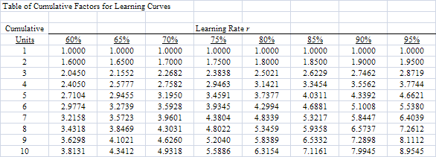
VI. Functions and the Function Wizard
A. Excel has many built-in financial, mathematical, statistical, and logical functions that perform tasks on specified cells. For example, the SUM function adds a set of numbers, and the ABS function takes the absolute value of a number.
B. A function may have arguments (inputs) that are necessary to compute the value of the function. An argument can be a number, words, a range, or even another function. Arguments are contained inside the parenthesis that follow a function, and they are separated by commas.
Examples
SUM(3,4) = 7
ABS(-6) = 6
TODAY() = today’s date (This function has no arguments.)
C. Several common functions are described on the “Excel Quick Reference Guide” provided at the end of these notes
D. The “Function Wizard” is a very helpful way to learn about the different functions and incorporate them into spreadsheets. The wizard includes function descriptions and input bays for the various inputs. It updates the formula result as inputs are entered. Invoke it by →Formulas→Function Library:→Insert Function

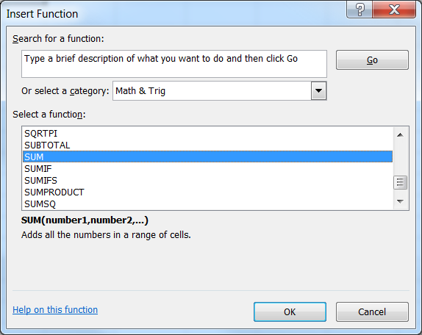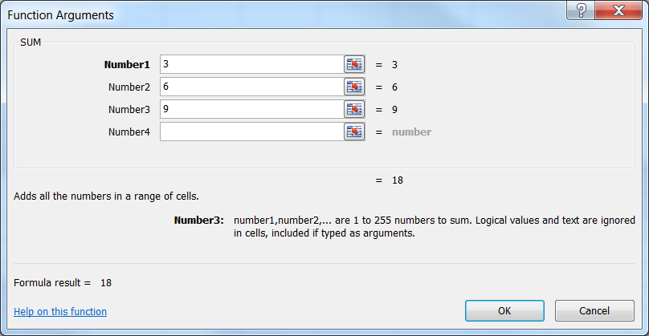

A printable page describing the function can be accessed.

Subsets of functions within the wizard can be accessed directly within the Function Library tab of the Formulas ribbon.

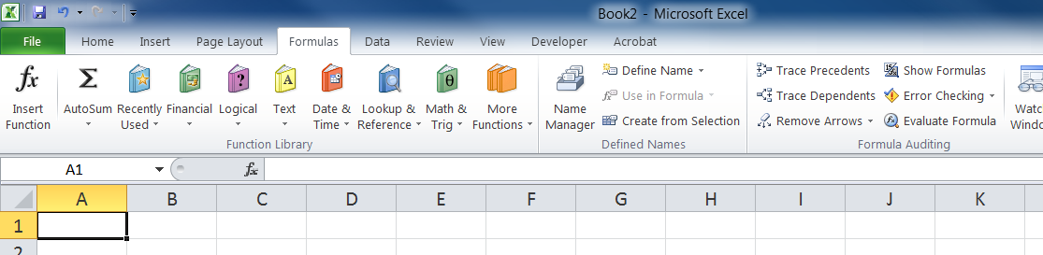

E. Conditional functions: IF and VLOOKUP. The IF function is useful for conditional true/false decisions, while the VLOOKUP function is useful for retrieving values from a table based on the value of an expression.
1. IF—Tests a True/False expression and returns a different value depending on whether the expression is true or false.
1st argument = expression to be evaluated
2nd argument = value to be returned if the expression is true
3rd argument = value to be returned if the expression is false
Examples:
IF(5>4,8,"No") returns the number 8
IF(5<4,8,"No") returns the word No
2. VLOOKUP—searches for the largest number in the first column of a table that is ≤ a specified number, and it returns a value from that row from a specified column.
1st argument = the number to look up
2nd argument = the range of the table
3rd argument = the column number from the table from which to retrieve
4th argument (optional) = if set to 0, the match must be exact
3. A quantity discount pricing example is shown below that uses both types of functions.

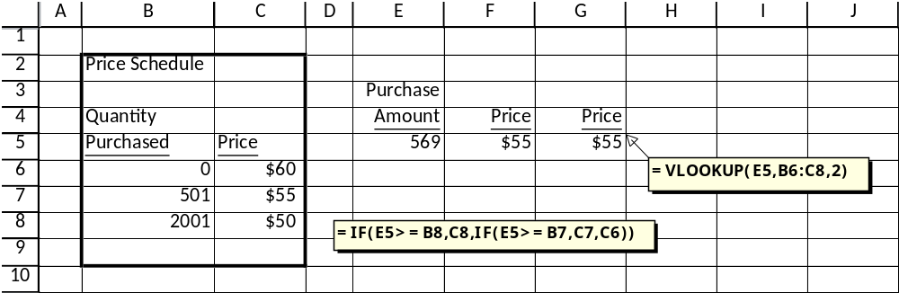

F. Functions that exclude blanks
AVERAGE MEDIAN
MAX MIN
STDEV COUNT
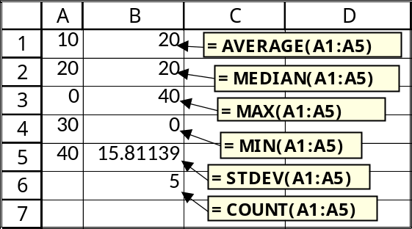
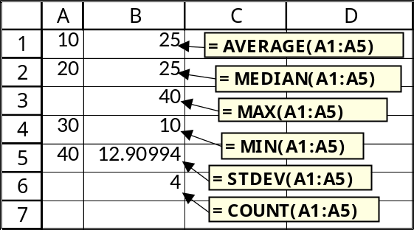
G. Rounding functions
1. ROUND—Rounds the 1st argument to the no. of decimal places in the 2nd
Examples:
ROUND(123.456,3) = 123.456
ROUND(123.456,2) = 123.46
ROUND(123.456,1) = 123.5
ROUND(123.456,0) = 123
ROUND(123.456,-1) = 120
ROUND(123.456,-2) = 100
ROUND(123.456,-3) = 0
2. INT—Rounds down to the nearest whole integer
Examples:
INT(45.6) = 45
INT(45.3) = 45
INT(45) = 45
3. CEILING—Rounds up to the nearest multiple of significance based on the 2nd argument
Examples:
CEILING(9876.123,1) = 9877
CEILING(9876.123,10) = 9880
CEILING(9876.123,100) = 9900
CEILING(9876.123,1000) = 10000

H. Other mathematical functions

1. SQRT—square root
Example: SQRT(16) = 4
2. LN—natural logarithm
Example: LN(6) = 1.791759
3. LOG—logarithm of base 10
Example: LOG(6) = 0.778151
4. EXP—the number e raised to the power of the argument
Examples:
EXP(1) = 2.781282
EXP(6) = 403.4288
LN(EXP(6)) = 6
EXP(LN(6)) = 6
5. z-table (Standard Normal Distribution)
NORMSDIST—returns the probability for the given z-value
NORMSINV—returns the z-value for the given probability
Examples:
NORMSDIST(1.645) = 95%
NORMSINV(.95) = 1.645
6. 1E+307—Can represent a very large finite number
I. NOW() returns the date and time
J. Exercise 3—Functions and Copying: Creating a Loan Table (see next page)
Exercise 3—Functions and Copying: Creating a Loan Table

1. Type the title and headings.
a. Type Monthly Payment on $10,000 at 8% in cell B1.
b. Type Months in cell B4 and Payment in cell C4.
c. Type 6 in cell B5 and 9 in cell B6.
2. Complete the “Months” series.
a. Select the range B5:B6.
b. Drag the fill handle down to cell B23 to complete the series 6 to 60.
3. Create the payment function.
a. Select cell C5.
b. Use the function wizard to locate the “PMT” function (under “Financial” functions).
c. Click <OK>.
d. Type 8%/12 in the “rate” formula bar.
e. Type B5 in the “Nper” formula bar.
f. Type –10000 in the “Pv” formula bar.
g. Click <OK>. (You should see $1,705.77 in cell C5.)
4. Complete the table and save.
a. Copy cell C5 to the range C6:C23.
b. Save the file under the name “Exercise 3”.
5. Add a column for interest paid.
a. Type Interest in cell D4.
b. Select cell D5.
c. Type =C5*B5-10000.
d. Copy cell D5 to the range D6:D23. (You may need to
widen column D to view all of the numbers.)

BETTER METHOD
6. Using input cells in the payment function instead of specific numbers.
a. Type Rate in cell F2 and PV in cell G2.
b. Give cell F3 the range name “RATE” and give G3 the range name “PV”.
c. Type 8% in cell F3.
d. Type 10000 in cell G3.
e. Edit cell C5 (<F2> key).
f. Replace “8%” with RATE, and replace “10000” with PV.
g. Copy cell C5 to the range C6:C23.
7. Using input cells in the interest function.
a. Edit cell D5.
b. Replace “10000” with PV.
c. Copy cell D5 to the range D6:D23.
8. Revise the table for 120 months.
a. Select the range B22:D23.
b. Drag the fill handle down to include row 43.
9 Sensitivity analysis and save.
a. Try different values for the interest rate and the loan amount.
b. Save the file.
VII. Random Numbers—Used for simulation modeling
A. Install Analysis ToolPak if not already installed:
Click File, and then click Options. Click Add-Ins from the list in the left column, and then in the Manage box, select Excel Add-ins. Click Go. In the Add-Ins available box, select the Analysis ToolPak check box, and then click OK. Tip If Analysis ToolPak is not listed in the Add-Ins available box, click Browse to locate it. If you get prompted that the Analysis ToolPak is not currently installed on your computer, click Yes to install it. After you load the Analysis ToolPak, the Data Analysis command is available in the Analysis group on the Data tab.
B. Functions (Press <F9> to draw a new number)
1. RANDBETWEEN(1,6)
Returns an integer between 1 and 6 inclusive
2. RAND()
Returns a decimal between 0 and 1 exclusive
3. NORMSINV(RAND())
Provides a random z-value from the standard normal

C. Automatic recalculation
Random numbers automatically recalculate every time something new is done to the spreadsheet

D. Manual Recalculation
Click File, and then click Options. Click Formulas from the list in the left column, and then in the Calculation options box, select Manual. After that, Excel only recalculates when the <F9> key is pressed.
VIII. Creating Charts
A. Excel has 8 different chart types, each with additional sub-types
B. Charts are automatically updated when the raw data change
C. To build them, use →INSERT→Charts:→Recommended Charts
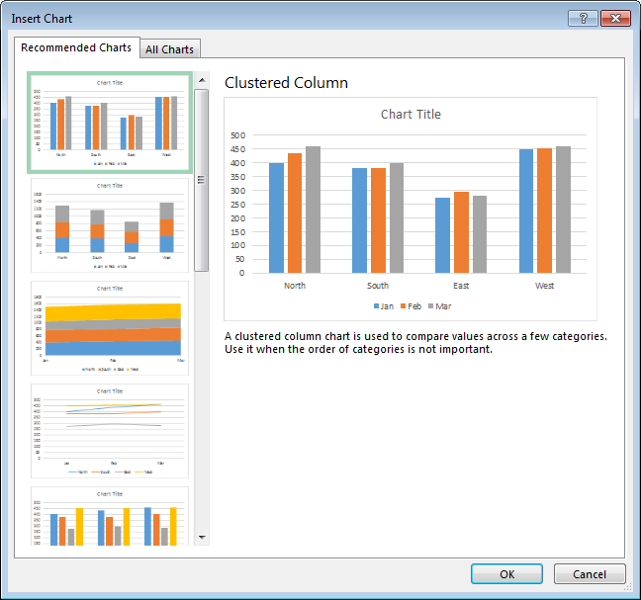
D. Once created, charts can be copied and pasted into other applications such as Microsoft Word
E. Exercise 4—Creating Charts (see next page)

Exercise 4—Creating Charts
Column Chart
1. Open the “Exercise 1” file.
2. Select the range B4:E8.
3. Click →INSERT→Charts:→Recommended Charts. Select the first type and click <OK>.
4. Move and size the chart as needed.
5. Titles, legends, etc. can be added. Select the chart, and the CHART TOOLS menu appears: →CHART TOOLS:DESIGN→Chart Layouts→Add Chart Element.

6. Grouping by month instead of by region.
a. Select the chart, and the CHART TOOLS menu should appear.
b. If it is not already highlighted, click on →DESIGN.
c. Click →Data: →Switch Row/Column.
7. The chart can be saved as a separate sheet, or embedded in the current sheet or even a different sheet. Try saving it as a separate sheet: →CHART TOOLS:Design→Move Chart.

Line Chart
1. Open the “Exercise 3” file.
2. Select the range C4:D23.
3. Click →INSERT→Charts:→Recommended Charts. Select the Line type and click <OK>.
4. Right click on the chart, and click on →Select Data....
5. Click →Edit under “Horizontal (Category) Axis Labels.”
6. Select B5:B23 and click <OK>.
7. Click <OK>.
8. Move and size the chart as needed.
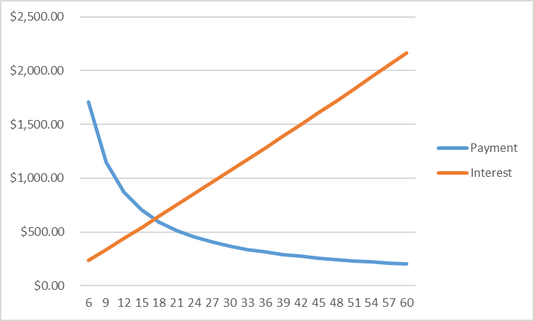

Excel Quick Reference Guide

Arithmetic
+ (plus); - (minus); * (times); / (divided by); ^ (raised to the power); % (divided by 100)
Precedence: 1st —negation (as in -1); 2nd—exponentiation; 3rd—multiplication and division; 4th—addition and subtraction; and operations for equal precedence are carried out from left to right.

Useful Commands
Undo an action: Click Undo 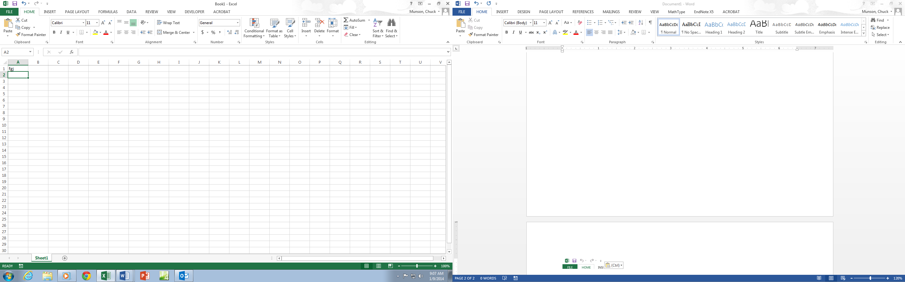on the Quick Access toolbar 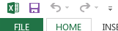, or press <Ctrl> Z.
→VIEW→Window:→Split (splits the spreadsheet into 2 or 4 windows)

Cursor Movement
<Home> (moves to column A in the same row)
<Ctrl><Home> (moves to cell A1)
<End><Home> (moves to last cell (bottom right) on the sheet)
Clicking on any cell with the mouse highlights that cell.
Arrow keys, Page Up and Page Down keys, and scroll bars create the expected movements.

Copying
Use the dollar sign ($) for anchoring cells when copying. A $ in front of the letter anchors the column, and a $ in front of the number anchors the row.
To copy calculated numbers but not their formulas, select and copy the originating cells, go to the cells where you want the numbers placed, click →HOME→Clipboard:→Paste→Paste Values.

Formatting
Select the cell or cells to be formatted (appearance of numbers, cell alignment, font size and type, cell borders, patterns and colors within cells). Then click →HOME→Font (or press Crtl 1).
Row widths and heights can be changed using the cursor or by using →HOME→Cells: →Format menu.

Important Functions
The function wizard or (FORMULASf_{x}) lists all of the functions.
=1E+307 (can represent infinity, i.e., the largest number that Excel can hold)
=ABS(B6) (returns the absolute value of the number in cell B6)
=AVERAGE(A1:B6) (calcs the mean of all numbers in the range A1 to B6, excluding blanks)
=CEILING(3.4, 1) (rounds 3.4 up to the nearest whole integer (4))
=COUNT(A1:B6) (counts all cells within the range that contain numbers)
=EXP(4) (returns e raised to the power 4)
=IF(A1=6,5,2) (if the value in cell A1 is 6, then a 5 is put in the cell; otherwise, a 2 is put there)
=INT(7.6) (rounds 7.6 down to the nearest whole integer (7))
=INTERCEPT(y-range, x-range) (provides the y-intercept of a regression line of dependent variables in the y-range with independent variables in the x-range)
=LN(6) (returns the natural log of the number 6)
=MAX(A1:B6) (returns the largest of all numbers in the range A1 to B6, excluding blanks)
=MEDIAN(A1:B6) (returns the median of all numbers in range A1 to B6, excluding blanks)
=MIN(A1:B6) (returns the smallest of all numbers in the range A1 to B6, excluding blanks)
=NORMSDIST(2.8) (returns the standard normal cumulative distribution function of 2.8 standard deviations)
=NORMSINV(.92) (returns the z-value for 92% from the standard normal distribution function)
=NOW() (returns the date and time)
=RAND() (returns a random fractional number between 0 and 1 inclusive)
=RANDBETWEEN(1,6) (returns a random integer number between 1 and 6, i.e. rolls a die)
=ROUND(5.4, 0) (rounds the number 5.4 to 0 decimal places (rounds to 5))
=SLOPE(y-range, x-range) (provides the y-intercept of a regression line of dependent variables in the y-range with independent variables in the x-range.)
=SQRT(7) (calculates the square root of 7)
=STDEV(A1:B6) (calcs the std. deviation of numbers in the range A1 to B6, excluding blanks)
=SUM(A1:B6) (adds all numbers in the range A1 to B6)
=SUMPRODUCT(A1:B2,D2:E3) (multiplies corresponding components in the given arrays, and returns the sum of those products, e.g., A1*D2+A2*D3+B1*E2+B2*E3)
=TODAY() (returns the date)
=VLOOKUP(40,A1:B3,2) (searches for the largest number ≤ 40 in A1:A3 & returns that row’s column B value)

The Goal

The Dice Game

Illustrates Dependent Events and Statistical Fluctuations

Expected throughput without =

Ways to Improve

