MgtOp 470

Professor Munson

Topic 2

Spreadsheet Engineering

“A typical code inspection finds errors in 5 percent of the lines of code written (and tested) by professional programmers. If this level of error rates characterizes professional programmers, how much more prevalent are errors among end-user programmers of spreadsheets?”
Powell and Baker, 2004, p. 93

“In general, end-user development in spreadsheeting seems to resemble programming practice in the 1950s and 1960s.”
R. Panko, Journal of End User Computing, vol. 10

“Spreadsheets are so simple that companies forget to institute quality control of the data and formulas (e.g., error checking and testing procedures). Many people think that because something is printed out from a spreadsheet, it must be true and accurate.”
Hesse and Scerno, “How Electronic Spreadsheets Changed the World,” Interfaces, 39(2), p. 166
Spreadsheets

- Prior to the 1980s, modeling was performed only by specialists using demanding software on expensive hardware—spreadsheets changed all that
- Mathematics and programming at an accessible level
- Correspond nicely to accounting statements
- Spreadsheet engineering—how to design, build, test, and perform sensitivity analysis
with a spreadsheet model
- “The Swiss Army Knife” of business analysis
  - The “second-best” way to perform many kinds of analysis (in lieu of simulation software, optimization software, etc.)
  - Spreadsheets perform many different functions adequately but not as well as specialized tools

Golden Rule of Spreadsheet Engineering
Thou shalt build thy spreadsheet not for thyself, but instead for the person who will replace thee after thou receives a promotion.

Problems with Spreadsheet Usage

- End-user spreadsheets frequently have major bugs (most spreadsheets have bugs)
- 1% of formula cells have errors
- 94% of financial reporting spreadsheets have errors (95% of U.S. firms use spreadsheets for financial reporting)
- 2003 Fannie Mae reported a $1.2 billion earnings calculation error
- Former VP of HealthSouth intentionally modified the spreadsheet for auditors to inflate earnings by $3.5 Bil.

- End users are overconfident about the quality of their spreadsheets (rarely spend time debugging their models and rarely have them reviewed by others)—no QC

- Development process can be inefficient

- End users typically do not plan their spreadsheets

- The most productive methods for generating insights are not employed

8 Rules for Spreadsheet Design

1. Plan—Sketch the Spreadsheet
- “Measure twice and cut once”
- Turn the computer off and think for awhile
- Physical layout of major elements
- Write out formulas in words (or rough indication of calculation flow)

2. Modularize
- Group like items & separate unlike items
- At the least—separate (1) data, (2) decision variables, (3) outcome measures, (4) detailed calculations
- Surround each module with a border (if not separated into a different worksheet)

3. Start Small
- Sketch the full design, but don’t build all at once
- One customer/one month/one quarter, etc.
- Isolate, build, & test one module at a time (much easier to detect local rather than global errors)

4. Isolate Input Parameters
- Formulas should not include hard-coded inputs!!! (use all cell references)
- Each parameter should only be entered once
PARAMETERS
Price, Cost, Seasonal, OHD rate, Sales Parameters, Sales Expense, Ad Budget

DECISIONS
Q1 Q2 Q3 Q4
Advertising

OUTPUTS
Profit Base case

CALCULATIONS
Q1 Q2 Q3 Q4 Total

Units Sold = Use Advertising and Sales formula
Revenues = Price × Units Sold
Cost of Goods = Cost × Units Sold
Gross Margin = Revenue – Cost of Goods
Sales Expenses = Fixed at 8,000 or 9,000
Advertising = The decision variables
Overhead = Fixed fraction of Revenue
Total Fixed Cost = Sales Expenses + Advertising + Overhead
Profit = Gross Margin – Total Cost
Profit Margin = Profit / Revenue

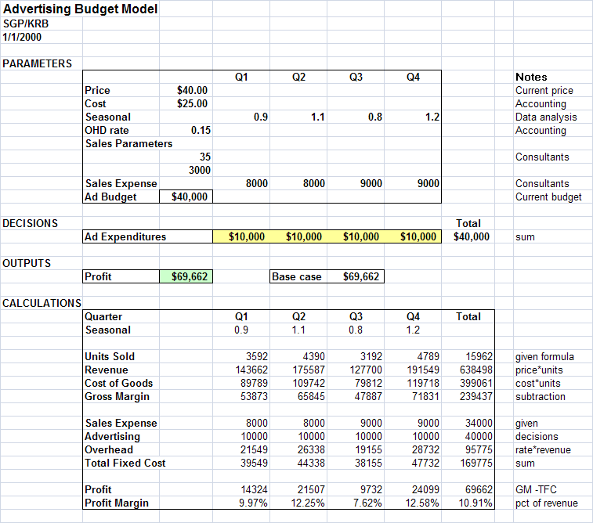
5. Design for Use
- Anticipate who will use the spreadsheet
- What types of questions will be asked?
- Make it easy to change common parameters
- Make it easy to find key outputs
- Group in one place
- Include graphs of outputs
- Consider recording numerical values of base case outputs (as a prelude to sensitivity analysis)

6. Keep it Simple
- Keep formulas short
- Decompose complex calcs into intermediate steps
- Easier to spot errors & explain calculations to others

7. Design for Communication
- Spreadsheets often live longer than expected
- Description in upper left of each sheet
- Use visual cues that reinforce model’s logic
- Informative labels and blank spaces
- Outlines, color, bold, etc.
- Consider something like: all inputs in yellow, decision variables in tan, and outputs in pink
- When possible, have a one-page window summary of inputs and outputs
- Consider split windows for large spreadsheets
- ViewWindow:Split
- Use a header or footer for filename & print date
Example: Four Sheets from the Workbook “Delta”

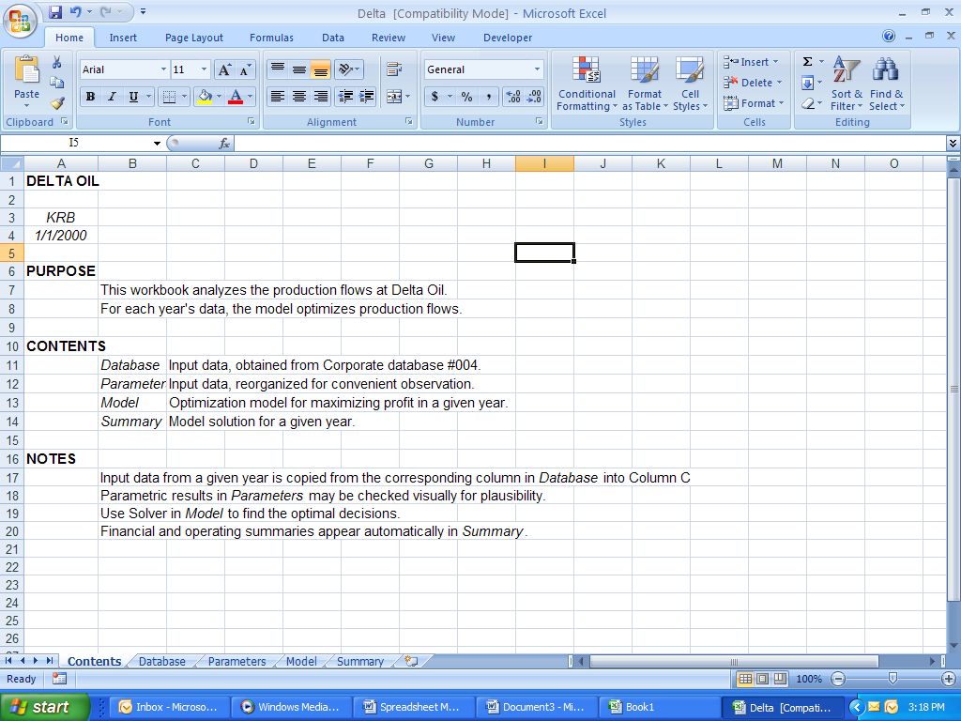
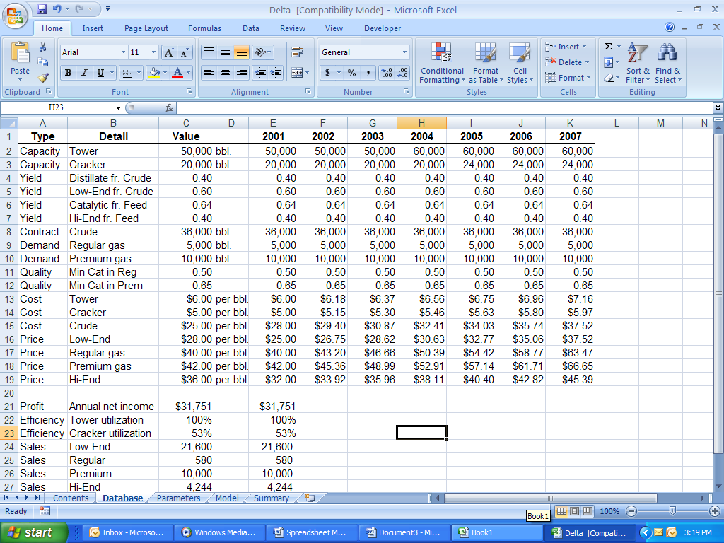
“Contents” “Database”

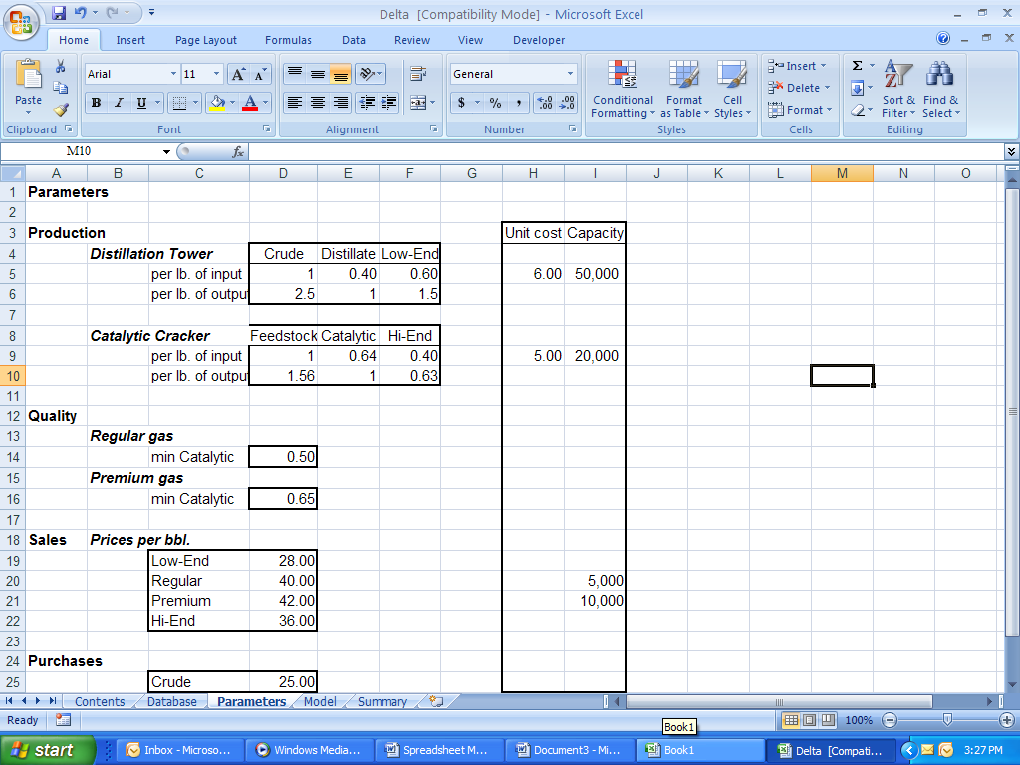
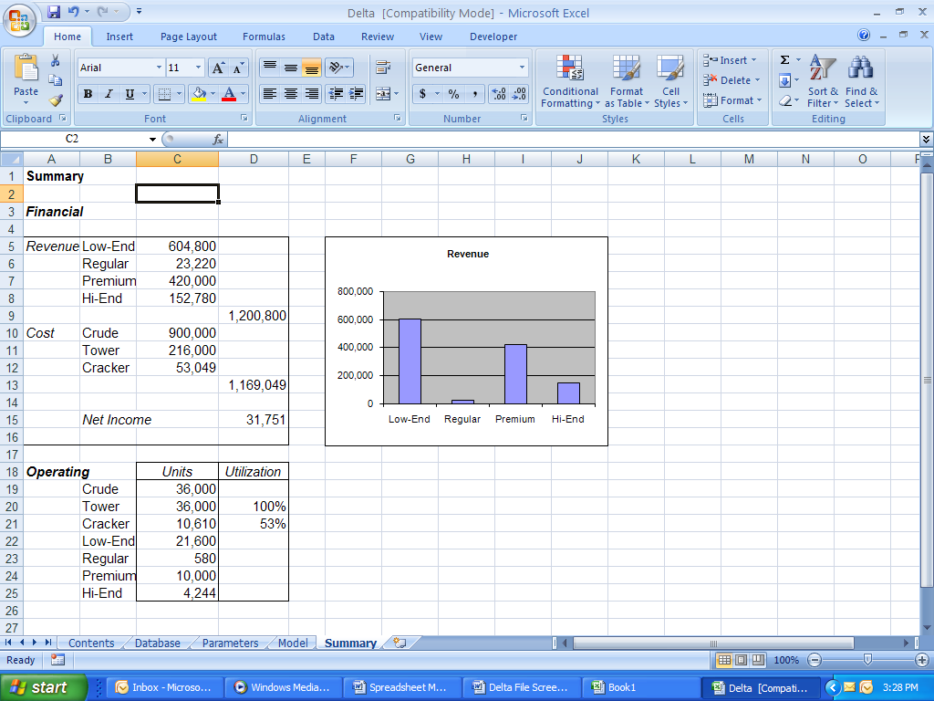
“Parameters” “Summary”

Headers and Footers

To have a header and/or footer print on every page, select:
InsertTextHeader and Footer

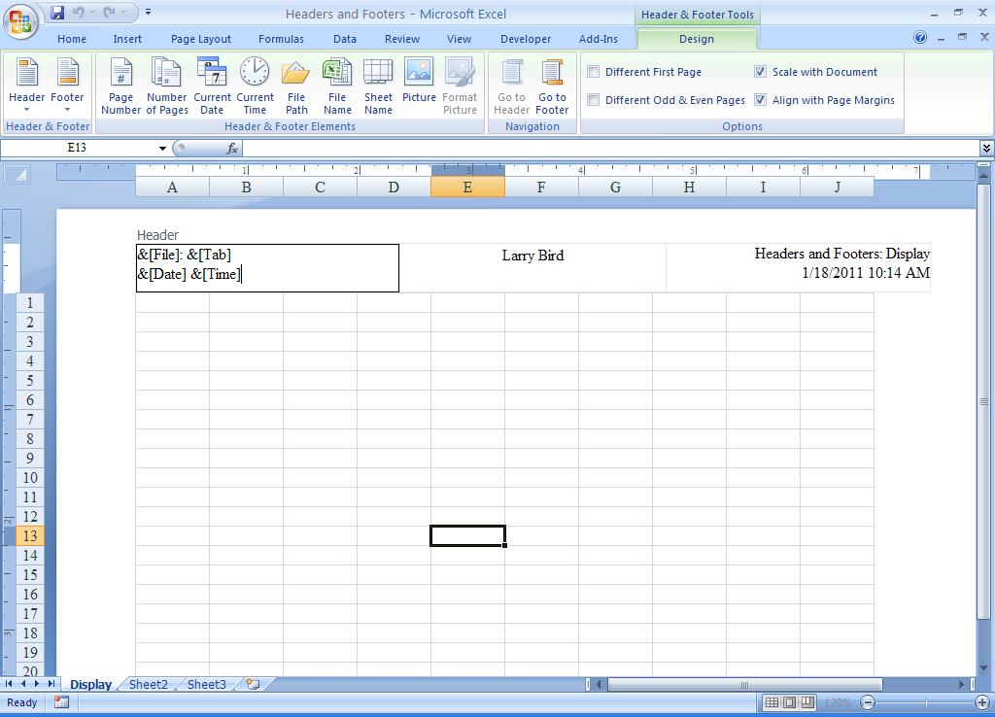
The above header has the following elements:
(1) The header is split into 3 sections (for illustration, the left & right are the same)
(2) The center section has the creator’s name typed in
(3) 1st line of left & right boxes has filename & sheet name (notice the colon & space)
(4) 2nd line of left & right boxes has date and time when printed (to identify most recent)

Items (3) and (4) are automatically updated by Excel.

To format text: select the text; then select HomeFont.
To insert the page number, date, filename, etc., simply position the cursor in the desired edit box, and choose the appropriate button.
An inserted picture can be formatted (insert the cursor anywhere in the edit box and press the Format Picture button).
Use button 2 to print the total number of pages in the sheet.
Buttons 1 and 2 can be combined to say, for example, “Page 10 of 12”.
Use button 5 (File Path) for both the path and the filename.
To return to the regular Excel view, select: ViewWorkbook ViewsNormal
8. Document Important Data & Formulas
- A spreadsheet model should be self-documenting
- Record source for important parameters
- Explain important formulas
- Consider a separate module (worksheet) to list assumptions
- Cell comments (called “notes” in Office 365)
  - Any cell can have an associated comment box
  - Right ClickInsert Comment (enter text)
  - Appears when cursor passes over red box
  - Comment boxes can be sized up or down
  - To change or resize: Right ClickEdit Comment
  - To show constantly:
Right ClickShow/Hide Comments

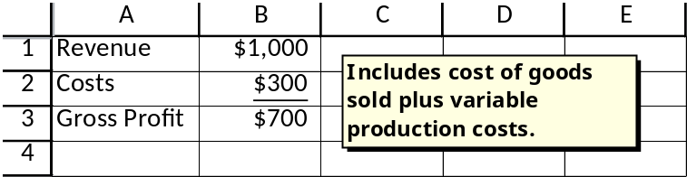

  - To remove “Show Comment”:
Right ClickHide Comment
- To remove the comment completely:
Right ClickDelete Comment
- 3 options for printing comments:
Page LayoutPage SetupSheetComments:
(1) (None)—none will be printed
(2) At end of sheet—all will be printed
(3) As displayed on sheet—only those “shown” are printed right on the spreadsheet
Issues of Entire Workbook Design

Worksheets
- Workbooks should be designed so that users need to interact with only a few, easily recognizable sheets (can isolate or hide details)
- Group similar info on separate sheets
- Name each worksheet & delete unused ones

Protection
- Most end-user worksheets should have all except parameter input cells and possibly decision variable cells protected (locked)
- First select the entire worksheet then make sure this is depressed:
HomeCells:FormatLock Cell
- Next select each range that you don’t want protected and:
HomeCells:FormatLock Cell (un-depress it)
- Then HomeCells:FormatProtect Sheet... OK (optional password)
- To unlock the sheet:
HomeCells:FormatUnprotect Sheet...

Hiding Sheets, Rows, Columns, and Formulas
- To hide a sheet, place the cursor over the sheet tab and:
Right ClickHide
- To display a hidden sheet, place the cursor over any remaining visible sheet tab and:
Right ClickUnhide...Select your sheet and click OK
- To hide consecutive rows (columns), select the rows (columns) &:
Right ClickHide
- To display hidden rows (columns), select the row (column) above (left of) and below (right of) the hidden set, and:
Right ClickUnhide
- To hide a formula:
HomeFontProtectionHiddenOK
The formula can only be hidden if the sheet is protected
Automating with Macros

Macros can automate sequences of keystrokes and mouse clicks used for repeated tasks.

Macros are stored in a Visual Basic module. Each menu command has an equivalent macro command.

Recording a Macro

Steps
1. Rehearse the necessary commands and steps.

2. Activate the macro recorder: click 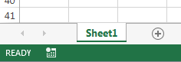 or
(ViewMacrosRecord Macro…).

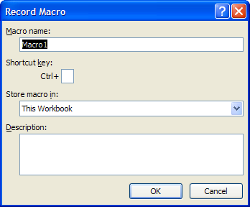
3. Name the macro. To run the macro by pressing a keyboard shortcut key, enter a letter in the Shortcut key box. You can use <CTRL>letter (for lowercase letters) or <CTRL><SHIFT>letter (for uppercase letters), where letter is any letter key on the keyboard.

4. Choose the storage location for the macro. Use This Workbook if the macro is specific to the current workbook, or save it to the Personal Macro Workbook in the Excel Startup folder for use in other workbooks.
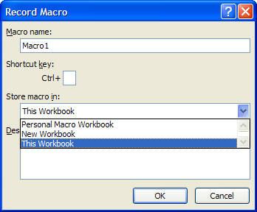

5. Click <OK>, and perform the steps to be included in the macro (using the keyboard and/or the mouse). Important: if you select cells while running a macro, the macro records absolute cell references unless you prefer relative cell references (turned on and off by ViewMacrosUse Relative References).

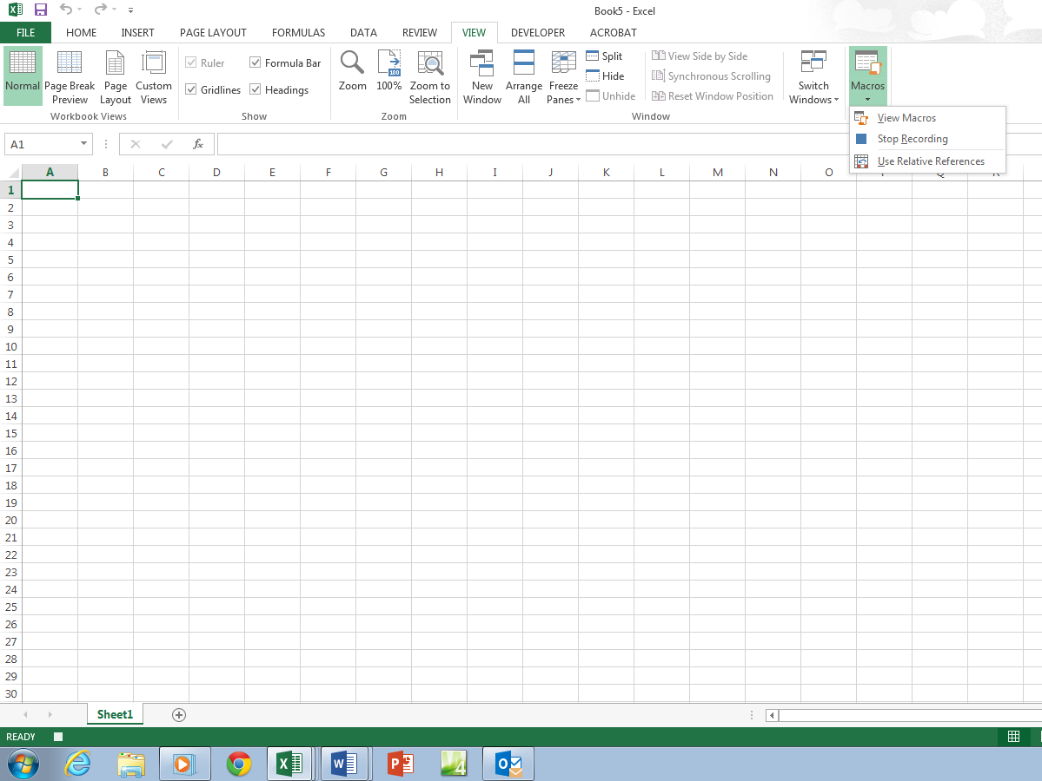
This symbol designates that a macro is currently being recorded. It can be clicked to stop recording.

6. To stop: ViewMacrosStop Recording.

Macro Examples
1. Clear a selection.

HomeEditing:Eraser Button (Clear)Clear All

2. Create a custom format.

HomeFont
FontFont Style:BoldColor:Red
BorderLine Style:Double Line
Line Color: Blue
Presets: Outline
Fill Background Color: Yellow<OK>

HomeCells:FormatAutoFit Column Width

3. Place a date & time marker at the bottom right of a
data set located in the northwest corner of the spreadsheet, and activate the macro via clicking a box.

Activate relative references.
<CTRL><HOME><END><RIGHT><END><DOWN>
<DOWN>=NOW()<Enter><UP>
HomeCells:FormatAutoFit Column Width
HomeClipboard:Copy Button
HomeClipboard: PastePaste Values
<ESC>
Stop recording.

Create a Text Box: InsertText:Text Box
Draw the box on the screen.
Right Click on the box,
Assign Macro…Select the macroOK
Macro Notes
- To apply a macro to any selected range, either pre-select a range or simply place the cursor in any cell prior to recording. Do not select a range after starting the recorder, unless you always want that exact range selected whenever the macro is run.
- The personal macro workbook loads every time a new workbook is open. By default, it is hidden. To edit or delete macros that have been saved to the personal macro workbook, click on:
ViewWindow:Unhide 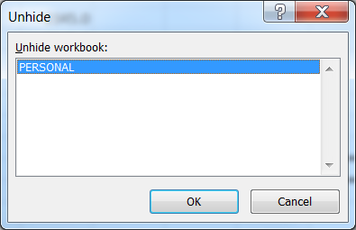,
and click <OK>.
- A personal macro can be added to the Quick Access Toolbar (QAT) (located in the upper-left corner of the screen). (Normally, this would only be done for macros saved in the personal macro workbook.)

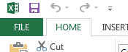

1. Click the dropdown next to the QAT and select More Commands.
2. In the left dropdown, select Macros. Select your macro from the list, and click the Add>> button to add it to the QAT. To change the icon, click the Modify button and choose from the available icons.
Drop-Down Lists
Drop-down lists represent a special form of data validation, providing a constrained set of options from which the user must choose.

Place this list of options in a column or row.
Place the cursor on the input cell and:
DataData Tools:Data Validation

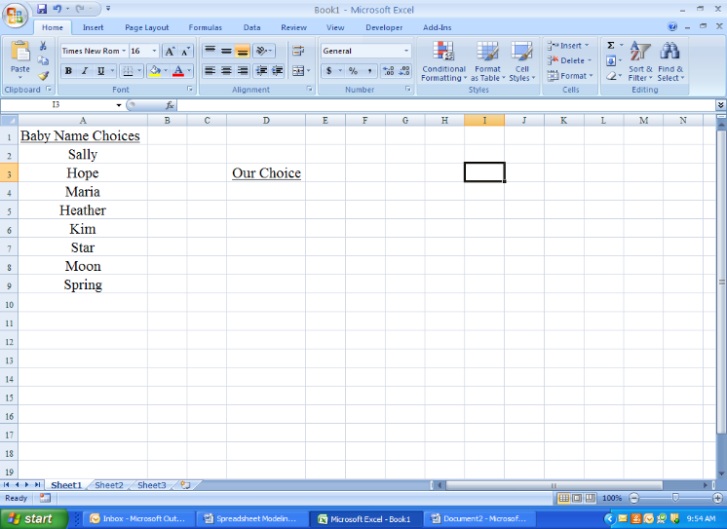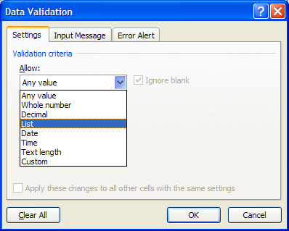

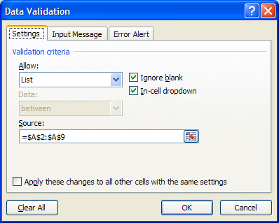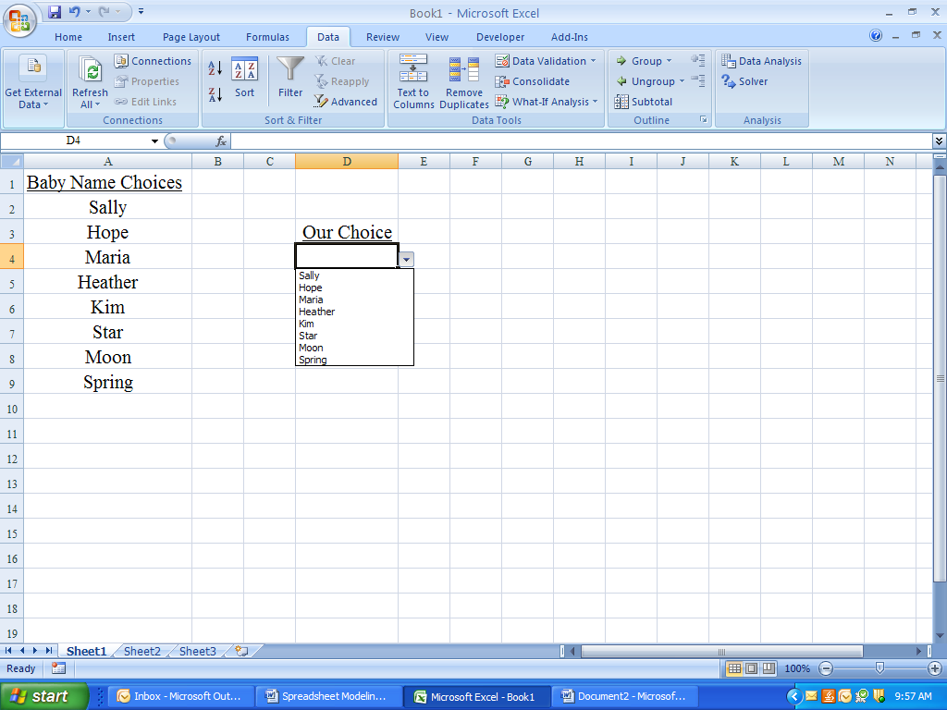
Form Controls
Form Controls provide a variety of data input options for users, so the users do not have to interact with the cells directly.
DeveloperControls:Insert 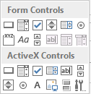

(If Developer is not in the ribbon, add it by checking:
FileOptionsCustomize RibbonMain Tabs: Developer)

Then drag and drop to the desired location.
Right click and choose Format Control...
Edit the inputs.

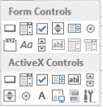
Button – Runs a macro that performs an action when clicked
– Automatically opens the macro box
– Right-click on the button to edit text, change font, etc.

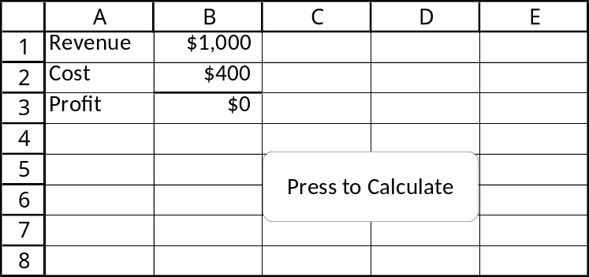

Navigation with Command Buttons
Make frequent use of command buttons to help users navigate within a sheet or from sheet to sheet.

The macro to move to a new sheet simply involves clicking on that sheet tab. However, the cursor will appear in the cell last visited on that sheet, so consider adding a <CTRL><HOME> command to start in cell A1 (or click on whichever desired beginning cell).

Use range names and the Move command (<F5>) to send the user to a desired range in any sheet of the workbook.

Example
1. Create a macro to go to cell A1 in sheet 3.
2. Create a macro to go to a named range in sheet 2.
3. Create two command buttons in sheet 1 and assign the macros to them.
4. Repeat step three in sheet 2.

Spin Button – Increases or decreases a value (number, time, or date) by clicking on the arrow
– A number can be typed into the associated cell, arrows will increment from that point

Example Right-click, Format Control…
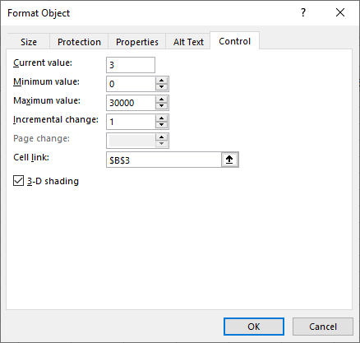
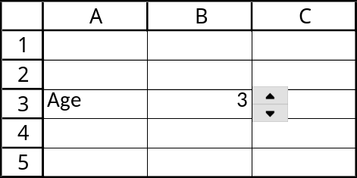

Scroll Bar – Scrolls through a range of values when arrows are clicked or box is dragged
– Arrows adjust by the incremental change
– Clicking between the box and the arrow adjusts by the page change

Example Right-click, Format Control…
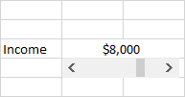
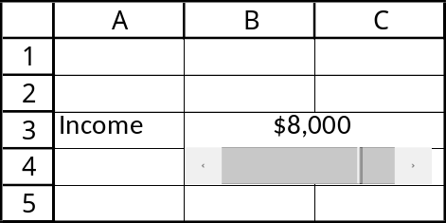
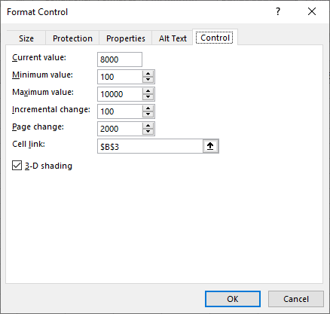
List Box – Displays a list from which the user can choose a single item
– The list items should be stored in a range somewhere in the workbook
– The index number of the chosen item is returned, not the actual item
– To convert from index number to item and enter the item into a specific cell:
=INDEX(list range, cell link)

Example Right-click,
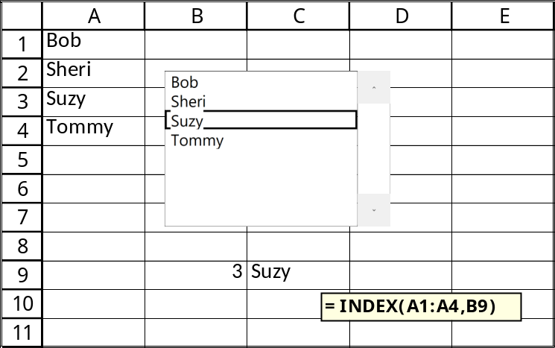
Format Control…
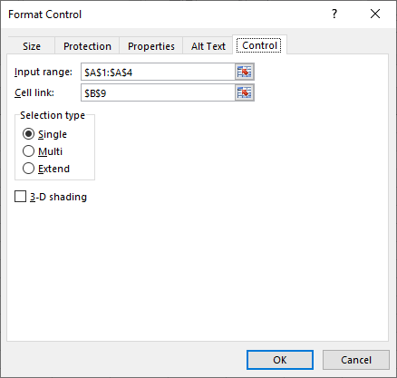

Combo Box – Works same as list box, except it’s more compact (a drop-down list box)
– The list opens when the triangle is clicked
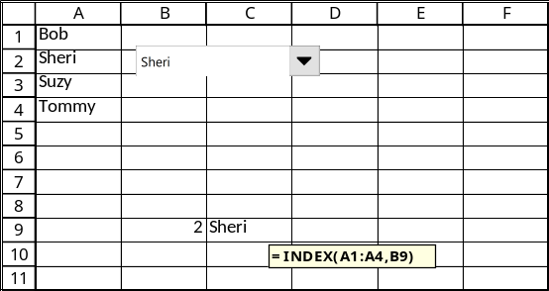
Group Box – Contains option buttons (mutually exclusive) or check boxes (multiple choices allowed)

Option Buttons – Allow a single choice from a set of mutually exclusive alternatives
– A single cell link is needed for the group; the number displayed is the index of the option chosen
– Can use an IF statement to do something with the choice

Example Right Click a Button,
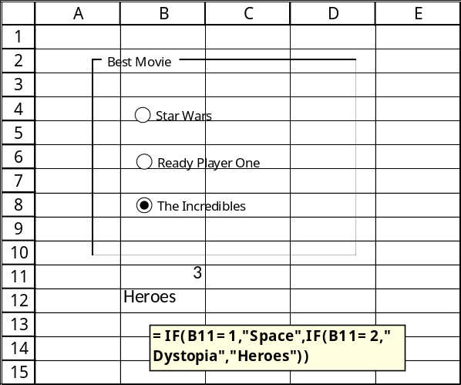
Format Control…
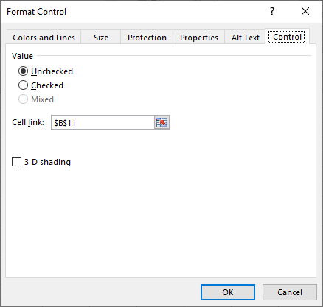

Check Boxes – Similar to option buttons, except multiple options can be selected
– Each box has a separate cell link, which will return TRUE or FALSE
– Use same cell link to activate and deactivate options together

Conditional Formatting
This is a powerful, yet easy-to-use, tool that helps to visually identify characteristics of data via formatting (especially colors or icons) applied only to data possessing certain characteristics. When the data change, the formatting may automatically change along with them. A great way to emphasize unusual values.

Examples:
- What are the exceptions to profit over time?
- What are the trends over time?
- What was the maximum profit? The minimum?
- Who sold more than $50,000 this month?
- Which products had demand decrease by more than 12% this month?
- Which products lost money last quarter?

Most important visual formats:
- color scales
- icon sets
- coloring the cells

The logic:
- If the condition is met, the formatting is applied.
- If the condition is not met, the formatting is not applied.
Two-Color Scale
This colors every cell by using a gradation of two different colors, e.g., more green vs. more yellow. Darker means more extreme.

Select the cell or cells to conditionally format and:
HOMEStyles:Conditional Formatting
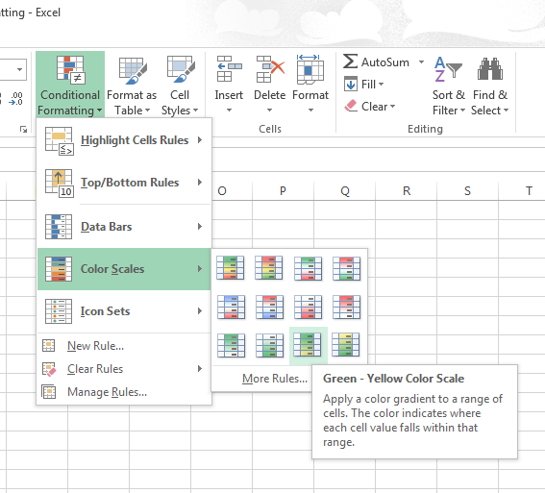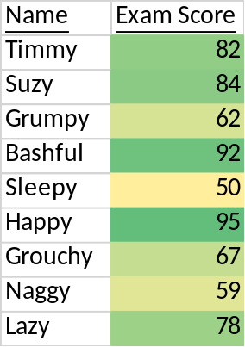

Or select More Rules… to choose your own colors. (Can also change to other conditional formatting.)
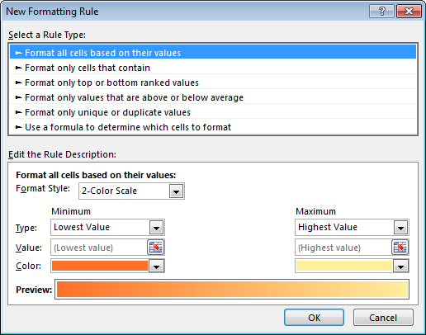
Icon Sets
This places an icon in every cell that can indicate high, medium, and low values. Both colors and icons can appear in the same cells. Scroll over the options to automatically see how they’ll appear.
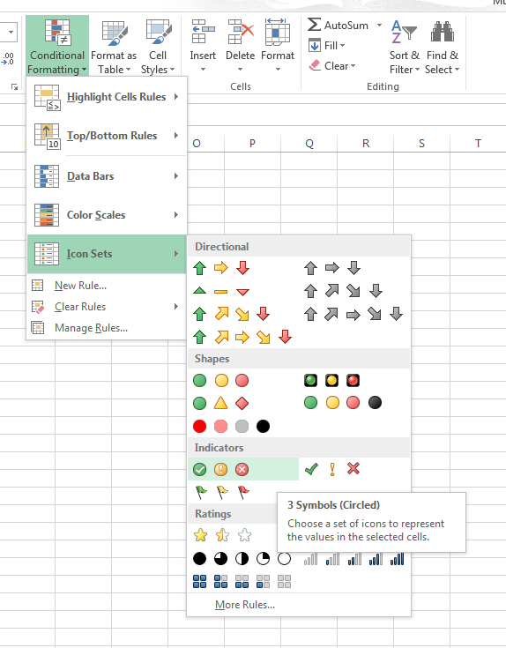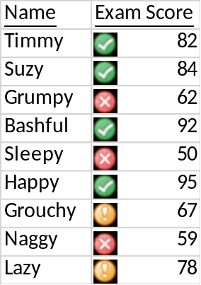

Not every cell has to have an icon. Click on
More Rules… to set different conditions.
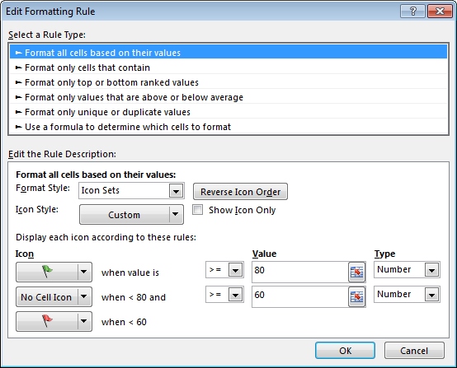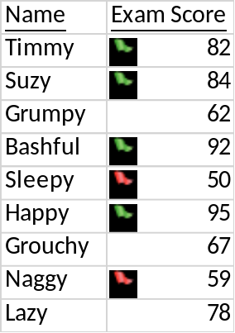
Other Examples:
For other types of rules, HOMEStyles:Conditional FormattingNew Rule…

1. Highlight the top 25% of scores in light green
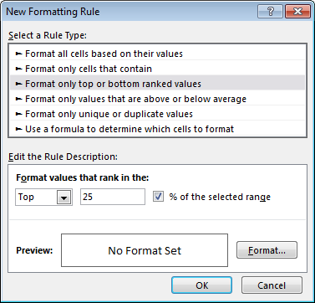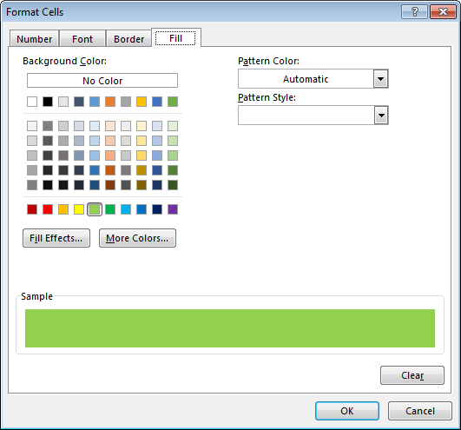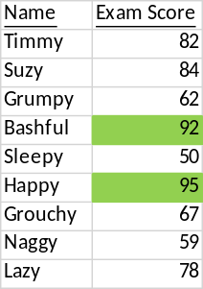

2. Highlight duplicates in yellow
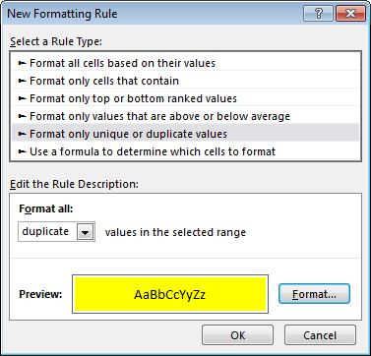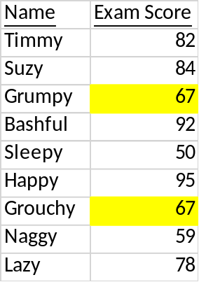

3. Highlight scores >= a threshold
=B2>=$C$2
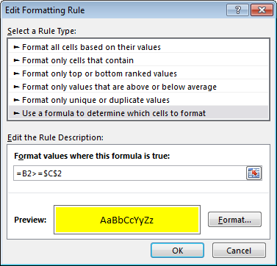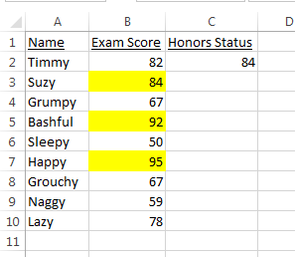
Use the first cell in the range to represent each cell. Be sure to anchor any other cells, if needed.
To change a rule, click on
HOMEStyles:Conditional FormattingManage Rules…

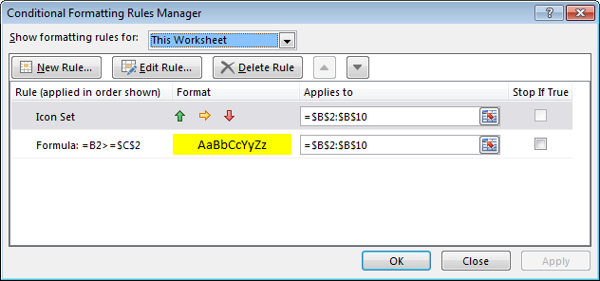

Show formatting rules for either the Current Selection or This Worksheet. Select the rule of interest. Then click on Edit Rule… to modify it.

Rules can be deleted either from the Rules Manager box or by selecting:
HOMEStyles:Conditional FormattingClear Rules…

Notes on Conditional Formatting:
- Cannot be applied to other workbooks
- If any cells in the range contain a formula that returns an error, the conditional formatting will not turn on. To apply the formatting to those cells, use the IFERROR function to return a value other than an error value.
Data Entry Validation
Data validation can be used to ensure that only legitimate values are used as inputs (highly recommended, especially with multiple users).

Highlight the cell or cells involved and:
DataData Tools:Data Validation

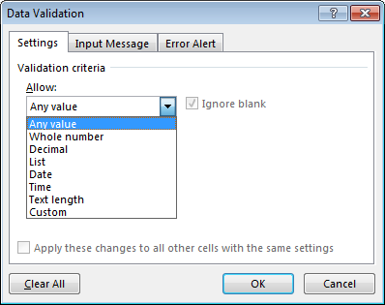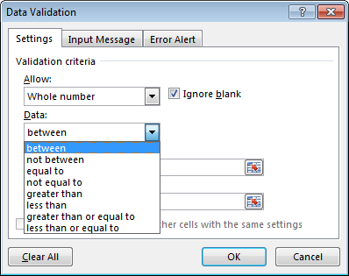

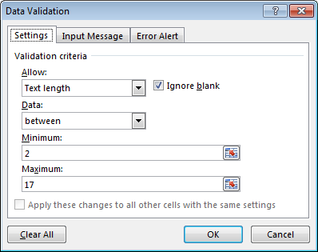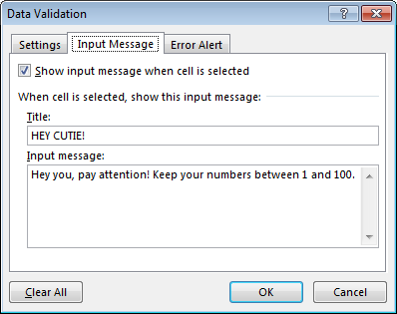

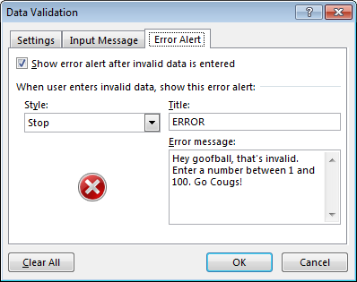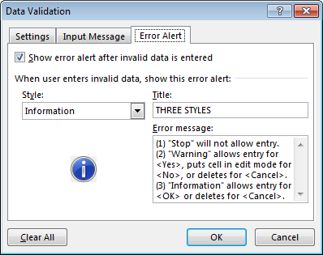

Examples of the Use of Logical Functions in Excel

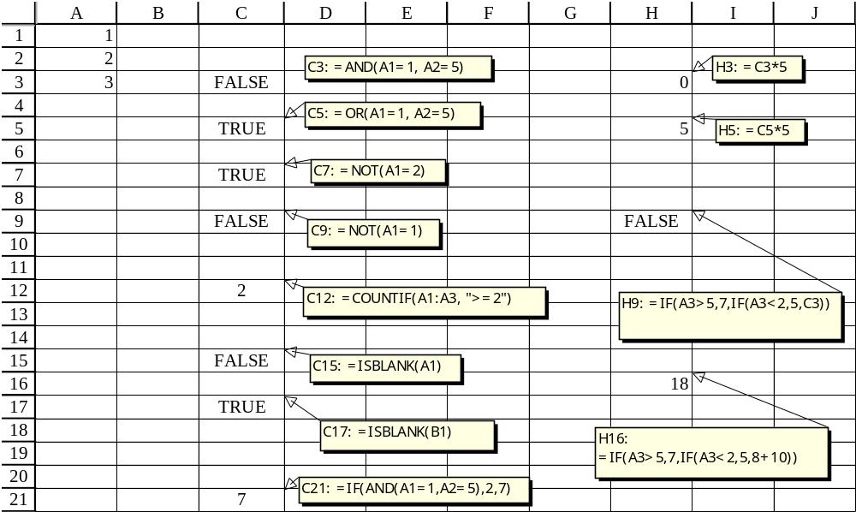
Testing a Spreadsheet

- Give it to an outsider to test!!!!
- Check numerical results with rough estimates, calculator verification, and/or testing extreme cases (out-of-bounds data)
- Especially monitor last row or column
- Individual cell references are color-coded when the F2 key is pressed
- All formulas can be displayed by pressing CTRL ` (cell values can be brought back by pressing CTRL ` again)
- Consider printing out all of your formulas during the debugging stage—look for breaks in the pattern
- Finally, check for plausible outputs over a range of inputs (sensitivity analysis)
Excel Functions

The function wizard or (FORMULASf_{x}) lists all of the functions.
=1E+307 (can represent infinity, i.e., the largest number that Excel can hold)
=ABS(B6) (returns the absolute value of the number in cell B6)
=AND(B2=6,C2=“Mary”) (returns “TRUE” (which has a value of 1) if both the value 6 is in cell B2 and the word Mary is in cell C2, and it returns “FALSE” (which has a value of 0) if both conditions are not true)
=AVERAGE(A1:B6) (calcs the mean of all numbers in the range A1 to B6, excluding blanks)
=AVERAGEIF(A1:B6,“>0”) (calcs the mean of all numbers in the range A1 to B6 that are positive)
=CEILING(3.4, 1) (rounds 3.4 up to the nearest whole integer (4))
=COLUMNS(B1:N7) (counts the number of columns in the range B1:N7)
=CONCATENATE("Mary"," ","Sanders") (puts those three strings together as one string: “Mary Sanders”)
=COUNT(A1:B6) (counts all cells within the range that contain numbers)
=COUNTIF(B4:M12,“<=60”) (counts all cells within the range with a value less than or equal to 60)
=EXP(4) (returns e raised to the power 4)
=FV(.12,5,1000) (returns the future value of $1000 received every year for 5 years at 12% interest)
=IF(A1=6,5,2) (if the value in cell A1 is 6, then a 5 is put in the cell; otherwise, a 2 is put there)
=INDEX(B2:B12,3) (returns the value in cell B4); =INDEX(B2:G5,2,3) (returns the value in cell D3)
=INT(7.6) (rounds 7.6 down to the nearest whole integer (7))
=INTERCEPT(y-range, x-range) (provides the y-intercept of a regression line of dependent variables in the y-range with independent variables in the x-range)
=ISBLANK(G2) (returns “TRUE” (which = 1) if cell G2 is empty, and returns “FALSE” (which = 0) if not empty)
=LARGE(B4:M7,2) (returns the 2nd largest number from the range B4:M7)
=LEFT("Darth Vader",3) (returns the first 3 characters from the string “Darth Vader”: “Dar”)
=LEN(“Luke Skywalker”) (returns the number of characters in the string “Luke Skywalker”)
=LN(6) (returns the natural log of the number 6)
=MATCH(4,B2:B14,0) (returns the relative position (index number) of the cell in the range B2:B14 containing 4)
=MAX(A1:B6) (returns the largest of all numbers in the range A1 to B6, excluding blanks)
=MEDIAN(A1:B6) (returns the median of all numbers in range A1 to B6, excluding blanks)
=MIN(A1:B6) (returns the smallest of all numbers in the range A1 to B6, excluding blanks)
=NORMSDIST(2.8) (returns the standard normal cumulative distribution function of 2.8 standard deviations)
=NORMSINV(.92) (returns the z-value for 92% from the standard normal distribution function)
=NOT(A5=7) (returns “TRUE” (which = 1) if A5 does not equal 7, and it returns “FALSE” (which = 0) if it does)
=NOW() (returns the date and time)
=NPV(.15,-1000,2000,3000) (returns the net present value of $1000 paid after 1 year, $2000 received after 2 years, and $3000 received after 3 years, discounted at 15% per year)
=OR(B2=6,C2=“Mary”) (returns “TRUE” (which has a value of 1) if either the value 6 is in cell B2 or the word Mary is in cell C2, and it returns “FALSE” (which has a value of 0) if both conditions are not true)
=PI() (returns the value of Pi, 3.1459265358979)
=PV(.12,5,1000) (returns the (negative of) present value of $1000 received every year for 5 years at 12% interest)
=RAND() (returns a random fractional number between 0 and 1 inclusive)
=RANDBETWEEN(1,6) (returns a random integer number between 1 and 6, i.e. rolls a die)
=REPLACE("Bob Jones",5,2,"BO") (replaces the two characters beginning with the 5th (“J”) with the letters “BO”: “Bob BOnes”)
=RIGHT("Darth Vader",4) (returns the last 4 characters from the string “Darth Vader”: “ader”)
=ROUND(5.4, 0) (rounds the number 5.4 to 0 decimal places (rounds to 5))
=ROWS(B1:N7) (counts the number of rows in the range B1:N7)
=SLOPE(y-range, x-range) (provides the y-intercept of a regression line of dependent variables in the y-range with independent variables in the x-range.)
=SMALL(B4:M7,2) (returns the 2nd smallest number from the range B4:M7)
=SQRT(7) (calculates the square root of 7)
=STDEV(A1:B6) (calcs the std. deviation of numbers in the range A1 to B6, excluding blanks)
=SUM(A1:B6) (adds all numbers in the range A1 to B6)
=SUMPRODUCT(A1:B2,D2:E3) (multiplies corresponding components in the given arrays, and returns the sum of those products, e.g., A1*D2+A2*D3+B1*E2+B2*E3)
=TODAY() (returns the date)
=VLOOKUP(40,A1:B3,2) (searches for the largest number ≤ 40 in A1:A3 & returns that row’s column B value)

