MgtOp 470

Professor Munson

Topic 3

VBA Programming in Excel for
Decision Support Systems

(Set 4—User Forms: Becoming a True “Windows Programmer”)

“Working with user forms is arguably the most fun part of VBA application development. You can use your creative and artistic talents to design the dialog boxes that user interact with.”

Albright, S. Christian, VBA for Modelers, 5th Ed., Cengage Learning, 2016, p. 231
Creating Dialog Boxes (User Forms)

Input boxes, message boxes, Yes-No boxes, and form controls (e.g., list boxes, spin buttons, etc.) work well for specific tasks, but they are limited by basically being able to perform only one operation. Many practical applications, however, necessitate “dialog boxes” that may require the user to enter several different responses into the same box. Programmers can employ “user forms” to accommodate such situations. These are the primary means for getting users’ inputs.

Two Parts to Creating User Forms
1. Design the form
For the required functionality and attractiveness
- Insert a user form
- Choose and place controls
- Set control properties

2. Write Event Handlers
To appropriately respond to user actions
- UserForm_Initialize Code
- btnCancel_Click Code
- btnOK_Click Code
- Code for any other controls
Designing User Forms

Getting Started
1. Project Explorer and Properties Window should be visible (use the View tab if they’re not).

2. →Insert→UserForm
(A blank form will appear with the Toolbox)

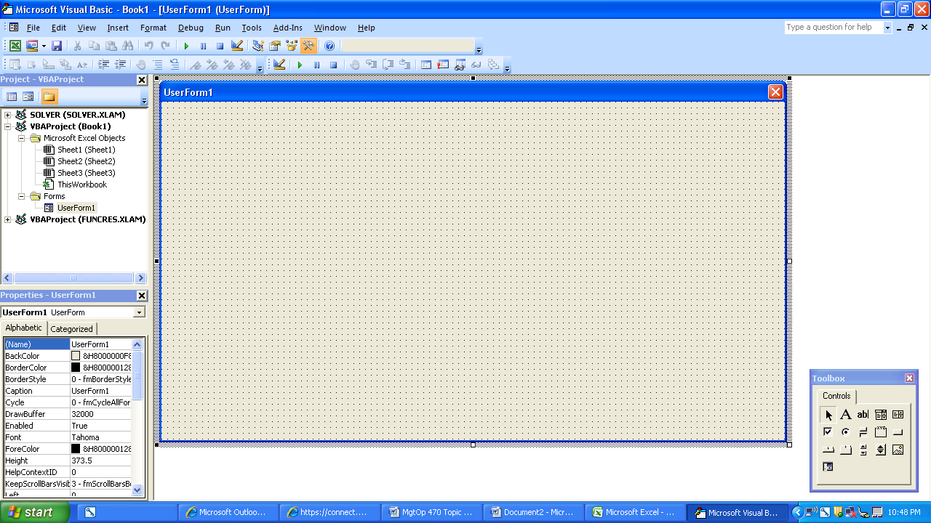
Available Controls
Pointer (put the cursor in ready mode)

Label (for explanations and prompts—no user input)

TextBox (user types something in the box)

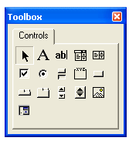
ComboBox (user chooses from a list or types in)

ListBox (user chooses one or more items from a list)

OptionButton (user
selects one of several ToggleButton (either options) depressed or not)

CheckBox (user selects Frame (groups related
any of several options) controls—especially
option buttons)
TabStrip (view different
sets of information for CommandButton (runs
related controls) subs)

Image (displays a picture)
MultiPage (presents multiple
screens of info as a SpinButton (increments and
single set) decrements numbers)

ScrollBar (returns or sets the value of another control based on the position of the scroll box)

RefEdit (similar to a TextBox control, but used
specifically to let the user select a worksheet range)

Adding Controls to the User Form
- To add any control, click it in the Toolbox and then drag it onto the form.

- Size a control by selecting it and then clicking and dragging one of the eight handles on the outside.

- Move a control by clicking it and dragging.

- Copy a control by first selecting it and then pressing Ctrl while dragging (to copy a Frame, place the cursor on the edge of the Frame before dragging).

- Resize and align either visually or with the Format menu (numerous options). To format several items together, →<Ctrl>→<Click> each one to select the set, then visit the Format tab.

- View the form by selecting the user form itself and pressing <F5>. Return to VBE by clicking on the X button (closing the form).
Setting Properties of Controls
Use the Properties Window to establish control parameters. Selecting a control automatically displays the appropriate properties window. Most settings do not need to be changed!

Common Properties to Set
All or most controls:
Name (Not what the user sees but what VBA code uses for that control—like a variable name. It’s a good idea to begin each name with an abbreviation for the control, e.g., btnCompute or optPullman.)

Caption (The text that is seen on the screen—it’s the title bar on the user form itself.)

OK button:
Use a command button to create an OK button.
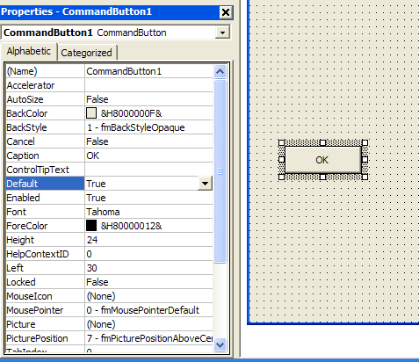
Caption OK

Default True
This makes pressing <Enter>
have the same effect as
clicking the button.

Cancel button:
Use a command button to create a Cancel button.
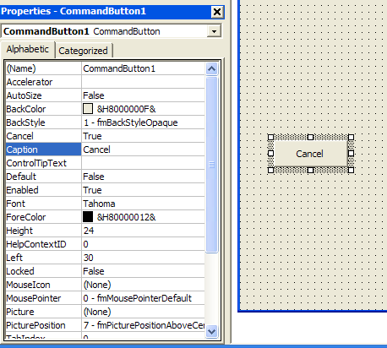
Caption Cancel

Cancel True
This makes pressing <Esc>
have the same effect as
clicking the button.

Label
Caption (whatever you want the box to say)

Text box
You generally only set the Name and otherwise place a label control somewhere near the box to describe what goes inside.

Frame
You generally only set the Name and Caption and otherwise make sure that all controls that are supposed to be grouped in the frame lie completely inside it.
Option button
You generally only set the Name and Caption. Make sure that all mutually exclusive options lie within the same Frame.

Check box
You generally only set the Name and Caption. Make sure that all related options lie within the same Frame.

List box
Set the Name and otherwise place a label control somewhere near the box to describe what goes inside.
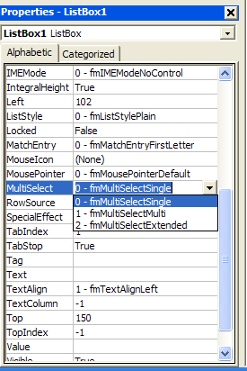
MultiSelect (from the drop-down list, choose
0-fmMultiSelectSingle to allow only 1 choice, or
2-fmMultiSelectExtended to allow the user to select multiple items from the list.

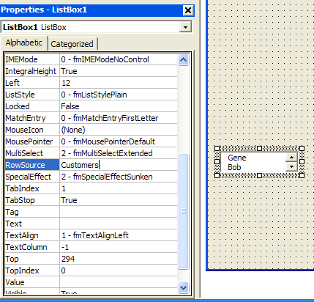
RowSource [enter the range name from Excel containing the list, e.g., “Customers” (do not include quotes); or type in the range itself]

Writing Event Handlers

In Windows, an “event” occurs whenever the user does something (e.g., clicking on a button, selecting a worksheet, clicking on a cell, etc.). An “event handler” is a Sub that contains code to provide instructions on what to do after a specific event occurs.

Note: Event handlers are not placed in modules (as regular VBA code is). Instead, they are placed in a user form’s associated Code Window. Toggle between the design window and the code window by pressing <Shift><F7> and <F7>, respectively.

Event handlers are not as daunting as they may first appear. For many applications, you only need one for the Cancel button that contains two short lines of code, and a second for the OK button that simply assigns the values of all of the choices to previously defined public variables (and closes the user form).

Creating an Event Handler Sub
In general, there is no need to learn the syntax for the first and last statement of each Sub. VBA will insert it for you.

Each control has a default event. To create a Sub for that event, simply double-click on the control in the design box. VBA will automatically take you to the code window and insert the first and last lines.

For all other events of a control, use the drop-down lists at the top of the code window. The figures below illustrates choosing the MouseDown event for a command button:

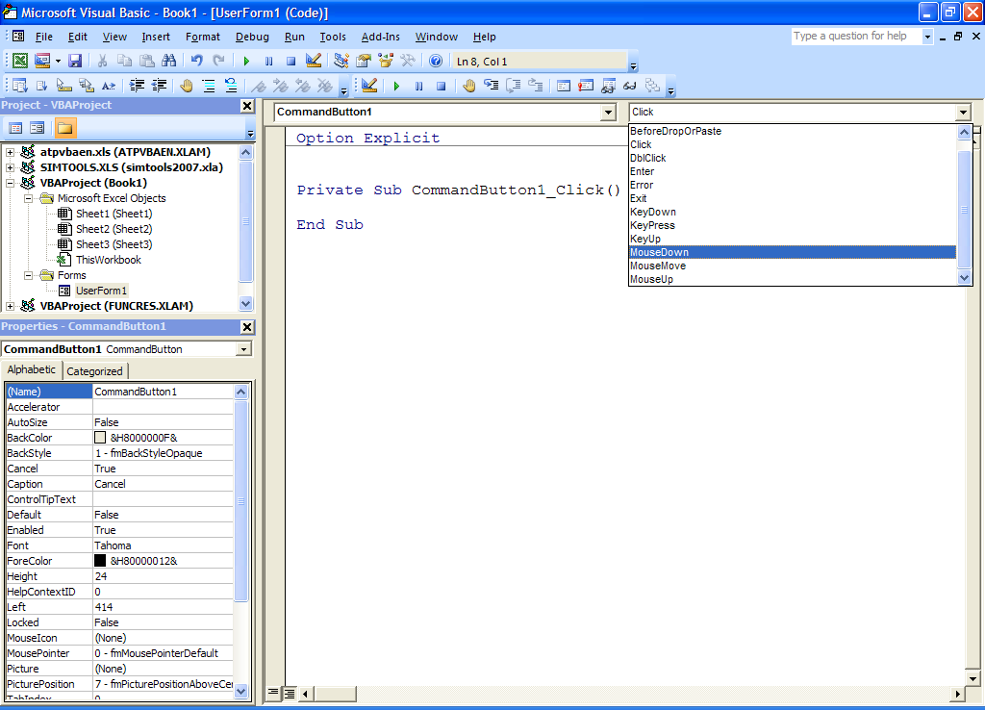

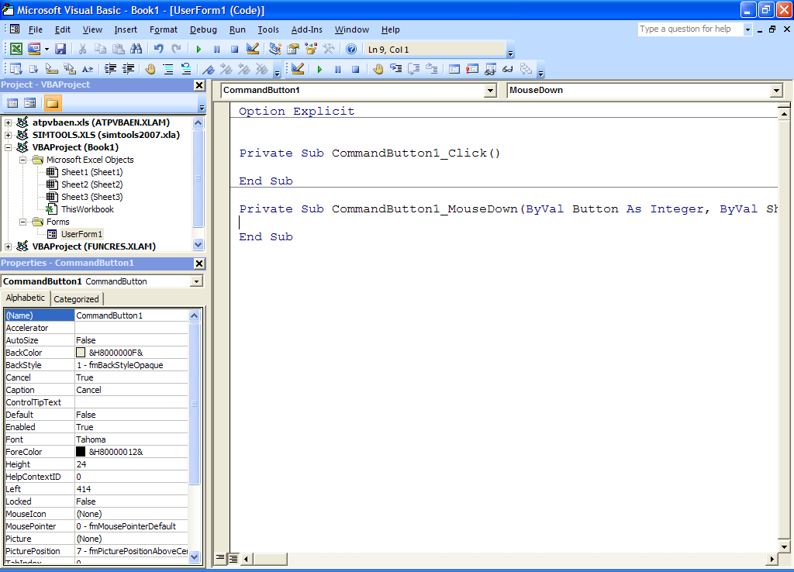
UserForm_Initialize
This Sub always has this name, and it determines how the user form will look when the user first sees it. It’s generally used to indicate, for example, which buttons are initially pressed or to insert a default name into a text box.
Ex: Private Sub UserForm_Initialize()
txtEmployee.Value = “Suzy Walsh”
optHourlyWorker.Value = True
chk401KPlan.Value = True
chkDentalPlan.Value = True
End Sub

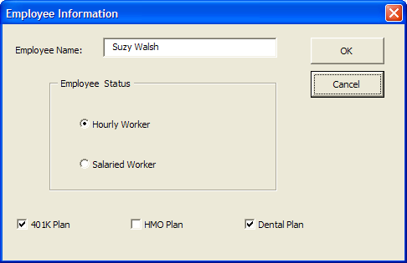

Cancel Button Code
The following code not only makes the user form disappear, but it also completely ends the program (not just the Cancel button Sub). The button is named “btnCancel”.

Private Sub btnCancel_Click()
Unload Me
End
End Sub

OK Button Code
The code here should include the program’s responses to everything that the user has entered. It might include some error checking (see Chapter 12), and otherwise it mostly assigns the responses to global variables that may be used in other Subs.

For option buttons, usually use either If constructions or Case constructions.

For a list box, the Value property indicates the string for the item selected, while the ListIndex property indicates its position in the list starting with 0. (If Value is blank, then no item is currently selected, and the ListIndex = −1.) Note: ListIndex exists but does not appear in the Properties Window for the list box.

Finally, you must unload the user form at the end of the OK button Sub. So the last statement before “End Sub” should be “Unload Me”.
Spin Button Code
The numerical result of a spin button (e.g., SpinButton1) should appear in a text box (e.g., TextBox1). To change the value in the box by 1 whenever an arrow on the spin button is depressed, perform the following steps:

1. Place an initial number into the text box by entering that number into the Value property for TextBox1.
2. Double-click on SpinButton1
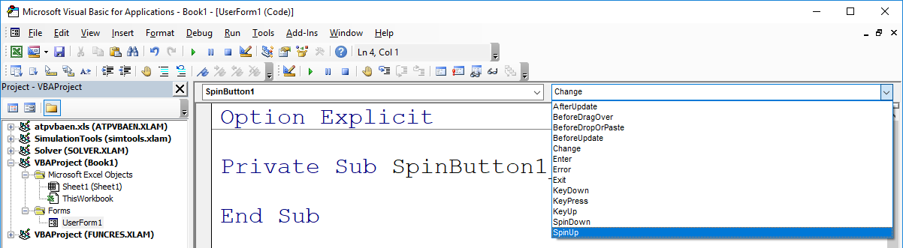
3. Select SpinUp
4. Insert the following code in the SpinUp() Private Sub:
TextBox1.Value = TextBox1.Value + 1

5. Repeat the procedure for SpinDown using “- 1”:
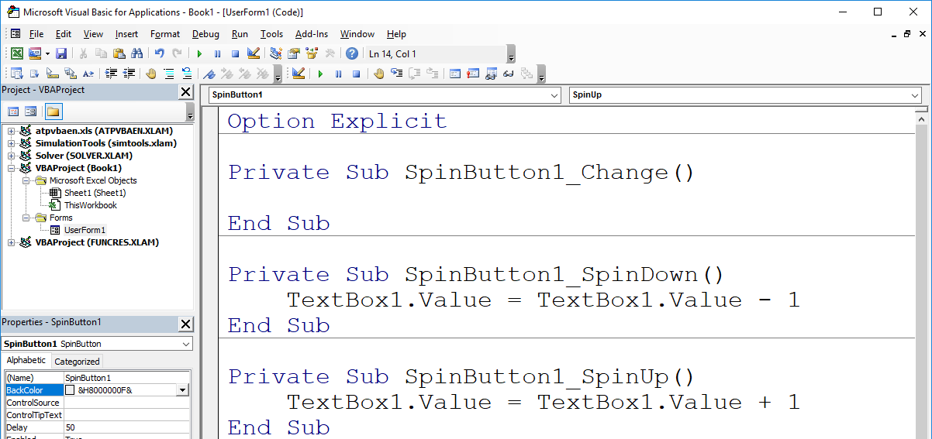
Dynamic User Forms
Suppose that you want a feature to appear on a user form only if the user makes a certain selection. You can use the Visible property to handle this.

Example: The user chooses either pasta or a burger for dinner. If pasta is chosen, then a new set of option buttons appears for the user to select which type of pasta. If burger is chosen, then a label and toggle button appear asking if the user wants to order fries as well.
The full user form design looks like this:
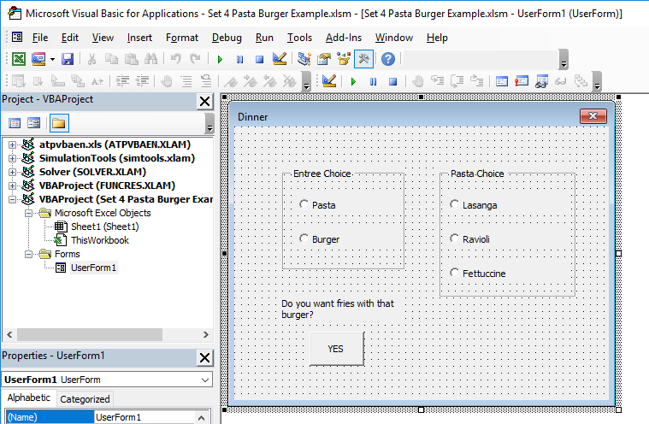

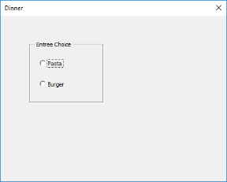
The following turns on and off the controls when either entrée choice is selected. When a frame is hidden, its option buttons are automatically hidden too. Be sure to manually set the Visible property as False for all three controls.
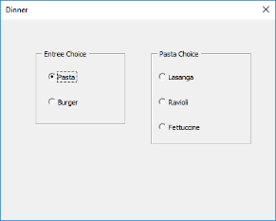
Private Sub OptPasta_Click()
FrmPasta.Visible = True
LblFries.Visible = False
TglFries.Visible = False
End Sub
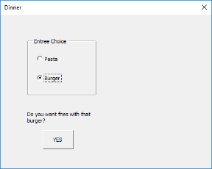
Private Sub OptBurger_Click()
FrmPasta.Visible = False
LblFries.Visible = True
TglFries.Visible = True
End Sub
Other Issues
Displaying the dialog box to the user
In some other controlling VBA code, enter the line:
userformname.Show

Ex: [if the user form is named “frmEmployee”]:
frmEmployee.Show

Looping through controls
You can use a For Each loop to loop through all controls. If you only want to loop through a certain type, try the TypeName function.

Ex: Dim ctl As Control
For Each ctl In Me.Controls
If TypeName(ctl) = “ListBox” Then
[Insert statements here]
End If
Next

Multi-list boxes
Use the Selected property of the list box. The (Boolean) property acts like an array (0-based) for each member of the list. Also, the ListCount property counts the number of items in the list.

Ex: For i = 1 to lbProducts.ListCount
isChosen(i) = lbProducts.Selected(i-1)
Next
Exercise: Create the following user form for an online dating service. Write the event handler Subs for the Cancel and OK buttons that assign values to global variables defined elsewhere in the program.

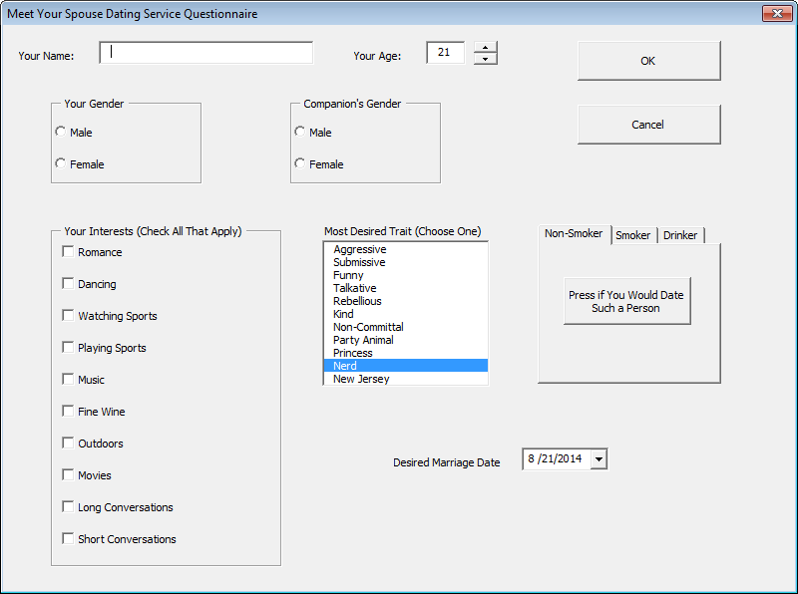
Step 1: Adding Controls to the User Form
1. Enter VBE and click on InsertUserForm.
2. Resize the User Form to make it wider and taller.
3. Insert an 8×3 label (Label1) in the upper left. (The 8×3 means approximately 8 dots wide and 3 dots tall.)
4. Insert a 27×3 text box (TextBox1) next to Label1.
5. Insert an 8×3 label (Label2) to the right of TextBox1.
6. Insert a 5×3 text box (TextBox2) next to Label2.
7. Insert a 3×3 spin button (SpinButton1) next to TextBox2.
8. Insert an 18×6 command button (CommandButton1) in the upper right of the User Form.
9. Insert an 18×6 command button (CommandButton2) below CommandButton1. (Can use copy/paste.)
10. Insert an 18×10 frame (Frame1) in the 2nd row of the User Form.
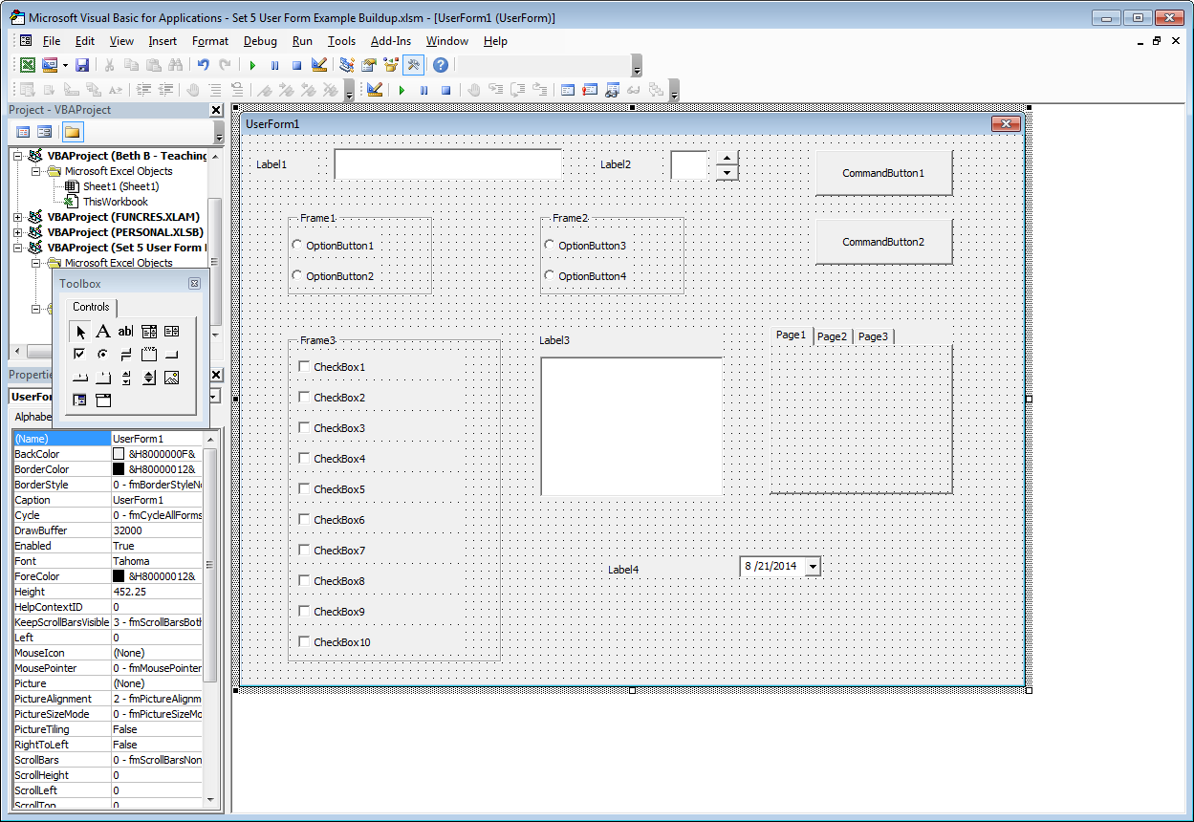
11. Insert a 12×4 option button (OptionButton1) in Frame1.
12. Insert a 12×4 option button (OptionButton2) below OptionButton1 within Frame1. (Can use copy/paste.)
13. Insert an identically sized frame with option buttons (Frame2 and OptionButton3 and OptionButton4) to the right of Frame1. (Can use copy/paste.)
14. Insert a 27×42 frame (Frame3) below Frame1.
15. Insert 10, 23×4 check boxes within Frame3. (Can use copy/paste.)
16. Insert a 22×3 label (Label3) next to the top of Frame3.
17. Insert a 22×18 list box (ListBox1) right below Label3.
18. Insert a 22×21 MultiPage next to ListBox1. Insert a third page by right-clicking on the tabs and clicking New Page.
19. Insert an 18×3 label (Label4) below ListBox1.
20. Finally, add a 10×3 date and time selector (DTPicker1) next to Label4. To add it to your controls Toolbox, right-click on the Controls tab, and click on Additional Controls… Then check Microsoft Date and Time Picker Control 6.0 (SP6) click <OK>.

Step 2: Setting Properties of Controls
1. UserForm1: Caption = Meet Your Spouse Dating Service Questionnaire
2. Label1: Caption = Your Name:
3. Label2: Caption = Your Age:
4. TextBox2: Value = 21
5. CommandButton1: Caption = OK
Default = True
6. CommandButton2: Caption = Cancel
Cancel = True
7. Frame1: Caption = Your Gender
8. OptionButton1: Caption = Male
9. OptionButton2: Caption = Female
10. Frame2: Caption = Companion’s Gender
11. OptionButton3: Caption = Male
12. OptionButton4: Caption = Female
13. Frame3: Caption = Your Interests (Check All That Apply)
14. CheckBox1: Caption = Romance
15. CheckBox2: Caption = Dancing
16. CheckBox3: Caption = Watching Sports
17. CheckBox4: Caption = Playing Sports
18. CheckBox5: Caption = Music
19. CheckBox6: Caption = Fine Wine
20. CheckBox7: Caption = Outdoors
21. CheckBox8: Caption = Movies
22. CheckBox9: Caption = Long Conversations
23. CheckBox10: Caption = Short Conversations
24. Label3: Caption = Most Desired Trait (Choose One)
25. For ListBox1, List the traits in the Excel sheet:
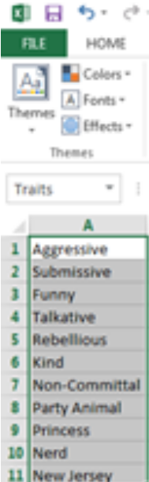
A1: Aggressive
A2: Submissive
A3: Funny
A4: Talkative
A5: Rebellious
A6: Kind
A7: Non-Committal
A8: Party Animal
A9: Princess
A10: Nerd
A11: New Jersey
In Excel, name the Range A1:A11 as “Traits”
Back in VBE, ListBox1: Rowsource = Traits
ListBox1: Value = Nerd [This chooses Nerd as the
default desired trait; it can be left blank or identified
by a different trait if desired.]
26. Page 1: Right-click on the tab, then select Rename… Change the caption to Non-Smoker and click <OK>. Similarly, change the caption for Page 2 to Smoker, and change the caption for Page 3 to Drinker.
27. Insert a 16×6 Toggle Button (ToggleButton1) onto the Non-Smoker page. Its caption = Press if You Would Date Such a Person
28. Copy ToggleButton1, and paste it onto the Smoker and Drinker pages (creating ToggleButton2 and ToggleButton3).
29. Label4: Caption = Desired Marriage Date
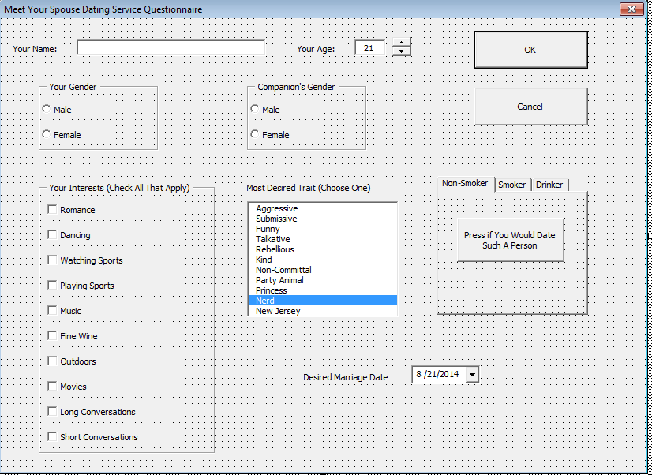

Step 3: Writing Event Handler Subs
1. Double-click on SpinButton1
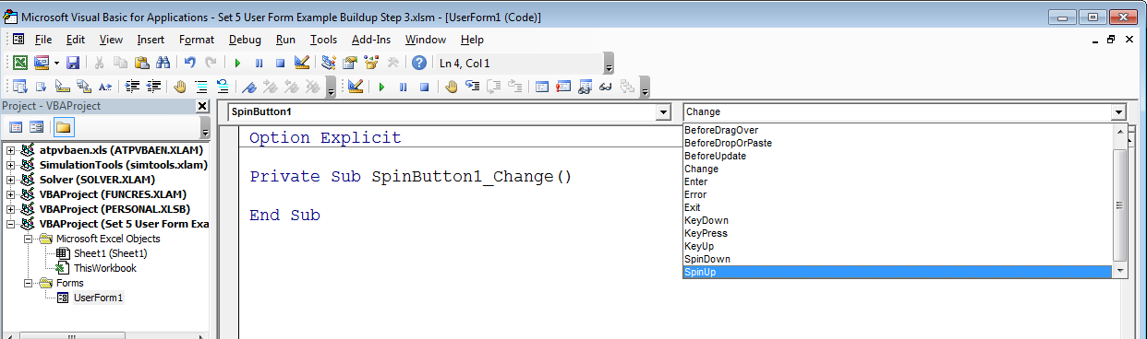
2. Select SpinUp

3. Insert the following code in the SpinUp() Private Sub:

TextBox2.Value = TextBox2.Value + 1

4. Repeat the procedure for SpinDown using “- 1”:

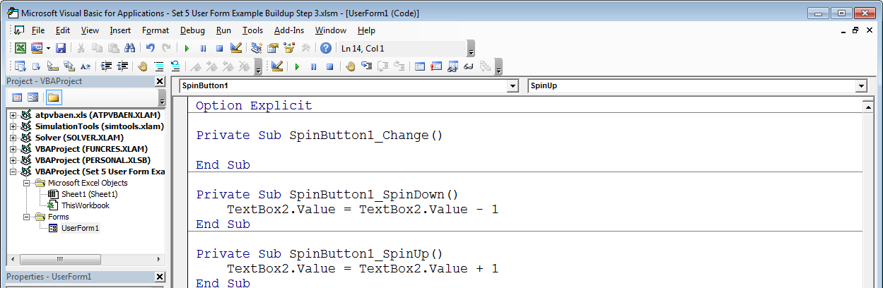

5. Press <Shift><F7> to return to the design page.

6. Double-click on the Cancel button.

7. Insert the following code into the CommandButton2_Click() Private Sub:
Unload Me
End

8. Press <Shift><F7> to return to the design page.

9. Double-click on the OK button.

10. For the CommandButton1_Click() Private Sub, the following code would assign values from the user form to global variables defined in another module (see #11 below):

Private Sub CommandButton1_Click()
YourName = TextBox1.Value
YourAge = TextBox2.Value

If OptionButton1.Value = True Then
YourGender = "Male"
ElseIf OptionButton2.Value = True Then
YourGender = "Female"
End If

If OptionButton3.Value = True Then
CompGender = "Male"
ElseIf OptionButton4.Value = True Then
CompGender = "Female"
End If

'Note that the following variables for the check boxes are Boolean
isRomance = CheckBox1.Value
isDancing = CheckBox2.Value
isWatchingSports = CheckBox3.Value
isPlayingSports = CheckBox4.Value
isMusic = CheckBox5.Value
isFineWine = CheckBox6.Value
isOutdoors = CheckBox7.Value
isMovies = CheckBox8.Value
isLongTalks = CheckBox9.Value
isShortTalks = CheckBox10.Value

Trait = ListBox1.Value

'Note that the following variables for the MultiPages are Boolean
willNonSmoker = ToggleButton1.Value
willSmoker = ToggleButton2.Value
willDrinker = ToggleButton1.Value

MarriageDate = DTPicker1.Value

Unload Me

End Sub
11. The following code might appear in a separate module. It first defines global (public) variables for all of the items on the user form. (Note how these definitions appear before any subs.) Then the sub called Main calls up the user form and produces a message box that displays some of the user’s entries.

Option Explicit

Public YourName, YourAge, YourGender, CompGender, Trait As String
Public isRomance, isDancing, isWatchingSports, isPlayingSports, isMusic, _
isFineWine, isOutdoors, isMovies, isLongTalks, isShortTalks, _
willNonSmoker, willSmoker, willDrinker As Boolean
Public MarriageDate As Date

Public Sub Main()

UserForm1.Show

MsgBox "Your information is:" & vbCrLf & "Your name is " & YourName _
& vbCrLf & "Your age is " & YourAge & vbCrLf & "Your gender is " _
& YourGender & vbCrLf & "Your companion's gender is " & CompGender _
& vbCrLf & "Your most desired trait is " & Trait _
& vbCrLf & "You want to be married on " & MarriageDate, _
vbInformation, "Your Data"

End Sub

