MgtOp 340—Operations Management
Professor Munson

Topic 7

Deterministic Demand
Inventory Theory

“Inventory does not improve quality. It only eats into profitability.”
Rune Svensson, President of Volvo Transport

“Most worker injuries are to the back, and are caused by moving inventory.”
Patrick Northey & Nigel Southway, Cycle Time Management

“‘Inventory is evil,’ says another JIT slogan. I say, ‘Tell it to the squirrels.’”
Paul H. Zipkin, Foundations of Inventory Management, 2000, p. 15.
Inventory

Inventory serves as a buffer between supply and demand processes that do not fit neatly together, to mitigate the costly disruptions that would otherwise occur.

Example of a nearly “perfect” supply process:
supply of cold water to homes

Specific Purposes
- Meet anticipated demand

- Decouple production & distribution
  - Permits constant production quantities

    - Permit smooth operations through work-in-process (WIP) inventory, i.e. decouples operations

    - Take advantage of quantity discounts

    - Provide hedge against inflation

    - Exploit economies of scale in supply

    - Protect against shortages
Disadvantages of Inventory

- Cost of holding (i.e. carrying) inventory

    - Difficult to control
- Determining optimal amounts

Record keeping
      - Storage and maintenance

        - Handling inventory is a non-value added activity

        - Reduces cash availability

        - Product might become obsolete
          - liquidation
          - reduced responsiveness to the market with new products

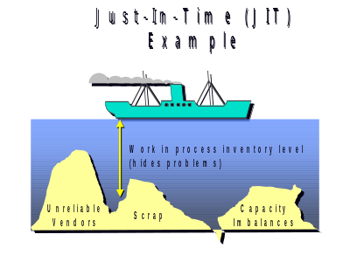
Hides production problems
ABC Analysis

Observation: 20% of units account for 80% of total inventory costs

Idea: Manage most important (costly) inventory items most closely.

Application: First analysis to undertake when addressing inventories.

Class A Items: ~ 15%-20% (most inventory-expensive units)
- intensive control
- constant management attention
- critical factor in controlling inventory costs
- develop these suppliers the most
- sophisticated forecasting necessary

Class B Items: ~ 30% (medium inventory-expensive units)
- moderate control
- computer control when possible
- management by exception

Class C Items: ~ 50%-55% (least inventory-expensive units)
- minimal control/simple techniques
- minimize transactions costs
- simple manual control whenever possible

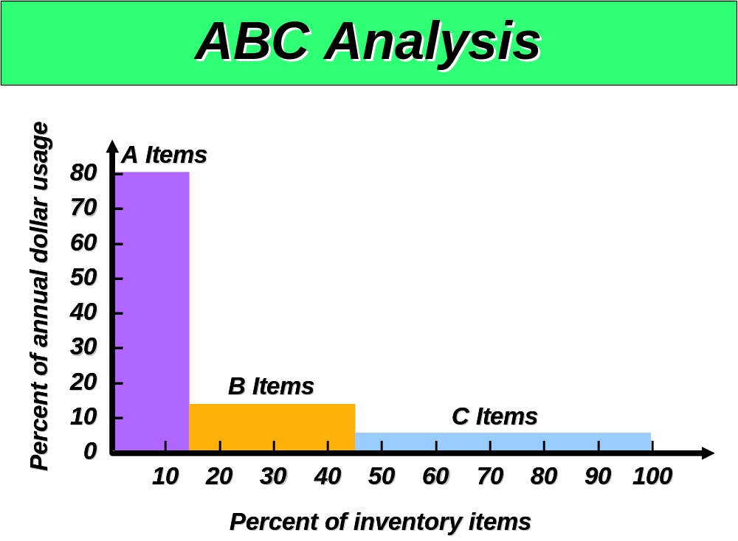
Managing Inventories

Inventory Systems—set of policies & controls
- Establish amount of inventory
- Monitor inventory levels
- Determine when to replenish inventories
- Calculate order/production quantities

Types of Demand

1. Dependent vs. Independent

- Independent—end product sold to customers
- Dependent—component used in end product

2. Deterministic vs. Stochastic

- Deterministic—demands known with certainty
- Stochastic—demands are uncertain, random

3. Static (Stationary) vs. Variable

- Static—expected demand does not change over time
- Variable—expected demand changes over time
Basic Inventory Models

Inventory models vary by product demand characteristics.

1. Deterministic, Independent, and Static Demand

- Economic Order Quantity (EOQ)
- Production Order Quantity (POQ)
- Quantity Discounts
- One-Time Sale
- Lumpy Demand (B-to-B transactions)

2. Deterministic, Dependent, Variable Demand

- Materials Requirements Planning (MRP)
- Various lot sizing models (e.g., Wagner-Whitin, Silver-Meal)

3. Stochastic, Independent, and Variable Demand

- Continuous review safety stock models
- Periodic review safety stock models

4. Stochastic, Independent, One-Time Demand

- Newsvendor models
Basic Economic Order Quantity
(EOQ Model)

Problem: How much of a given item to order every time that the item is ordered.

Assumptions
1. The time horizon is infinite.

2. Demand rate is constant over time (e.g., 10,000 units/year).

3. Demand rate is uniform (i.e., demand occurs continuously and smoothly).

4. Purchasing lead time = 0, and the order arrives in one lot (infinite production rate).

5. No constraints on the order size.

6. Decisions for one item are made independently of decisions for other items.
7. Deterministic world (i.e., no uncertainty in demand, lead time, or supply).

8. No backorders are allowed.

9. The order quantity can be a fraction.

10. Purchased price does not depend on lot size.

11. Cost factors remain constant over time.

Cost Elements of the EOQ Model

Purchase cost is ignored since it does not vary with lot size and demand is known.

We consider 2 costs:
1) setup costs per order, and
2) inventory holding costs.

Setup Costs
- time needed to prepare a purchase order
- receiving and inspection
- order forms
- postage
- telephone calls
- authorization
- vendor’s fixed charge

Inventory Holding Costs
- warehouse space
- interest on tied-up money
- obsolescence, breakage, spoilage, deterioration
- taxes
- insurance
- pilferage
- worker’s compensation costs
EOQ Model
Minimizing Costs
How Much to Order?

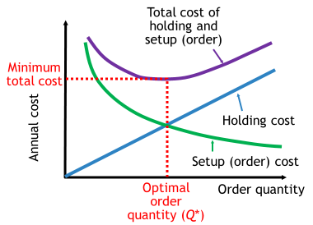
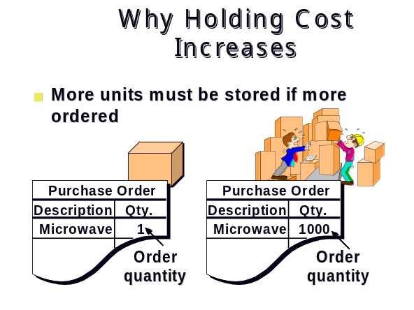
Why Order Cost
Decreases
Why Order Cost
Why Order Cost
Decreases
Decreases
■
■
Cost is spread over more units
Cost is spread over more units
Example: You need 1000 microwave ovens
Example: You need 1000 microwave ovens
Purchase Order
Description
Qty.
Microwave
1000
1
Microwave
1 Order (Postage $ 0.37)
1 Order (Postage $ 0.50)
1000 Orders (Postage $370)
1000 Orders (Postage $500)
Order
Order
quantity
quantity
Purchase Order
Description
Qty.
Microwave
1
EOQ with Assumption 1: Holding cost is expressed per unit

Let D = annual demand
S = setup cost per order
H = holding cost per unit per year
Q = number of units per order
(decision variable)
Q* = optimal order quantity

Number of orders per year:

Average inventory:

Total Cost = annual setup cost + annual holding cost

EOQ with Assumption 2: Holding cost is an annual percentage of unit cost (not the sales price that the firm will charge its customers)

Let c = cost per unit
I = annual holding cost percentage

EOQ Theorem
At the optimal order quantity, the ordering cost equals the holding cost.

Example 1: D = 12,000 units/year
S = $60/order
H = $10/unit/year

Holding Cost = 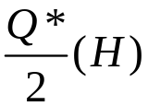=

Setup Cost = 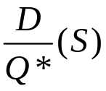=

Example 2: D = 48,000 units/year
S = $20/order
I = 18%
c = $100

Production Order Quantity (POQ)

- Use with a finite production rate
- Like the EOQ, answers how much and when to order
- Allows partial receipt of material
  - Other EOQ assumptions apply
    - Especially suited for a production environment
      - Some of what is produced is used immediately
      - Provides a production lot size
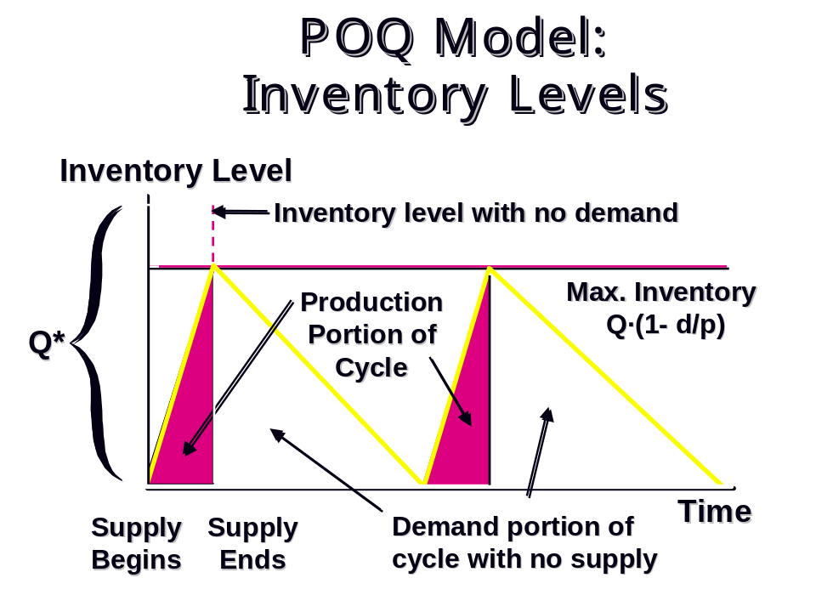
- Lower (effective) holding cost than the EOQ environment since avg. inventory is lower

POQ Model Equations

Additional Notation
d = daily demand rate
p = daily production rate

Annual Setup Cost = 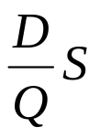

Annual Holding Cost = 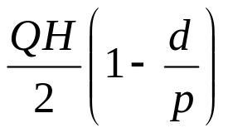

Optimal Order Quantity =

Maximum Inventory Level =

Annual Setup and Holding Cost at Q = Q_{P}* =
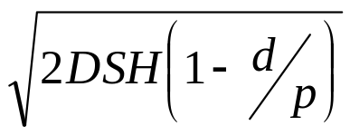

POQ Example
The Watkins Chemical Company produces a chemical compound that is used as a lawn fertilizer. The compound can be produced at a rate of 10,000 pounds per day. Demand for the compound is 0.6 million pounds per year. The fixed cost of setting up for a production run of the chemical is $1,500, and the variable cost of production is $3.50 per pound. The company uses an annual interest rate of 22% to account for the cost of capital, and the annual costs of storage and handling of the chemical amount to 12% of the value. Assume that there are 250 working days in a year. What is the optimal lot size, maximum inventory level, and total cost?

Quantity Discounts
Survey Comparison between Munson and Rosenblatt (1998) and Jackson (2015) Regarding Reasons for Quantity Discounts*

Issue | Munson and  Rosenblatt (1998) | Jackson (2015)
Operations Reasons
Cost Savings Due to Economies of Scale | 56% | 54%
Increase Order Size and Decrease Order Frequency | 27% | 31%
Shipping: Truckload/Transportation Discounts | Common | 38%
Shipping: To Ship in Standard Package/Container Sizes | N/A | 23%
Reduce Inventory | Some | 8-15%
Coordinate Order Quantities in the Supply Chain | N/A | 8%
Synchronize Order Timing of Different Customers | N/A | 0%
Marketing Reasons
Marketing to Increase Annual Demand | ≈56% | 54%
Marketing to Lock in Customers for the Long Term | Some | 62%
Marketing to Win Large Orders | N/A | 46%

*Source: Munson, Charles L. and Jonathan Jackson, “Quantity Discounts: An Overview and Practical Guide for Buyers and Sellers,” Foundations and Trends in Technology, Information and Operations Management, 8(1) (2014), 1-124.

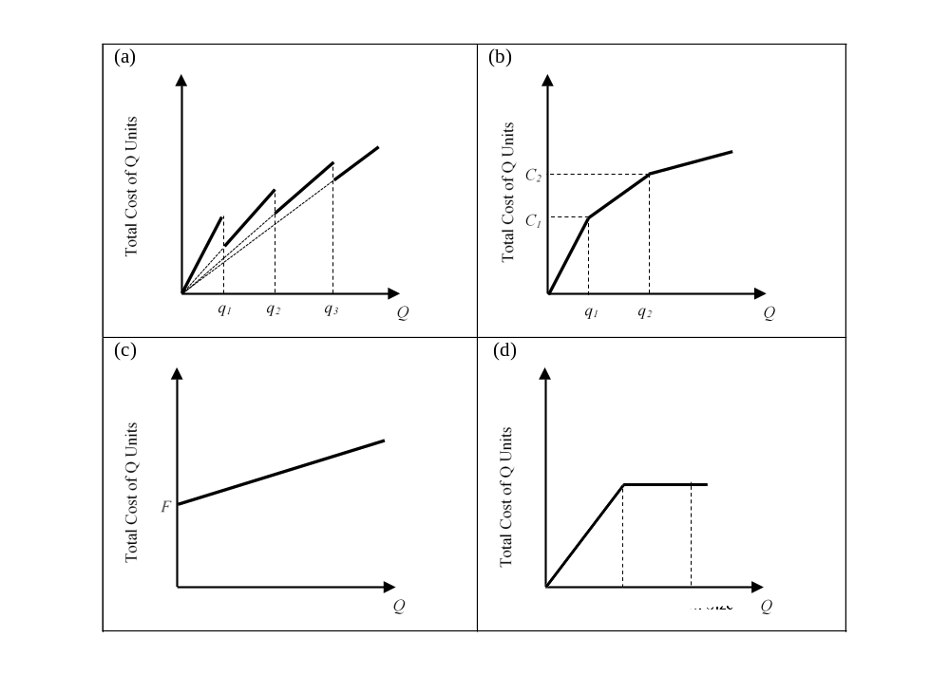

Four common forms of quantity discounts: (a) all-units quantity discount, (b) incremental quantity discount, (c) fixed fee or two-part tariff, and (d) truckload discount

Survey Comparison between Munson and Rosenblatt (1998) and Jackson (2015) Regarding Characteristics of Quantity Discounts*
Issue | Munson and  Rosenblatt (1998) | Jackson (2015)
Negotiate More Than Half of Their Prices | 87% | 67%
Form: All-Units | 95% | 71%
Form: Incremental | 37% | 33%
Form: Fixed Fees | 29% | 29%
Number of Price Breakpoints | Most < 5 | Most 2-6
Time Aggregation | 76% | 43%
Item Aggregation | 63% units or  BVD | 27% units  54% BVD
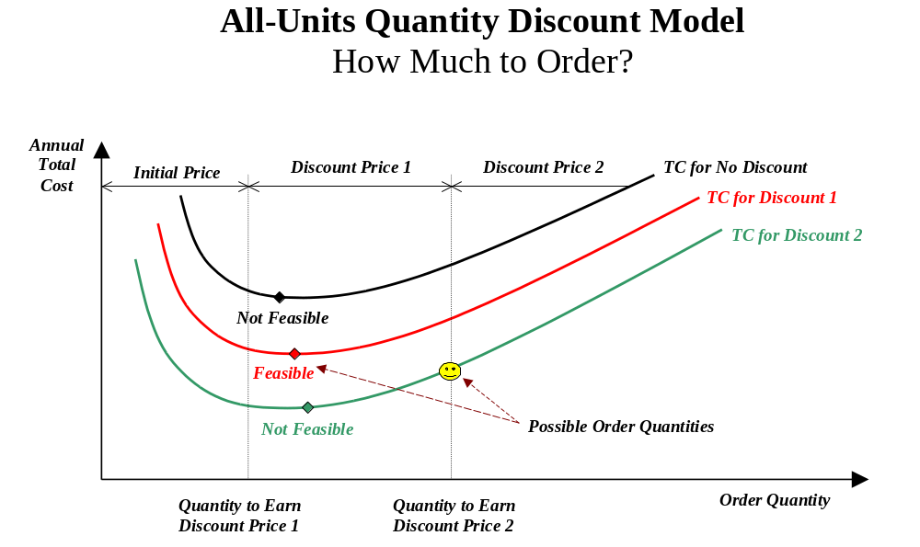
All-Units Quantity Discounts

Note: You must use the EOQ model where holding cost is expressed as a percentage of cost (H = Ic).

Solution Procedure
1. Beginning with the lowest purchase price, calculate the EOQ for each price level until a feasible EOQ is found. It is feasible if it lies in the range corresponding to its price.
2. If the first feasible EOQ found is for the lowest purchase price level, this quantity is the best lot size. Otherwise, calculate the total cost (purchasing plus inventory holding plus setup) for the first feasible EOQ and for the larger price break quantity at each lower price level. The quantity with the lowest cost is optimal.

Solution Procedure in Pseudo Code
1. Let c = the lowest purchase price.
2. Let Q = the EOQ at c.
3. If Q is feasible (i.e., if it lies in the quantity range corresponding to c), go to Step 5. Otherwise go to Step 4.
4. Let c = the next higher purchase price and go to Step 2.
5. If c = the lowest purchase price, then Q is the best lot size. Stop. Otherwise, go to step 6.
6. Let TC* = the total cost (setup plus holding plus purchasing) of Q at c. Let Q* = Q.
7. Let Q = the price break quantity (lowest possible quantity) for the next lower price than c.
8. Let TC = the total cost (setup plus holding plus purchasing) of Q at c.
9. If TC < TC*, let TC* = TC and let Q* = Q.
10. If Q is the last (highest) price break quantity, Stop. The optimal order quantity is Q*. Otherwise, go to step 7.
Examples
1. Consider the all-units quantity discount schedule below.

Units Ordered Price Per Unit EOQ at that Price
1-400 $100 200
401-800 $90 506
801-1000 $80 700
1001-1250 $70 800
1251-1500 $60 900
≥ 1501 $50 1400

What are the possible optimal order quantities?

2. Consider the all-units quantity discount schedule below.

Units Ordered Price Per Unit EOQ at that Price
1-999 $36.00 1200
1000-1999 $32.00 1450
2000-4999 $30.00 2500
5000-7999 $26.00 2780
≥ 8000 $20.00 6000

Which of the following sets of order quantities is guaranteed to contain the optimal solution?

A. {1450, 2500}
B. {1450, 999}
C. {1, 1000, 2000, 5000, 8000}
D. {1200, 1450, 2500, 2780, 6000}
E. {2500, 5000, 8000}
Quantity Discount Example
A supplier for Lower Florida Keys Health System has introduced all-units quantity discounts to encourage larger order quantities of a special catheter. The price schedule is:

Order Quantity Price per Unit
0-299 $60.00
300-499 $58.80
500 or more $57.00

The firm estimates that its annual demand for this item is 936 units, its setup cost is $45 per order, and its annual holding cost is 25% of the catheter’s unit price. What’s the best order size?

EOQ_{57.00} =

Total Cost for the Quantity Discount Case:

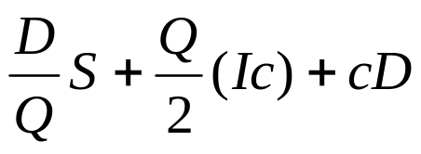

One-Time Sale
With a Discount of Δ dollars per Unit

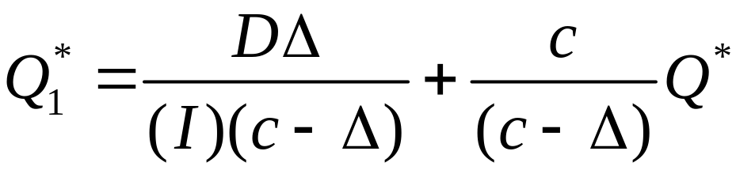

Trade Promotion Example
Annual demand = 20,000 units
Setup cost = $80 per order
Holding cost percentage = 30%
Undiscounted unit cost = $10

Suppose that a one-time discount per unit of $2 is offered.

EOQ with Lumpy Demand

An important assumption of the EOQ model is that demand is smooth and continuous. Effectively, that means that customers are constantly ordering infinitesimally small orders. In reality, of course, customer orders vary in size, particularly for business-to-business (B2B) transactions. To the extent that there are many customers and there’s little seasonality in demand, the EOQ assumption may be a good one. However, what happens if a large industrial customer orders its own EOQ from you? For example, if you produce a customer-specific item that is being ordered, say, once per month at 10,000 units per order, what should your lot size be?

Theorem 1
Given a steady, lumpy demand pattern, the supplier should produce in an integer multiple K of the customer’s order size Q.

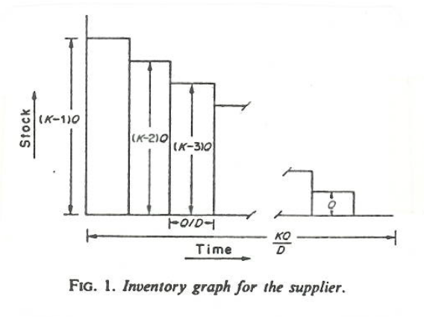
Corollary 1
The average inventory under the conditions of Theorem 1 equals (K−1)Q/2.

TC =

Defining ⎣x⎦ as the greatest integer ≤ x, the optimal lot size multiplier K is:

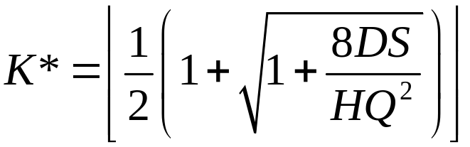

Example
Suppose that a seller’s single customer periodically orders its EOQ of 900 units. Suppose further that the annual demand is 25,000 units, the seller’s setup cost is $200 per order, and the seller’s annual holding cost per unit is $2.00. What is the seller’s optimal order quantity?

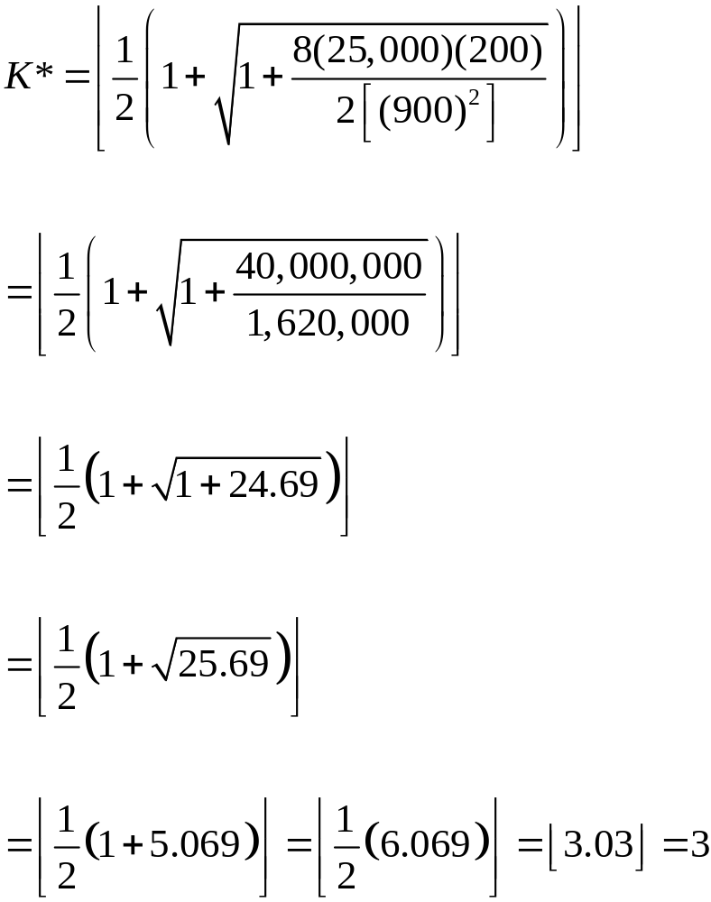
Material Requirements Planning (MRP)

Used for “dependent demand,” i.e. demand that depends on the demand of its “parent” product.

For example, if a firm manufactures bicycles, then the demand for bikes would be independent, but the demand for tires would be dependent upon the demand for bikes.

Start with a bill of material, which is a record of all the components of an item, the parent-component relationships, and usage quantities derived from engineering and process designs.

A master production schedule details the demand over time for the end product.

Using the bill of materials and MRP tables, determine the gross requirements (how much of each component is needed and when) and the planned order releases (when production should be started) for each component. Adjust accordingly for lead times and lot sizes.
