SDLC – systems development life cycle, a methodology to plan and execute a sw development project.
Steps – plan (managers), analyze (IT staff), design (Internal IT staff), development (internal or external coders), testing (eventual users of the app), implementation, maintenance (internal/external)
Planning – steering committee - define the biz need, gauge the importance of the new functionality, determine feasibility of app. Technical feasibility, financial feasibility, ROI? IS the app the money maker?
Analysis – Figure out what new system needs to do. Document system needs and current and hoped for reengineered processes. What features do we need? What data and transaction support should the system provide (mandatory vs. nice to have). Do BPM and hopefully BPR.
Create the requirements definition document (RDD). Program users and steering committee needs to accept the RDD (but problem…no prototype). It’s just a virtual, intangible thought experiment.
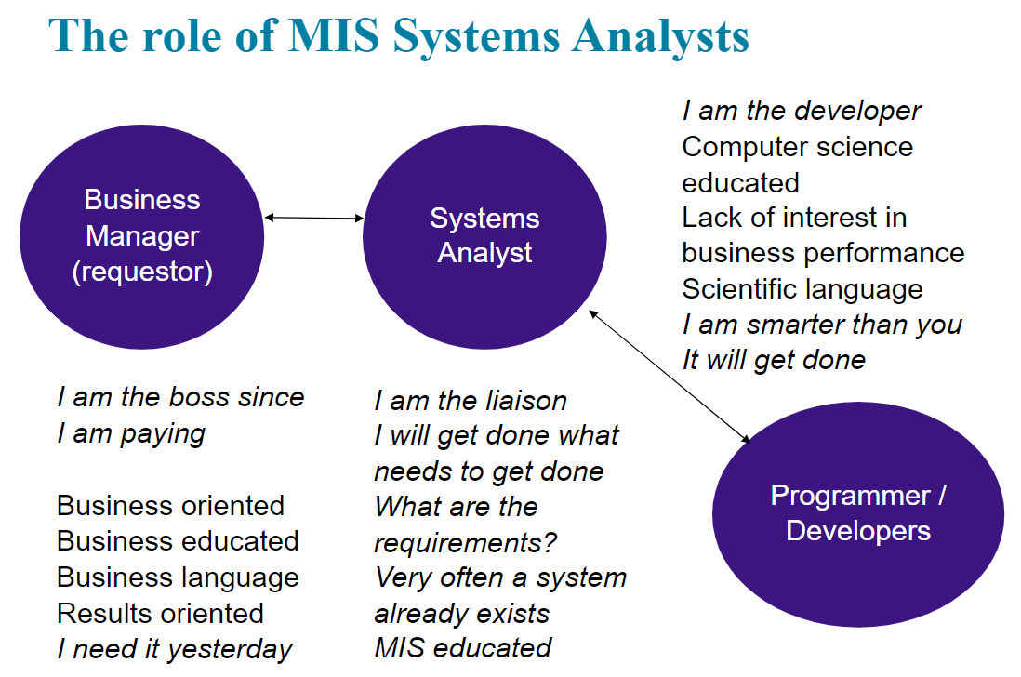
Design – take requirements and go shopping for existing software? use requirements to lease/buy full-featured app. Or begin to build system or assemble from pre-existing components.
Maybe the business processes or customer experience needs to be mapped out
First – swim lanes and use case diagrams (must spend considerable time here)
next IT-specific data flow diagrams, and database design.
BTW is the design frozen (other than aesthetics) once development begins?
What sw dev tools? What sw dev language? Let’s argue!!
Are we thinking to use Internal developers (more loyal to the cause?) vs. external developers (more easily held accountable? Are you sure about that?) What about when something goes wrong?
How will new app or module communicate (retrieve data and update data) with pre-existing systems?
SOA – service oriented architecture – buy/lease components and connect to service providers (ie shopping cart payment, credit check process) How to string together the right mix of services? Could be complex. Are processes orthogonal (unrelated?)
API? Application programming interfaces (your program and talented programmers connect to services that return compiled or calculated data and answers. You feed the app input over the API and the service returns results or functionality needed. Blackbox computing.
Database design, then user interface. (system should look up values not expect the human to have important numbers).
Development – who is developing the software? In-house, consultant, vendor-approved service provider? Can you sense the risk? Which approach gives better control?
Important concerns: version control, scrum sprints, check-ins with end-users.
Build or lease or buy? Firms used to be proud to develop ‘in-house’ now buying components and apps is preferred for many reasons (however code review is important rather than rely on sales rep to demo and explain functionality). Beware, buying software is not as simple as buying more toilet paper.
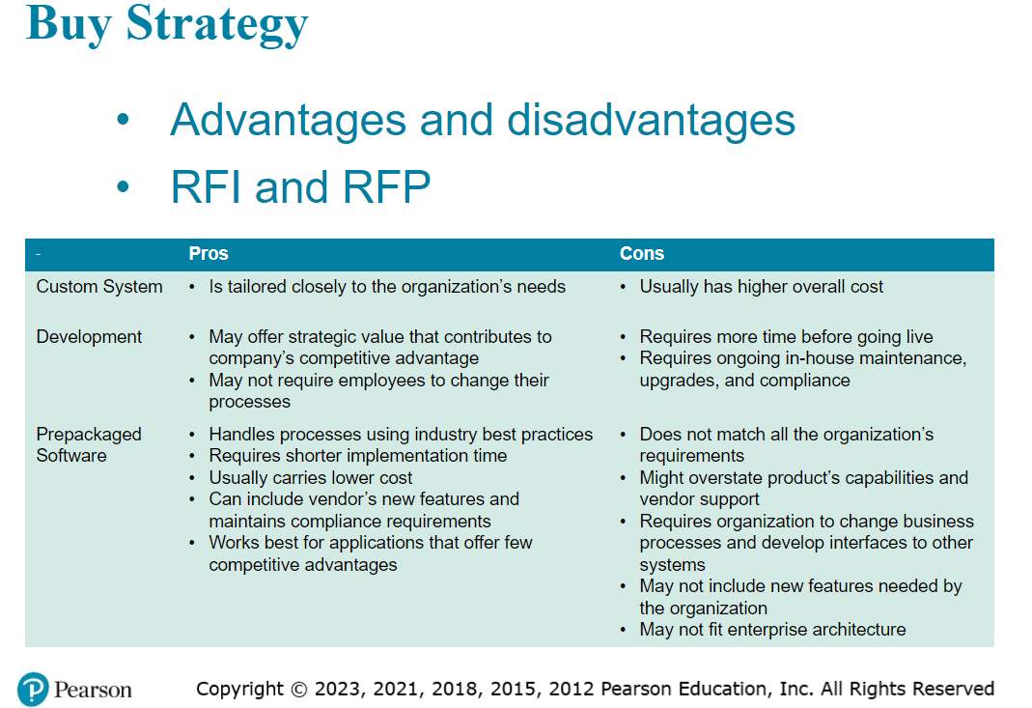
Obviously if a sw app is already built (ie quickbooks) it can be sold for 10% of the cost of building it.
Is it smart to lease/buy mission critical sw from strangers? From different countries? Wait can we buy it from AWS? Do you agree with the weightings below?
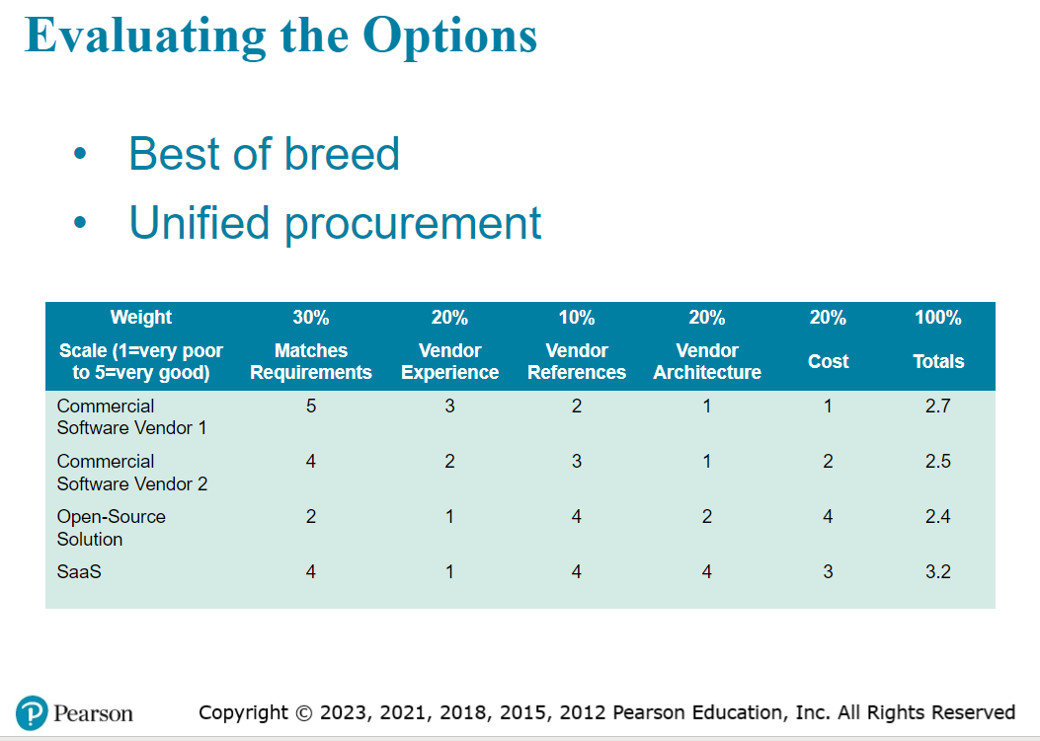
Who reviews the code to ensure it is secure? What if your company has no IT dept. Do you just lease and pray? What if end-user testing is a failure, but the budget is already spent?
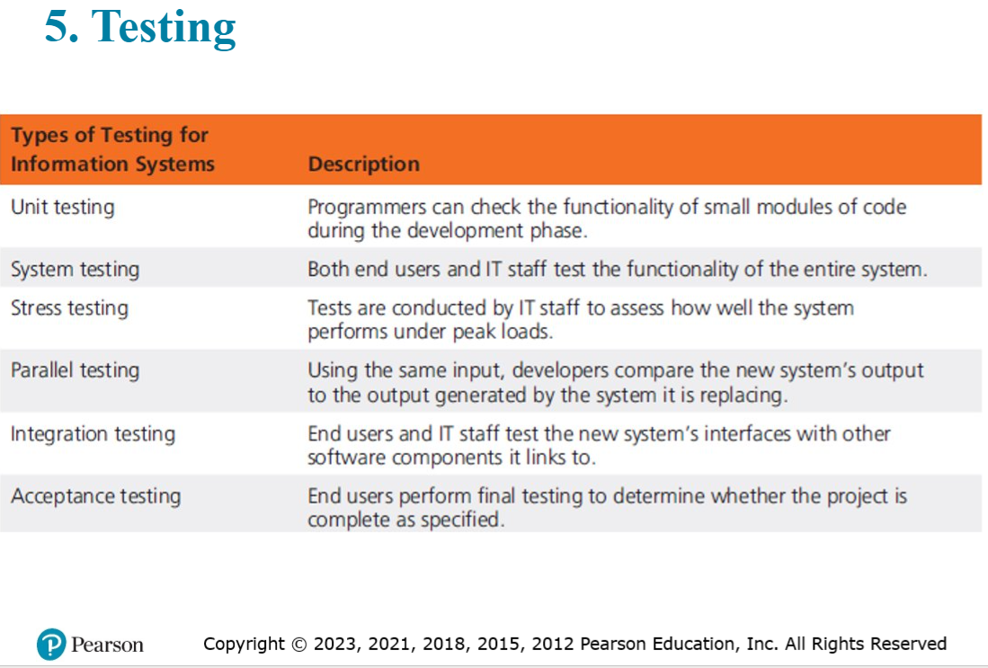
Implementation – direct implementation (cut-over or new implementation) vs. phased implementation (implement and train and test pieces one at a time – after each sprint?), vs. parallel implementation (important for financial systems to be able to check the new system against the known working system.)
What are some context where each implementation approach is preferred?
Which do you think is safest? Which do you think is most/least expensive?
Maintenance – is the software vendor still in business? If we used a consultant, are they answering our calls? Do we need to implement the new version every year (80% of a vendors revenue comes from the yearly update).
If you built the software inhouse or with a consultant, is change control (version control) important?
What if you skip a version, will the software begin to malfunction?
What if you built the systems using 20 individual services, are you going to maintain each of them?
What if software is 20 years old and functioning perfectly?
What if the in-house developers are nearing retirement? Or what if they already moved to the next company?
Do you fix something that isn’t broken? Do you spend $$ on new software or on product development or ??? (hiring, dividends, expansion, etc.) Paying for new software/hardware has low ROI.

Coug Hot Dog Delivery App
Planning
Analysis
Design – make app funny and cool, and show delivery driver enroute and provide maps to the delivery driver. Pre-payment by CC and crypto.
Development – hire CS majors?
Testing
Implementation
Maintenance

