A little history & info about Featherman
- Born in the suburbs of New York
- Associates in Marketing (SUNY system) – worked construction, custodial, kitchen
- Bachelor of Science in Management (SDSU) – retail manager
- Masters of Systems Management (USC) – General Dynamics SCM MGMT (UOG)
- Ph.D. in Information Systems (UH) – webmaster, instructor, professor
- Featherman researches how consumers evaluate the risks and benefits of technologies
- Married, 2 children (16, 22). Being a parent is by far my most rewarding life experience.
- Started working at 16. Self-made. Boot-strapped.
- Owned 2 businesses (computer consulting/DB Programmer/Analyst – 4 years),
currently working on a 3rd business. Many of lessons learned instilled in MIS420
- Expert ASP.NET web/database programmer and SQL database analytics/PowerBI developer (MIS420)
- Helped 1000’s of MIS@WSU students prepare for and find employment
(enjoy mentoring or giving career suggestions to students)
- Teach and practitioner of Shotokan Karate
- Interested in macroeconomics, Buddhism/Taoism, and EV industry
- Member of the 300 club.
- 22 years at WSU – working on study abroad Thailand Summer 2024 (#7)
- Can smell BS very easily plus vagueness is problematic to him.
- Does not like long beautiful emails, just say what you want in 2 sentences.
- Anything else you want to know?

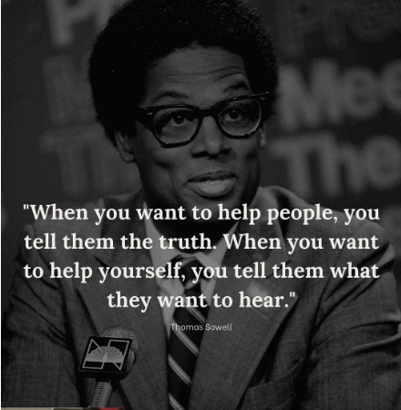

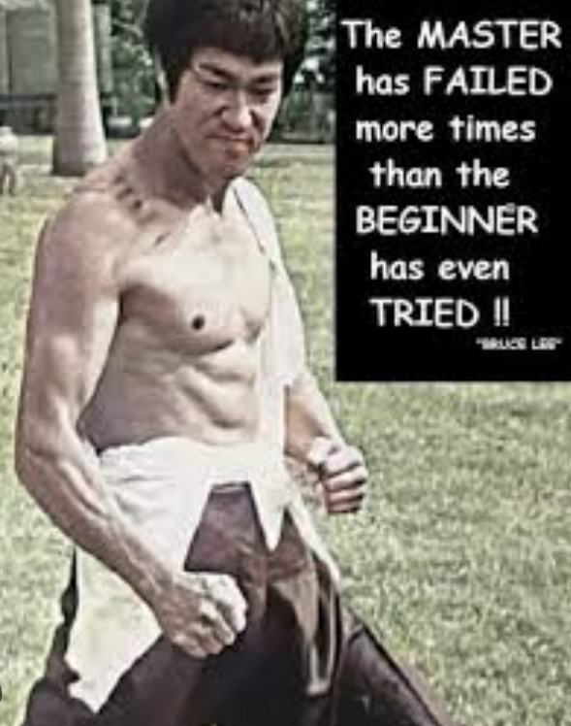

Core Belief – you make your own luck


