Conservation Grazing Plan
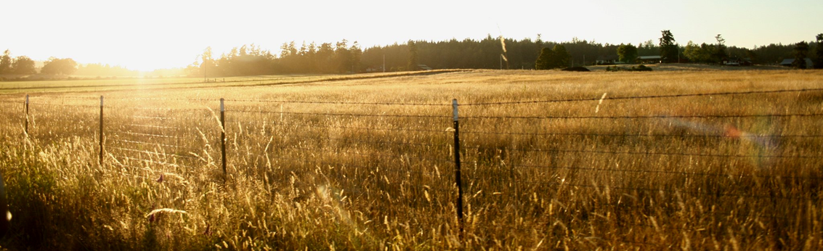
Farm Name (if one):
Address:
Address:
Parcel ID:

PREPARED BY:
Technician Name:
Title:
Phone:
Email:
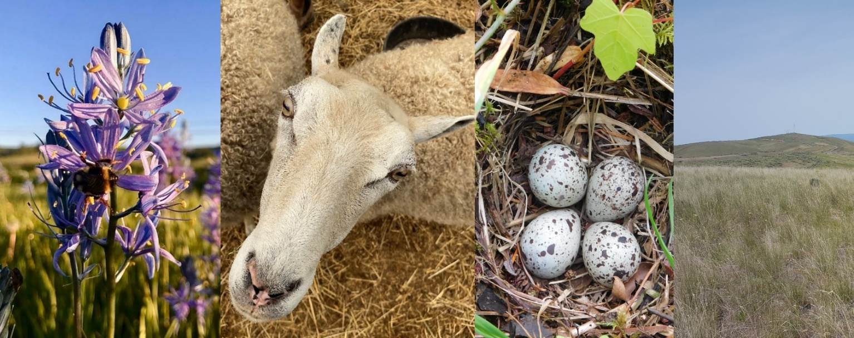

Property and Vicinity Description
*This should describe the property location and any surrounding area information that could be beneficial.

Climate
Elevation | ____ ft
Average Annual Precipitation | _____ inches

Average monthly rainfall (consider a chart here)

Average monthly temperature (consider a chart here)

Property Description
Parcel Number
Section, Township, Range
Zoning
WRIA (Watershed)
Critical Areas Present | ☐ Wetlands  ☐ Flooded areas  ☐ Critical Aquifer Recharge areas  ☐ Habitat Conservation Areas  ☐ Geologically Hazardous Areas

Site Information
First frost:__________________ Last frost:__________________ Frost free days:_________

Rainy season: _______________ Dry season:________________

Note anticipated start and end dates for grazing periods on the map for each pasture or field.

Soil types: Identify soil type by field, note on map on subsequent page
Map of Property
Directions (include somewhere, see NRCS link; soil survey are same). Refer to common map symbols, i.e. for trough, etc; existing vs. proposed infrastructure – use clear symbols.

(Consider a separate soils map from Web Soil Survey, include soil limitations)

FARM AND SITE GOALS
Pasture goals

Animal goals (per acre and per animal)

Conservation/habitat goals
What are the floral and fauna species-specific goals for the site in terms of presence/absence of species, percent cover, goals for species numbers and any preferred/target species?

Describe habitat objectives for the site, drawing on knowledge from resource inventory. Note specific goals for wetlands, biodiverse edges/patches, notable topographical features, ….

Describe envisioned habitat structure, i.e. composition of herbaceous, shrubby, and woody species, potential areas for disturbance gradients, and objectives for homogenous or heterogeneous structure.

What plant succession or site progress is envisioned? i.e. progression to savanna/agroforestry, expansion of high-quality perennial species, reintroduction of native forbs, reduction of sod-forming non-native grasses, etc.

List overall habitat/conservation/landscape objectives, i.e. grazing to reduce fire risk, manage invasive species, species re-introductions (floral or fauna), etc.

Financial performance goals

Marketing goals

Additional landowner goals (preferences are documented as well (ex. “would prefer no livestock guardian dog”)

Who can help reach these goals? Identify what agencies, entities, or partners can support this work or who the operator is working with already. See back page for partner contact information.

Is the landowner interested in collaborating with other organizations for funding or technical service?
Yes/No

Does the landowner approve sharing grazing plan and inventory with other partners?
Yes/No

Goals notes:

RESOURCES INVENTORY
Conservation Values
Plant species of conservation value. Identify species where possible, and otherwise functional groups (i.e. annual/perennial native, and non-native forbs)
Field # | Native | Non-native | Notes: grass/forb, rare/ common, other

Note any target/desired species of interest for the site.

Fauna/wildlife that occupy the site, rare or common: Note any target/desired species of interest for the site.

Habitat on the property that has current or potential conservation value

Habitat connectivity. Note any nearby reserves, or potential wildlife corridors the property is close to:

Soils
Soil test is available (yes/no), include with grazing plan. Note soil texture, drainage, fertility, considering potential for forage production and habitat conservation by field.
Field # | Soil conditions

Infrastructure
Water. Describe available water resources, noting source (ground/surface), capacity (GPM), and description (source, piping size, distance, locations).

Fencing
Type | Construction | Charger type and joule | Source of equipment | Condition of fencing
Notes:

Buildings and Equipment
To the extent appropriate with the landowner/manager, describe available equipment, such as trucks, trailers, tractors, corral systems, barns, other:

Acreage and Short Description of Baseline Conditions of Fields
Include: acreage, access road, surface soil (series and textural class), preliminary conditions. Broadly group/separate fields with an eye to similar/dissimilar management needs.
Field:  Acreage: Road access:  Soils:  Preliminary conditions: | Field:  Acreage: Road access:  Soils:  Preliminary conditions:
Field:  Acreage: Road access:  Soils:  Preliminary conditions: | Field:  Acreage: Road access:  Soils:  Preliminary conditions:
Field:  Acreage: Road access:  Soils:  Preliminary conditions: | Field:  Acreage: Road access:  Soils:  Preliminary conditions:
Field:  Acreage: Road access:  Soils:  Preliminary conditions: | Field:  Acreage: Road access:  Soils:  Preliminary conditions:

Vegetation Condition
Describe the starting or baseline condition of each field, as a basis for building goals and grazing practices that are appropriate for each field.

FORAGE INVENTORY
Forage Species
Note predominant pasture species by field number, including species of non-forage value:
Field # | Forage species | Non-forage species

Vegetation Structure
Note any trees, shrubs, and potential habitat value:

Forage Availability per Field
Field number (#) | Acres | Anticipated grazing months (optional) | Annual forage production (tons/acre) | Total forage availability  (ac x t/ac) | Monthly forage availability (optional) (tons/field/mo)*
*Note: Workbook 528 contains a worksheet to calculate AUMs for individual months and fields. It also contains a worksheet for the spreadsheet below to calculate monthly AUMs per field based on the percent of annual growth that occurs in each month.
Forage Availability per Month by Field (AUMs)
To calculate forage availability per month in AUMs, multiple acres x annual yield (tons/acre) x % of forage available by month x 2.2 (conversion factor for tons to AUMs). Note row identifying forage available by month (%) for droughty lowland Puget Sound soils.
For example: 10 acres x 2 tons/acre x 0.03 x 2.2 = 1.3 AUMs for a 10-acre field in February.
Note: Workbook 528 Prescribed Grazing can be used to complete this table with embedded equations in a spreadsheet.

 | Oct | Nov | Dec | Jan | Feb | Mar | Apr | May | Jun | Jul | Aug | Sep
Field # | 6% | 3% | 1% | 3% | 8% | 14% | 22% | 19% | 17% | 6% | 0% | 1%
Total
Notes:

Forage Needs. Multiple copies of this sheet may be necessary. Use Workbook 528 Prescribed Grazing to complete this section.
Note livestock type(s): _______________________________________________________________________________________
Note Animal Unit Factor(s) from Workbook 528: ____________________________________________________________________
Number of animals: _________________________________________________________________________________________
(this may vary by month and field)
To calculate animal AUMs for each month, multiply the Animal Unit Factor x Number of Animals. i.e. 1.15 x 10 = 11.5 AUMs

Livestock Numbers and Animal Unit Months (AUMs) Requirements
Livestock type | No. animals | Oct | Nov | Dec | Jan | Feb | Mar | Apr | May | Jun | Jul | Aug | Sep
Total

FORAGE-ANIMAL BALANCE
From the tables above, transcribe the AUMs of forage available and needed by grazing animals. Note: Workbook 528 Prescribed Grazing can be used to complete this table with embedded equations in a spreadsheet.

Matching Forage Inventory with Grazing Demand for Each Grazing Period
 | Oct | Nov | Dec | Jan | Feb | Mar | Apr | May | Jun | Jul | Aug | Sep
Total AUMs available per month
Total AUMs needed per month
Difference

WRITING THE GRAZING MANAGEMENT PLAN
Identify the grazing management objectives based on their baseline conditions. Some fields may have the same baseline conditions and can be grouped together.

Provide Rational Underlying Objectives as Needed

Research Potential Grazing Practices/Alternatives to Achieve Grazing Management Objectives
Refer to the Resources section below for a link to the conservation grazing practices toolkit. This provides photographs and descriptions of grazing and restoration practices that have been used for grassland habitat protection and enhancement. They are organized into management decision areas, including: (a) livestock type and breed selection, (b) grazing systems, (c) stocking rate, (d) grazing distribution and timing, (e) disturbance regimes, (f) soil Management, (g) animal behavior, and (h) restoration. These are the main areas where land managers can take action to direct conservation outcomes. Using the toolkit, your experience, and experience of the landowner, identify practices to achieve the desired forage, livestock, and habitat conservation outcomes.

Identify Species for Increase or Decrease as Needed (if helpful, organize by functional group: perennial, annual, bunchgrass, rhizomatous, leguminous, grass, forb, native, non-native)

Recommended Management Strategies and Practices to Achieve Objectives
Describe proposed grazing practices for each baseline condition. Identify stocking rate, grazing system, timing/rest, deferments, stubble height goals (or residual lbs/ac), functional groups for increase/decrease, weed management, soil management, vegetation structure goals, sensitive areas or species, and any inter-annual grazing variation. Consider the practices you researched above.
Grazing Practice Recommendations
Baseline Condition | Grazing Practice Recommendations  (note goals the recommendations relate to)

Grazing Plan Map
Map the fields and how livestock, the grazing system, stocking rates, non-grazing disturbance (i.e. fire or other), soil fertility, and other actions are applied on the landscape to meet objectives.

Restoration Plan
Consider: invasive species removal, native plant enhancement needs and timing, implementation plan. As possible, organize by baseline condition and field.
Baseline Condition | Restoration Recommendations

Related Ongoing Work
Note any other agricultural or conservation plans or partnerships for the site to help potential partners align and coordinate.

MONITORING PLAN
This should include implementation monitoring (if grazing and restoration practices are being followed), progress toward landowner and conservation goals, and changes to the habitat and/or species of concern (are they improving, declining, etc).
Assess baseline conditions of vegetation and soils that should be used to monitor progress to goals

Identify reference sites. These can be ungrazed sites identified for each baseline condition. Alternately choose a continuously grazed reference site for comparison with planned grazing.

Consider a ‘highest potential quality’ reference site (never tilled, native vegetation) for potential soil carbon sequestration to compare with fields under management.

Select Indicators
Select indicators of soil health as needed (consider SOM/SOC, Total N, C:N ratio, bulk density, soil moisture, soil temperature, water infiltration, soil aggregate stability, Haney measures: respiration, POXc, organic C:N, minerals, and NRCS Soil Quality Assessment).

Select indicators of forage and overall vegetative quality/health as needed (consider NRCS Pasture Condition Scoresheet, relative cover of functional groups, species richness and/or abundance, % cover of functional groups or target species, laboratory forage quality assessment, total biomass, utilization, residual dry matter, and stubble height).

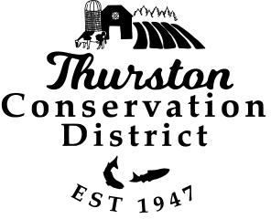






Contact information:

RESOURCES

South Sound Conservation Incentive Programs
https://www.thurstoncd.com/southsoundconservationincentiveprograms/

Notes
- It’s suggested that you test the water you’re using for your animals
- Instead of measuring quantitatively, apply BMPs to improve water quality
- Provide guidelines for what to test for different habitat or safe drinking water goals.
- Include links to farm management for animal health.

Climate data comes from Northwest Climate Toolbox, 1971-2000 period mean
Elevation data from Puget Sound LIDAR Consortium
Parcel information comes from Thurston County Geodata
Grazing plan template developed with additional conservation elements added to existing templates, including the ATTRA Grazing Planning Manual and Workbook (https://rangemanagement.extension.colostate.edu/wp-content/uploads/sites/42/2020/07/grazingplanning.pdf), and NRCS Prescribed Grazing (528) Conservation Practice Standard (https://www.nrcs.usda.gov/resources/guides-and-instructions/prescribed-grazing-ac-528-conservation-practice-standard)
To estimate annual forage production, use clip and weigh method, pasture stick, or rising plate meter. See Resources listings for guidance at the end of this document.

