 | Food Safety and  Preservation | 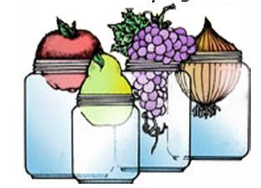

LOW ACID/PRESSURE CANNING STUDY QUESTIONS

- How long should a pressure canner be vented before putting the weight or counterweight on?

- What is the difference between dial and weighted gauges? Advantages and disadvantages of each.

- True or False:
Dial gauges for pressure canners should be checked occasionally for accuracy and replaced if they are more than 2 lbs. off.

- True or False:
As a margin of safety, home canned low acid foods, such as vegetables, meats, and combination foods containing those items may be heated for 10 minutes prior to eating.

- It is _________________ to force cool a pressure canner to get the jars out of the canner more quickly and start processing another batch.
a. recommended
b. not recommended

- Low acid foods __________ be safely reprocessed within 24 hours if incorrectly processed or the lids failed to seal.
a. may
b. may not

GIVE SHORT ANSWERS

- What should I do if the pressure canner goes below the recommended pressure during processing?

- List and briefly explain 2 or 3 of the serious errors in maintaining proper temperatures in canners that can occur:

9. Why do low acid foods need to be canned in a pressure canner to be safe?

10. How are pressure canners sized?

11. What recommendations would you make to someone that wants to preserve squash.

- Which gauge(s) are okay to test? Write yes or no.

a.__________ b.__________

c. __________ d. ___________

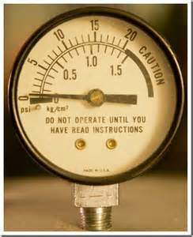 | 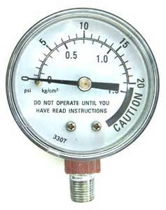
a. | b.
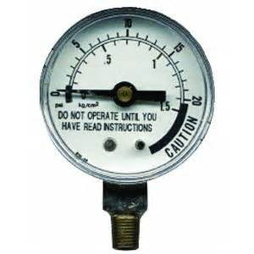 | 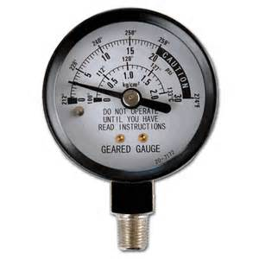
c. | d.

WSU Extension programs and employment are available to all without discrimination. Evidence of noncompliance may be reported through your local WSU Extension office.

