 | Food Safety and  Preservation | 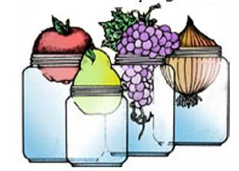

LOW ACID/PRESSURE CANNING QUESTIONS AND ANSWERS

- How long should a pressure canner be vented before putting the weight or counterweight on?

10 minutes

- What is the difference between the dial and weighted gauges? Advantages and disadvantages

You cannot precisely adjust weighted for higher altitudes. Have to listen for jiggles of weighted gauges and different for different weighted gauges.
Dial gauges can see the exact pressure, but must be tested yearly

- True or False:
Dial gauges for pressure canners should be checked occasionally for accuracy and replaced if they are more than 2 lbs. off.

False

- True or False:
As a margin of safety, home canned low acid foods, such as vegetables, meats, and combination foods containing those items may be heated for 10 minutes prior to eating.

False, needs to be boiled, not just heated.

- It is _B_to force cool a pressure canner to get the jars out of the canner more quickly and start processing another batch.
a. recommended
b. not recommended

- Low acid foods _A_ be safely reprocessed within 24 hours if incorrectly processed or the lids failed to seal.
a. may
b. may not

GIVE SHORT ANSWERS

- What should I do if the pressure canner goes below the recommended pressure during processing?
Increase stove temperature to reach recommended canner pressure. When recommended pressure has been reached, begin timing the entire processing time over again.

- List and briefly explain 2 or 3 of the serious errors in maintaining proper temperatures in canners that can occur:

  - Internal canner temperatures are lower at higher altitudes and can result in under-processing if altitude adjustments aren’t made.

  - Air trapped in a canner lowers the temperature and results in under-processing. The cause is not venting long enough before pressurizing canners.

  - Inaccurate dial gauges can result in under-processed food. Have your dial gauge checked annually before use or if it is bumped. Replace the gauge if it is more than 2 lbs. off. With weighed gauges, use the 15 lb. weight for 10 lb. processing times at elevations over 1000 feet.

9. Why do low acid foods need to be canned in a pressure canner to be safe?

Low acid foods require a temperature higher than boiling water to destroy harmful bacteria that cause botulism and other types of food spoilage. Low acid foods must be processed in a pressure canner at 240º-250ºF for a recommended time for specific foods. Canning times range from 20-120 minutes. The exact time depends on the kind of food being canned, the way it is filled into jars, and the size of the jars.

10. How are pressure canners sized?

They are sized by the volume of water they will hold when empty, not how many jars they will hold.

11. What would you tell someone how to preserve squash.
Do it is cubes of 1 or 2 inches. NOT mashed.

- Which gauge(s) are okay to test? Write yes or no.

a.___NO__ b.____YES___

c. _YES___ d.___NO_____

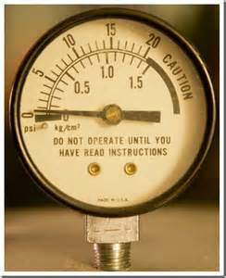 | 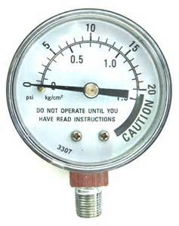
a. | b.
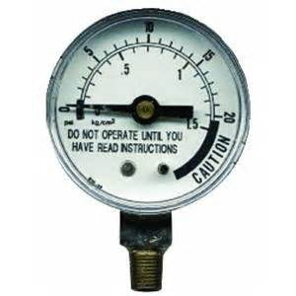 | 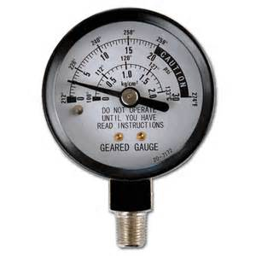
c. | d.

WSU Extension programs and employment are available to all without discrimination. Evidence of noncompliance may be reported through your local WSU Extension office.

