 | Food Safety and  Preservation | 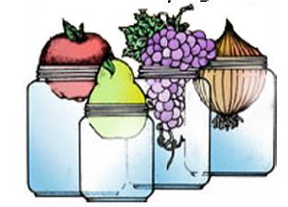

PICKLES AND RELISHES
STUDY QUESTIONS

- The best way to change a pickle recipe so the pickles are less sour is to:
  - Reduce the amount of vinegar
  - Add Sugar
  - Can’t be done

2. The vinegar used for making pickles should be:
- 1-2 percent acid
- 4-6 percent acid
- 10 percent acid
- doesn’t matter

3. The usual fermentation time for both brined dill pickles and sauerkraut is:
- 1 week
- 2 weeks
- 7 weeks
- 14 weeks

4. Why should the blossom ends be removed from cucumbers?

5. When making brined pickles, what is a good way to keep the cucumbers under the brine?

6. Why should pure granulated salt be used in making pickles?

7. What is the difference between brined and fresh pack pickles?

8. What are 4 signs of spoilage in pickles?

9. Describe the two acceptable methods of heat processing pickles.

10. Why isn’t it recommended to use waxed cucumbers for pickles?

11. When a recipe calls for green or unripe fruits, can you use ripe fruits instead? Why or why not?

12. Name two signs of spoilage in pickles, how it happened and what should be done with the product if this happens.

13. What is your recommendation to someone who wants to use a specialty vinegar for pickling?

14. Name three acceptable alterations that can be made in making salsas and still have a safe product.

15. Name three unacceptable alterations that can be done to salsas that would make them unsafe for canning.

16. Name three acceptable salts used for pickling and how do they differ?

17. What are your recommendations to a consumer that wants to preserve garlic and herbs in oil?

