 | Food Safety and  Preservation | 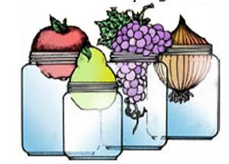

CANNING FRUITS AND TOMATOES
BASIC CANNING EQUIPMENT STUDY QUESTIONS

- What liquids can be used to cover fruits before canning?

- Is open kettle canning an approved method of canning fruits? Why or why not?

- What are some reasons for jar breakage?

- What is the difference between hot pack and raw pack?

- List 3 advantages of using the hot pack method of canning.

- Why does tomato juice separate?

- Describe the process that prevents tomato juice from separating.

- When can food be reprocessed and when should it not be reprocessed?

- Name 3 reasons fruits float.

- Name 3 reasons a jar may fail to seal in a boiling water bath canner.

- How much bottled lemon juice should be added to tomatoes?

- What factors affect the processing times and how are they determined?

- If rings are tightened too much before processing, what could be the consequences?

- Why should bottled lemon juice be added to tomatoes when canning them?

- If a food was not processed correctly or something went wrong, what are some options for saving the food?

- How do you dispose of the potentially unsafe canned food?

- Are steam canners recommended for use? Why or why not?

- What would you discuss with a client that wants to can fruits on a smooth cook top surface?

- What is headspace?

- Should you be concerned about the safety of a fruit product that lost a lot of liquid during the processing time? What caused the loss of liquid?

- What is dry canning. Would you recommend it or not and why?

