 | Food Safety and  Preservation | 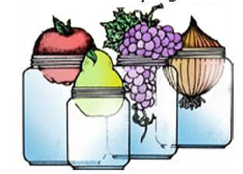
Lewis County Julie Pirtle 360-740-1212
17 SW Cascade Ave julie.pirtle@wsu.edu
Chehalis, WA 98532. https://extension.wsu.edu/lewis/mfpmaterials/

FREEZING QUESTIONS

- Describe the process of steam blanching.

- What is the difference between steam and water blanching?

- What is the purpose of blanching?

- What causes freezer burn?

- How do you prevent fruit from darkening while frozen?

- What kinds of containers should not be used for freezing? Why?

- Describe the glazing process used on fish.

- Suzie Jones said her freezer stopped while she was away for the weekend. The large pieces of meat are hard in the center. The vegetables, fruit, and ice cream are soft. The seafood casserole is completely thawed. What are your recommendations to her?

