 | Food Safety and  Preservation | 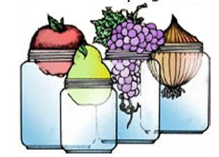
Lewis County Julie Pirtle 360-740-1212
17 SW Cascade Ave julie.pirtle@wsu.edu
Chehalis, WA 98532. https://extension.wsu.edu/lewis/mfpmaterials/

Drying Fruits and Vegetables Study Questions

- Why should vegetables be blanched before drying?

- If food is dried in the sun, what will happen if the temperature is too low?

- Where should dried foods be stored?

- What cuts of beef are suitable for jerky?

- How can you tell if fruit leather is properly dried?

- What type of wire screening should not be used for constructing a drying tray?

- Describe three methods of making meat jerky.

Multiple Choice Questions. Please circle your answer.

- Generally, an oven or food dehydrator should be maintained at a temperature of __________
while drying food.
  - 110- 120 degrees F.
  - 145-155 degrees F.
  - 175- 195 degrees F.

- ______________ are the most common spoilage organisms on improperly dried foods.
  - Bacteria
  - Molds
  - Yeast

- When food is dried in an oven, the door should be____________
  - open
  - closed

Give short answers:
- How does drying preserve foods?

- What types of containers are suitable for packaging dried foods?

- Why do we need to follow specific heating recommendations for drying meat jerky?

14. What is conditioning and why is it an important step in food drying?

- How do you determine when the following foods are sufficiently dried?

Fruits –

Vegetables –

Jerky -

