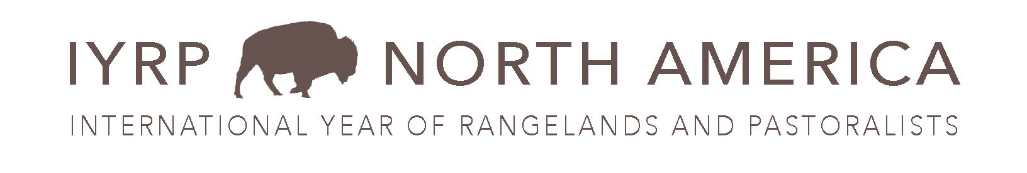
Evaluation Plan for Exhibit Sites
Congratulations on receiving a WSARE-funded exhibit for the Arts-Based IYRP project. Below is guidance for evaluation. Digital files of evaluations were emailed; ask if you need it them!
Having received an exhibit, our primary expectation is for selected sites to participate in evaluating the impact of these public venue displays. Below are the components of our evaluation plan we would like you to implement. Please complete both the evaluation form and intercept interviews, and if possible the follow-up interviews.
Evaluation forms
- For exhibits with a program, add an evaluation item to the agenda of 5-10 minutes
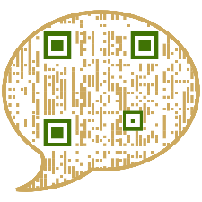
- Print and hand out paper evaluation forms. Or provide the QR code so folks can complete the evaluations online (WSU uses Qualtrics). PRINT A LARGE VERSION OF THE QR CODE TO PLACE PROMINENTLY ON YOUR EXHIBIT:
Paper survey
- The QR code is included on the exhibit with this QR icon. You can steer folks towards this on the exhibit as well.
- Goal: as many evaluation forms per site as possible (at least 20). If they are completed on paper, please mail them to: WSU Thurston Co. Extension, 3054 Carpenter Rd SE, Olympia, WA 98506.
- Alternately, bulk scan and email to bramwell@wsu.edu
- https://wsu.co1.qualtrics.com/jfe/form/SV_81ReVEZiufQ2u5o
Intercept interviews
- Engage viewers!
- Whether a formal event or just a casual display in a public space, ask “intercept interview” questions of viewers
- These are structured set up questions but can be administered in an unstructured manner so long as documented).

- Goal: roughly 10 intercept interviews per site in 2026. If possible, please enter data into this linkIf they are completed on paper, please mail them to: WSU Thurston Co. Extension, 3054 Carpenter Rd SE, Olympia, WA 98506.
Intercept interview
- https://wsu.co1.qualtrics.com/jfe/form/SV_9yLf6VG52E7FBMW
Follow-up interviews
- We hope to have an opportunity for follow-up interviews (brief) with policymakers or others who agree to a brief follow-up in one year’s time.
- Goal: roughly 10 follow-up interviews over the course of the project through 2027.

