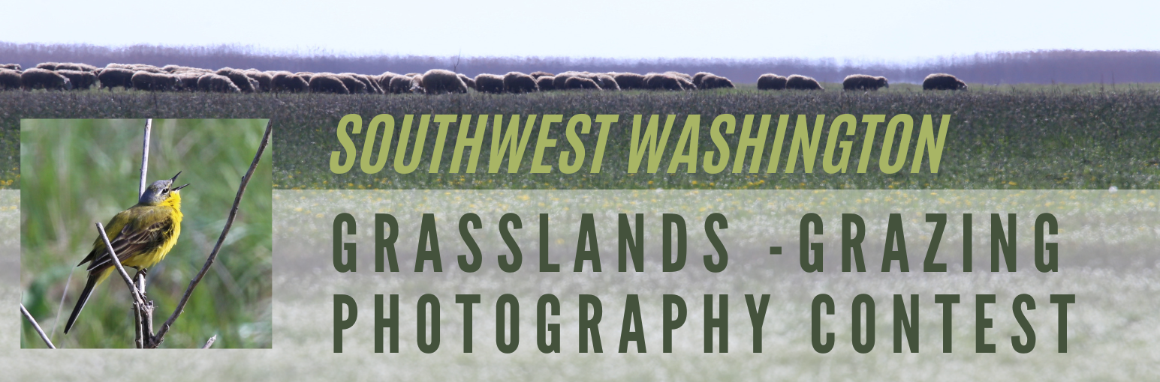

Agricultural photography is helpful to tell the story of farming, natural resource conservation on farms, and the rewards and challenges that farmers and farm families encounter in their day-to-day lives. Interested photographers are invited to participate in this regional photography contest to showcase their work while helping to tell the story of local, grass-based agricultural production. Farmers and non-farmers, professionals and ameteurs, are welcome to participate.

This photography contest is focused on grazing lands and prairies in Grays Harbor, Lewis, Mason, Pacific, and Thurston Counties. The competition is timed to generate images and stories in preparation for the upcoming 2026 United Nations “International Year of Rangelands and Pastoralists”. All submissions will be eligible for public arts exhibits planned for 2026 throughout the five-county region.

Timing
The contest will run from May 1st through November 15th, 2025.

Contest Details
- Participants are invited to submit four photographs.
- All submissions must be printed, mounted on foam core, and delivered to the WSU Thurston County Extension office (see below for instructions)
- Digital copies of images need to be uploaded along with the entry form at the link HERE (https://wsu.co1.qualtrics.com/jfe/form/SV_7257kTVeFz3pCnk)
- Additional entry instructions are noted below

Purpose
The contest is designed for educational and artistic purposes through a collaboration of non-profit agricultural education organizations. The mission is to bring greater awareness to farming and farmers in the region, and support farm viability and sustainable agriculture. The intent is to raise public awareness through arts-based education that inspires action and supports local agricultural communities and sustainable natural resource management.

Judging

Submissions will reviewed by a panel of three judges in person at the Thurston County Fairgrounds in the Heritage Hall. This will be a public event with refreshments, an engaging review of the entries, and a brief comments by a local rancher and local grasslands conservation specialist.

ENTRY INSTRUCTIONS
• Delivering prints in advance. During the period from May 1 through November 14, print entries may be delivered during business hours to WSU Thurston County Extension, 3054 Carpenter Rd SE, Lacey, WA 98503. No entries will be accepted after 5:00 pm on Nov 14.
• Protecting your prints. For protection of your prints and to keep your images grouped with the entry form, please place them in a bag or package of some kind. Prints must be accompanied by a completed entry form. Please ensure your name, print numbers, and titles match the online form.
• Judging. Prints will be judged on Saturday, December 13, beginning at 10 a.m. in Heritage Hall at the Thurston County Fairgrounds. Exhibitors are encouraged to attend the judging, and all community members are welcome. Refreshments and brief comments by two speakers included.
• Print handling. WSU Thurston County Extension and The Olympia Camera Club will exercise all possible care in the handling and processing of prints for this exhibition. They are not responsible for loss or damage while the prints are in their custody.
• Picking up your prints. Following the December 13th judging event, selection of photographs for 2026 exhibits will be completed by January 15th. Participants willing to allow their images to be displayed will be notified by that time. Photographers of prints not selected for exhibits will be notified by January 15th. Prints may be picked up at the WSU Extension Office between January 20th and January 29th, 2026 (Tu-Fri 8:00 a.m. and 5:00 p.m). Entries will not be mailed to exhibitors. Entries not picked up by January 29th will be left in the WSU Thurston County Extension Office.
• The exhibitor of the print must be the original maker of the image. The use of AI software shall be limited to minor repairs, noise reduction, sharpening, etc. The use of AI to generate significant content is not allowed.
• The image may have been made in any type of camera, including camera phones. Images may be computer enhanced.
• A print entry must be at least 8” x 10” and up to 16” x 24” in size (including mat, if applicable). Odd-size entries are acceptable, so long as the shortest side is no more than 16” and the longest side is no larger than 24”. Panorama images are an exception to this rule but may not exceed a 12” x 36” measurement. Square prints can be submitted up to 18” x 18”.

Mounting and Delivering photographs
The WSU Thurston County Extension Office is located at 3054 Carpenter Rd SE, Lacey, WA, 98503. The office is open to take in photographs from 8am to 5pm Tuesday-Friday. Images can be commercially mounted or photographers can access a tutorial developed by Olympia Camera Club to learn how to mount on foam core themselves.

Categories
- Wildlife (or more broadly ecosystem services) in prairies/grasslands
- Rural livelihood from grasslands and grazing (including sustainable livestock products linking sustenance to land)
- Traditional knowledge (indigenous or Euro-American) and culture connected to grasslands
- Pastoralist/rancher/grazer women and youth
- Grassland loss
- International

Rights in Use
Use of images submitted to this contest will be strictly limited to the following educational uses and can be modified by the photographer by selecting among use restrictions in the Contest Application. Images will be used for the intended purpose of creating displays to promote the “International Year of Rangelands and Pastoralists” (IYRP). For this contest, Rights in Use applies to physical exhibits held in Grays Harbor, Mason, Lewis, Pacific, and Thurston Counties. Additional uses if agreed upon by the photographer include:
- Use in regional and national physical exhibits. Regional or national exhibits would pertain to inclusion in physical exhibits in public spaces, potentially including but not limited to libraries, malls, airports, and city halls. Display would be limited to physical installations.
- On up to two promotional websites directly associated with the IYRP noted below.
Either use will only be exercised after prior discussion with and approval by the photographer.

Digital Use: Websites for Use Upon Approval by Photographer
- IYRP Homepage: https://iyrp.info/
- Western Region SARE Arts-Based Education Team Webpage: https://extension.wsu.edu/thurston/arts-grasslands-rangelands/
File Storage
Digital files used for exhibits in the Washington counties noted above will be stored in a WSU-managed, password-protected Dropbox account accessible only to the contest organizer (WSU Extension, Stephen Bramwell). Files allowed for regional or national exhibits will be stored in a password-protected library archive at the University of Arizona in their Rangelands Gateway database. Access to this database is restricted to website editors.

Termination
Photographers can terminate rights in use at any time and modify rights in use at any time, within the parameters of use identified in this document, and by mutual agreement with the contest organizer.

Attribution
All works will be attributed to the photographer in a manner that meets the photographer’s specifications for adequate acknowledgement, and fits in a suitable manner such as not to distract from the exhibit.

Additional Uses
No rights in use beyond those described here (including any manner of file or print sharing) is allowable unless confirmed in writing between the contest organizer (WSU Extension, Stephen Bramwell) and the photographer. No use outside those identified here for commercial application or otherwise are allowable.

Acknowledgements. This project is made possible with collaboration among the following organizations, and with funding from the USDA Western SARE Program.







