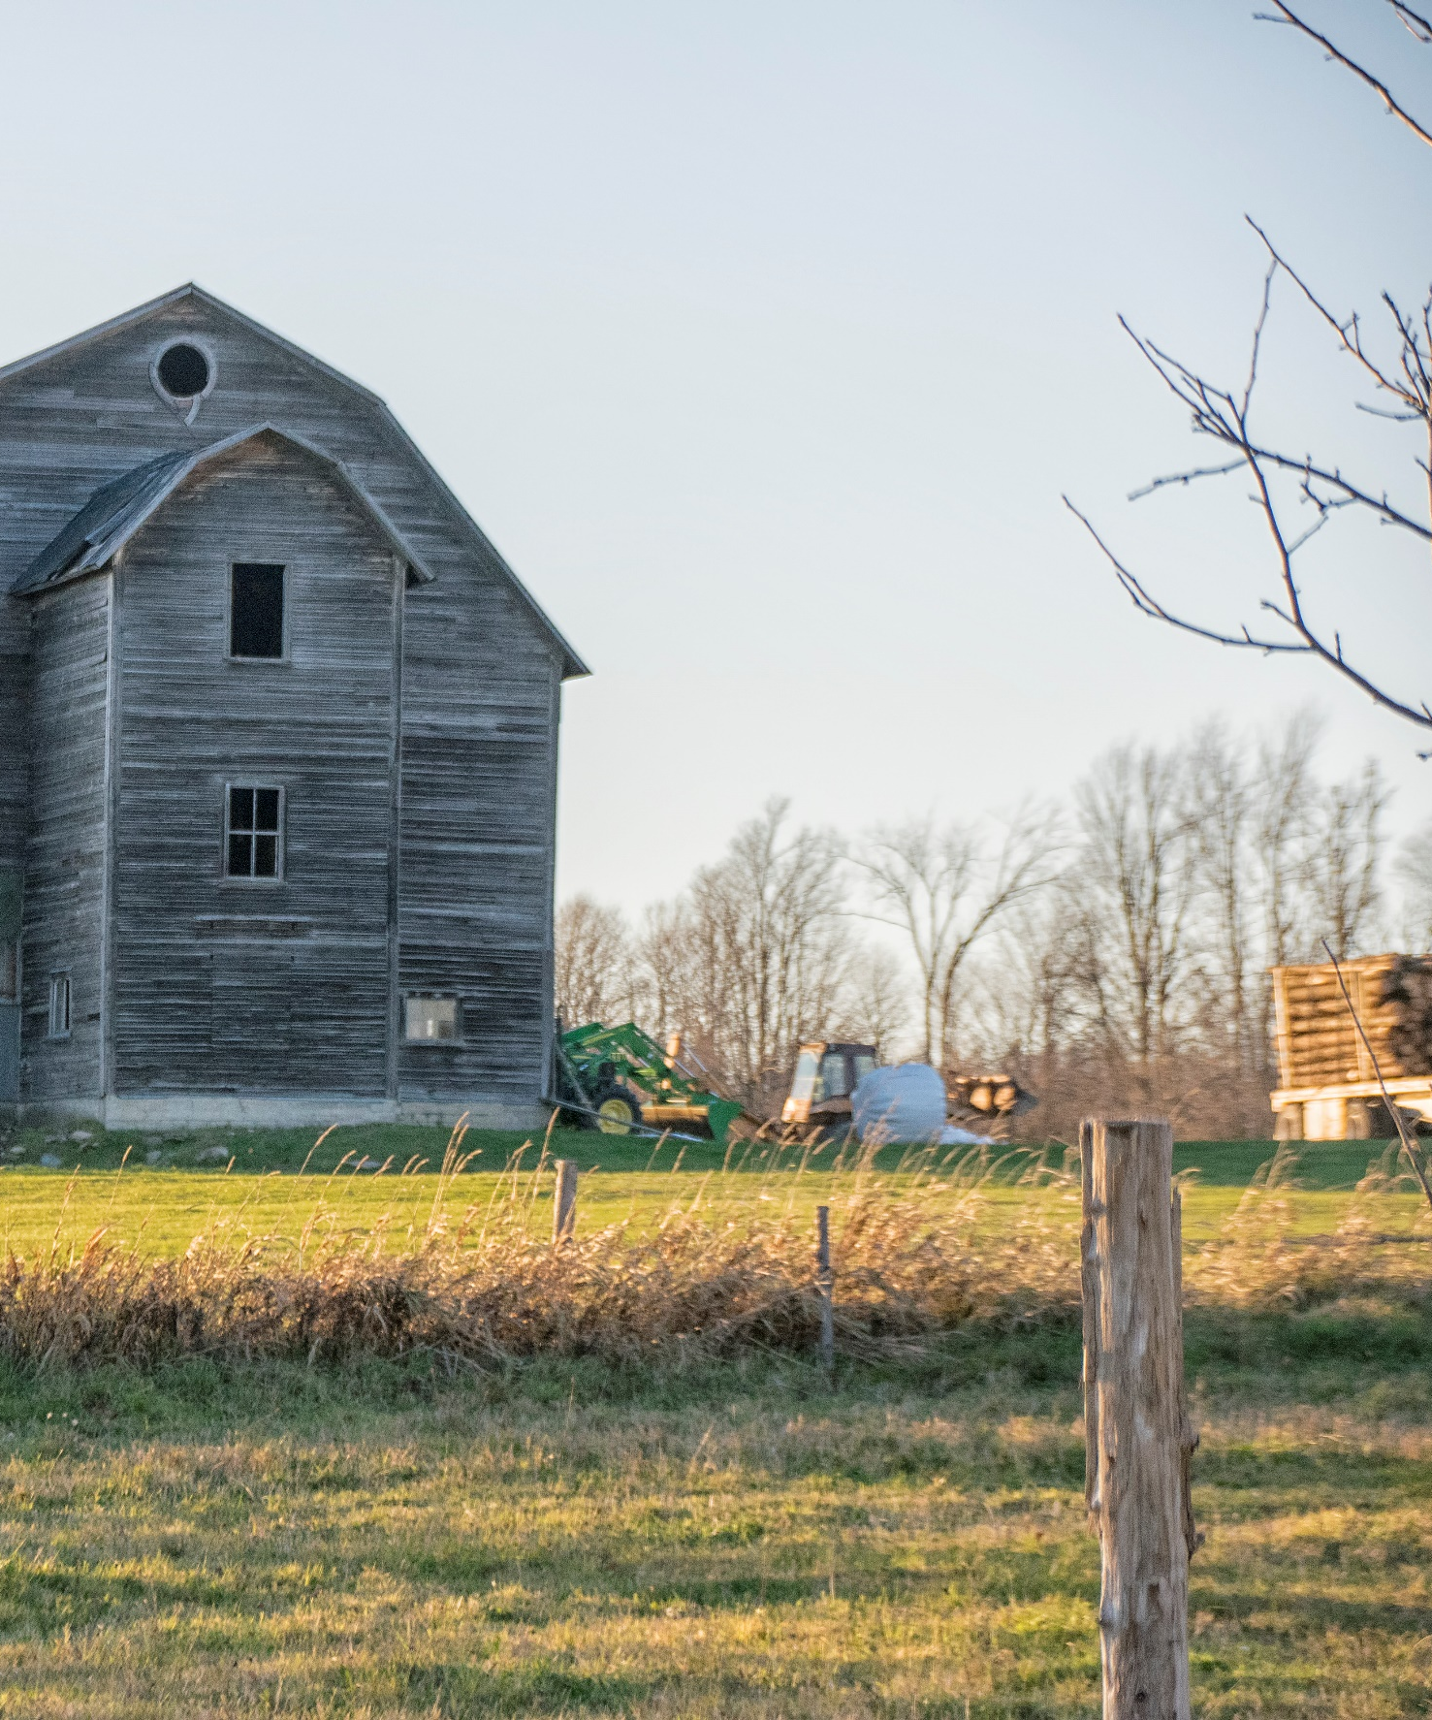

JBLM sentinel Landscape
  - COMMUNICATIONS PLAN July 2021

Goals and Objectives

Vision
A South Puget Sound Region with sustainable military operations at Joint Base Lewis McChord (JBLM), a vibrant agricultural economy, and effective conservation of rare species and their habitats.

Mission
The JBLM Sentinel Landscape partnership (Partnership) brings together federal, state, and local governments, non-governmental organizations, and landowners in the South Puget Sound Region to collaboratively sustain JBLM’s military Mission, protect the agricultural economy, and conserve rare species and their habitats.

Goals
G1: Increase military training flexibility on JBLM by creating opportunities to conserve prairies and listed species outside JBLM.
G2: Maintain the South Puget Sound agricultural landscape by promoting mutually beneficial projects that support local agricultural viability, sustainable community development and prairie conservation on working lands.
G3: Protect and enhance rare species and their habitats outside JBLM to promote rare species conservation and minimize chances of further species listings within the JBLM Sentinel Landscape.

Purpose
Outreach and communication are critical for reaching others who may be able to assist the Partnership in achieving our goals. To strategically focus this effort, the Partnership will prepare an outreach and communication plan, and develop support materials to inform others about the Partnership. The Partnership will also (1) reach out to landowners to increase awareness of, and facilitate enrollment in, Partner programs; (2) reach out to veterans to increase awareness of programs that allow them to be employed, or start businesses, in conservation and agriculture; and (3) collaborate with other organizations as a means to achieve our goals.
This communications plan is intended to support the 3-year JBLM Sentinel Landscape implementation plan (2020-2022). Updates to the implementation plan will necessitate a review and update of this communications plan.

Strategy
The degree to which the 2020-2023 JBLM Sentinel Landscape Implementation Plan will be successful depends in large part on the Partnership’s ability to effectively engage partners, local communities, and other organizations. The Outreach and Communication Strategy has five objectives and 16 actions related to collecting and organizing the right information and getting it to the right audience at the right time. The Partnership will focus first on preparing this Outreach and Communication Plan, along with materials, web platforms, guidance documents, and pamphlets, to ensure that we reach the necessary individuals and groups.
With these tools and processes established, the Partnership will then Reach Out to Landowners (at least 50 landowners annually) to increase awareness of Partner programs and enlist at least 10 landowners annually¹ in one or more of the Partner’s programs. Partners will seek landowner involvement through partnering with existing programs, utilizing agricultural liaisons, holding workshops and outreach events, and participating in other partners’ on-farm technical assistance programs. The Partnership will also Reach Out to Veterans (at least 20 veterans annually¹) to increase their awareness of programs that support veteran employment and aid veterans in starting conservation and agriculture businesses. The Partnership will also Collaborate with Other Organizations (at least 10 annually¹). The Sentinel Landscape is large, the audiences and markets are diverse, and the ability to effectively implement the 78 actions identified in the 3-year implementation plan will depend upon the combined actions of all our Partners. Collaborating with others will expand our ability to reach landowners, support our partner’s efforts, and leverage collective actions. Toward this end, the Partnership will utilize websites, develop social media streams, and partner with others on outreach programs to reach our target audiences. In addition, we will hold annual multi-stakeholder meetings to Share Successes and Seek Partnering Opportunities.

Objectives and Actions

Strategy Objective  (quantifiable over the next 3 years) | Action | Aligns  with  Goal(s)
Objective 4.1 ̶ Develop an Outreach and Communication Plan  By 2020, develop an outreach and communication plan that informs others about Sentinel Landscapes and helps progress the Partnership’s goals. Update annually. | Action 4.1.1 – Assess existing incentive programs to determine gaps, barriers, and opportunities for participation. | G1,G2,G3
 | Action 4.1.2 – Develop an inventory of landowners interested in participating in programs. | G1,G2,G3
 | Action 4.1.3 – Develop online materials and platforms, such as the local JBLM Sentinel Landscape website, a Facebook site, and other online social media. Produce online media releases about events and Partnership news. | G1,G2,G3
 | Action 4.1.4 – Develop pamphlets and guidance documents for the various actions undertaken by each Strategy. | G1,G2,G3
 | Action 4.1.5 – Identify targeted opportunities for communication and outreach. | G1,G2,G3
Objective 4.2 – Outreach to Landowners  Reach out to at least 50 landowners annually to increase awareness of Partner programs and enlist at least 10 landowners annually in one or more of the Partner’s programs. | Action 4.2.1 ̶ Utilize existing Partner programs to reach out to landowners about the Partnership’s technical assistance and funding opportunities, e.g., NRCS Farm Bill programs, the USFWS Partners for Fish and Wildlife Program, and Thurston County’s Voluntary Stewardship Program. | G2,G3
 | Action 4.2.2 ̶ Utilize Partnership’s existing agricultural liaison (Thurston Conservation District staff), as a means of linking people with Partnership programs and facilitating enrollment in, or application of, various assistance programs. | G2,G3
 | Action 4.2.3 ̶ Hold workshops and outreach events, such as those held in 2019 by Washington State University, about management practices that demonstrate compatibility between agriculture and conservation. | G2,G3
 | Action 4.2.4 – Utilize on-farm technical assistance, such as the Thurston Conservation District’s Individual Stewardship planning, as a means to promote and provide access to conservation programs. | G2,G3
Objective 4.3 – Outreach to Veterans  Reach out to at least 10 veterans annually to increase awareness of programs that allow them to be employed, or start businesses, in conservation and agriculture. | Action 4.3.1 – Reach out to veterans about programs to help  them start and maintain agricultural and conservation  businesses, such as Enterprise for Equity’s Veterans program. | G2
Objective 4.4 – Collaborate with Other Organizations  Coordinate and directly collaborate with at least 10 organizations annually to assist with progressing joint goals between our organizations. | Action 4.4.1 ̶ Utilize other organization’s websites to communicate our efforts and needs, (e.g., Cascadia Prairie- Oak Partnership), to inform others of new opportunities and collaborate on ways to progress joint goals. | G2,G3
 | Action 4.4.2 ̶ Hold annual multi-stakeholder meetings with other organizations, such as the Regional Working Groups for each listed species. | G2,G3
 | Action 4.4.3 – Provide outreach materials to organizations and partners for use in outreach events and on their websites. | G2,G3
 | Action 4.4.4 – Continue to support and maintain a presence at the Annual Prairie Appreciation Day. | G3
Objective 4.5 – Share Successes and Seek Partnering Opportunities  Provide consistent information on Partnership successes, opportunities, and priorities to all existing, and at least 10 potential new, partners by 2023. | Action 4.5.1 – Post materials on our Sentinel Landscape website and other websites. | G1,G2,G3
 | Action 4.5.2 – Hold an annual summit meeting with other conservation, agriculture, and military organizations and agencies. | G1,G2,G3

Organizational Identity
The Partnership identifies innovative approaches, leverages resources from multiple sources to maximize conservation benefits, and coordinates the delivery of federal, state and local programs to landowners whose working and natural lands serve to protect the military mission, the prairies and woodlands of the rural landscape, and habitat for fish and wildlife.

Target Audience
This communications plan is multifaceted with each identified objective reaching out to a different population. Objective 4.1 (the creation of this plan) is intended to coordinate communication plans within the partners of the JBLM Sentinel Landscape (Landscape).
Objective 4.2 is intended to inform landowners within the Landscape boundary about conservation opportunities on their property. Specifically, this plan targets agricultural landowners and/or landowners with critical habitat, Endangered Species List (ESA) listed species, or the potential to create habitat for listed species. A Global Information Systems (GIS) working group of the PIC is working to develop a prioritization scheme to identify high-value parcels which will be targeted by outreach efforts.
Objective 4.3 targets military Veterans by connecting them with agricultural and business opportunities within the Landscape, while Objective 4.4 targets other organizations working towards similar goals within the Landscape. Finally, Objective 4.5 is intended to share successes with all partner organizations and reach new potential partners.

Communication Channels
Internal communications between members of Partnership will be facilitated through the organizational structure established by the charter. External communication products will be developed by the communications working group. Products will be reviewed and approved by the Planning and Implementation Committee (PIC). When necessary PIC members may consult with their Executive Leadership Group (ELG) representative for final approval. Trainings and technical documents intended for internal use will be developed to help each agency understand and convey the breadth of opportunities available to the landowners they work with.
Communications with landowners is complicated by the myriad of complex incentive programs available across the Partnership, each with established communication channels and audiences. The partnership must coordinate consistent messaging around these opportunities and will develop Landscape-wide outreach materials such as booklets, brochures, flyers, and direct mailers to be distributed by all within the Partnership. Outreach materials will identify the Thurston Conservation District (TCD) as the single point of contact for all landowners interested in incentive programs. TCD is a non-regulatory organization which partners with private landowners to support voluntary land stewardship. As the single point of contact, TCD will provide information on the breadth of incentive programs available to landowners and guide them to land trusts and other appropriate agencies.
Veteran communications will be directed through established partnerships between TCD, Washington State University Extension (WSU), and the Washington Department of Veteran Affairs (WDVA). WDVA has established networks of Veteran farmers through local incubator farms and agricultural business training courses.
Communications directed at new partners and external organizations will again be developed by the communications working group and approved through the PIC. Inter-organizational communications will identify the Landscape coordinator as the single point of contact.

Branding:
The Partnership is diverse and the inclusion of all Partner logos on every outreach product would be unwieldy and confusing. The Sentinel Landscape logo is currently unrecognized by local landowners. Educational and outreach content developed by the Sentinel Landscape partnership and directed at local landowners will bear two trusted, non-regulatory logos, Thurston Conservation District and Washington State University Extension. These organizations are responsible for leading the development of these communications products with assistance from the communications working group. TCD and WSU would have final approval over use of their respective logos in any communication products. Communications products directed at other organizations and agencies will bare the Sentinel Landscape and JBLM logos primarily.

Websites:
The national Sentinel Landscape site managed by the Department of Defense (DOD) will be the primary home for general information about the Landscape and its accomplishments. The JBLM Sentinel Landscape coordinator will work with DOD to keep the national page updated with developments within the Landscape.
Landscape information relevant to landowners will be housed on a locally-managed JBLM Sentinel Landscape site. The site will have a url (to be determined) that is neutral of any of the Partners and clearly identifies it as a service for local landowners and managers. This website will contain all the outreach materials produced to serve the Landscape with a focus on the comprehensive list of landowner incentive programs. Descriptions of each incentive program will link to the sponsoring agency and provide appropriate contact information. This website will be developed and managed by the Thurston Conservation District with input and review by the communications working group of the PIC. Each Partner may link directly from their website to this Sentinel Landscape landowner information site.
All web products should be developed using User Experience (UX) design principles, ensuring information can be found quickly by our target audience
National DOD managed site: https://sentinellandscapes.org/landscapes/joint-base-lewis-mcchord/
Local landowner information site: url to be determined

Social Media:
A JBLM Sentinel Landscape facebook page was created to announce education and outreach events that are explicitly related to the Landscape. To maintain relevance this site would need regular, multi-weekly postings. In the current opinion of the communications working group, a social media presence is not likely to reach the target audience and is therefore not a worthwhile investment of time. Events will be announced via the social media channels of Sentinel Landscape partners. It is recommended that the Landscape’s facebook page be taken down until a comprehensive social media strategy is developed by the Partnership.
https://www.facebook.com/jblm.sentinel.landscape

Messages, Materials and Activities
Simplifying and consolidating conservation opportunities for landowners is paramount. This requires compiling the available opportunities and resources, educating the outreach personnel from each agency, and minimizing the number of contacts a landowner must make.
All products will be created using a to-be-developed JBLM Sentinel Landscape style guide. Outreach communication will be in plain language, removing jargon, and assuming an unfamiliarity with legal conservation practices and terms.
Following are the planned communications actions with the 3-year timeline laid out in Table 1.

Objective 4.1 Internal Communications:

Documents
- Communications Plan (Objective 4.1)
- JBLM Sentinel Landscape style guide (Action 4.1.3, 4.1.4)
- Comprehensive list of landowner incentives (Action 4.1.1)
- Mitigation banking roles and terms clarified (Action 4.1.4)
- Standard operating procedure for interested landowner intake, including standardized answers to frequently asked questions (Action 4.1.4)
- Easement stacking negotiated, clarified and documented (Action 4.1.4)

Activities:
- Establish “Land Acquisitions Working Group” to facilitate Land Trust coordination (Action 4.1.5)

Events:
- Mitigation training for agencies and land trusts (Action 4.1.4)

Web Products:
- Develop a standalone landowner information website to house: (Actions 4.1.3, 4.4.1)
  - All the Landscape’s published outreach products
  - Expanded information on each incentive program, including links to each agency and contacts for land trusts
  - All recorded landowner workshops, webinars, and events
- Link from Partner webpages to the landowner information website (Actions 4.1.3, 4.4.1)
- Recorded trainings on mitigation programs for agency personnel will be hosted on the County webpage (Action 4.1.4)

Data Collection:
- Database of properties that meet the target criteria for priority conservation (assigned to the GIS working group) (Action 4.1.2)
- Database of landowners who have expressed interest in conservation (Action 4.1.2).
NOTE: As of yet, there does not appear to be a method to share databases of landowner information between agencies due to privacy concerns. The Partnership will need to discuss how best to capture and share landowner interest to ensure that landowners are not lost between agencies. Perhaps a central landowner database can reside within a single agency such as the Thurston Conservation District.

Objective 4.2 Landowner Communications:

Paper Products:
- Brochure. Conservation Easement Basics: What is an easement, how does it work? (Actions 4.2.1, 4.2.2, 4.4.3)
- Booklet. Easement options and stacking. What programs exist to fund conservation easements? How do different easements interact and interface with mitigation? (Actions 4.2.1, 4.2.2, 4.4.3)
- Brochure. Farmer’s Protecting Grasslands: Introduction to the gradient of grassland protection a landowner can engage in. (Actions 4.2.1, 4.2.2, 4.4.3)
- Postcard. Direct mailer to targeted landowners (Action 4.2.2, 4.4.3)
- Booklet. Mitigation Credits Document: What are they, how do they work? (Actions 4.2.1, 4.2.2, 4.4.3)
- Fact Sheet. Conservation Grazing (Action 4.2.4)

Events:
- Virtual workshop: Introduction to Easements (Action 4.2.3)
- Virtual workshop: Farmers Protecting Grasslands – introduction to grasslands and how to protect them (Action 4.2.3)
- Virtual workshop: Mitigation credits – what are they, how do they work and where do you get more information (Action 4.2.3)

Objective 4.3 Veteran Communications:

Events:
- Host “Whole Farm Planning” courses and provide scholarships to Veterans (Action 4.3.1)
- Host Agripreunership training with scholarship for Veterans (Action 4.3.1)

Objective 4.4 External Organizations Communications:

Events:
- Host annual Taylor’s checkerspot working group meetings (Action 4.4.2)
- Table at Prairie Appreciation Day (Action 4.4.4)

Objective 4.5 Recruitment Communications:

Web Products:
- Annually update the DOD-hosted JBLM Sentinel Landscape webpage (Action 4.5.1)

Events:
- Hold an annual summit meeting inviting other military and conservation organizations (Action 4.5.2)
- Participate in the Cascadia Prairie Oak Partnership conference (Action 4.4.2, 4.5.2)

Partners
Capitol Land Trust
Center for Natural Lands Management
Ecostudies Institute
Enterprise for Equity
Forterra
Joint Base Lewis McChord
Natural Resource Conservation Service
Nisqually Land Trust
Pierce Conservation District
Thurston Conservation District
Thurston County
US Fish and Wildlife Service
Washington Department of Commerce
Washington Department of Fish and Wildlife
Washington Farmland Trust
Washington State University Extension Thurston County

Budget

This plan will be executed as funded through REPI and other sources by the project partners.

Evaluation
We plan to engage 150 landowners over the next 3 years. Each year we will evaluate our database of interested landowners to ensure that we are on track to meet this goal. We will assess the consistent interpretation of conservation opportunities across agencies by conducting annual knowledge assessments of interested landowners on those current opportunities. Finally, we will assess our achievement of private land protection by reviewing our annual progress towards the goal 200 acres of private land protected by 2024.
Outreach Outputs Tracked:
- Website and social media analytics
- Flyers, brochures, booklets distributed
- Virtual workshop attendees
- Conservation easements in place
- Acres of land purchased
Outreach Outcomes Tracked:
- Number of interested landowners in our database
- Familiarity with easement options by interested landowners
- Number of properties actively engaged in the easement process
- Number of acres protected by conservation easements

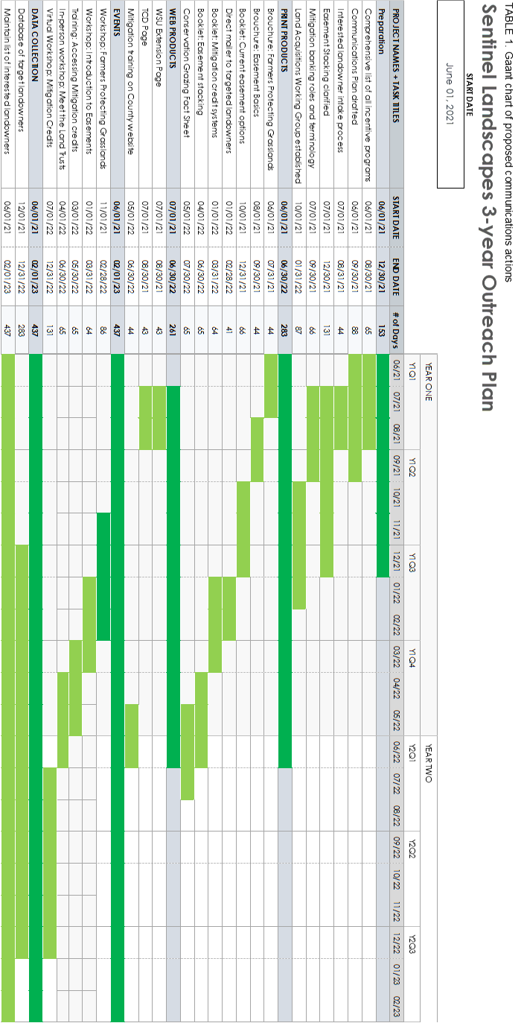

Joint-Base Lewis-McChord Sentinel Landscape Partnership Implementation Plan 2020 – 2023, page 6

